

MICRO CREDIT LOAN DEFAULT

Submitted by:

BALPREET KAUR

**ACKNOWLEDGMENT**

**ACKNOWLEDGMENT**

The references I used are:

* Pandas documentation.
* Libraries documentation like:
* [Scikit-learn](https://scikit-learn.org/)
* Seaborn
* Used Stack Overflow website for some technical issues.
* Other tutorial websites for some visibility such as:
  + <https://seaborn.pydata.org/tutorial/categorical.html>
  + https://towardsdatascience.com/a-complete-guide-to-plotting-categorical-variables-with-seaborn-bfe54db66bec
  + <http://www.sthda.com/english/articles/32-r-graphics-essentials/129-visualizing-multivariate-categorical-data/>
  + <https://bookdown.org/max/FES/visualizations-for-categorical-data-exploring-the-okcupid-data.html>
  + https://www.kaggle.com/aantonova/practical-eda-on-numerical-data
  + <https://www.kaggle.com/general/208207>
  + <https://www.kaggle.com/sivakrishna3311/delinquency-telecom-model>
  + <https://towardsdatascience.com/exploratory-data-analysis-eda-72ba03480417>
  + https://www.analyticsvidhya.com/blog/2020/08/exploratory-data-analysiseda-from-scratch-in-python/

And also consulted tutorials from DataTrained python basic visualization videos.

**INTRODUCTION**

* Business Problem Framing

The business problem is the following one:

Decide whether the user will be paying back the loaned amount within 5 days of insurance of loan. The goal is to study if the user has intention of paying back the loan given the features and conditions by the bank in order to understand better and execute the strategies for user payback plan.

How this can be related to the real world:

This study is useful whenever there is a study of any kind of loan or other financial product such as renting and can guide the features and parameters that are important in order to get the best online store properties by studying its best features.

* Conceptual Background of the Domain Problem

Domain concepts that will be useful for this project is to fully understand the meaning of the features and understand the correlation with the target and study and get full knowledge of the important features concluded by the algorithm. This last acknowledgement should be required after having analysed and conclude the algorithm and get to know the best of the best features concluded by the algorithm in order to give the best conclusions and recommendations.

* Review of Literature

Most of the literature review is based on online resources, open access articles and the Towards Data Science collection and some research and visualization learning books to have solid foundation in visualization and descriptive statistics techniques about how it can be applied accurately to our study case.

I checked the provided documentation and identified the names of the features. And researched different websites in order to understand fully the meaning of each of one.

And my main goal for the research was to find, understand and have the better knowledge I can have of the loan financial characteristics and features in order to better understand the relationship between all features and apply the intensive understanding and knowledge of these features on my analytical project.

* Motivation for the Problem Undertaken

Being honest, I am also a Finance graduated, not only a data science enthusiastic. So, I did have information about this type of market and how it works. But at the same time, the data we were about to study was simple and the questions (as features) was straightforward and clear. So, I can say there was no such difficulty in understanding and doing the analysis. In the end, more knowledge is something valuable that we can get at every stage of our life. We do not know everything 😊.

**Analytical Problem Framing**

* Mathematical/ Analytical Modeling of the Problem:

I did statistical description and studied correlation of the features of the dataset I had for training purposes.

* + In statistical description I checked a first view of skewness. I checked if we had any type of skewness (at first sight) and if so, what type of skewness we had by checking the median, mean and mode.
  + Also, as important study in the statistical descriptive analysis, we checked and got some first insights on the outliers comparing the maximum of each feature with the 75%.

Then in the correlation matrices and heatmaps we did understand the correlation and the quantification of the impact of each feature on our target loan return.

And after that, we did an intensive study on the features understanding their important relations and the impacts each feature has on the other one.

I also did print some VIFs values in order to get ride of the features that were mostly correlated to other features and were impacting more due to high multicollinearity.

And after having studied the important features relationships and fully understand the data we have, we started with the process of modelling. As it was a case of loan default, we followed the basics steps and instructions for categorical relationship studies as loan has 2 unique values, 0 and 1.

In summary, we did pre-process the data and evaluate the prediction accuracy of the models. It has multiple stages that are required to get the prediction results.

These steps are:

-processing: both datasets will be checked and pre-processed using the methods which have various ways of handling data such as mode, median or mean for each feature.

- Data splitting: separating the dataset into two parts n order to train the model with one and use the other in the evaluation. The dataset will be split 75% for training and 25% for testing.

- Evaluation: the accuracy of both datasets will be evaluated by measuring the Accuracy, precision, recall and f1score rate when training the model alongside an evaluation of the actual outputs on the test dataset with the outcome that was being predicted by the model.

- Correlation: correlation between the available features and loan default will be evaluated using the Pearson Coefficient Correlation (default correlation method) to identify whether the features have a negative, positive or zero correlation with the house price.

* Data Sources and their formats

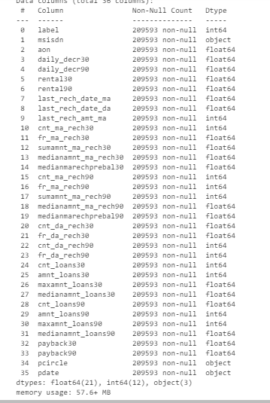

The data was given in the ziP format file and attached to the study case. In the dataset we have a total of 209593 rows and 36 columns. Checking the data types, we have a total of 21 floats and 12 integer as numerical features and 3 features as object type.

So, for our analysis, throughout the process, we reconverted the type of data we have in order to analyse it more in detail. For example, we had to convert the features and encode them in order to add them in the machine learning algorithms.

The info we get from the data sample itself and its datatypes is the following:

We have set of 209593 rows entries and 36 columns including the target column. In this dataset, our target variable is label which defines if the client has paid the loan or not.

We have columns without missing data. We see and notice them when comparing the total rows in the whole dataset and the total rows we have in each feature.

We can check the datatype of each feature in the above list: we see right now we have 3 object type data, 21 float type data and 12 integer columns.

If we check the dataframe, we can see we have a column named pcircle that is a kind of telecom circle that we will drop as the telecom circle is same for all instances.

If we check the dataframe, we can see we have a column named msisdn that have cellular numbers which can be treated as indexing column and that we will drop before doing our ML algorithm training.

So in this dataset we have several features such as daily_dec,rental, last_rech_date, cnt_ma_rech or even median kind of columns and the target label that can be breakdown in some kind of categorical data.

But in the final all features excluding label and pdate, all other features excluding pcircle and msisdn will be prepared and treated as numerical features and analize them though boxplot and use these as ML inputs.

* Data Preprocessing Done

The steps we followed for data processing and cleaning was check for missing values and also to impute the extremes values of the training set or values non viable.

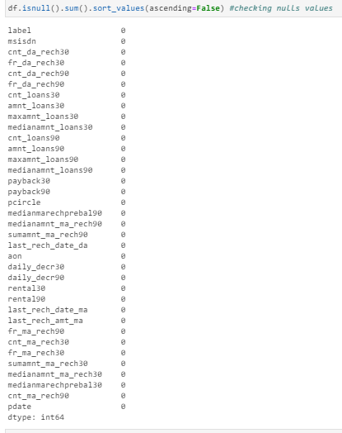

So, no missing values were found.

Regarding the extreme values, we did impute these by the mean after having excluded the extremes values.

Then, we also checked how many unique values we had in our dataset by column:

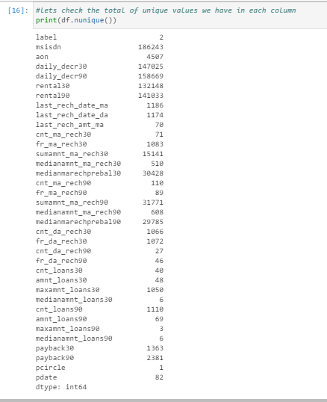

We see label for example has only 2 unique values which means label is a binary feature.

Then, we also have features that have uniques values between 1 and 6 which are as follows:

- first of all, we have pcircle which has only 1 value for all the rows, which means we can remove this column we there is no pattern to be studied within this column.

- then, we have column maxamount_loans90 which has only 3 unique values which we will find out late.

- the mediamnt_loans90 has 6 unique values

We also have features that have unique values between 27 and 10 which are cnt_da_rech90, fr_da_rech90, cnt_loans30, amnt_loans30, amnt_loans90, last_rech_amt_ma,cnt_ma_rech30, fr_ma_rech90 and cent_ma_rech90. And even dataframe's column pdate has 82 unique values.

And in adittion, we also have columns that have a number of unique value higher than a thousand that is the case of the remaining columns excluding medianamnt_ma_rech90 or mediaamnt_ma_rech30.

We will also need to drop pcircle column as it has only one unique value for all the instances.

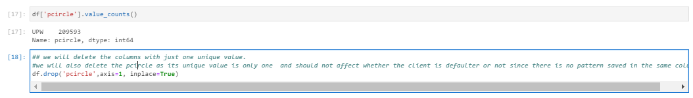

* Data Inputs- Logic- Output Relationships

So, when we study the relationship between our features with regards our output target, we have several considerations to have in mind:

* + First of all, the data format of the input and output:
    - As we said, we had several different formats of our input data such as integer, float and object.
    - Regarding the integer and float data type, there was no such issue as these were already numerical type data.
    - The problem was basically with other object type data when considering them for the relationship purposes. But, for our case, we do not need it for our machine learning as the object was applied only on the phone numbers which could only be used as indexing feature and not as categorical or numerical factor.
  + Relation and affection between the input and output:
    - When checking the relationships between the features and the target, we see some feature like dailydecr30, dailydecr90, last_rech_amnt_ma, cnt_ma_rech30, fr_ma_rech30, sumamnt_ma_rech30, medianamnt_ma_rech30, cnt_ma_rech90, sumamnt_ma_rech90, medianamnt_ma_rech90, cnt_loans30, amnt_loans30, amnt_loans30, payback30 and pdate that are more correlated and have more possibility to impact more on our target variable label.
* State the set of assumptions (if any) related to the problem under consideration:
  1. The life total max age we assumed is 125 years, which affects several features such as age of mobile usage among others.
  2. For daily_decr30, daily_decr90 and others features related to period of lifetime such as maximum recharge days :

As we can see in the below document from website worldbank, we can understand and fix the minimum poverty rate to 29764.7 Indonesian rupiah as of year 2019 <https://databank.worldbank.org/data/download/poverty/987B9C90-CB9F-4D93-AE8C-750588BF00QA/AM2020/Global_POVEQ_IDN.pdf>

So, taking 29764.7 Indonesian rupiah per day per capita, we can replace all the cases where daily spent is more than 29764.7 Indonesian rupiah by 0. After replacing the higher values than 29764.7 Indonesian rupiah by 0, we can replace the 0 by average of column daily_decr30. (so that we dont impact the average with fake higher number for a Daily amount spent from main account, averaged over last 30 days (in Indonesian Rupiah)

* 1. So, here we clearly see that the unique values that only have 1 total value are values which were inserted by error. Because values from 846099.63221 till last one 747564.075282 dont make any sense. These are irrational as the accounts are from poor families. So we will drop those irrational frequencies and will impute them with mean.
  2. Since this is a mobile number of user, so basically in general we have a unique and different mobile number for each client. Maybe the case we have more than one client that uses the same number for more than one loan case. So, basically in general, we have wide range of mobile cell phone numbers in our data. That’s why our violin has wide range of msisdn column.

Talking about the cellular phone number, we need to mention the following:

As the mobile number of the user is unique for each client, it wont help for our machine learning purposes.

Even if we see several mobile phone numbers with more than one unique value, it still does not help much as it has a large list (186k) of unique phone numbers that wont help us except being a index kind of feature and using it as a unique identifier of a customer and counts or analyze other features. But still, it has large list of indexs. But still if interested, we can use to analize the other features highlighting the main pattern or the others' unique values for some main indexed customers throughout the index telephone number.

So, we will keep it if we need to analyze some pattern or data for x customer via telephone indexing.

And talking about the age of the cell phone, we should mention:

we can’s have numbers like 567623 or 553012, etc. Because it means the user has lived around 1555 years and it cant be possible for the case where we have aon of 567623 . So we need to drop all numbers from starting from 45625 as 45625 is the number of days one can live which is around 125 years.

from the wikipedia we can find:

The list of the oldest people in the world in ordinal ranks. To avoid including false or unconfirmed claims of old age, names here are restricted to those people whose ages have been validated by an international body dealing in longevity research, such as the Gerontology Research Group (GRG) or Guinness World Records (GWR), and others who have otherwise been reliably sourced.

According to this criterion, the longest human lifespan is that of Jeanne Calment of France (1875–1997), who lived to age 122 years and 164 days. She supposedly met Vincent van Gogh when she was 12 or 13. She received news media attention in 1985, after turning 110. Interesting right!

Country of her nationality: France

So, it is rational to take and use 125 years of ase as maximum age of living being.

And regarding daily_decr30 and daily_decr90:

As we can see in the below document from website worldbank, we can understand and fix the minimum poverty rate to 29764.7 Indonesian rupiah as of year 2019

https://databank.worldbank.org/data/download/poverty/987B9C90-CB9F-4D93-AE8C-750588BF00QA/AM2020/Global_POVEQ_IDN.pdf

So, taking 29764.7 Indonesian rupiah per day per capita, we can replace all the cases where daily spent is more than 29764.7 Indonesian rupiah by 0. After replacing the higher values than 29764.7 Indonesian rupiah by 0, we can replace the 0 by average of column daily_decr30. (so that we dont impact the average with fake higher number for a Daily amount spent from main account, averaged over last 30 days (in Indonesian Rupiah).

For maximum days of recharge, we will take the same approach as age on cellular network in days. We will use 45625 days as max days of recharge as taking into account the max age of 125 of a human being.

And for feature fr_ma_rech30, here we clearly see that the unique values that only have 1 total value are values which were inserted by error. Because values from 846099.63221 till last one 747564.075282 didn’t make any sense. These were irrational as the accounts were from poor families. So, we dropped those irrational frequencies and will impute them with mean.

And regarding the minimums and maximums of each feature, let's check how we suggested to adjust them:

Regarding the feature "Median of main account balance just before recharge in last 30 days at user level (in Indonesian Rupiah)", maximum of 999479.42 and minimum of -200 should be normal as 999500 is 70 usd so that is fine as of median for a poor family account's balance and -200 indonesian rupia is also okay as sometimes some balances are in negative due to lack of money (as mine, once 😉).

Regarding the feature "Number of times main account got recharged in last 90 days", the minimum of 0 and maximum of 336 seems to be okay, nothing so extreme!

Regarding the feature "Frequency of main account recharged in last 90 days", the minimum is 0 and maximum is 88 is also fine as seems to be a normal freuency as for period of 90 days.

Regarding the feature "Total amount of recharge in main account over last 90 days (in Indonasian Rupiah)", the maximum is 953036 and the minimum is 0, which are also normal as 953036 is around 67 usd and 0 is supermeganormal without any doubt.

Regarding the feature "Median of amount of recharges done in main account over last 90 days at user level (in Indonasian Rupiah)", the maximum of 55000 and the minimum 0 are also totally normal medians.

Regarding the feature "Median of main account balance just before recharge in last 90 days at user level (in Indonasian Rupiah)", the maximum is 41456.5 and the minimum is -200 ar also fine including -200 which, as i said previously, sometimes the account does not have enough money in it.

Regarding the feature "Number of times data account got recharged in last 30 days", the maximum is 99914.44 and the minimum is 0. This MAIXUMUM is extremely weird and the minimum is okay. We will check this out after over comments.

Regarding the feature "Frequency of data account recharged in last 30 days", the maximum is 999809.24 and the minimum is 0. This maximum is also very very strange having total period of 30 days. We will check the this out and the minimum is okay.

Regarding the feature "Number of times data account got recharged in last 90 days" the max is 38 and the min is 0. Both max and min are in normal range.

Regarding the feature "Frequency of data account recharged in last 90 days" the max is 64 and the min is 0. Both max and min are in normal range.

Regarding the feature "Number of loans taken by user in last 30 days" the max is 50 and the min is 0. Here we can notice it is not normal taking 50 loans in just 30 days. Let's check this one also eventhough the minimum can be considered normal.

Regarding the feature "Total amount of loans taken by user in last 30 days" the max is 306 and the min is 0. Okay, fine are the min and max of the total amount of loans taken by the user.

As we have seen, regarding the feature "Maximum amount of loan taken by the user in last 30 days" the max is 99864.56 and the min is 0 and regarding the feature "Median of amounts of loan taken by the user in last 30 days" the max is 3 and the min is 0. Both features has fine maximum and minimums that can be considered normals.

Ok, so we also need to check the feature "Number of loans taken by user in last 90 days" as it has a maximum of 4997.51 which is strange, weird but the minimum of 0 is fine.

So, here the same, the feature "Total amount of loans taken by user in last 90 days" has maximum of 438 which is super strange and weird and a min of 0 which is normal. So we only need to adjust the maximum.

Going forward, we also have:

- the feature "Maximum amount of loan taken by the user in last 90 days" with a max of 12 and the min of 0.

- the feature "Median of amounts of loan taken by the user in last 90 days", the max is 3 and the min is 0.

These 2 features are fine and we can consider them as normal maximum and minimum values.

And finally, regarding the below features:

- Regarding the feature "Average payback time in days over last 30 days", the max is 171.5 and the min 0.

- Regarding the feature "Average payback time in days over last 90 days", the max is 171.5 and the min 0.

For these last two, the only valid value is 6 and 12. We will check and adjust these last 2 features too.

* Hardware and Software Requirements and Tools Used

I used Jupyter-notebook and Python 3 language.

Imported required libraries such as:

- pandas

- numpy

- matplotlib.pyplot

- seaborn

- sklearn

For modelling, we imported different algorithms, pre-processing, splitting tools, data transformation and metrics from different libraries:

# Algorithms

from sklearn import linear_model

from sklearn.linear_model import LogisticRegression

from sklearn.ensemble import RandomForestClassifier

from sklearn.linear_model import Perceptron

from sklearn.linear_model import SGDClassifier

from sklearn.tree import DecisionTreeClassifier

from sklearn.neighbors import KNeighborsClassifier

from sklearn.naive_bayes import MultinomialNB, BernoulliNB

from sklearn.ensemble import GradientBoostingClassifier

from sklearn.svm import LinearSVC

from sklearn.svm import SVC, LinearSVC, NuSVC

import xgboost

from xgboost import XGBClassifier

from sklearn.naive_bayes import

from sklearn.ensemble import RandomForestClassifier, AdaBoostClassifier, GradientBoostingClassifier

#import all libraries i may use (almost all libraries i normally use but in this case we won't need the regression algorithm)

import numpy as np

import pandas as pd

import matplotlib.pyplot as plt

#from imblearn.over_sampling import SMOTE

from sklearn.metrics import accuracy_score, log_loss, classification_report, confusion_matrix, recall_score, precision_score, f1_score, classification_report, confusion_matrix, accuracy_score, log_loss

import warnings

warnings.filterwarnings("ignore", category=FutureWarning)

from sklearn.model_selection import cross_validate, cross_val_score

from sklearn.model_selection import train_test_split,GridSearchCV

#from sklearn.externals import joblib

from sklearn.model_selection import cross_val_score

#alt.renderers.enable("notebook")

from sklearn.model_selection import train_test_split,KFold, cross_val_score, RepeatedStratifiedKFold, StratifiedKFold, GridSearchCV

from sklearn import feature_selection as fs

from sklearn.preprocessing import PowerTransformer

from scipy import stats

%matplotlib inline

from scipy.stats import skew

import pickle

from sklearn.preprocessing import MaxAbsScaler

All these previous imports were executed in order to fit and train the data.

* From sklearn.model_selection imported train_test_split

The train_test_split was used to split the data in the training and testing set.

* From sklearn.preprocessing import LabelEncoder

LabelEncoder helped me to convert the object type data to numerical for statistic analysis including correlations, plotting purposes and machine learning algorithm training.

* From scipy.stats import skew 🡪 for skewness calculation.
* From statsmodels.stats.outliers_influence import variance_inflation_factor 🡪 to calculate VIF and check multicollinearity.
* From scipy.stats import zscore 🡪 to calculate zscore and check the outliers.
* From sklearn.preprocessing import power_transform🡪 to transform and reduce the skewness.
* From sklearn.preprocessing import StandardScaler🡪 to normalize the data and put it in the same scale for better comparison.
* From sklearn.metrics import r2_score, mean_absolute_error,mean_squared_error🡪 metrics error to calculate for algorithm comparison and will help us to select the best algorithm for our case.
* From sklearn.model_selection import GridSearchCV
* From sklearn.model_selection import RandomizedSearchCV

The gridsearch CV and randomizedsearch CV is used to get the best CV we can get in order to get the best scores through our best algorithm.

* From sklearn.model_selection import cross_val_score

Cross_val_score helps us to calculate the score of the cross validation.

* Executed %matplotlib inline to call the predefined functions that will plot and default style the plot for you.

Also did import warnings in order to ignore them:

warnings.filterwarnings('ignore')

And also imported pickle for the model saving.

Let’s do a mini intro research on the value counts of each feature:

Here are my quick comments:

- as we said, our label has only 2 unique values which is 1 or 0. 1 means the the laon has been paid and 0 means the client has got defualt in loan payment.

- second one, column misisdn has mobile phone of the corresponding client and should be unique for each client. However,we will not cover and safe this feature for our ML as thephone does not show us or different us any pattern and but the cell phone number can be used as "key" for indexing purposes.

- third one, we have aon which is a age on cellular network in days and has a high number of different ages in our data and can be analyzed as numerical data.

- and columns like daily_decr30, daily_decr90, rental30, rental90 or even last_rech_date_ma orlast_rech_date_da, last_rech_amnt_ma, , cnt_ma_rech30,sumamnt_ma_rech30.. are numerical but can be analized as categorical data eventhough we wil still use these as numerical data in our ML. And all these columns are as follows: daily_decr30, daily_decr90, rental30, rental90, last_rech_date_ma, last_rech_date_da, last_rech_amt_ma, cnt_ma_rech30, cnt_da_rech30, fr_ma_rech30, fr_da_rech30, fr_da_rech90, sumamnt_ma_rech30, medianamnt_ma_rech30, medianmarechprebal30, medianamount_loans30, meianamount_loans90, cnt_ma_rech90, fr_ma_rech90, sumamnt_ma_rech90, medianamnt_ma_rech90, medianmarechprebal90, amnt_loans30, amnt_loans90, cnt_loans30, cnt_loans90, payback30, payback90, pdate.

* Identification of possible problem-solving approaches (methods)

The main approach I decided to follow is to use several classifications as the model should do a prediction of a categorical target variable loan.

* Run and Evaluate selected models

Then, after checking and doing some statistical descriptive analysis, we decided starting with simple classification model and ensemble techniques.

I also decided to check and compare the results of:

* + DecisionTreeClassifier
  + KNeighborsClassifier
  + LogisticRegression
  + RandomForestRegressor
  + AdaBoostRegressor
  + GradientBoostingRegressor

Checked these algorithms metrics and compared the results and scores:

**(Please check the comments on the code fyi):**

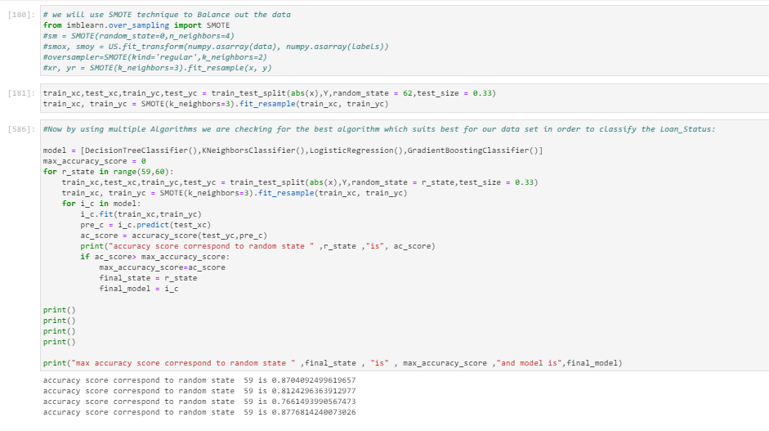

As you see above, we trained the algorithm, we did some study on the best CVs and printed the results score and checked for Accuracy, precision, recall and f1score so that we can decide which algorithm is working best for our study case.

I also tried some ensemble techniques such as Random Forest Regressor or Gradient Boosting Classifier among others and compared the results.

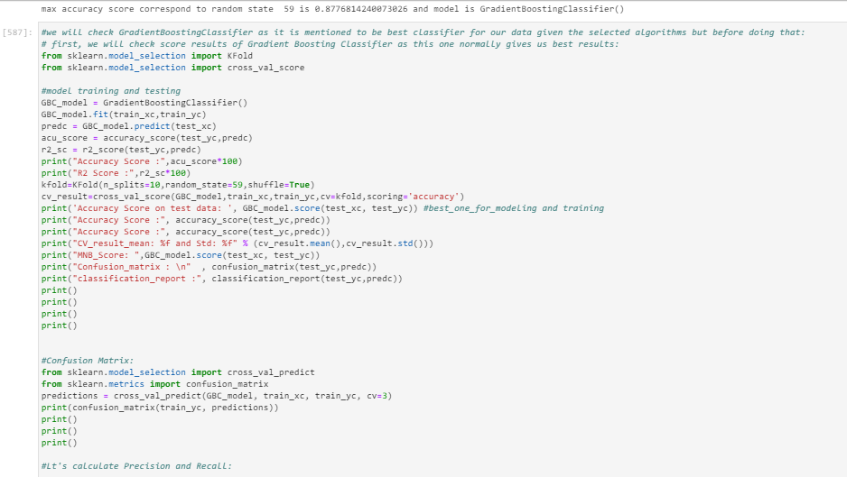

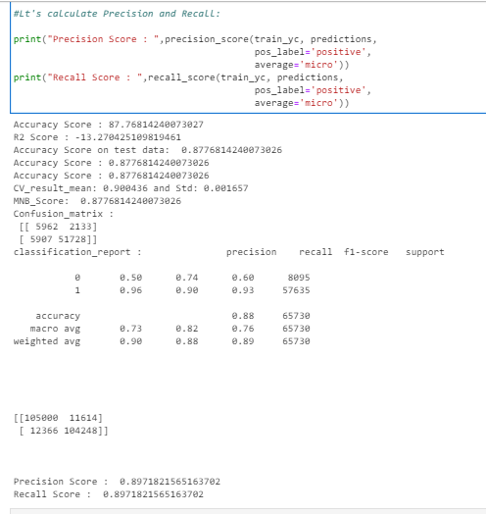

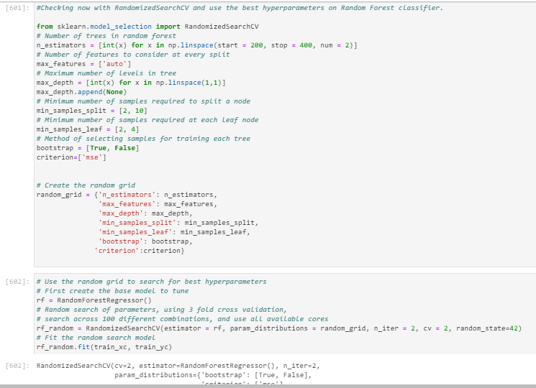

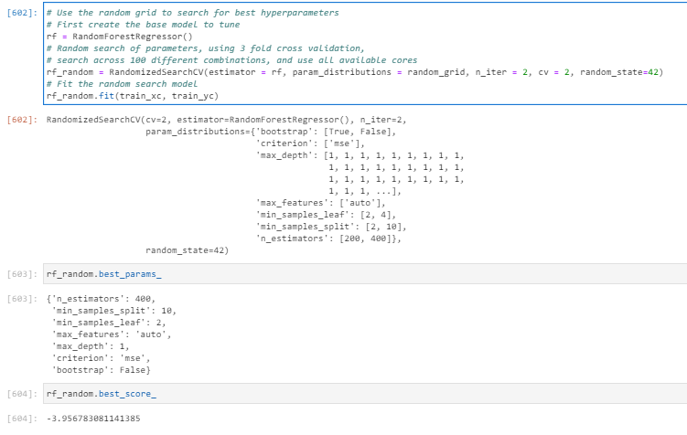

Checking results of RFC:

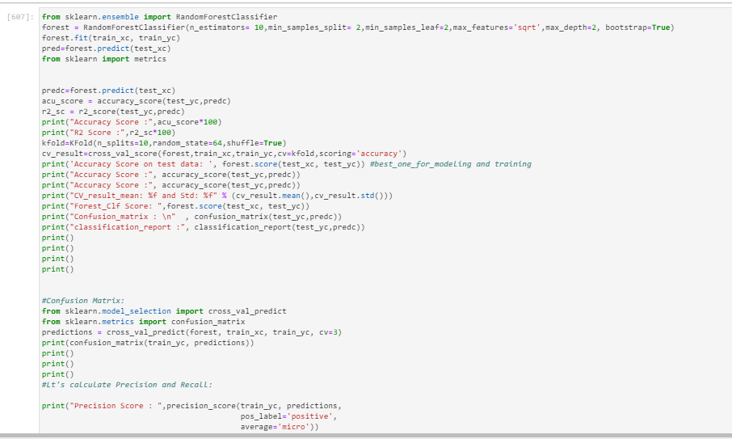

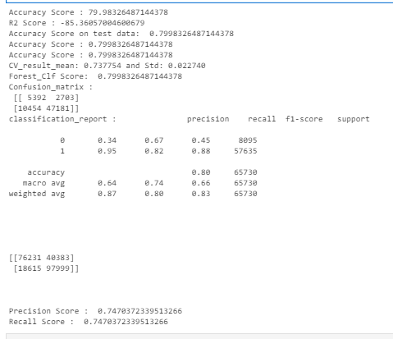

Using RF classifier with different parameters and check the results:

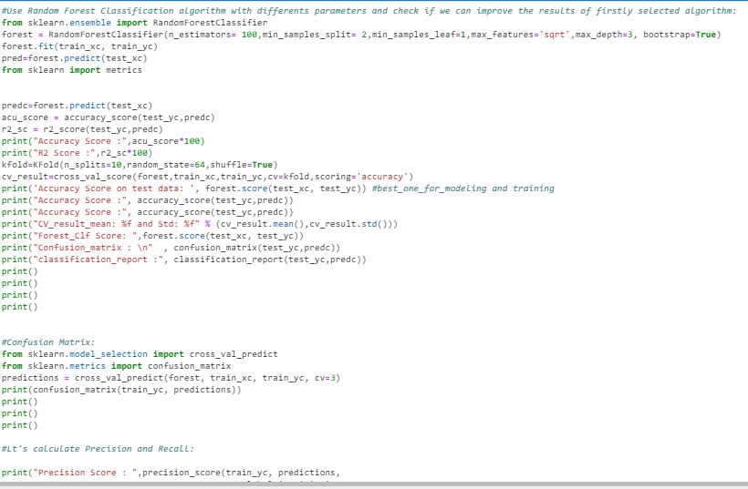

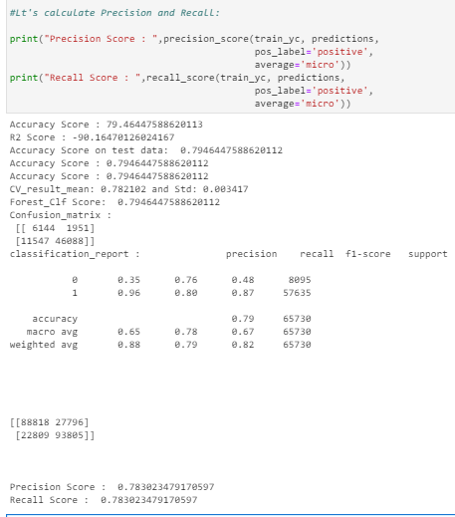

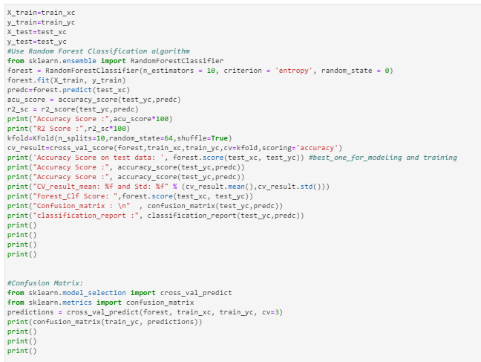

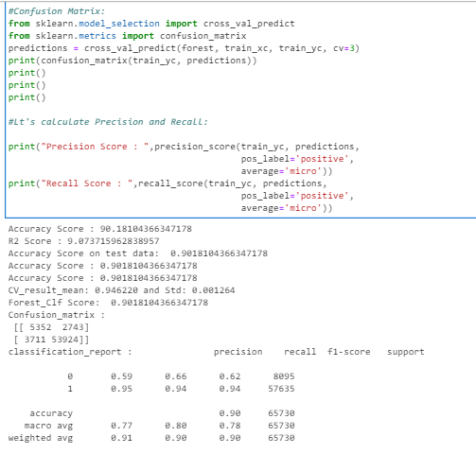

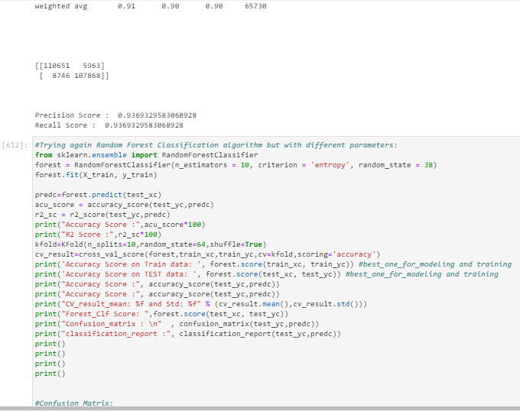

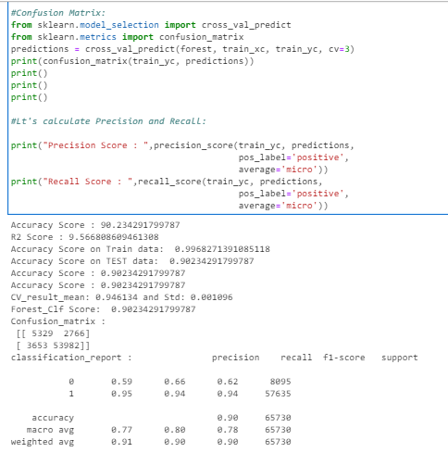

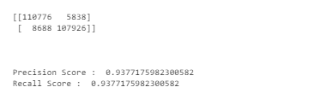

Here above screenshot we clearly see that our best algorithm RF has better score results (90,2%) to offer than the algorithm GBC which has score of 87,76%.

**Let’s check again the most used algorithms used for classification and compare the results:**

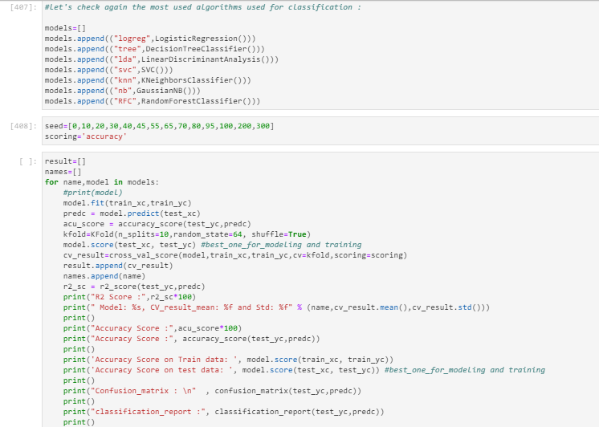

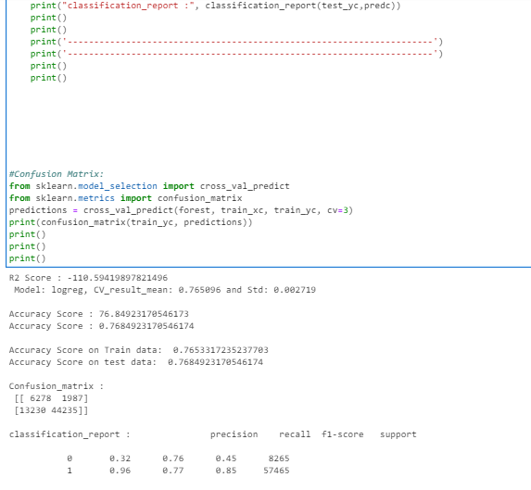

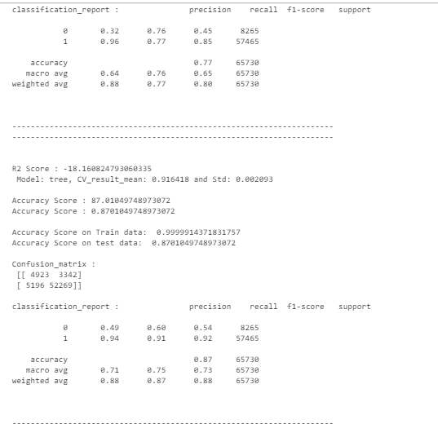

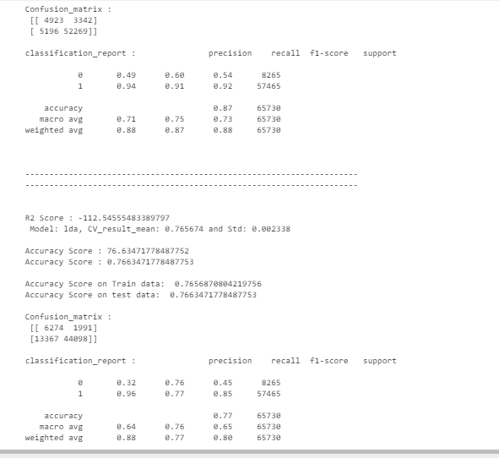

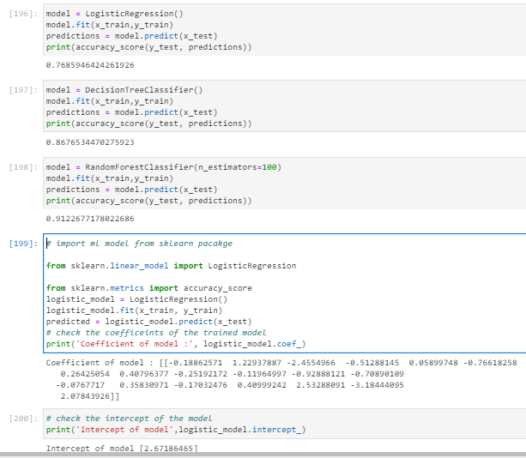

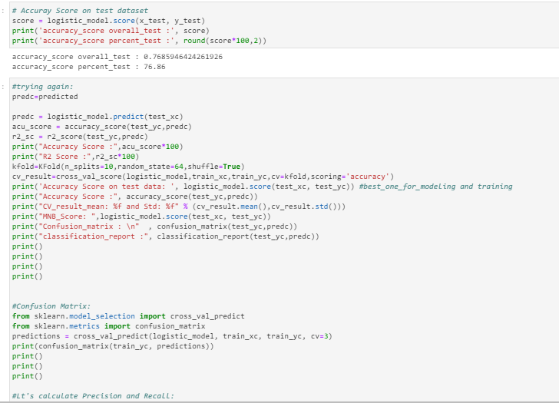

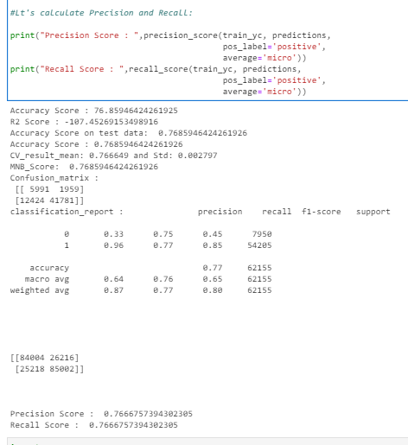

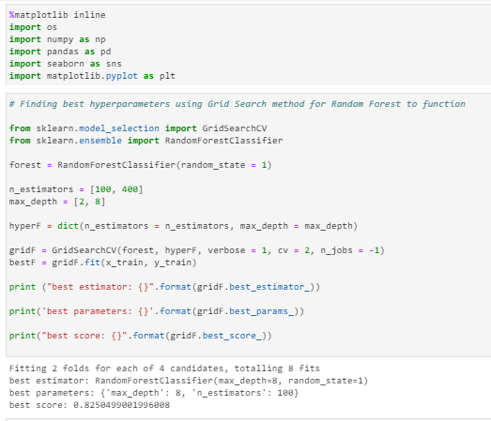

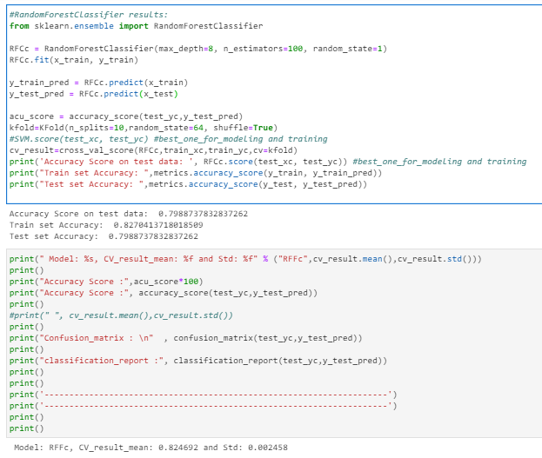

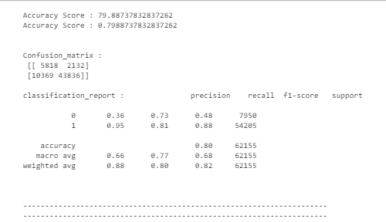

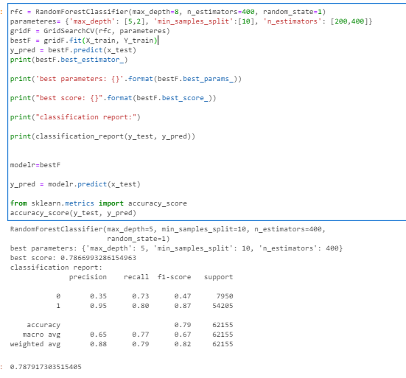

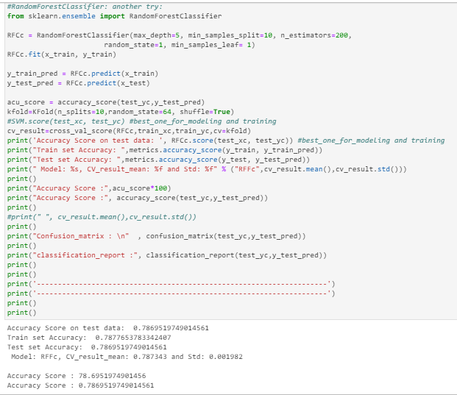

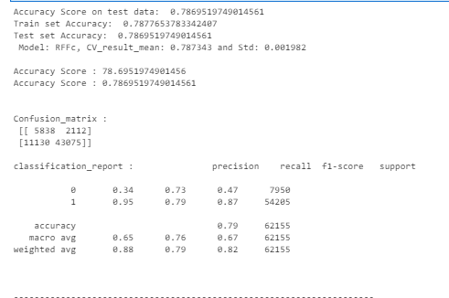

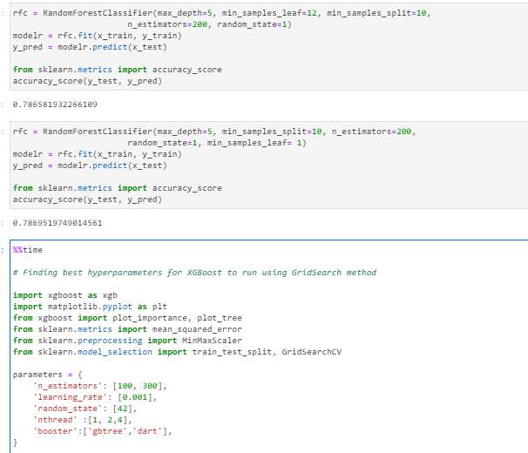

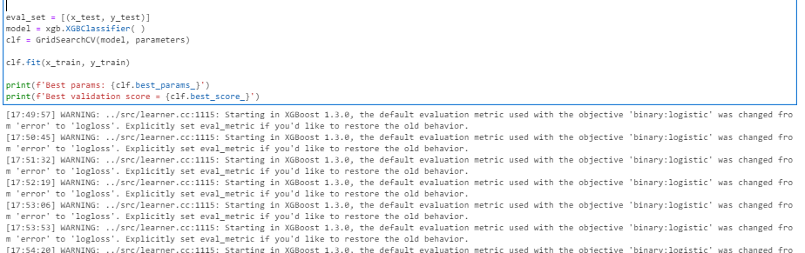

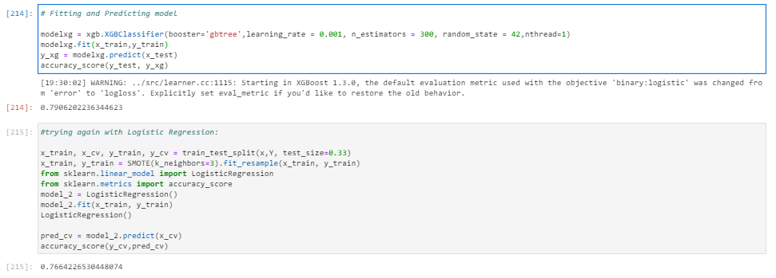

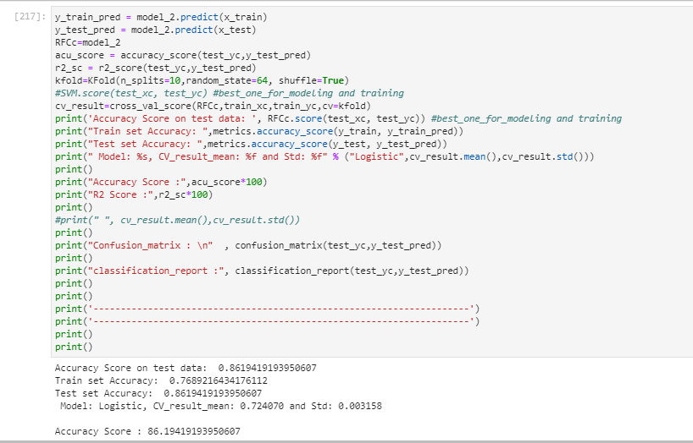

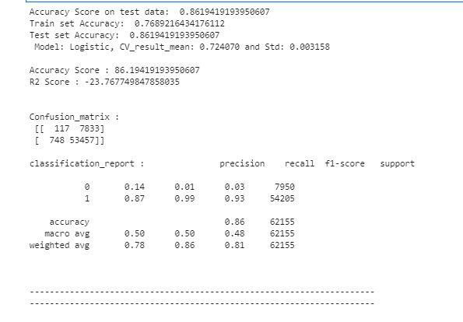

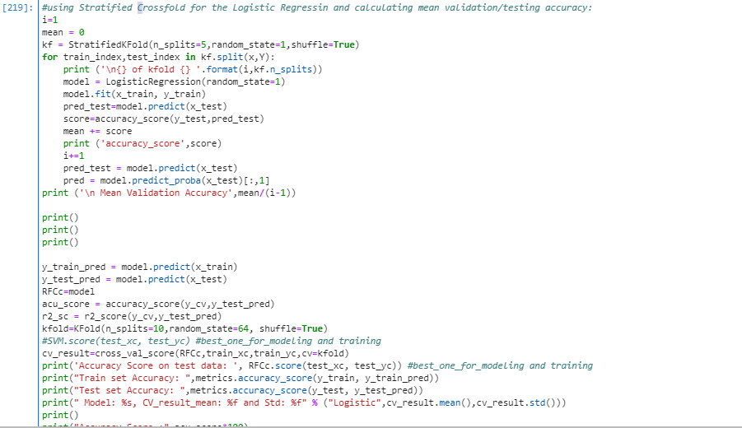

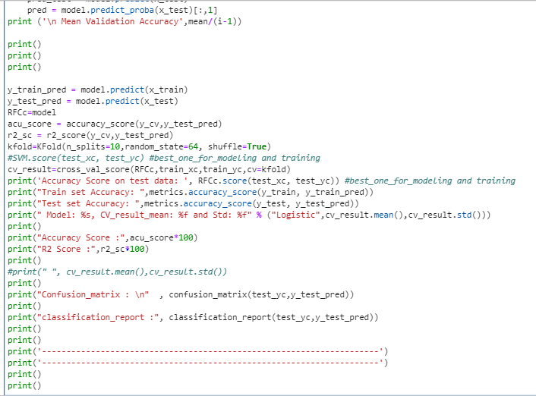

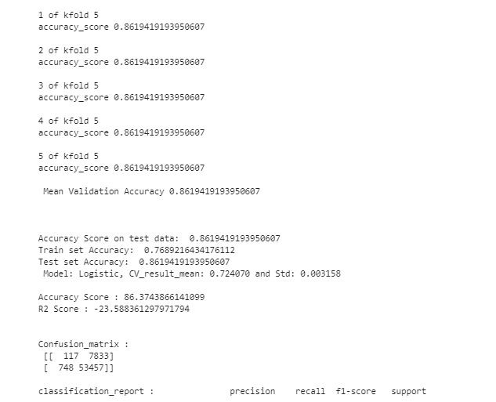

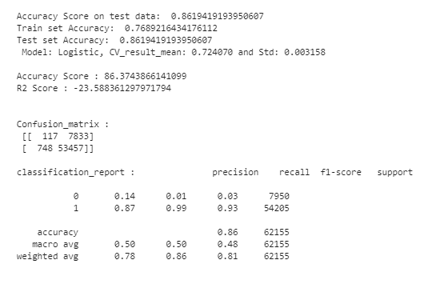

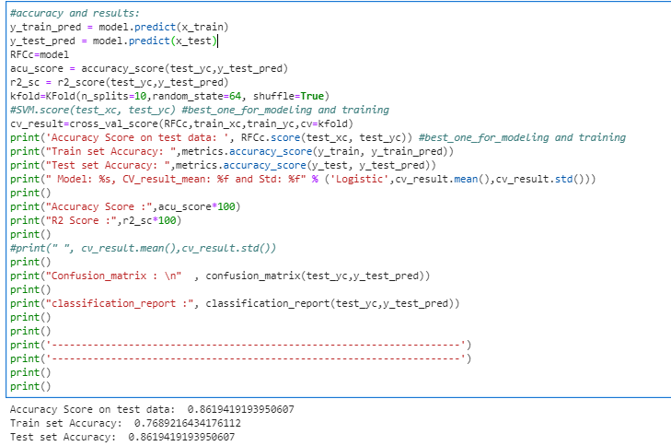

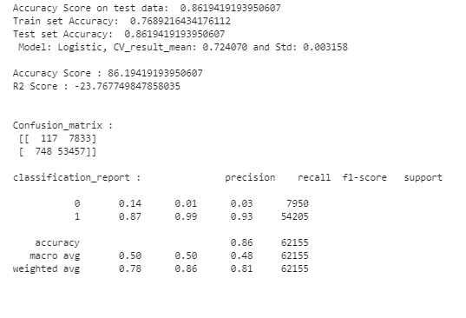

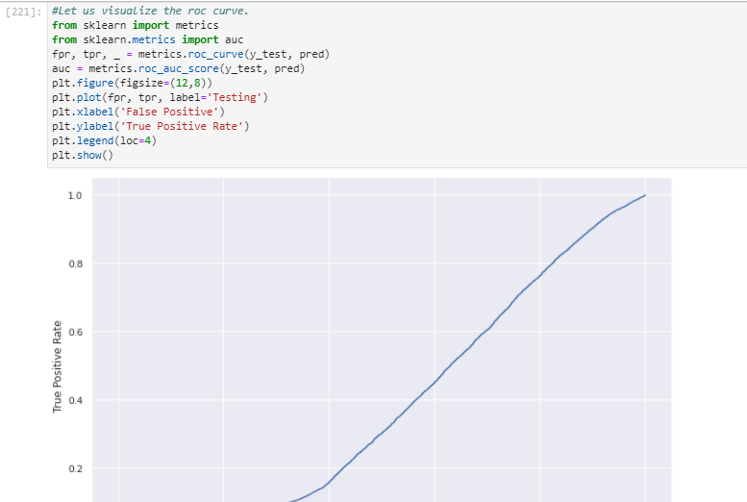

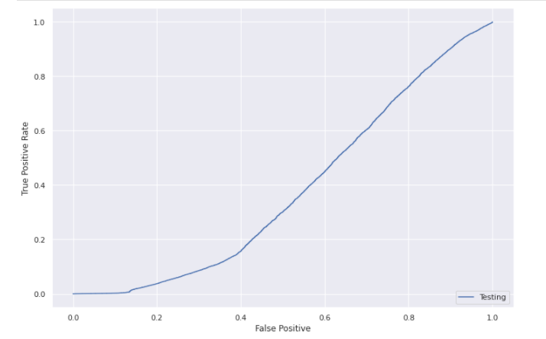

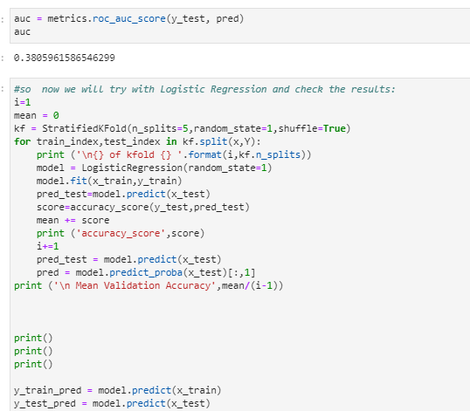

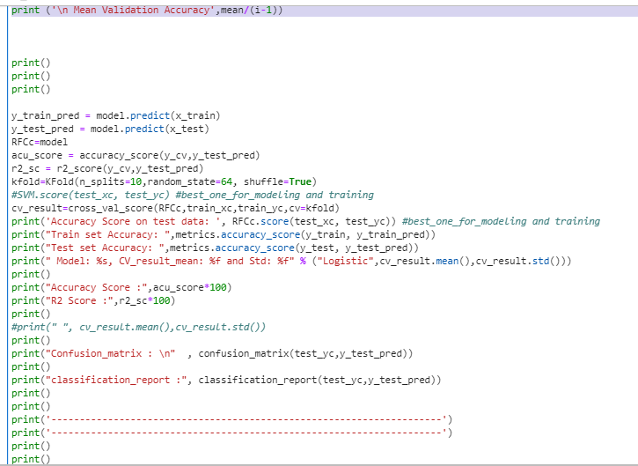

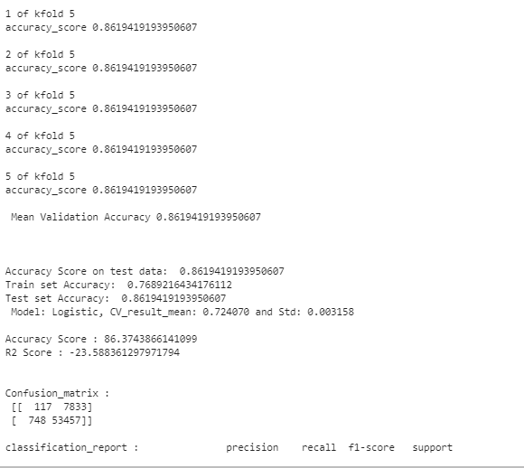

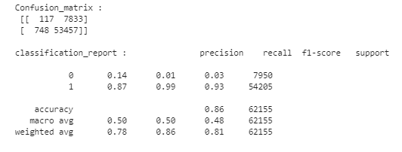

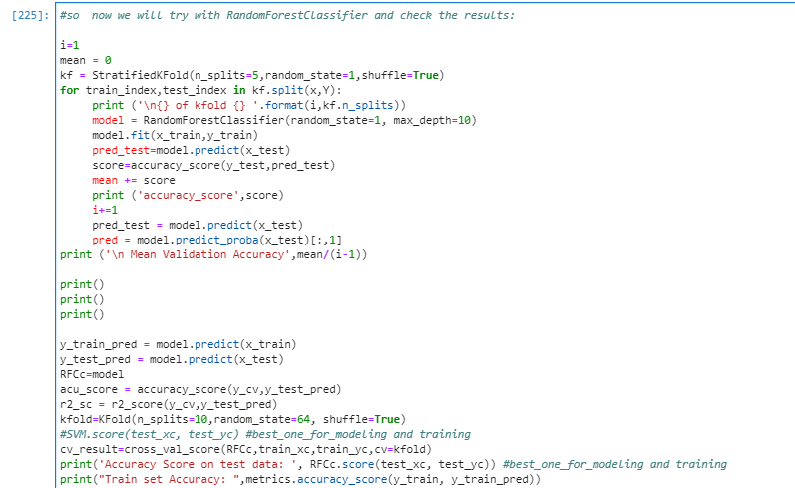

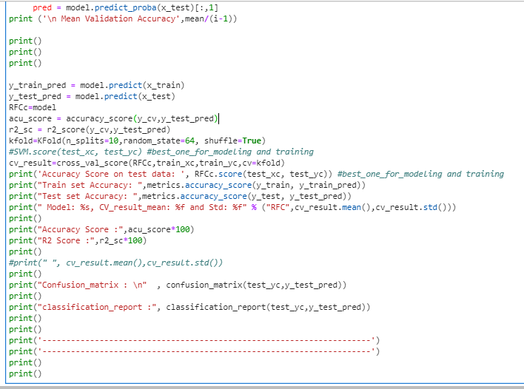

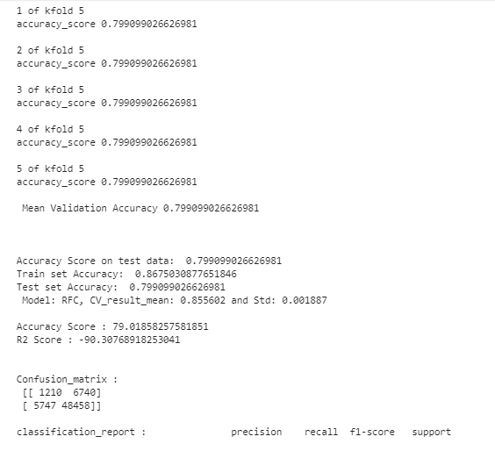

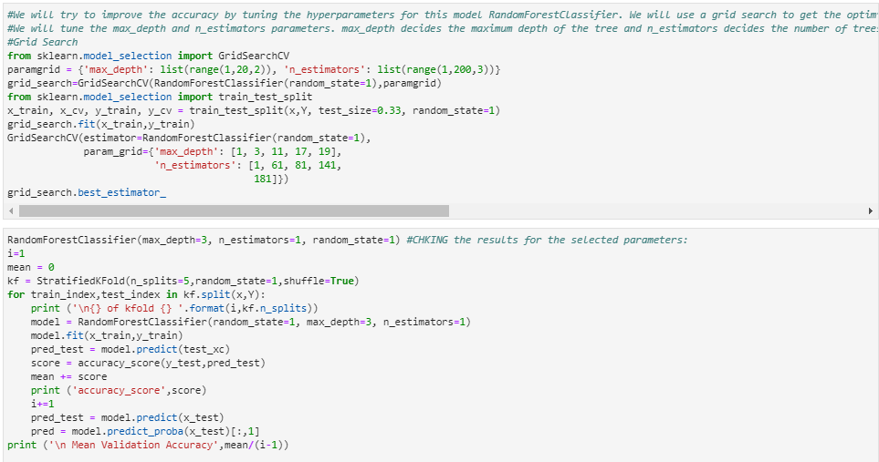

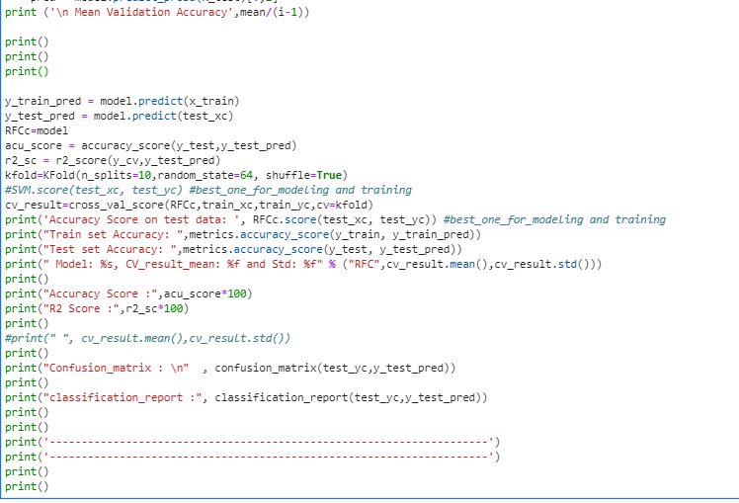

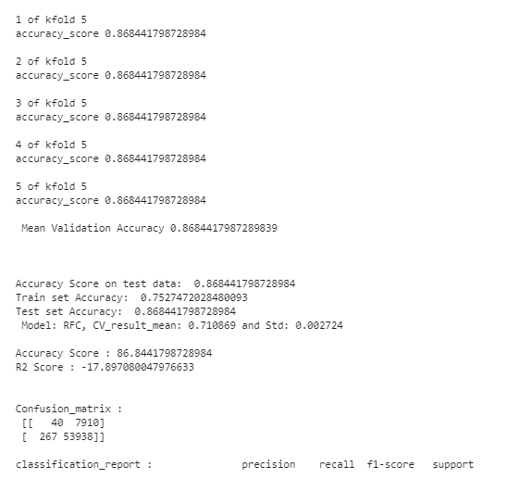

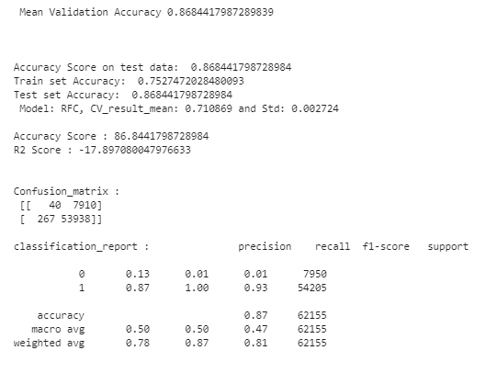

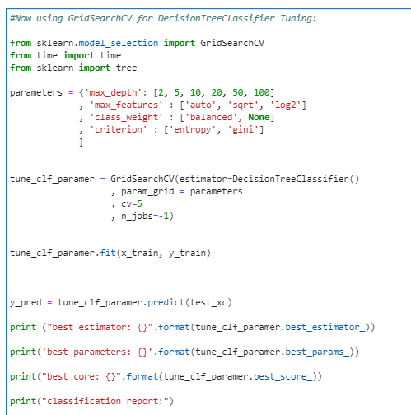

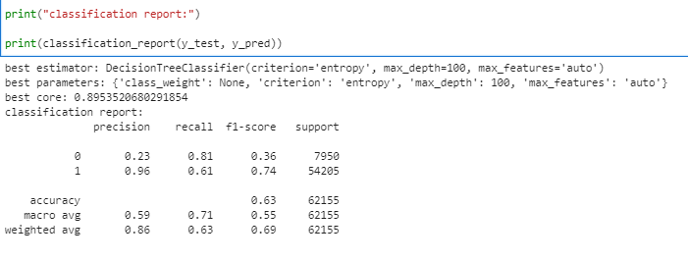

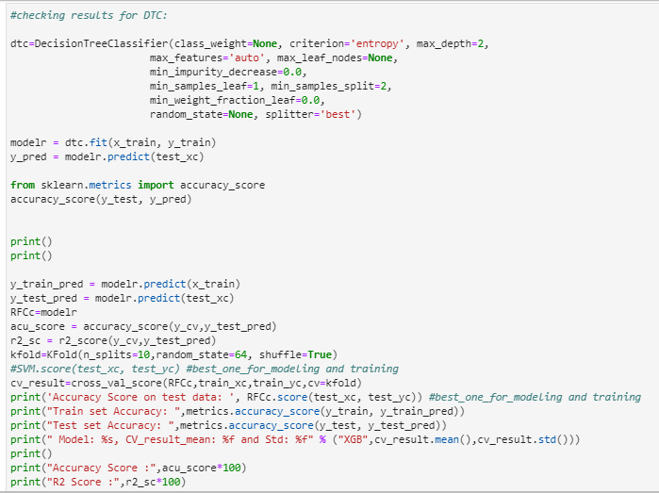

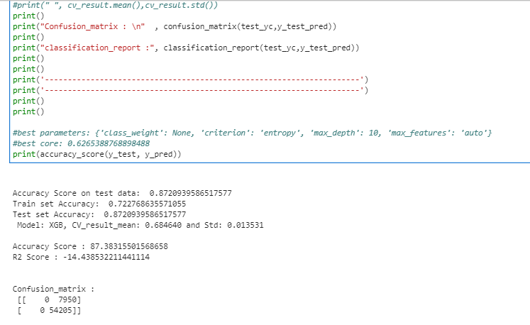

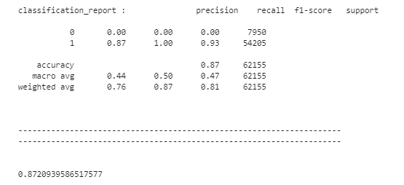

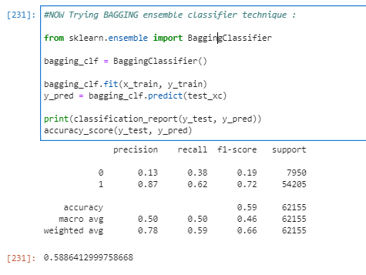

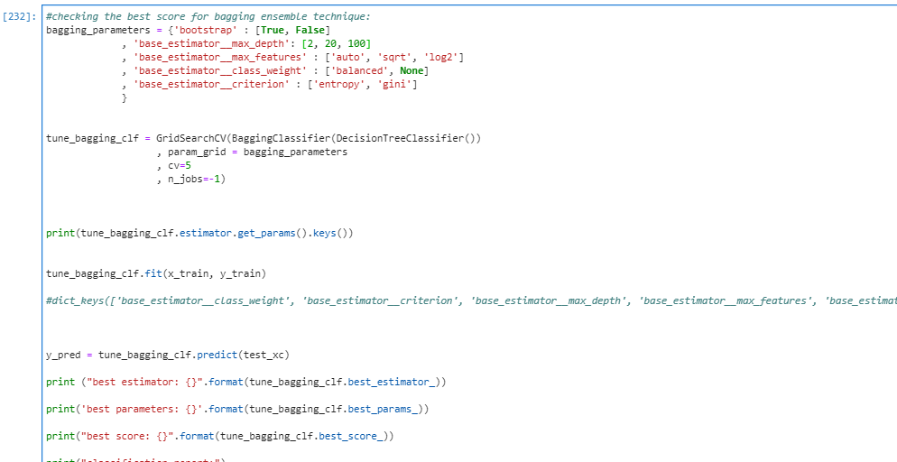

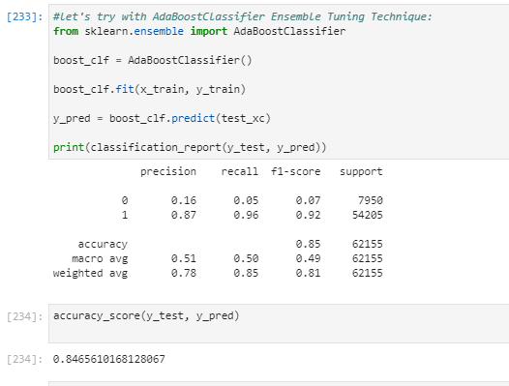

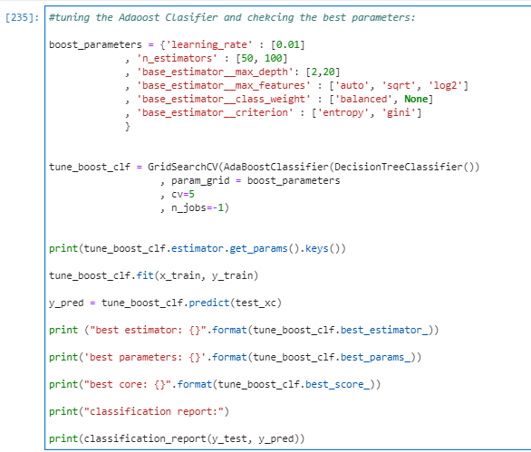

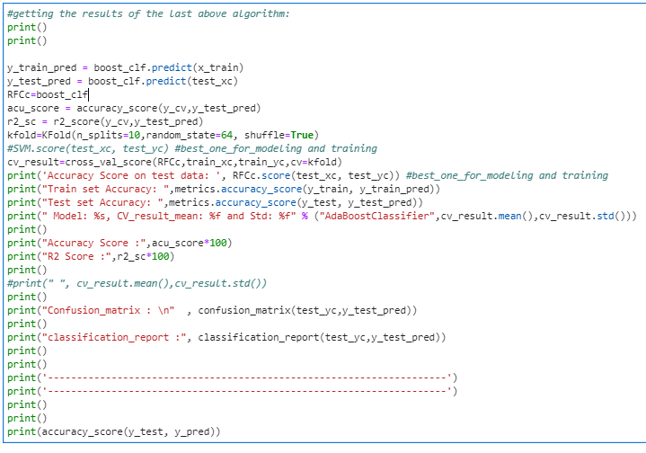

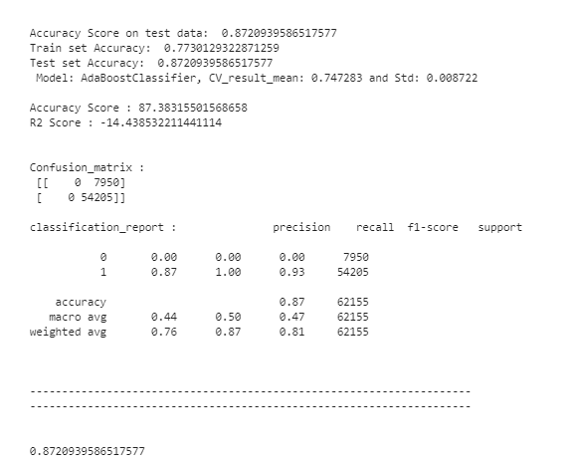

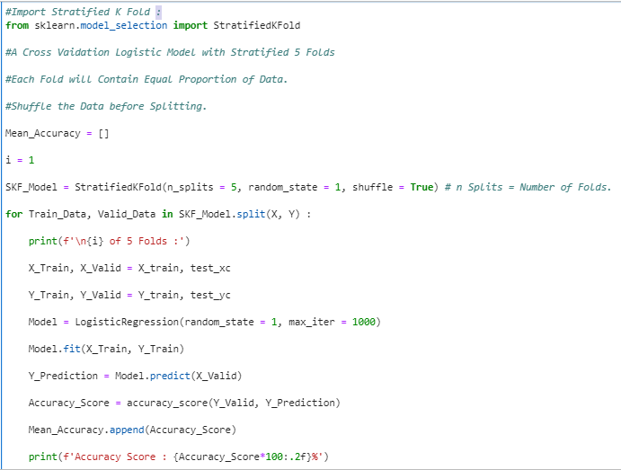

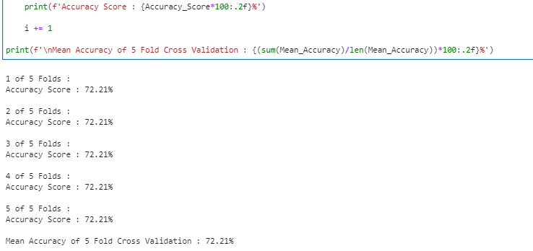

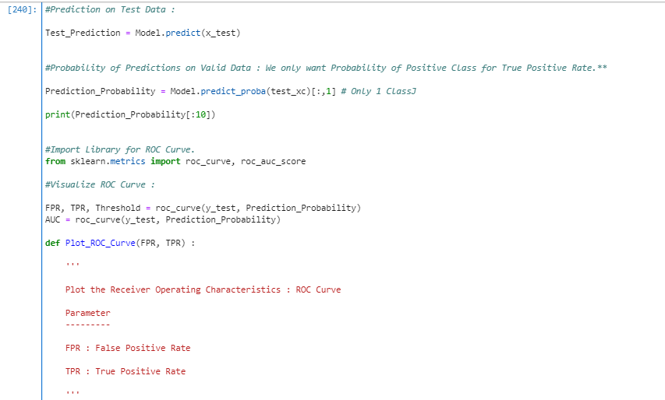

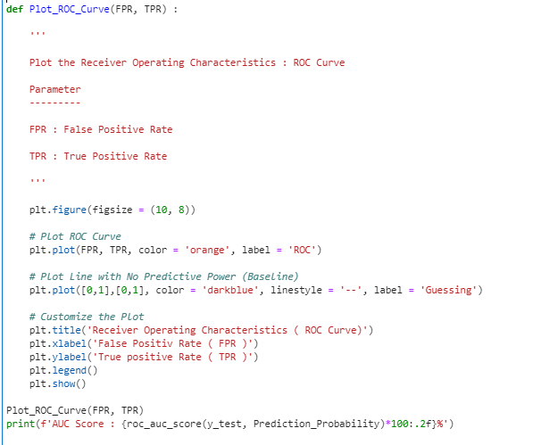

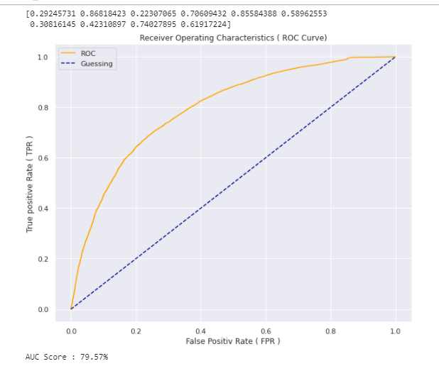

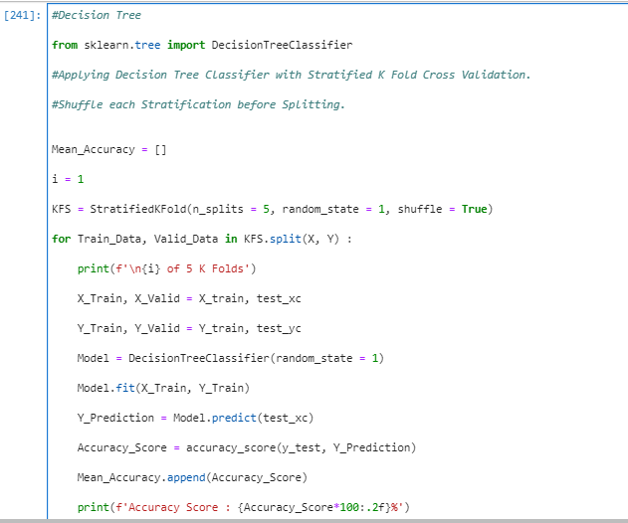

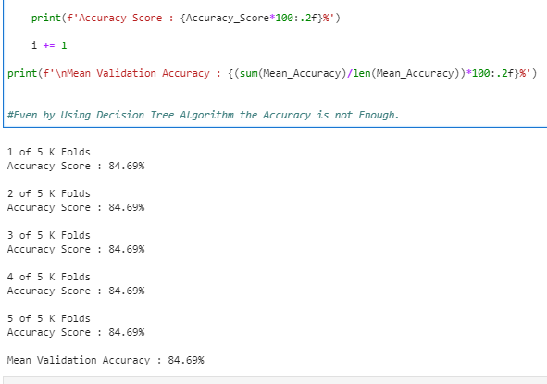

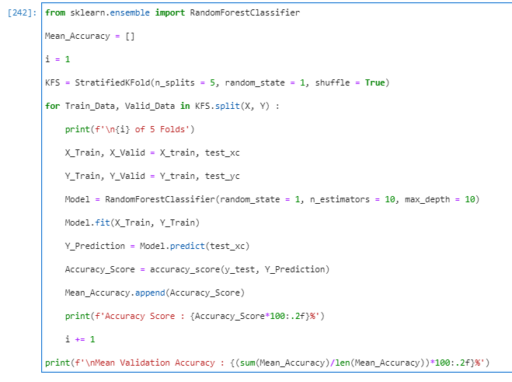

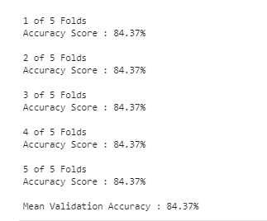

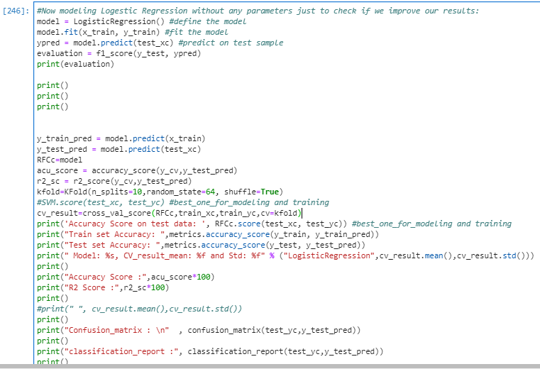

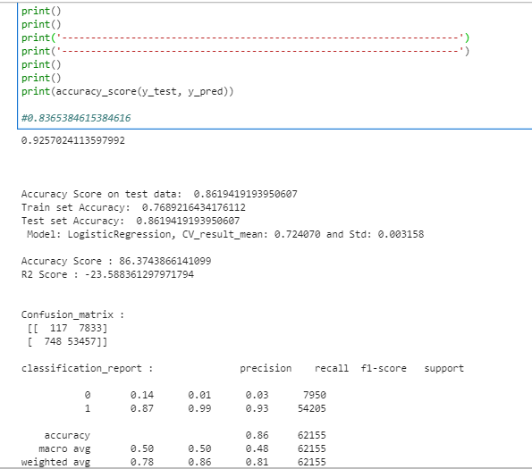



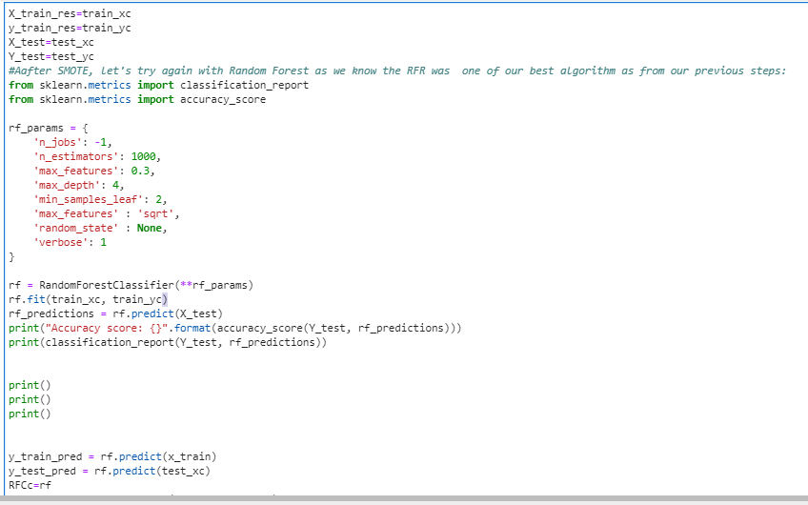

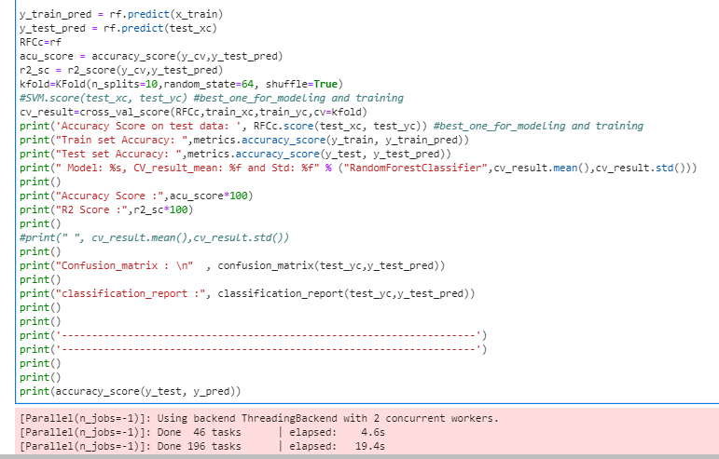

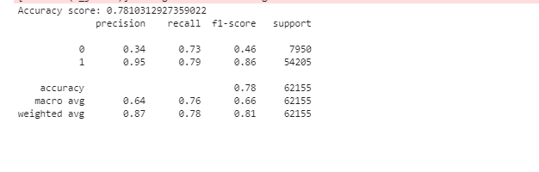

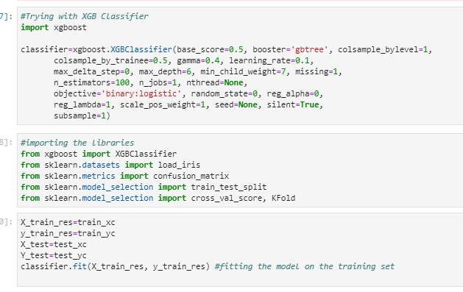

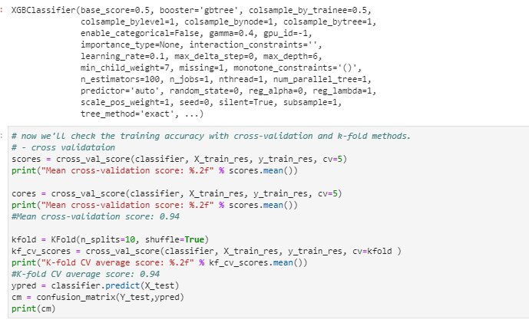

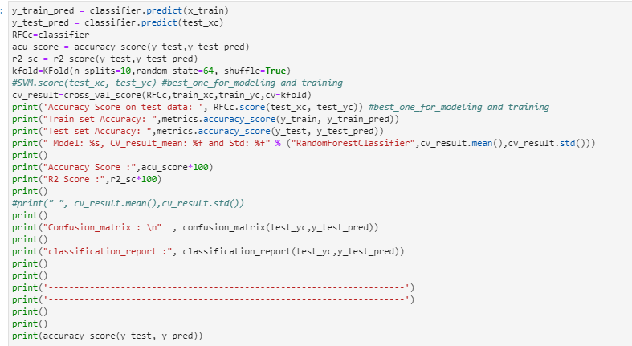

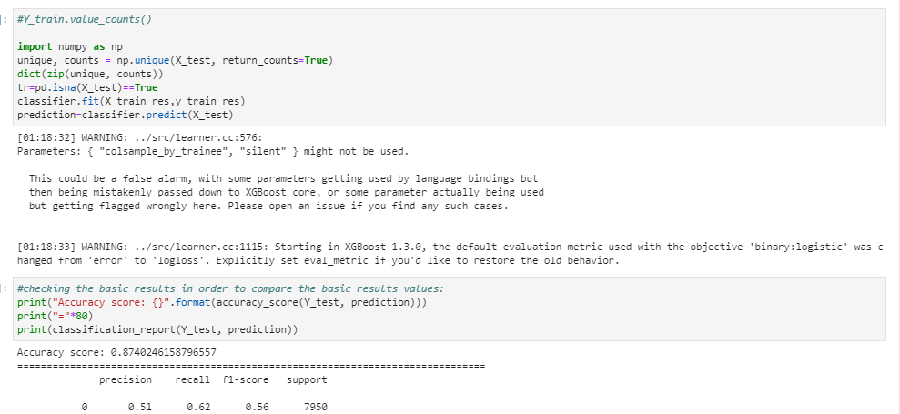

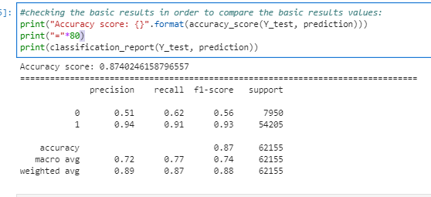

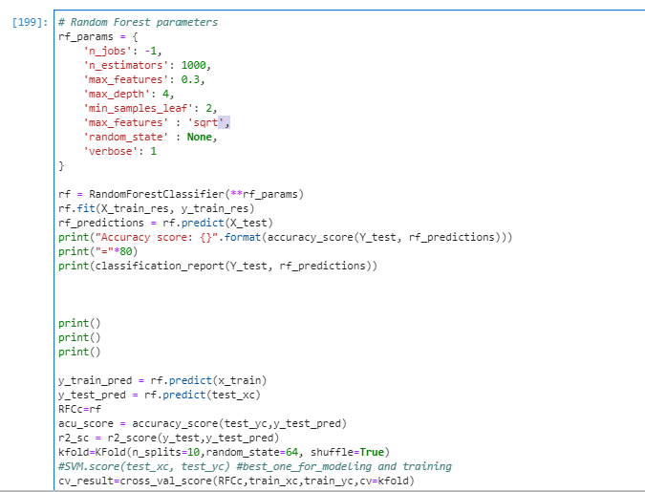

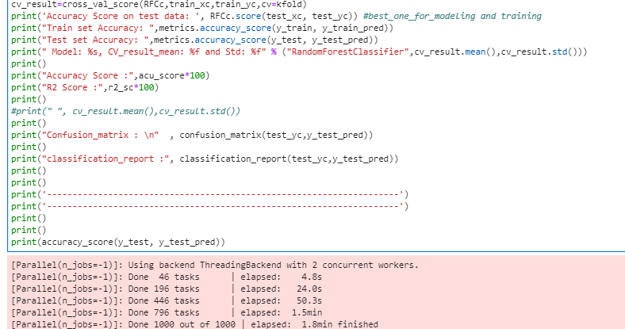

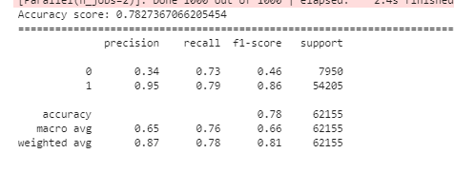

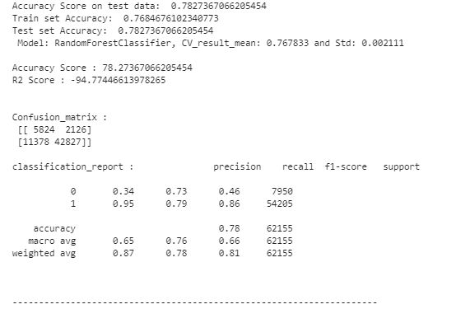

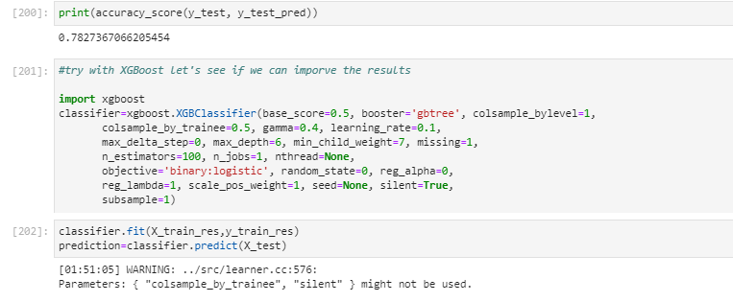

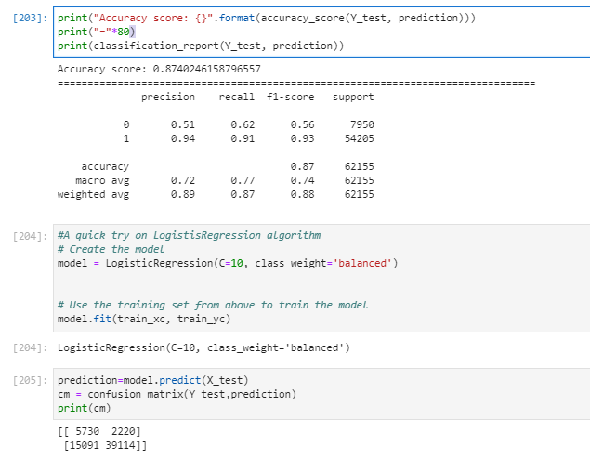

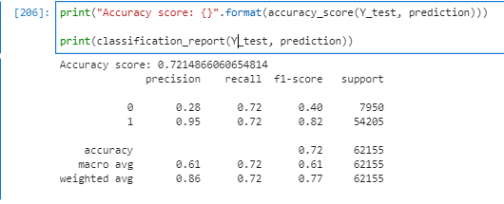

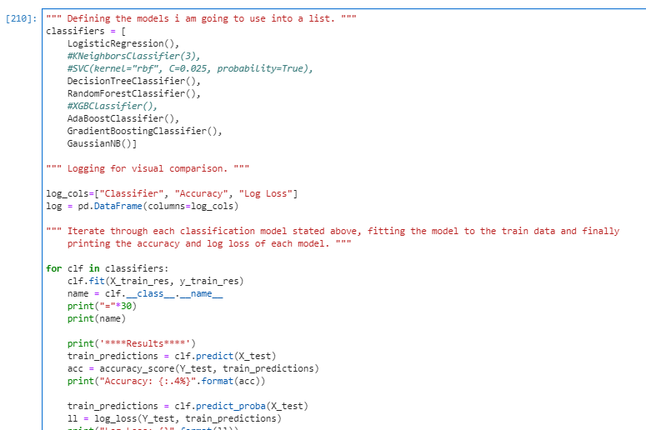

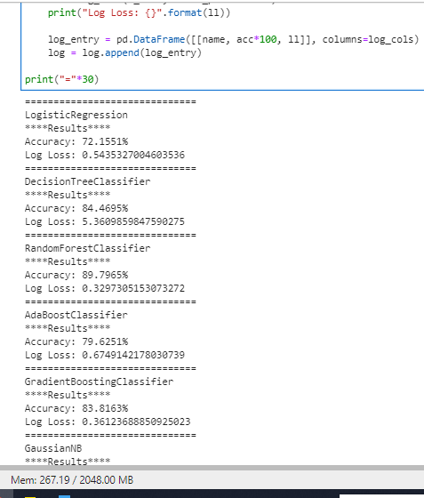

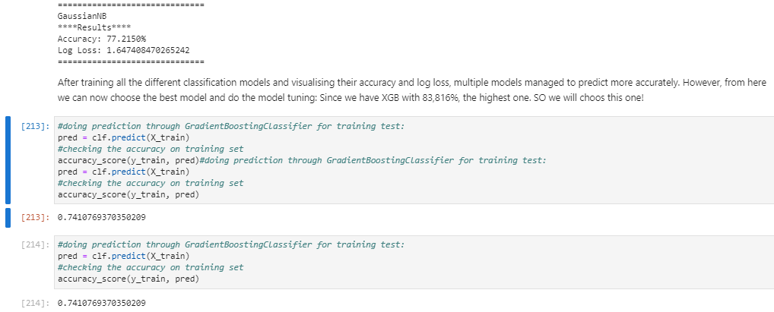

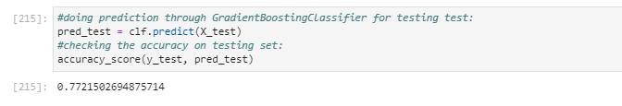

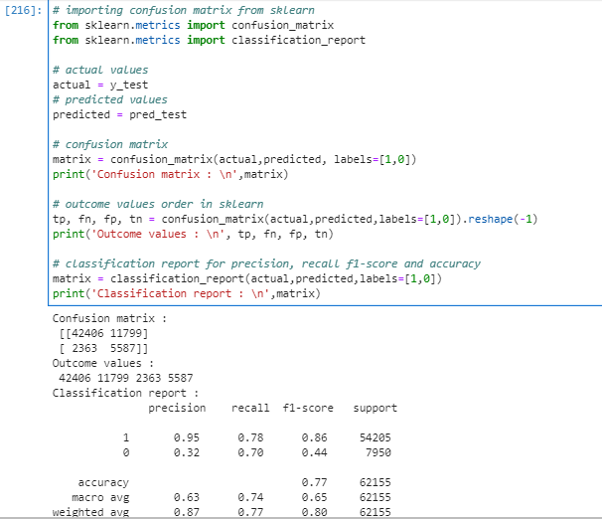

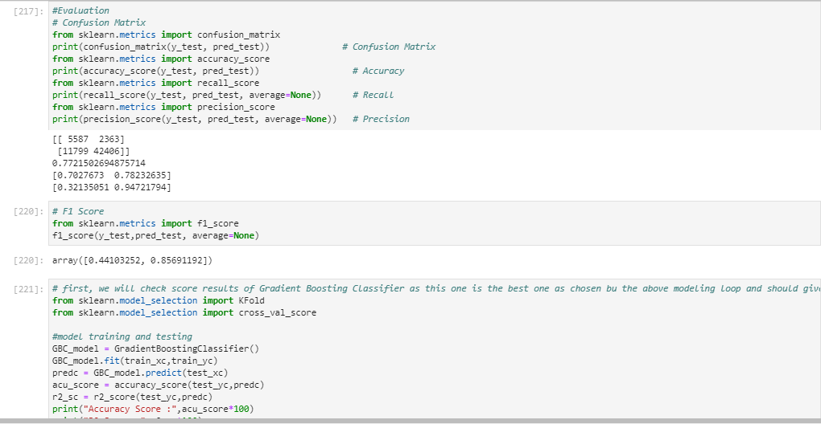

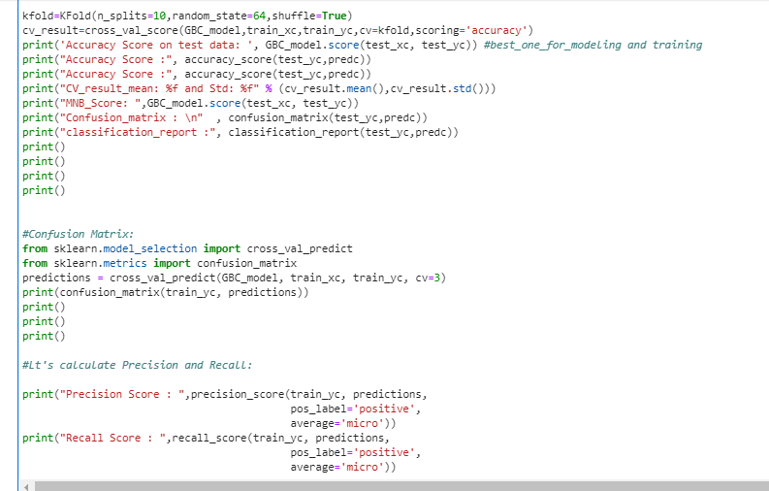

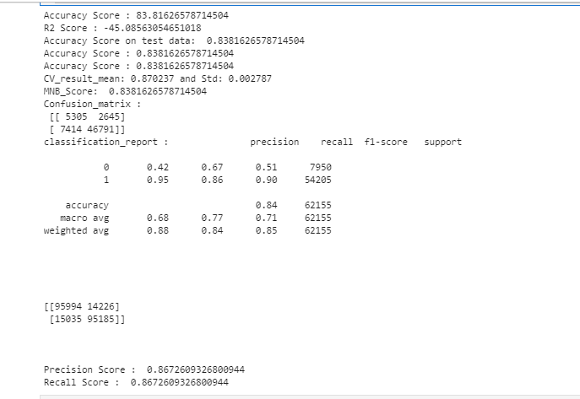

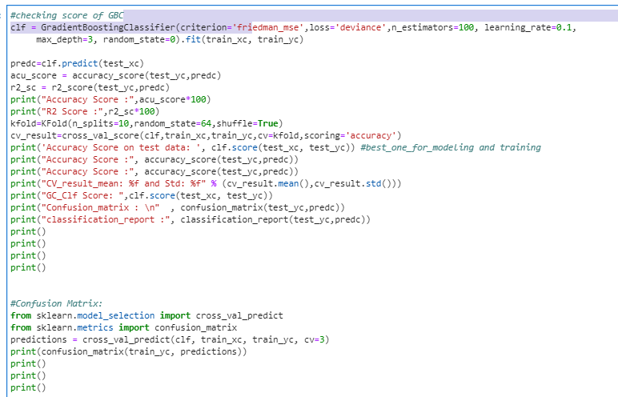

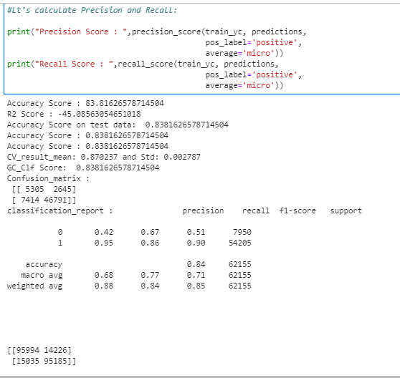

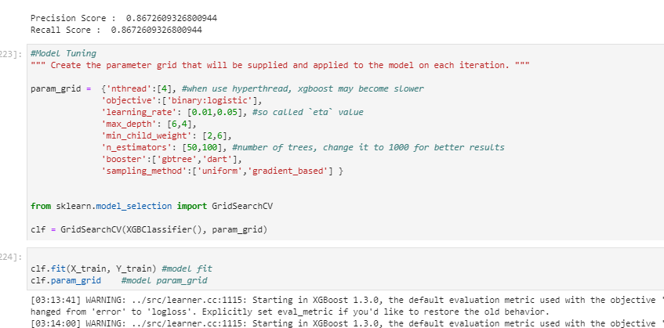

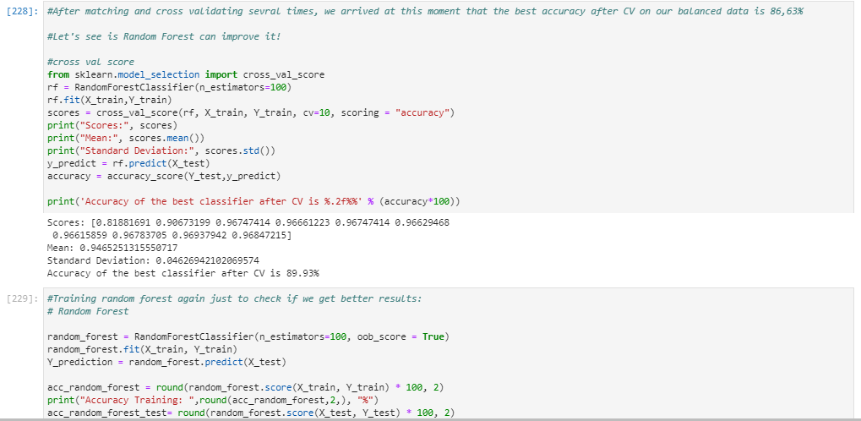

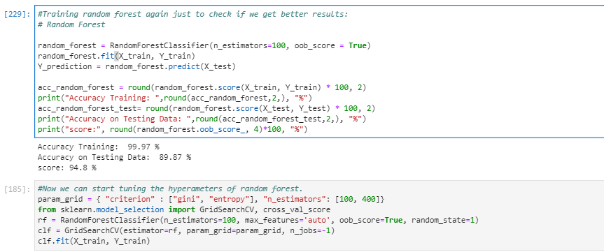

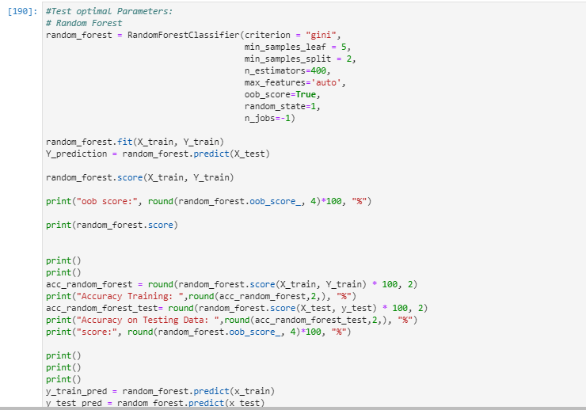

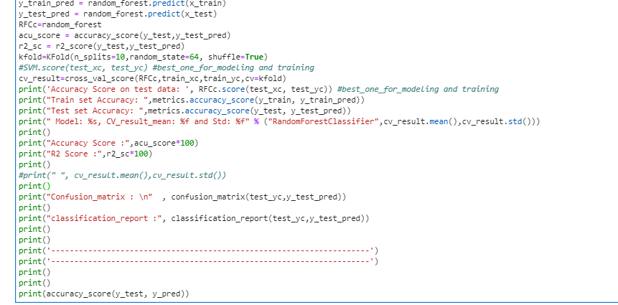

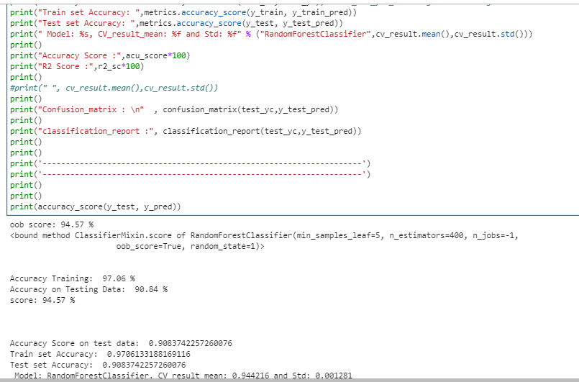

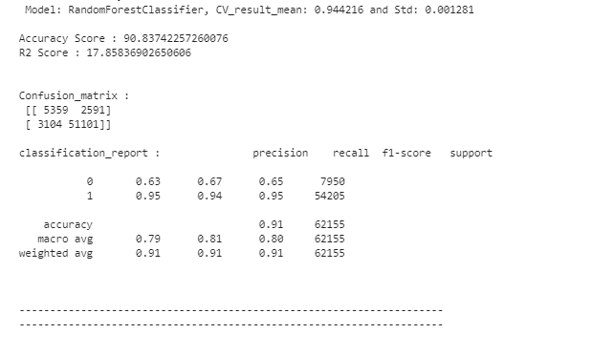

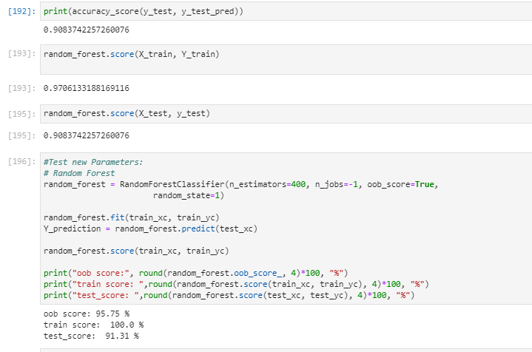

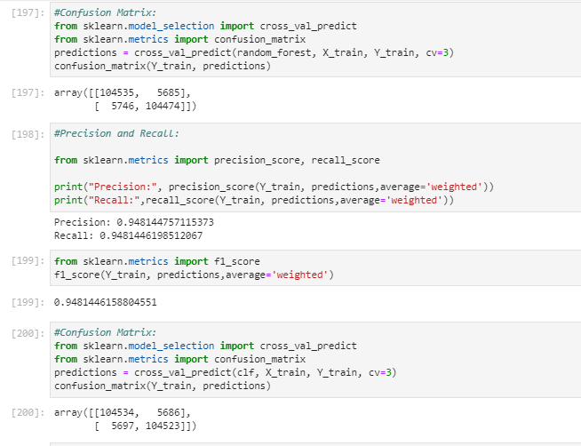

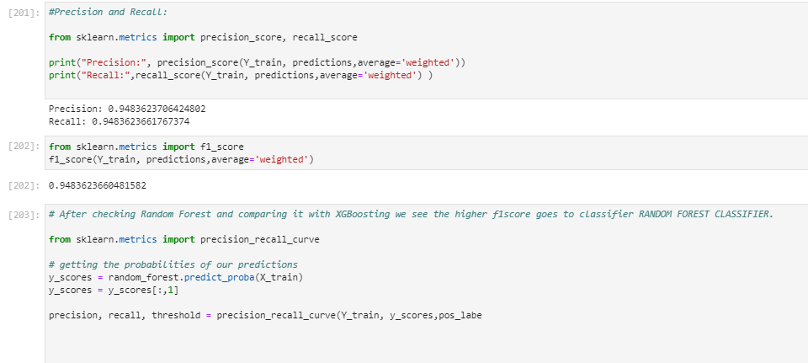

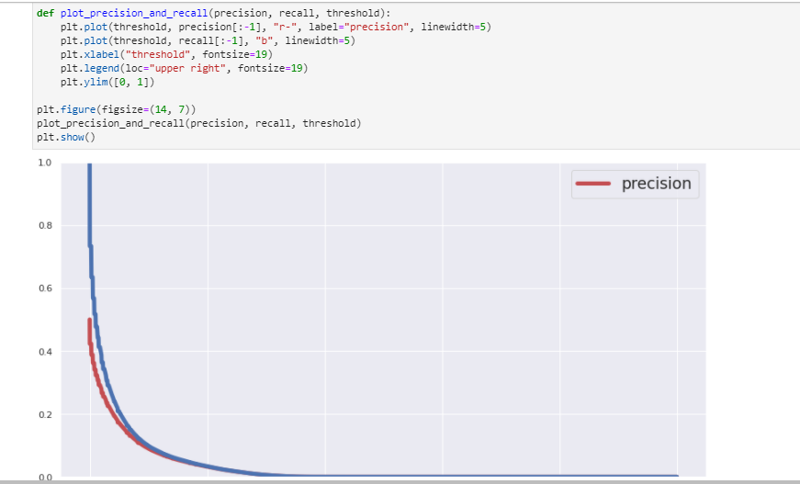

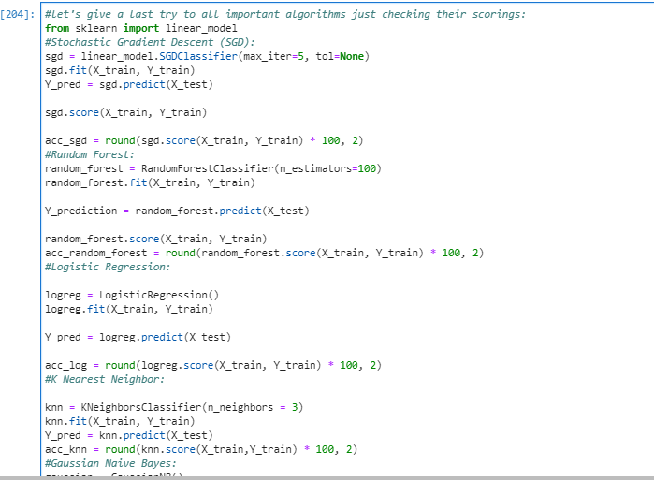

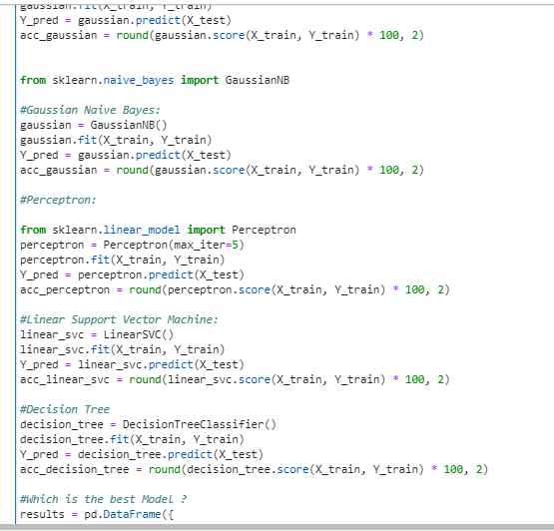

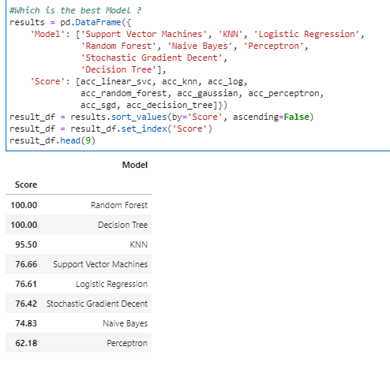

**As we can see, the Random Forest classifier goes again on the first place and then Decision Tree. Since we already compared and studied results of RFR, we will stop here for the classifier study.**

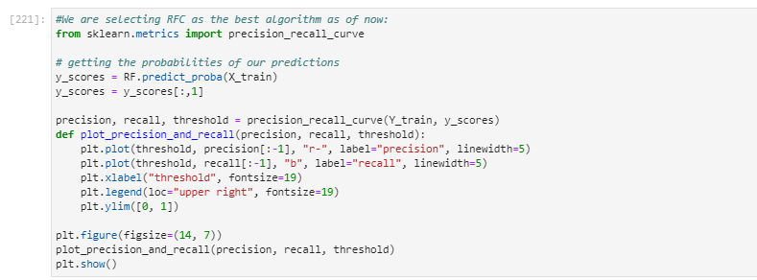

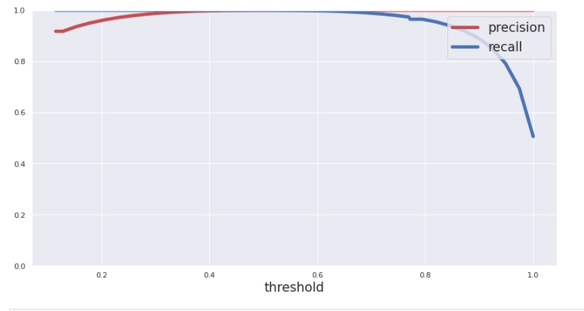

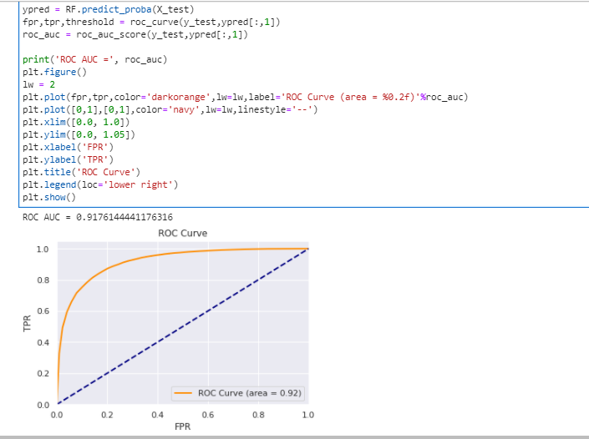

We have a very good ROC AUC Score: 91,76%

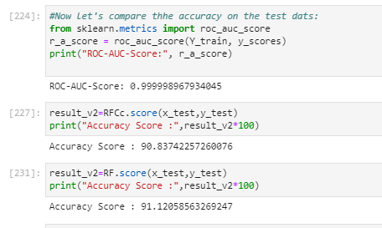

**And, we can compare and see the best algorithm from the bests is the algorithm RF with the accuracy on test data of 91,12%**

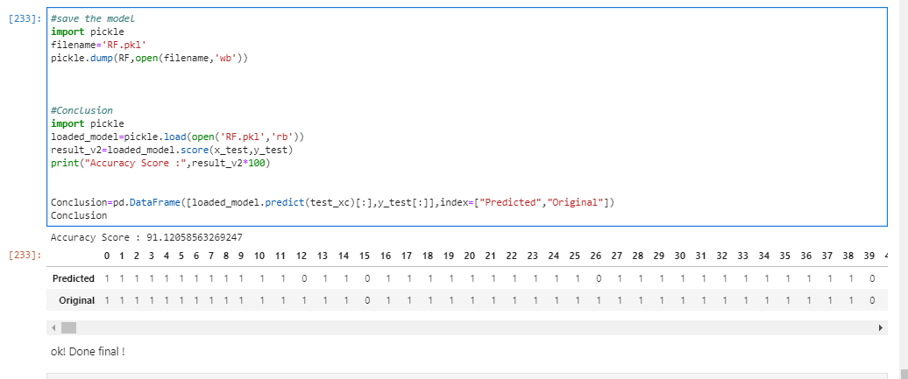

Even after checking both algorithm scores, we clearly see that RF scores are way better. And the test score is 91,12% from the split test data.

* Key Metrics for success in solving problem under consideration

Basically, I used the Accuracy, precision, recall, f1score and ROC-AUC Score alongside the test score in order to compare and choose the best algorithm.

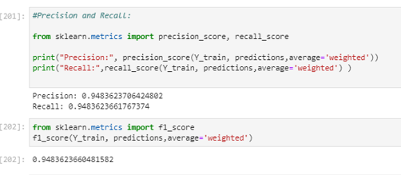

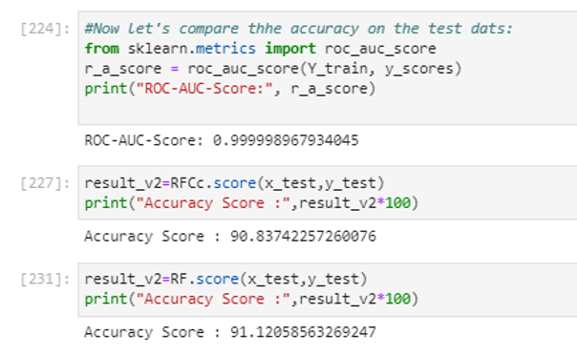

I considered all the results and scores one by one and compared this way all algorithms and chose the best one which is RF.

You can easily understand the all the process I did when you read my python script as it has complete similar comments on most of the main steps and everything written here will make more sense and you will understand all the steps and considerations commented here. Please go through all the comments in the given code script and will also make it easy to understand this report:

* Visualizations:

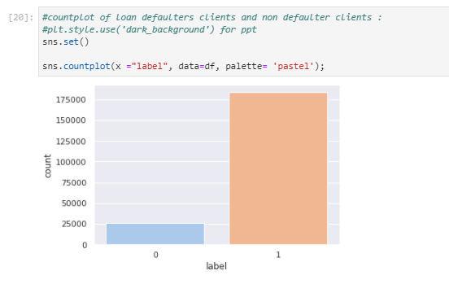

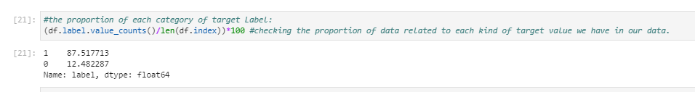

As obvious, we have more non defaulter cases (87%) than loan defaulter cases (12%).

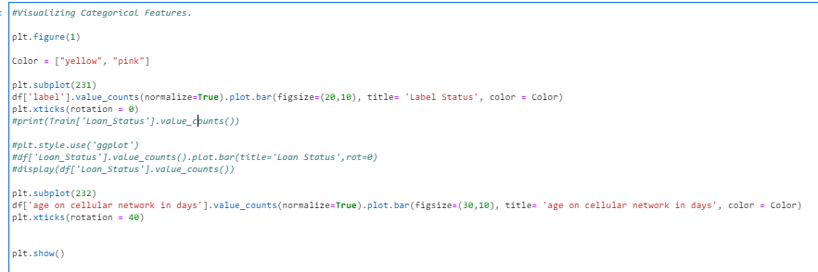

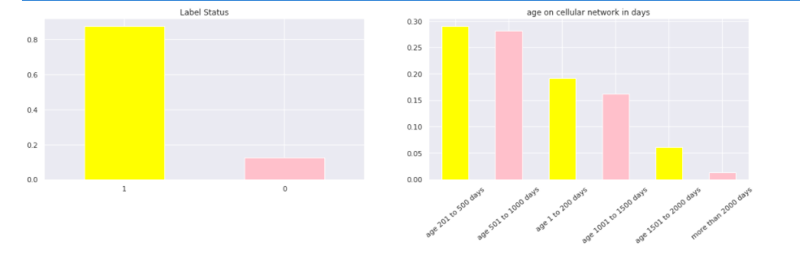

Okayso alongside the label category, we also plotted the age on cellualr network categories by differents groups as follows:

- cellular aging from 1 to 200 days

- cellular aging from 201 to 500 days

- cellular aging from 501 to 1000 days

- cellular aging from 1001 to 1500 days

- cellular aging from 1501 to 2000 days

- cellular aging more than 2000 days

After checking the plot of cellular ages in days, we can say and conclude that we have highest number of cellular aging from 201 to 500 days, which means from around 6 months to 1 year and 4 months.

And in the second place we have cellular aging from 501 to 1000 days which means from 1year 4months to 2 years and 9 mnths.

In third place and fourth place, we have cellulars aging from 1 to 200 days and cellular aging from 1001 to 1500 days.

At last, we can say we have less cellular aging more than 1500 days.

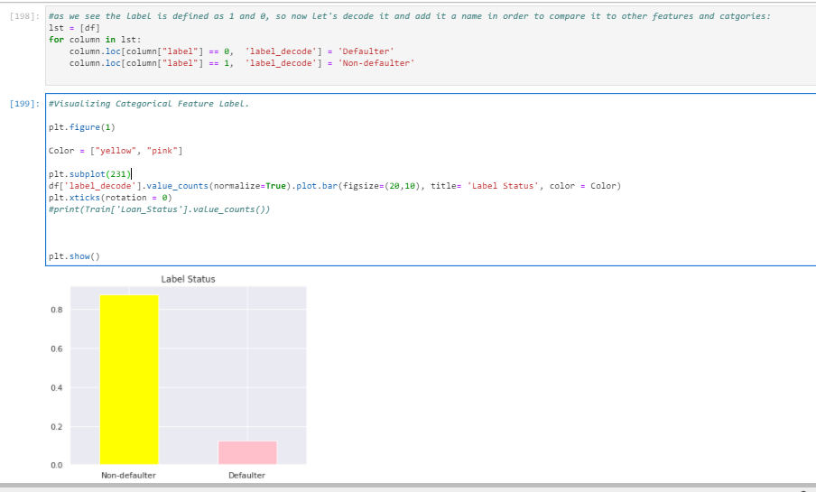

Now, it's easier to check and notice which bar is what. In conclusion, we can say that we have way more cases of non defauter than defaulter as expected since defaulter are less to occur.So, we can say we have a imbalanced data which we need to balance through SMOTE technique.

We did similar breakdown with all our numerical data that can be categorized and put into a bin:

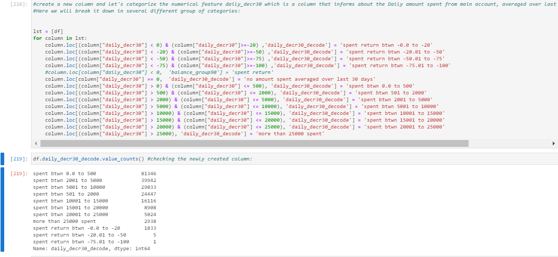

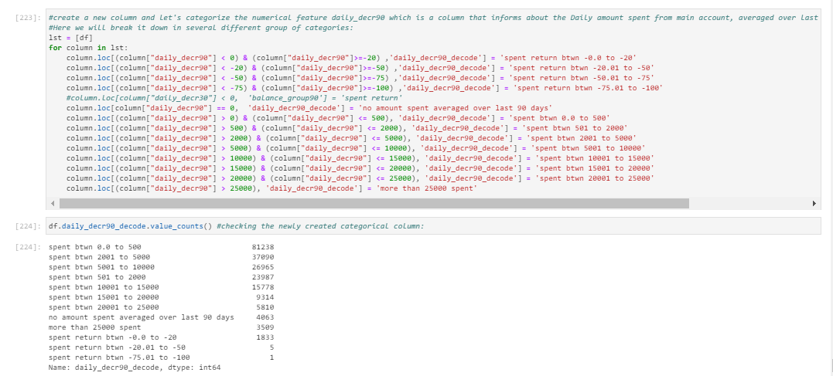

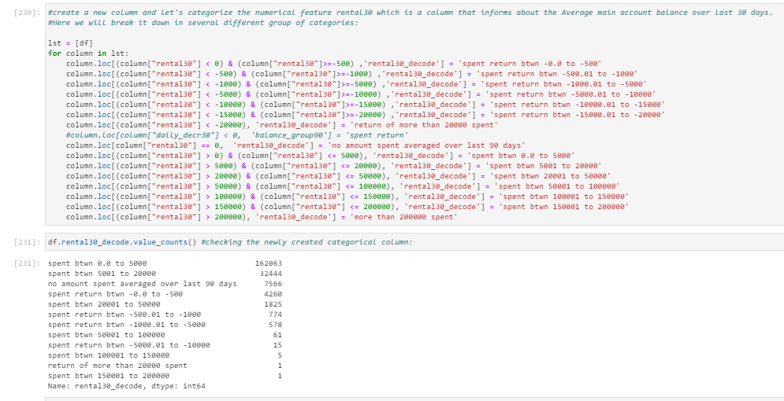

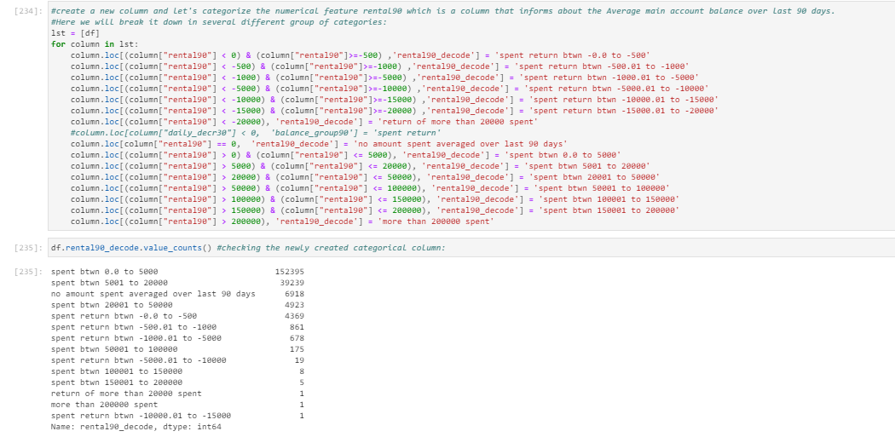

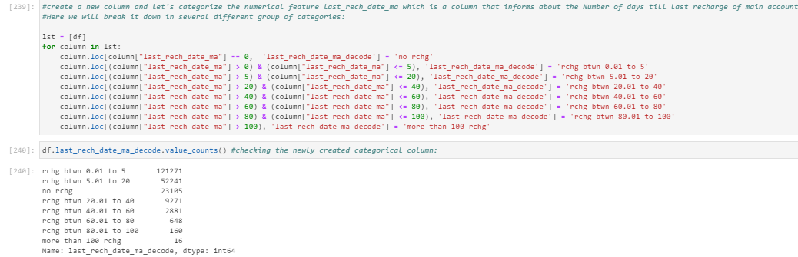

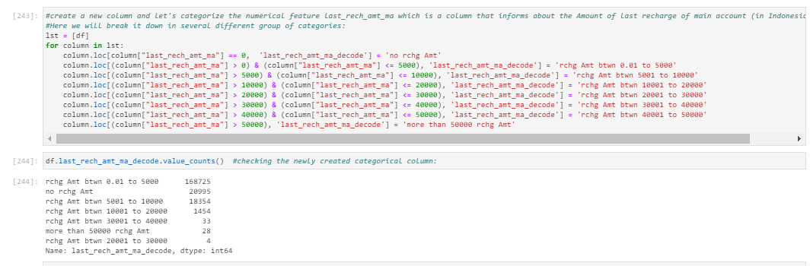

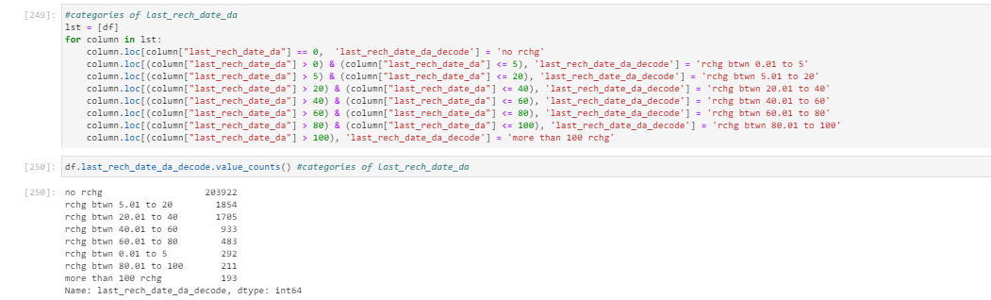

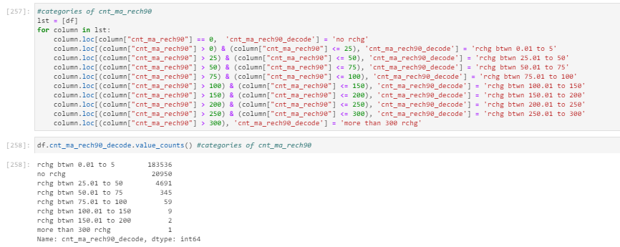

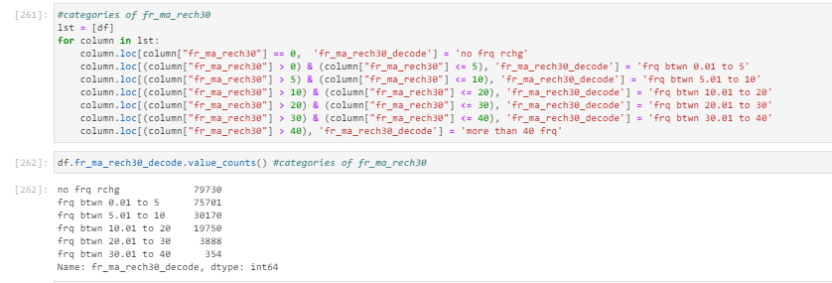

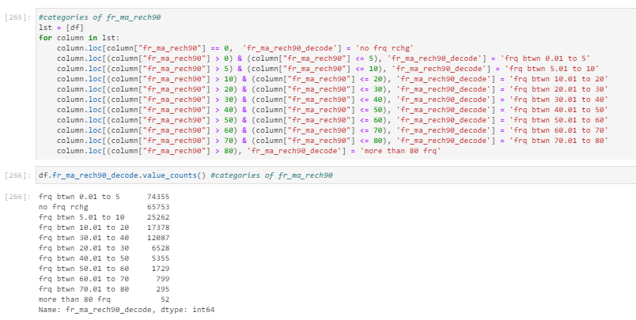

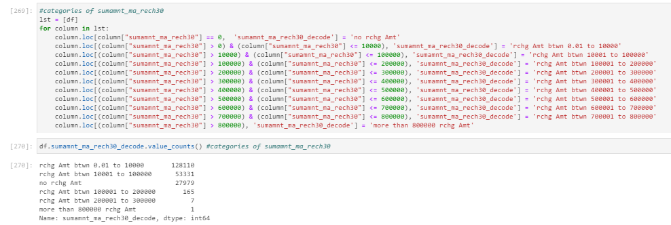

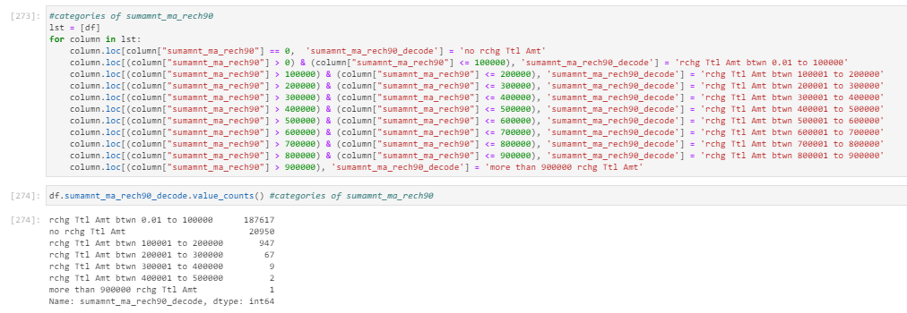

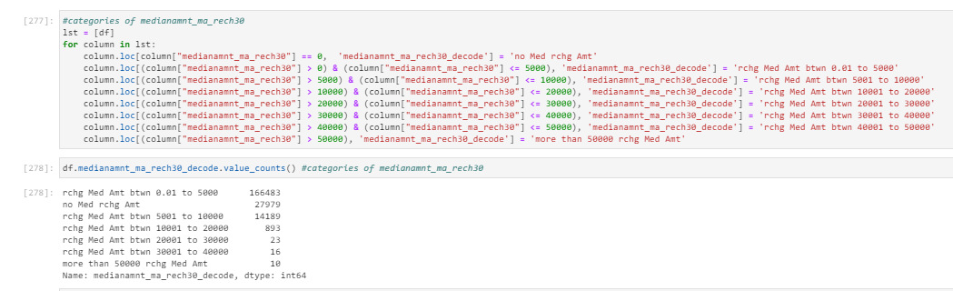

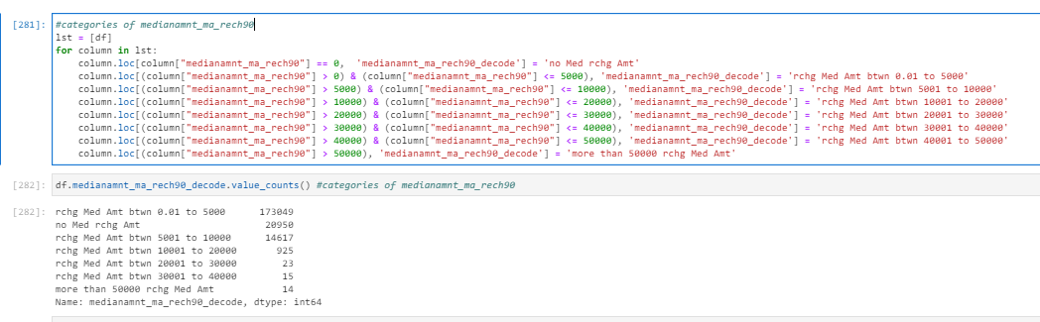

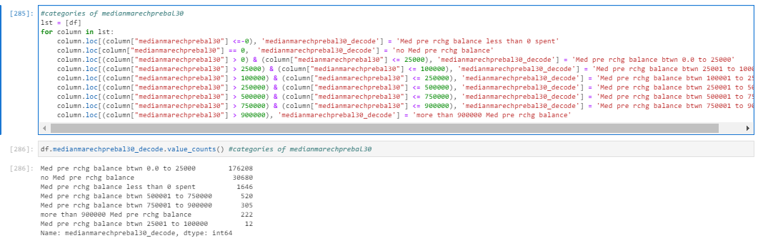

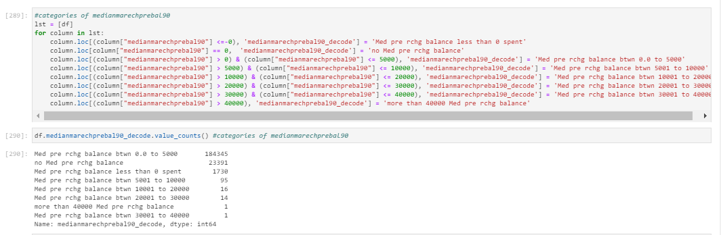

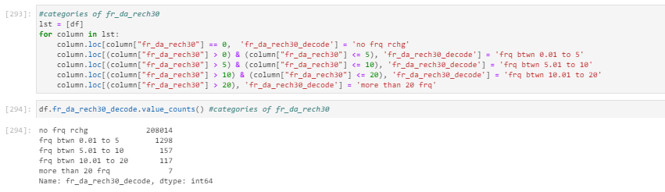

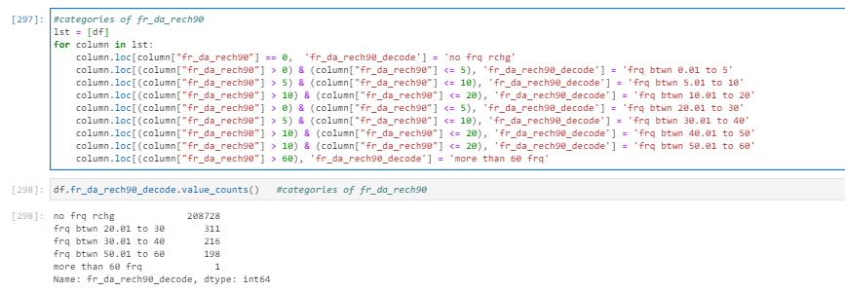

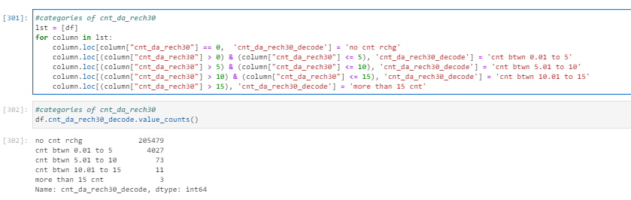

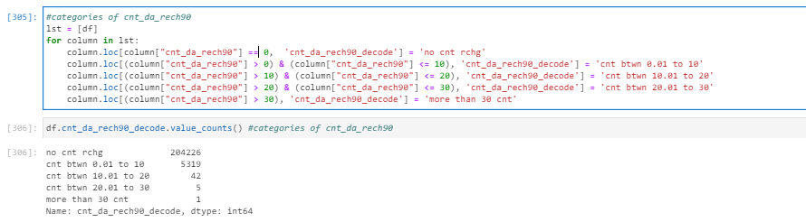

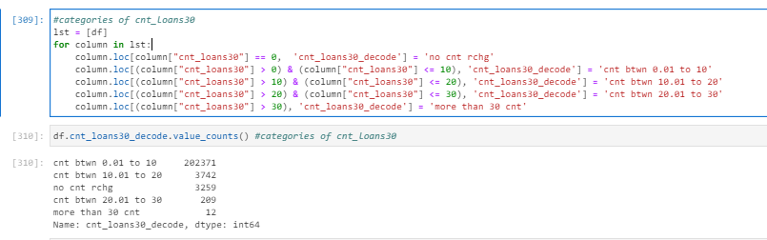

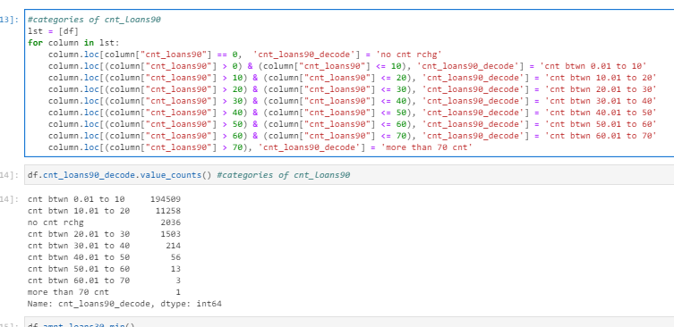

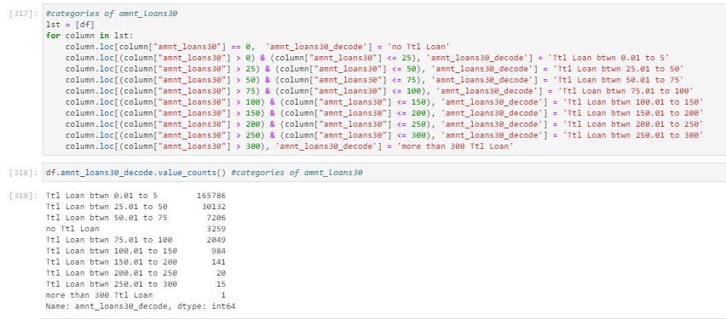

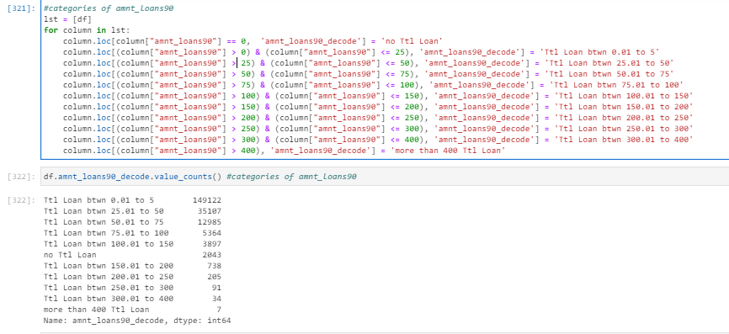

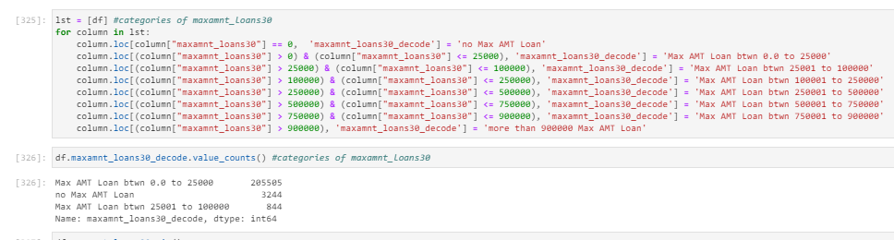

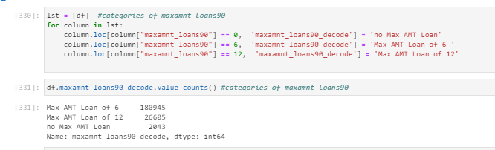

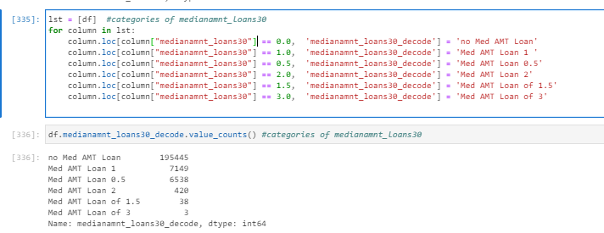

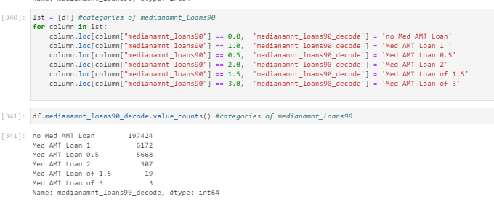

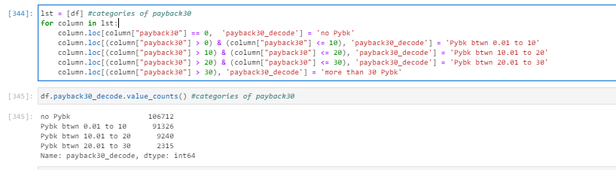

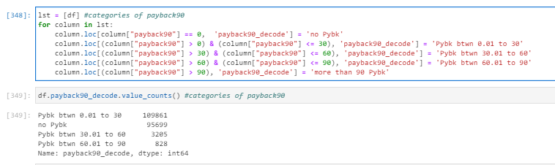

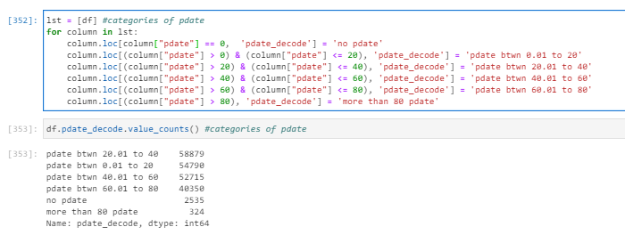

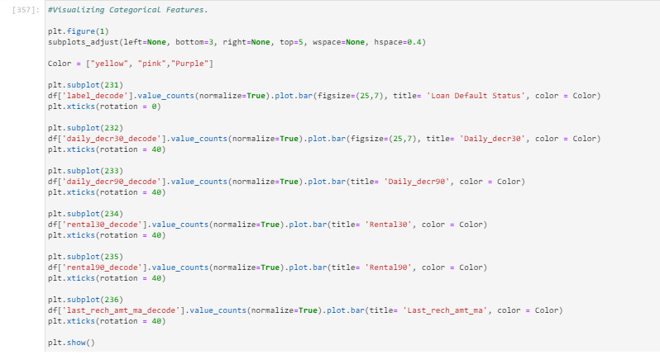

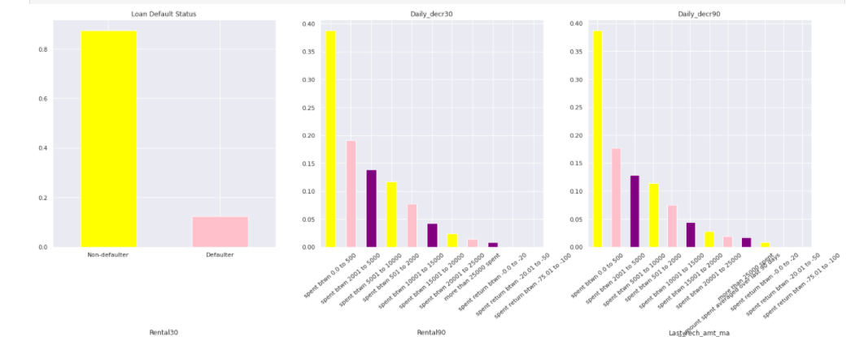

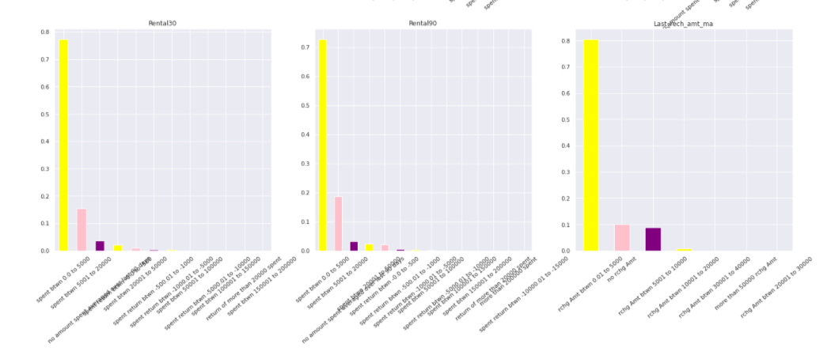

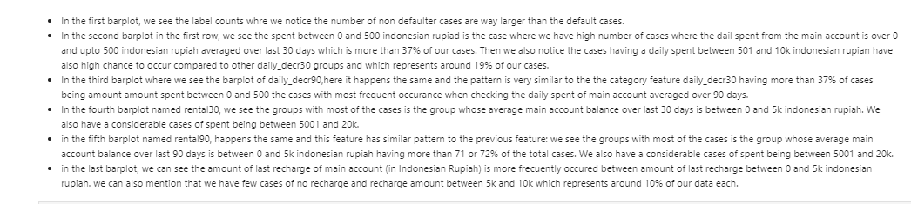

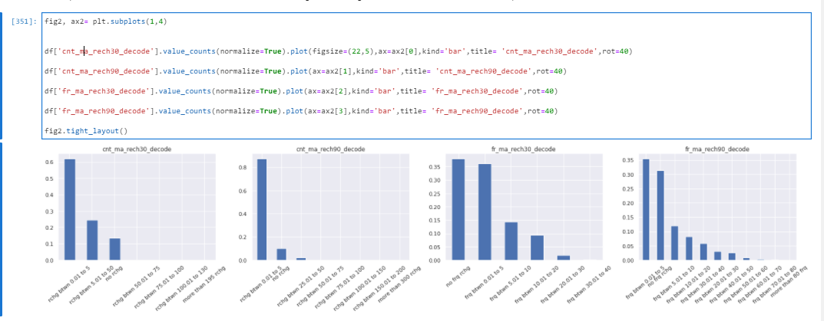

- we have feature cnt_ma_rech30 where we can highlight that the most frequest interval of amount to occur is the interval of recharge between 0 and 5 when counting the number of times main account got recharged in last 30 days. We also have a few cases where the main account is charged between amount 5 and 50. And also around 14% of our cases are accounts with no recharge at all.

- happens the same with the feature cnt_ma_rech90 where we can highlight that the most frequest interval of amount to occur is the interval of recharge between 0 and 5 when counting the number of times main account got recharged in last 90 days. We also have a few cases where the main account is charged between amount 0 and 5. And also around 0.1% of our cases are accounts with no recharge at all.

- we have feature fr_ma_rech30 where we can highlight that the 2 most frequent interval of amount to occur is the interval of recharge between 0 and 5 when counting the frequency of main account recharged in last 30 days and similar is the same frequency (a bit less) that occurs when accounts have no recharge at all. We have several cases, around 15% of our data, where the the frequency of main account recharged in last 30 days is between 5 and 10. And we have around 10% of our data where the frecuencies are between 10 and 20.

- Then, for the feature fr_ma_rech90, we can highlight that the 2 most frequent interval of amount to occur is the interval of recharge between 0 and 5 when counting the frequency of main account recharged in last 30 days and similar is the same frequency (a bit less) that occurs when accounts have no recharge at all. We have several cases, around 10% of our data, where the the frequency of main account recharged in last 90 days is between 5 and 10. And we have around 8% of our data where the frecuencies are between 10 and 20.

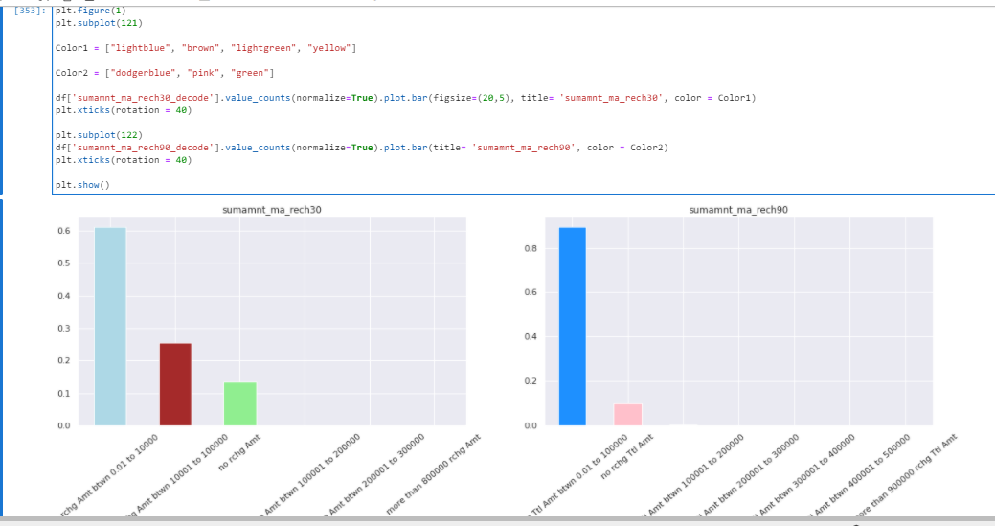

Checking similarities, In the above two barplots, we can see that the most frecuent group when chekcing total amount of recharge in main account over last 90 days and 30 days is the interval of recharge amount between 0 and 10k indonesian rupiah!

Chekcing the differences of above plots, we see in the semamnt_ma_rech30 we have more than 25% of cases where total amount of recharge in main account over last 30 days is between 10k and 100k and we have no recharge amount for more than 13% of cases. On the other hand, when checking the sumamnt_ma_rech of 90 days, then we see we have only 10% of the cases where there is no total amount of recharge in main account over last 90 days .

Then, we plot and check the distribution of other features:

'aon':

Regarding the age on cellular network in days, we have :

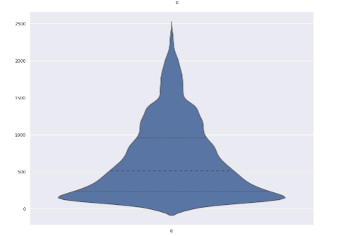

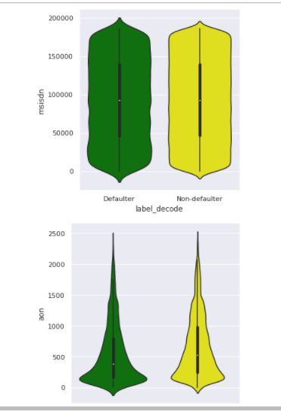

That the majority of the cases/instances are between age 0 and age 1500 days which is a average of 4 year which makes sense as being the age on cellular network.

'daily_decr30':

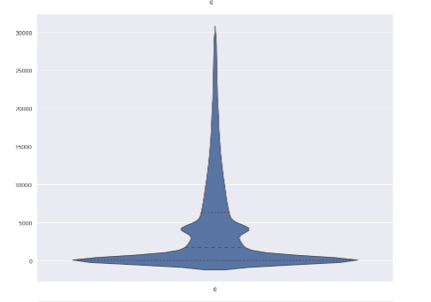

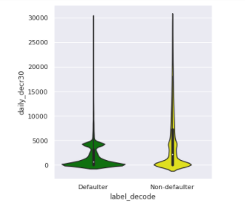

'daily_decr90':

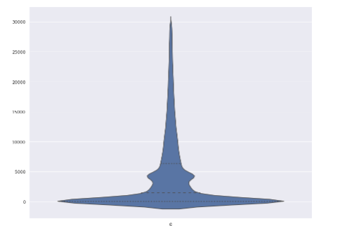

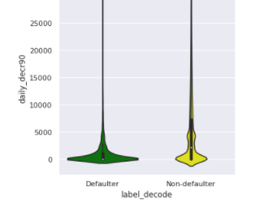

We can see in both cases, 'daily_decr30' and 'daily_decr90', we have more cases around value 0 and lesser between 5k and 30k. In both cases, we have a second peak of high values around 4k value.

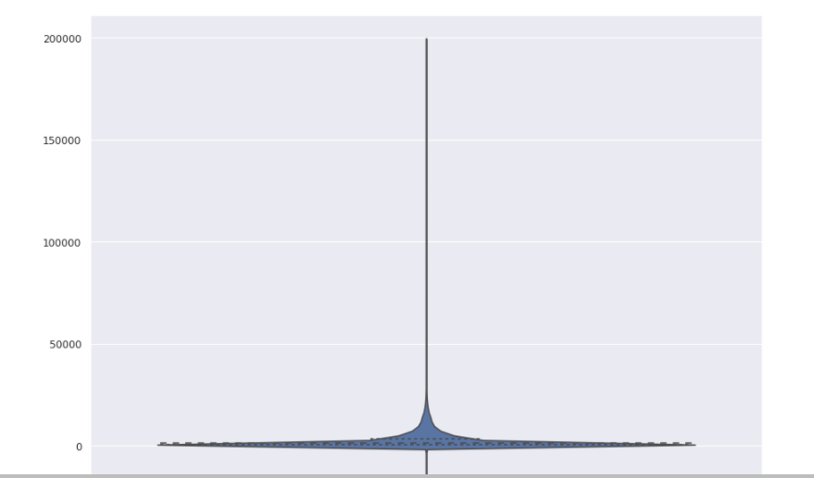 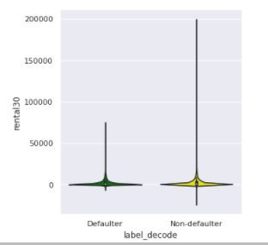

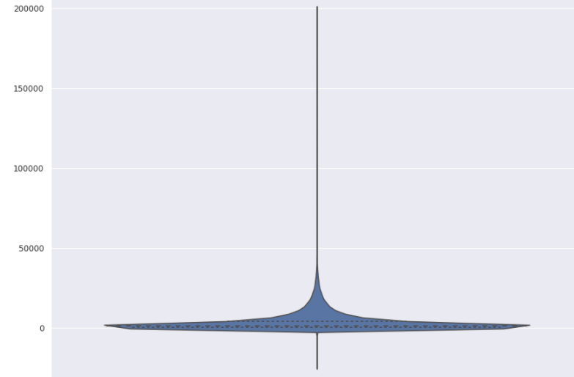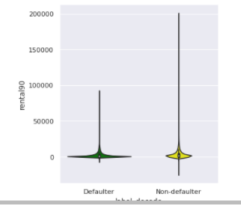

Regarding 'rental30', and 'rental90', we notice the majority of the values are located around value 0.

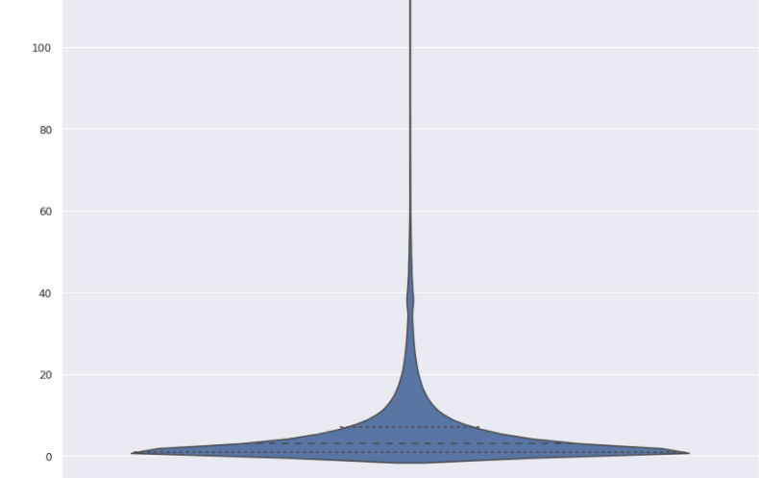 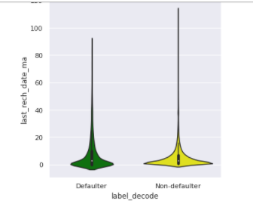

Regarding 'last_rech_date_ma', the majority of values are between 0 and 20.

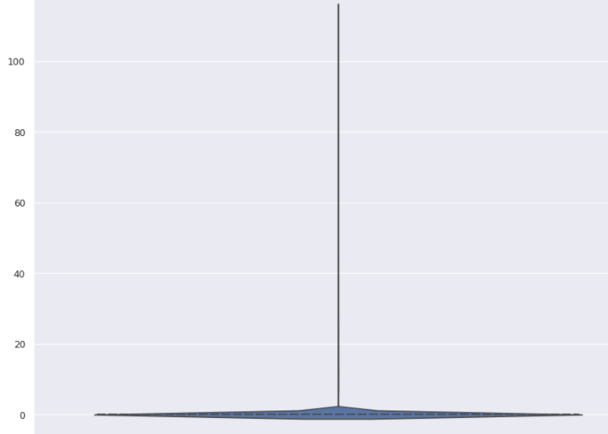 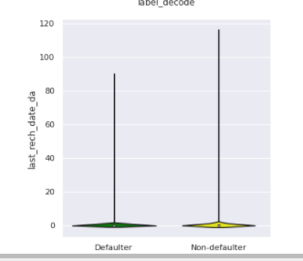

Regarding 'last_rech_date_da', the majority of values are between 0 and 2.

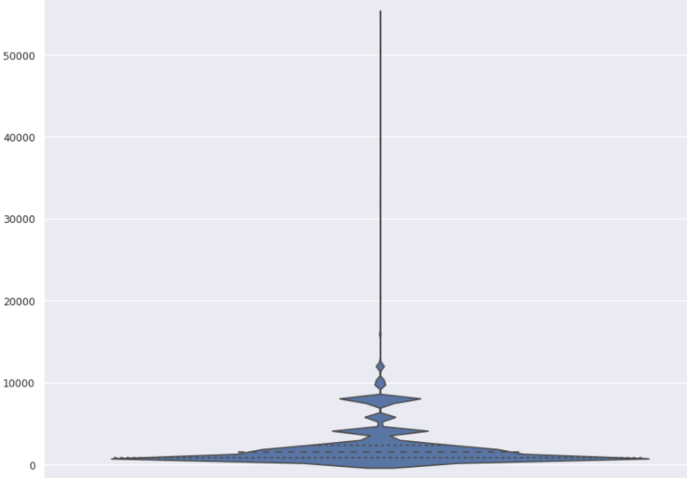 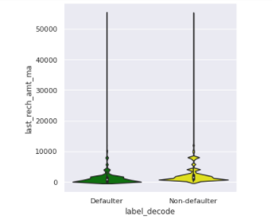

Regarding 'last_rech_amt_ma', we see the amounts of last recharge of main account are mostly between 0 and12k Indonesian Rupiah.

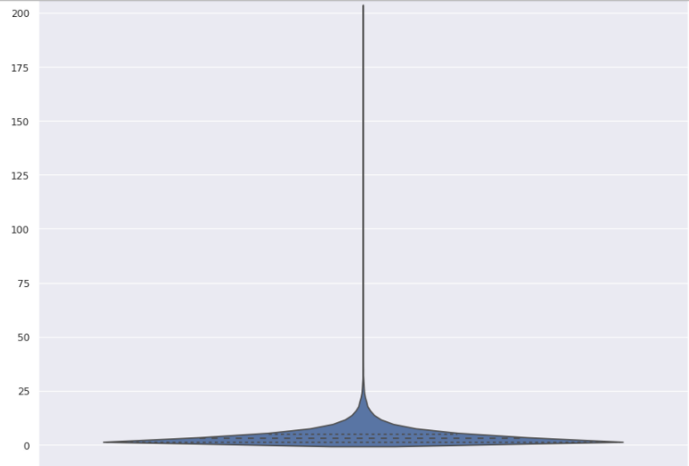 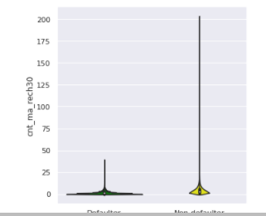

In the column 'cnt_ma_rech30', the Number of times main account got recharged in last 30 days has also most of cases of instances between value 0 and value 25.

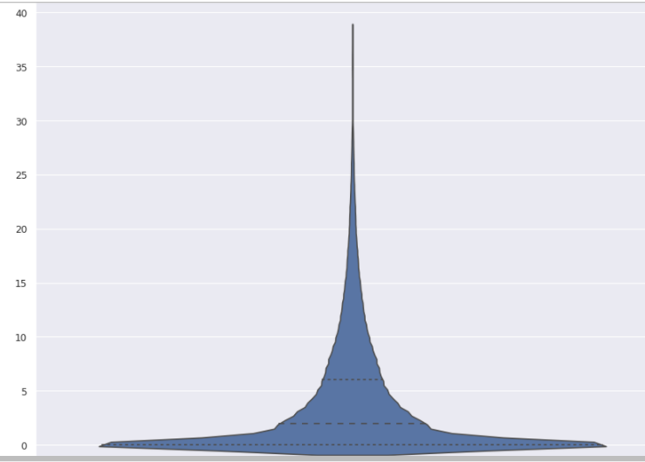 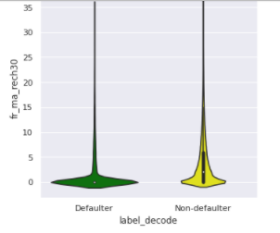

Regarding 'fr_ma_rech30', the values of Frequency of main account recharged are between 0 and 15 in last 30 days. Meand the main account gets frecuently recharged in the 30 days eventhough we have more cases of being charged around 0 frequencies.

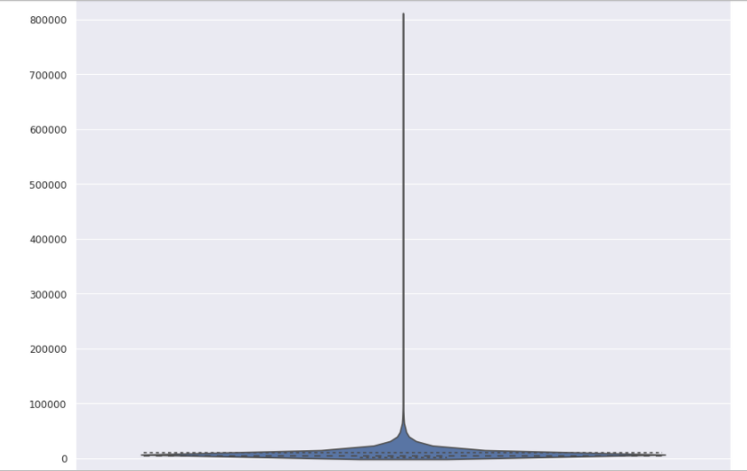 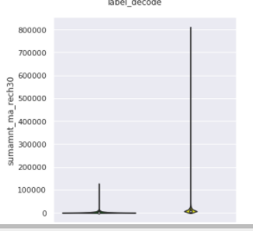

Regarding 'sumamnt_ma_rech30', Total amount of recharge in main account over last 30 days (in Indonesian Rupiah)

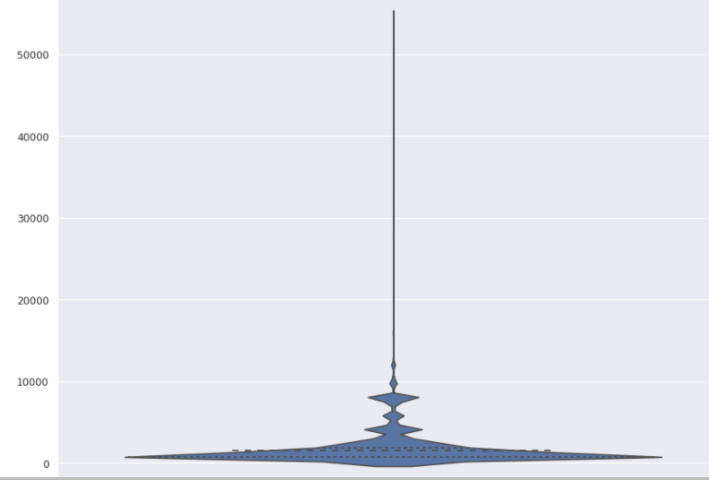 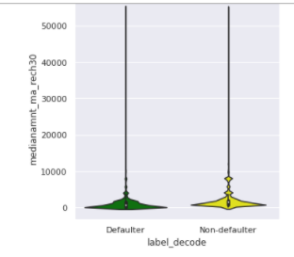

Regarding the 'medianamnt_ma_rech30', the median amount of recharges done in main account over last 30 days at user level is mostly averaged between 0 and 10k in Indonesian Rupiah.

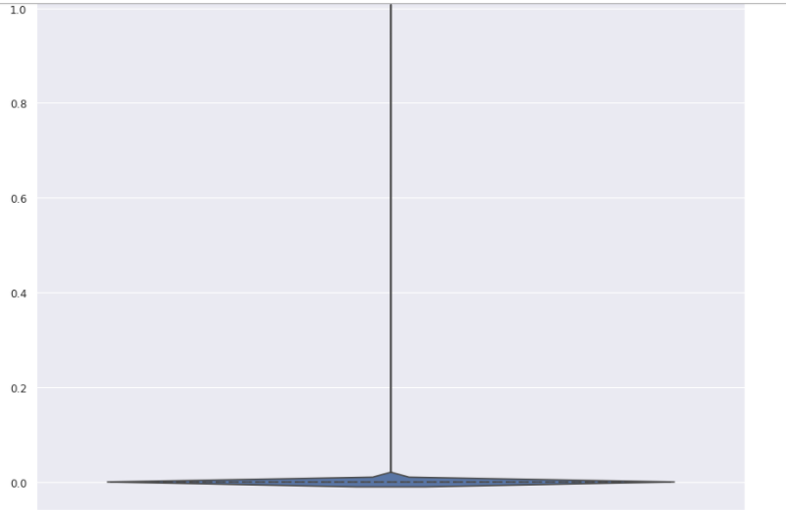 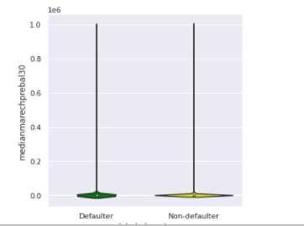

Regarding ‘medianmarechprebal30’, the Median of main account balance is around value 0 just before recharge in last 30 days at user level.

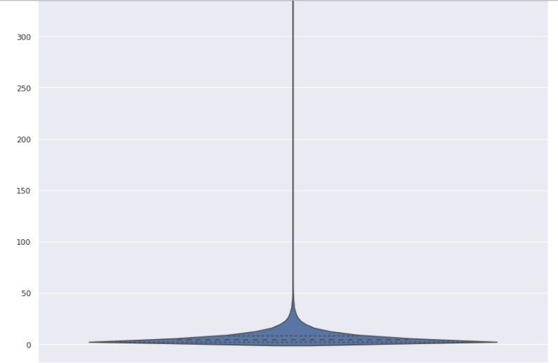 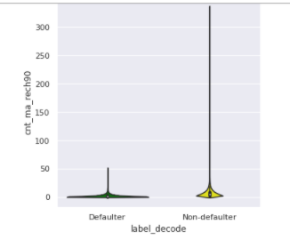

Regarding the feature 'cnt_ma_rech90', the Number of times main account got recharged in last 90 days is between value 0 and 50.

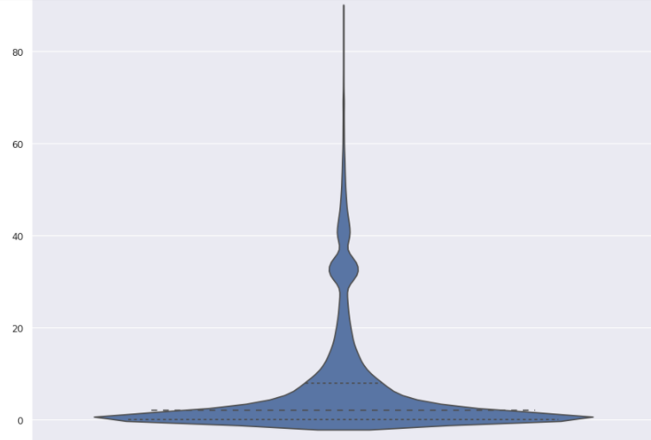 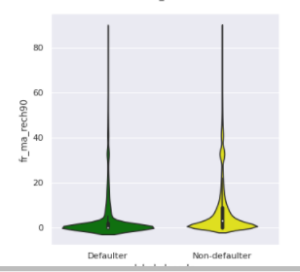

Regarding the feature ‘fr_ma_rech90’, we see the values are distributed between 0 and 40 but mostly mostly between -2 and 15 as the values most frequent of main account recharged in last 90 days.

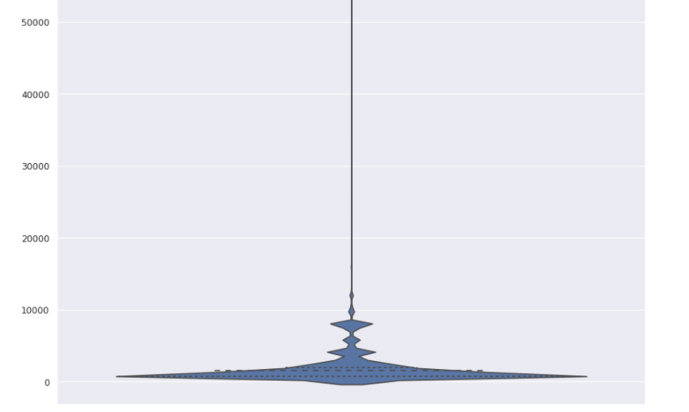 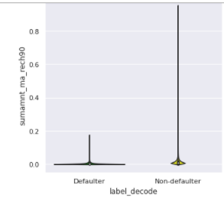

Regarding ‘sumamnt_ma_rech90', the total amount of recharge in main account over last 90 days is distributed between the value 0 and 10k Indonasian Rupiah.

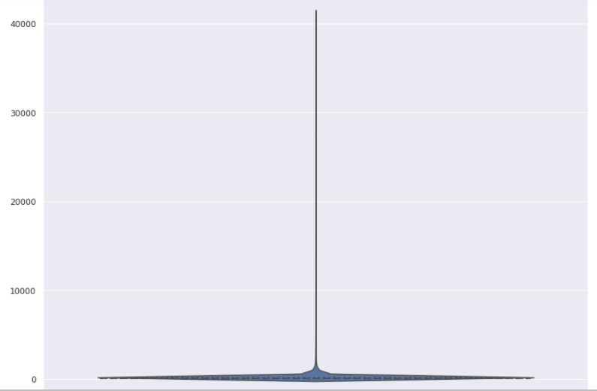 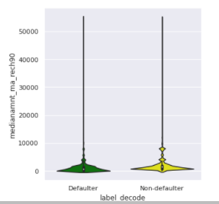

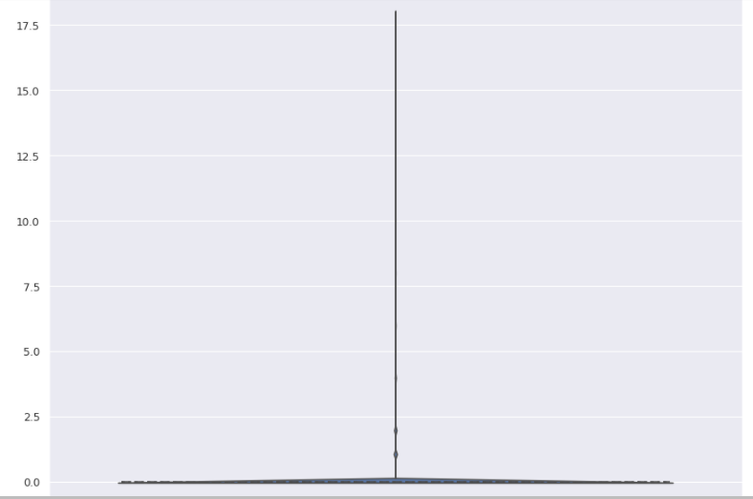 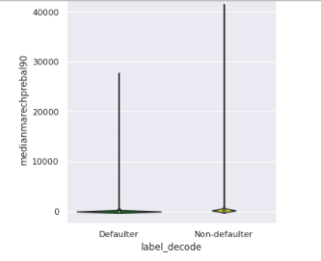

Regarding the 'medianamnt_ma_rech90' and 'medianmarechprebal90', the Median of amount of recharges done in main account over last 90 days at user level and the Median of main account balance just before recharge in last 90 days at user level are around value 0. No wide distribution of both columns.

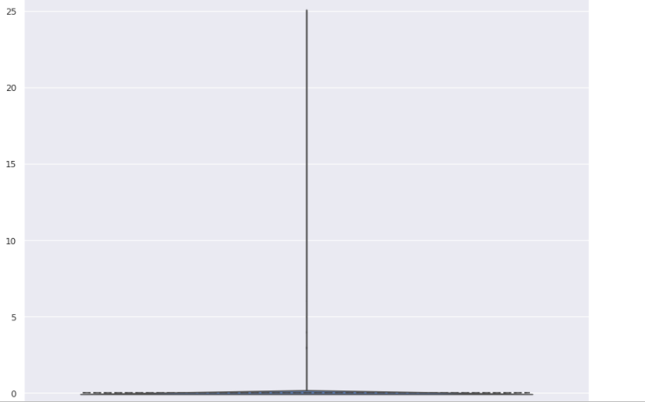 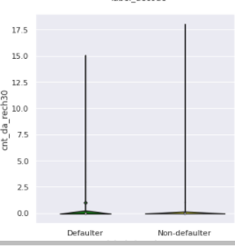

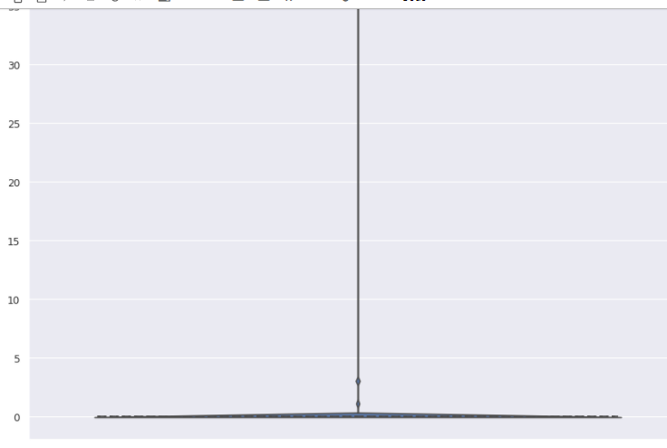 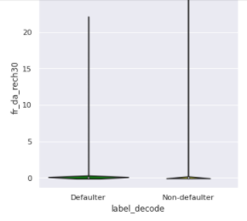

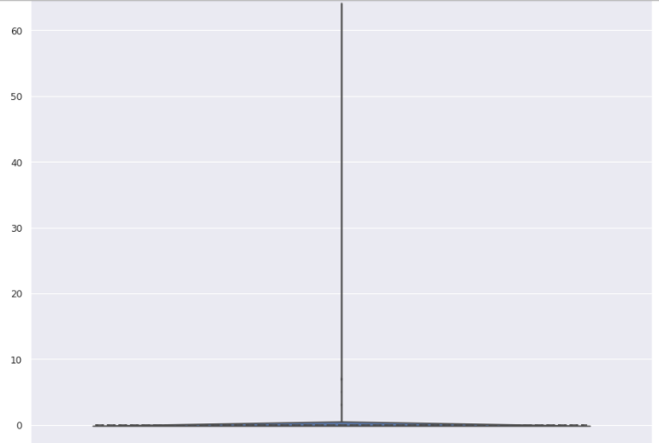 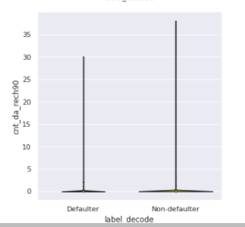

Regarding the 'cnt_da_rech30', 'fr_da_rech30', 'cnt_da_rech90', again, the number of times data account got recharged in last 30 days, frequency of data account recharged in last 30 days and number of times data account got recharged in last 90 days are all three distributed around value 0.

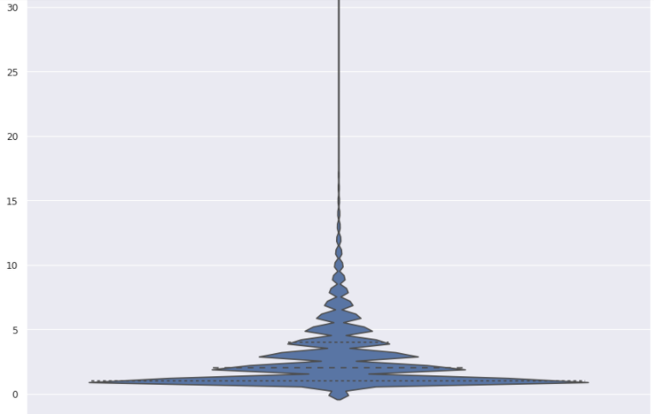 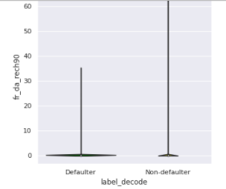

And if we check 'fr_da_rech90', the frequency of data account recharged in last 90 days is mostly between value 0 and 7.

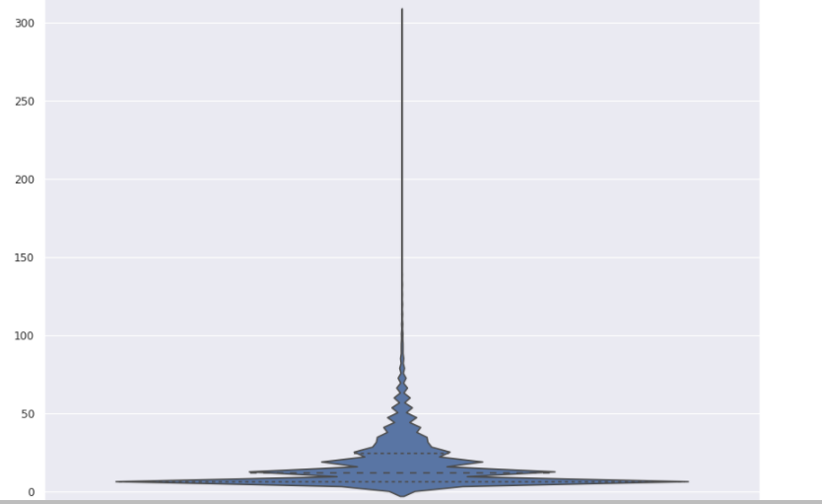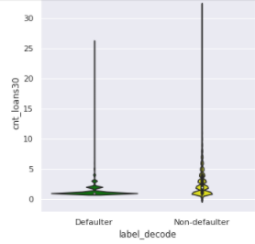

If we check 'cnt_loans30', we see the cases are more distributed between 0 and 50 loans taken by user in last 30 days.

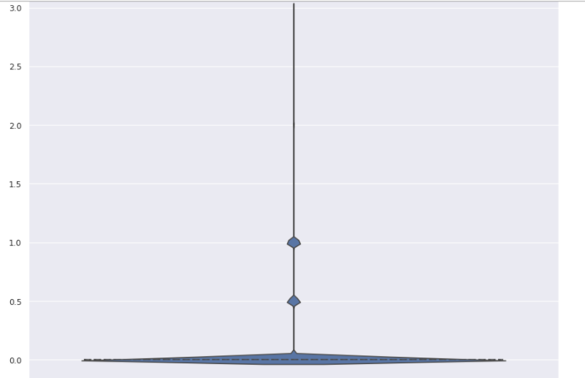 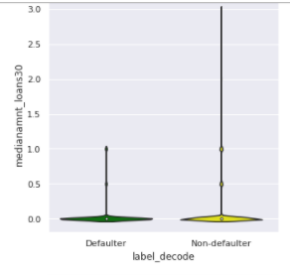

In feature 'medianamnt_loans30', we see the values around 0 are the most frequent in our distriution.

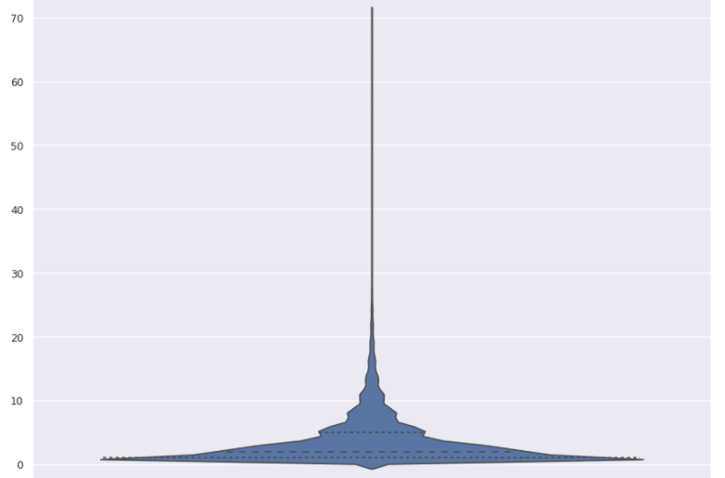 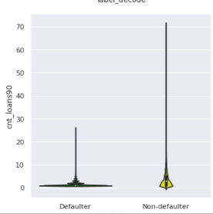

If we check 'cnt_loans90', the feature values are distributed between value 0 and 10 as the number of loans taken by user in last 90 days.

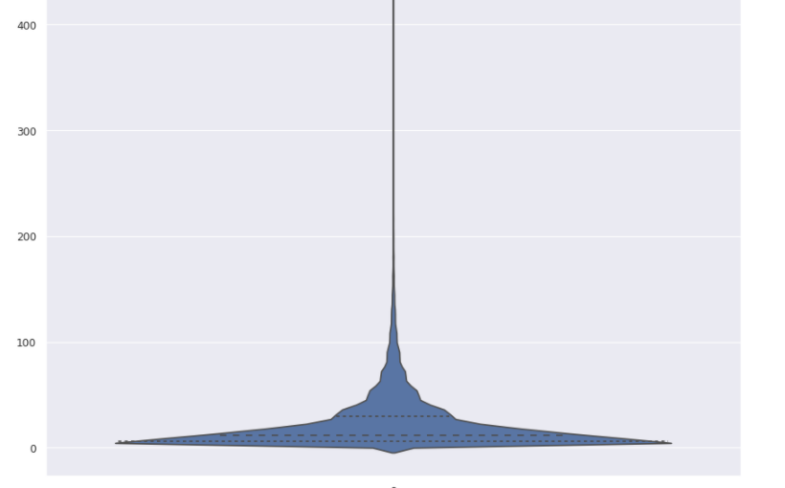 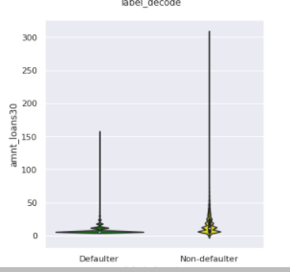

And checking feature 'amnt_loans90', the values are mostly between 0 and 50 as the total amount of loans taken by user in last 90 days.

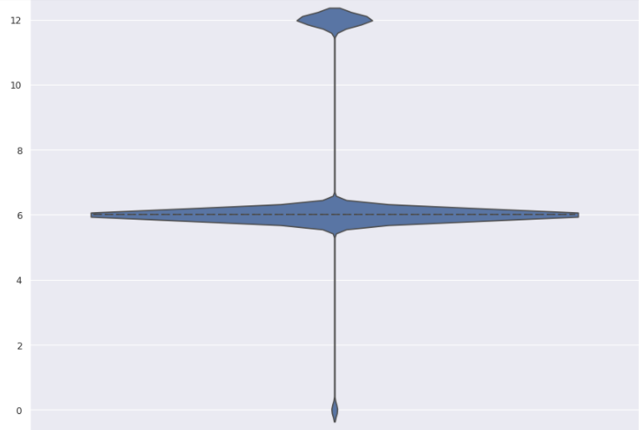 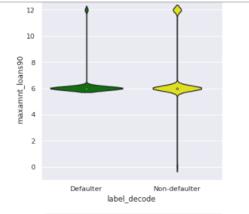

The feature 'maxamnt_loans90', the maximum amount of loan taken by the user in last 90 days is mostly around 6 and some cases either for value 12 or value 0.

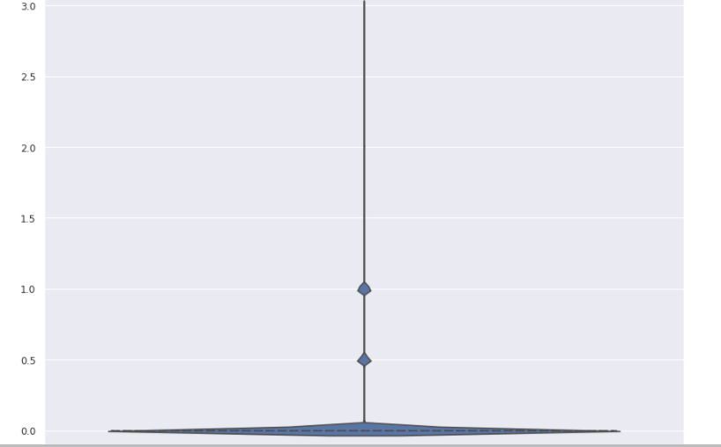 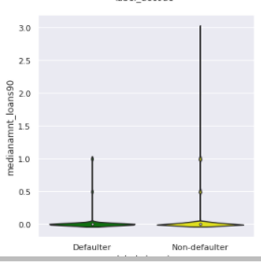

The feature 'medianamnt_loans90', the median of amounts of loan taken by the user in last 90 days, we see la majority of all cases (almost all) are around value 0 and few values around 0.5 or 1.

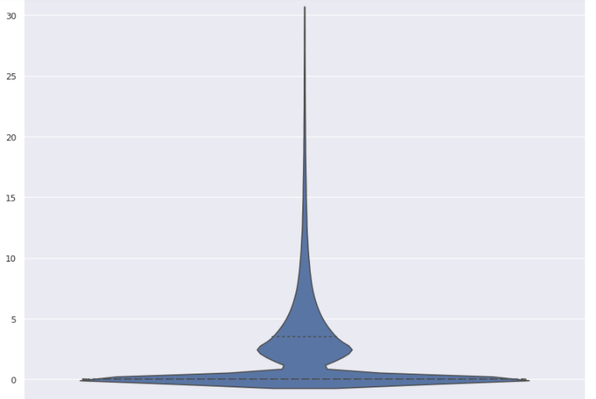 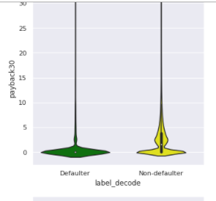

Regarding the feature 'payback30', we can see and highlight that mostly the value is around 0 but we also have some cases that have values between 0 and 5 as average payback time in days over last 30 days.

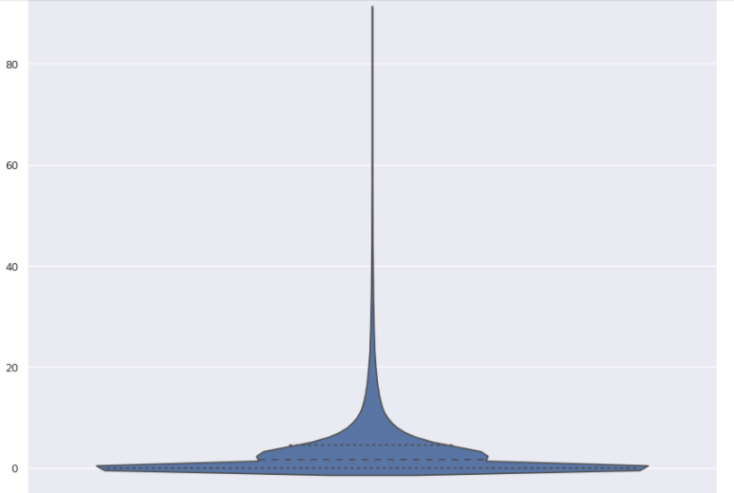 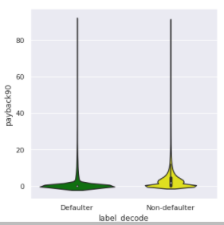

Regarding the feature 'payback90', we can see and highlight that mostly the value is around 0 but we also have some cases that have values between 0 and 20 days as average payback time over last 90 days.

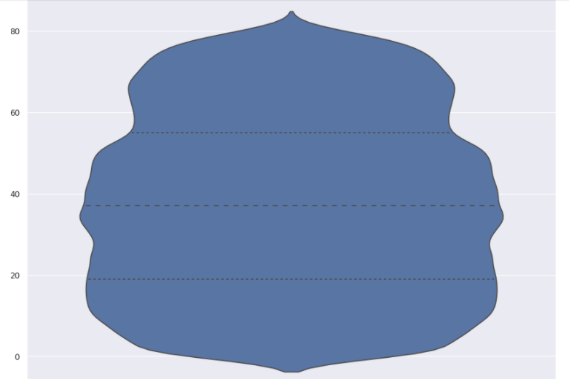

And finally if we check the feature pdate, we see we have wide range of dates which goes from 0 to 80 days.

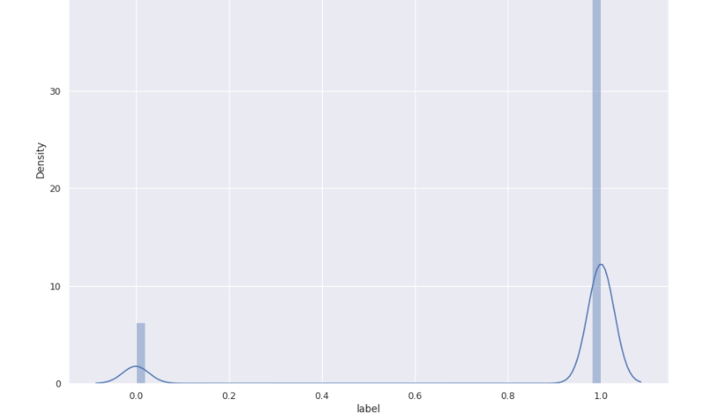

S we said, the label has only 2 values: 0 and 1.

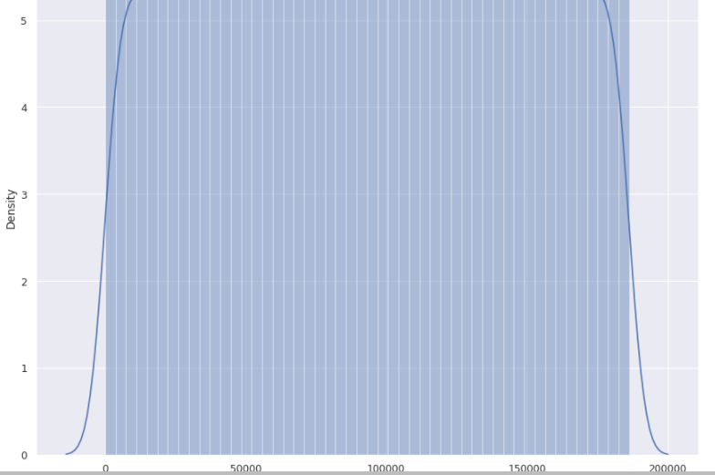

Msisdn is mobile number of user and which has different and wide range of mobile cell phone number.

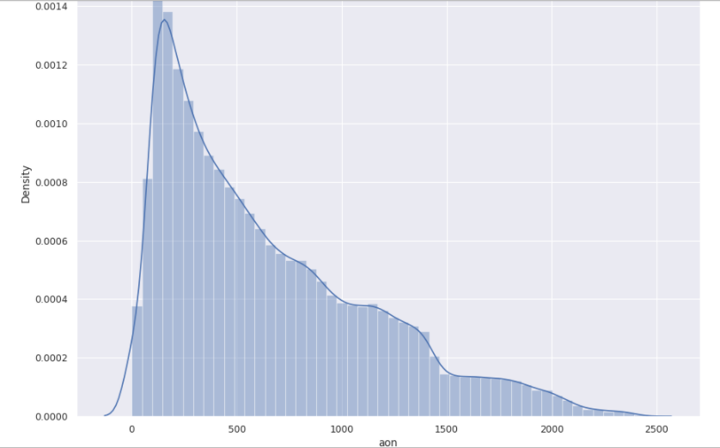

The distribution of aon, age on cellular network in days, has a right skewed distribution. Which means, we have more values near to 0 compared the values near to the max. In addition, the right skewed data means the mean is higher than the mode and the median. Here in this case, we see our data is distributed mostly between value 0 and value 1500. Which means mostly the clients have a cellular for around 4 years old as an average.

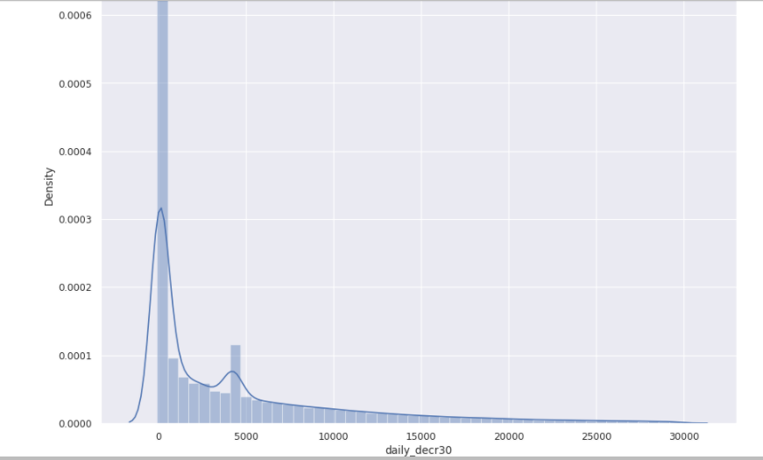

The distribution of daily_decr30, Daily amount spent from main account, averaged over last 30 days (in Indonesian Rupiah), has a right skewed distribution. Which means, we have more values near to 0 compared the values near to the max. In addition, the right skewed data means the mean is higher than the mode and the median. Here in this case, we see our data is distributed mostly between value 0 and value 5000 indonian rupiah. Which means mostly the clients spend for around 4 an average between 0 and 5k indosnesian rupiah as the daily amount spent from the main account averaged over the last 30days.

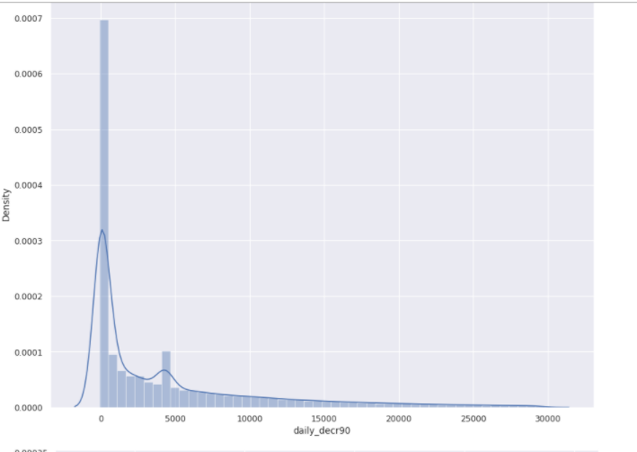

The distribution of daily_decr90, Daily amount spent from main account, averaged over last 90 days (in Indonesian Rupiah), has a right skewed distribution. Which means, we have more values near to 0 compared the values near to the maximum. In addition, the right skewed data means the mean is higher than the mode and the median. Here in this case, we see our data is distributed mostly between value 0 and value 5000 indonesian rupiah. Which means the clients mostly spend for around average between 0 and 5k indosnesian rupiah as the daily amount spent from the main account averaged over the last 90 days.

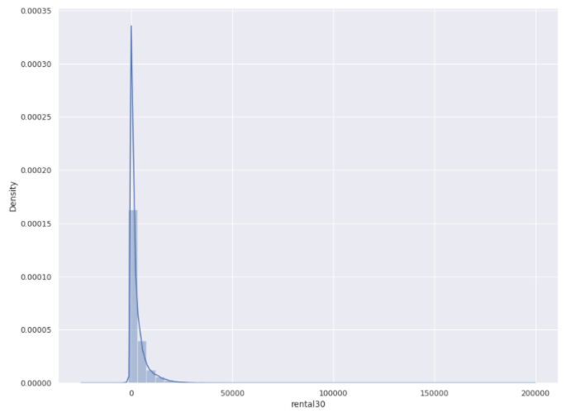

For feature rental30, we see we have the values between 0 and 25k as the average main account balance over last 30 days. It has right skewed distribution.

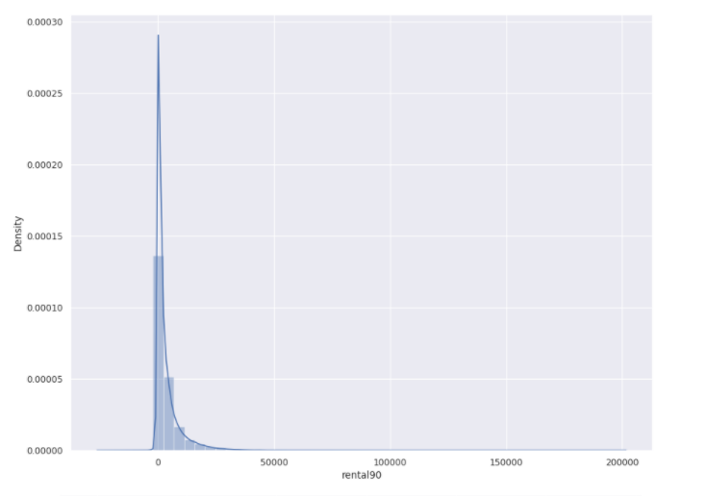

For feature rental90, we see we have the values between 0 and 25k as the average main account balance over last 90 days. It has right skewed distribution.

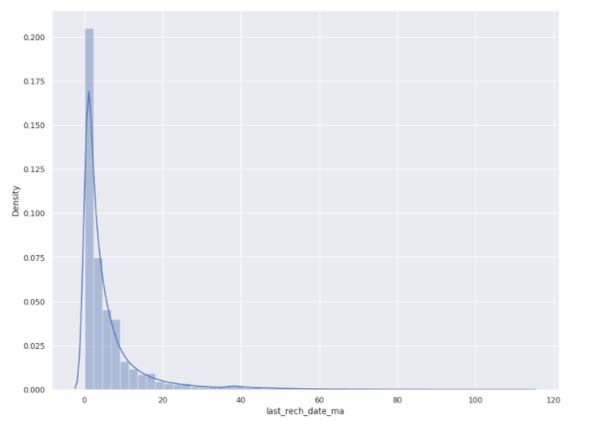

For feature last_rech_date_ma, we see we have the values between 0 and 40 as the number of days till last recharge of main account. It also has right skewed distribution. We see almost all the data is spread between 0 and 20 days till last recharge executed of main account.

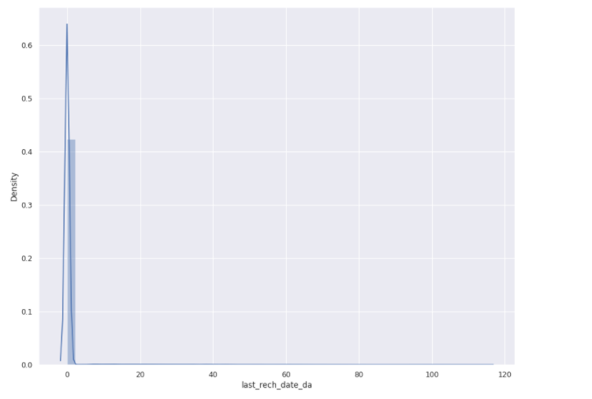

For feature last_rech_date_da, we see we have the values between 0 and 2 as the number of days till last recharge of data account. It also has a minit bit of right skewed distribution but not that much.

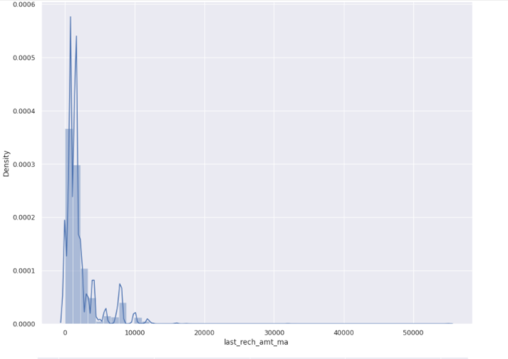

For feature last_rech_amt_ma, we see we have the values between 0 and 10k as the amount of last recharge of main account (in Indonesian Rupiah). It is right skewed distribution. We see almost all the data is spread between 0 and 10k Indonesian rupiah being the amount from 0 to 10k as the amount most frequent in our data for feature last_rech_amt_ma.

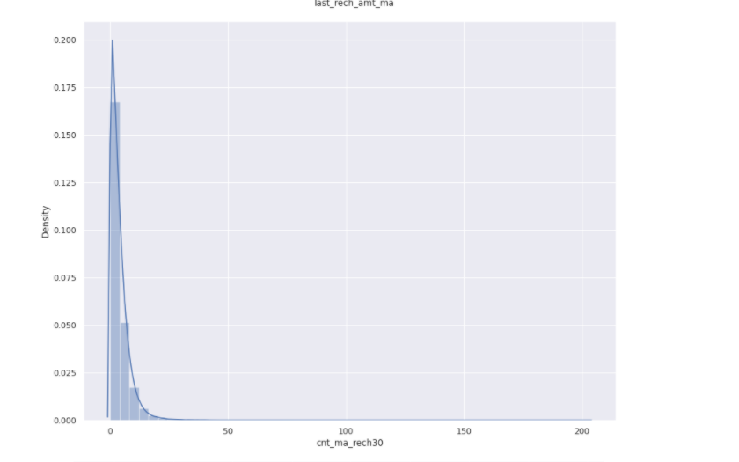

So checking the feature cnt_ma_rech30 , which informs about the number of times main account got recharged in last 30 days, we see the distribution is concentrated between values 0 and 20. It is right skewed distribution. We see almost all the data is spread between 0 and 20-25k Indonesian rupiah being the amount most frequent in our data for feature cnt_ma_rech30.

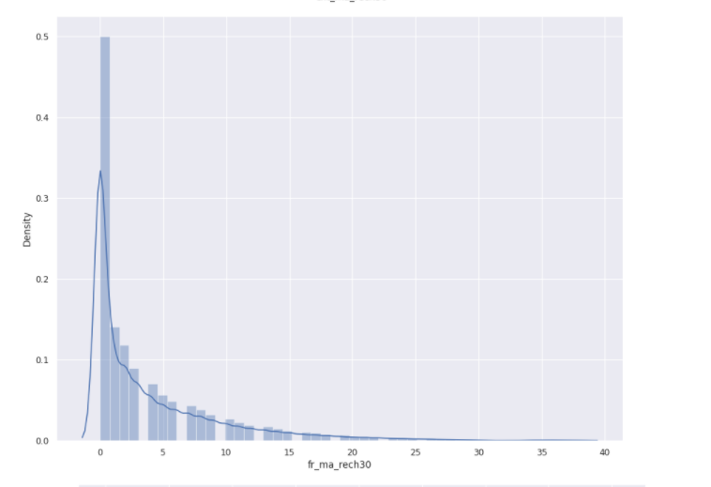

So checking the feature fr_ma_rech30 , which informs about the frequency of main account recharged in last 30 days, we see the distribution is concentrated between values 0 and 25. It is right skewed distribution. We see almost all the data is spread between 0 and 20-25k Indonesian rupiah being the amount most frequent in our data for feature fr_ma_rech30.

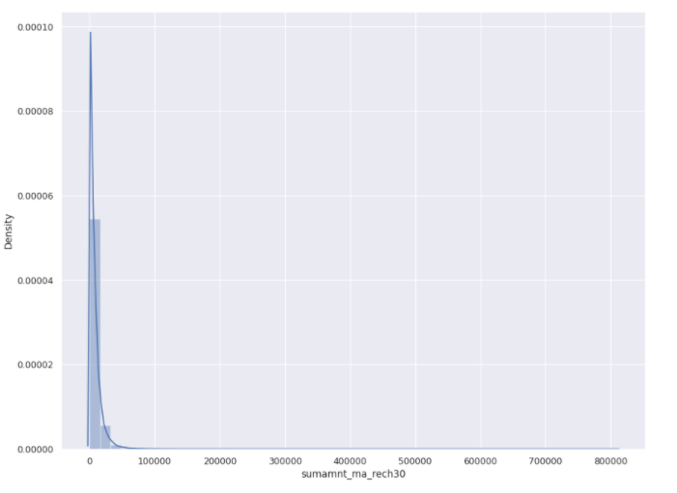

So checking the feature sumamnt_ma_rech30, which informs about the Total amount of recharge in main account over last 30 days (in Indonesian Rupiah), we see the distribution is concentrated between values 0 and 1k Indonesian rupiah. It is right skewed distribution. We see almost all the data is spread between 0 and 1k Indonesian rupiah being the amount most frequent in our data for feature fr_ma_rech30.

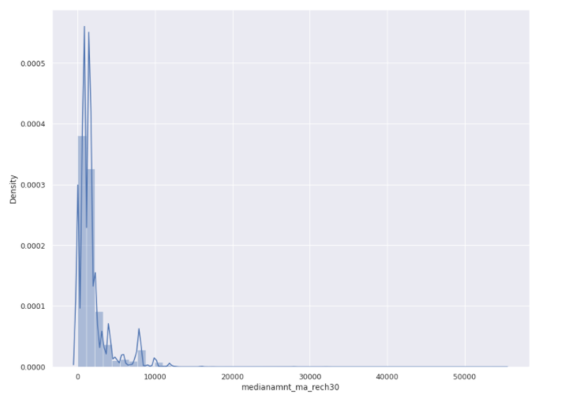

So checking the feature medianamnt_ma_rech30, which informs about the median of amount of recharges done in main account over last 30 days at user level (in Indonesian Rupiah), we see the distribution is concentrated between values 0 and 10k Indonesian rupiah. It is right skewed distribution. We see almost all the data is spread between 0 and 10k Indonesian rupiah being the segment of amount most frequent in our data for feature medianamnt_ma_rech30.

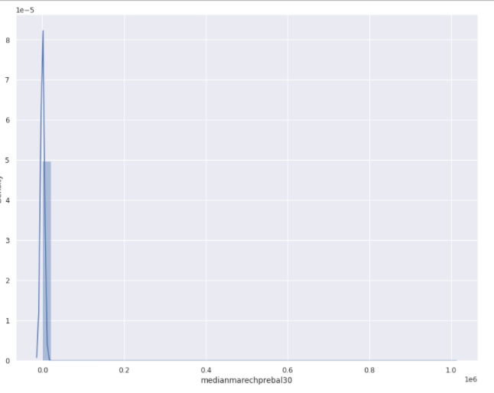

So checking the feature medianmarechprebal30, which informs about the median of main account balance just before recharge in last 90 days at user level (in Indonasian Rupiah), we see the distribution is concentrated between values 0 and 0.1 Indonesian rupiah at user level. It is right skewed distribution. We see almost all the data is spread between 0 and 0.1 Indonesian rupiah being the segment of amount most frequent in our data for feature medianmarechprebal30.

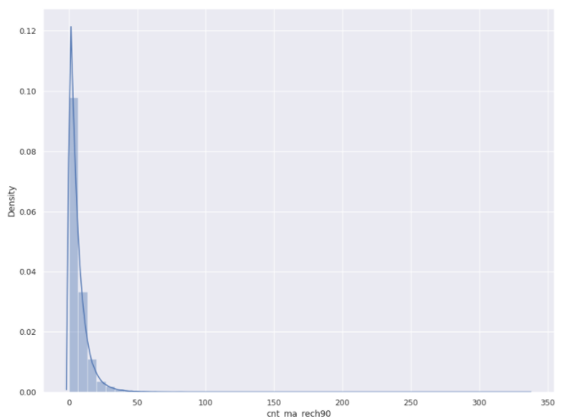

So checking the feature cnt_ma_rech90, which informs about the number of times main account got recharged in last 90 days, we see the distribution is concentrated between values 0 and 50.It is right skewed distribution. We see almost all the data is spread between 0 and 50 times being recharged for the segment of amount most frequent in our data for feature cnt_ma_rech90.

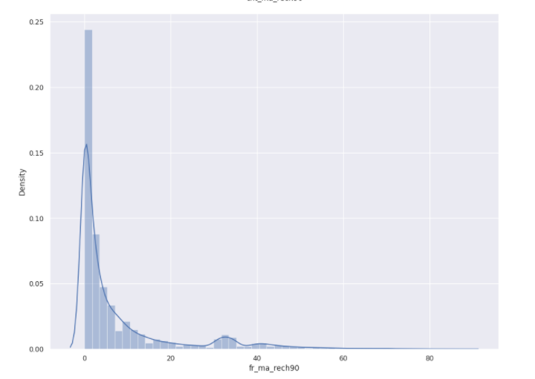

So checking the feature fr_ma_rech90, which informs about the frequency of main account recharged in last 90 days, we see the distribution is concentrated between values 0 and 60.It is right skewed distribution. We see almost all the data is spread between 0 and 50 times being recharged for the segment of amount most frequent in our data for feature fr_ma_rech90.

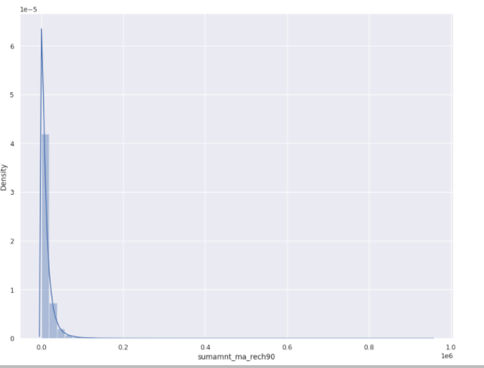

So checking the feature sumamnt_ma_rech90, which informs about the total amount of recharge in main account over last 90 days (in Indonasian Rupiah), we see the distribution is concentrated between values 0 and 0.1 .It is right skewed distribution. We see almost all the data is spread between 0 and 0.1 times being amount recharged for the segment of amount most frequent in our data for feature sumamnt_ma_rech90.

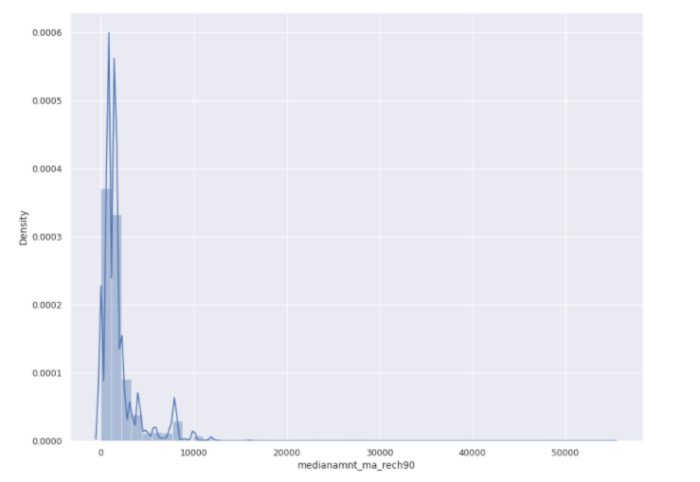

So checking the feature medianamnt_ma_rech90, which informs about the median of amount of recharges done in main account over last 90 days at user level (in Indonasian Rupiah), we see the distribution is concentrated between values 0 and 10k indonesian rupiah .It is right skewed distribution. We see almost all the data is spread between 0 and 10k being median amount recharged for the segment of amount most frequent in our data for feature medianamnt_ma_rech90.

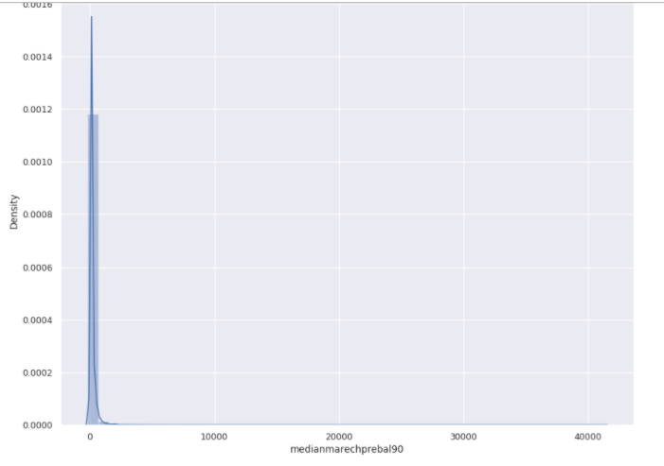

So checking the feature medianmarechprebal90, which informs about the median of main account balance just before recharge in last 90 days at user level (in Indonasian Rupiah), we see the distribution is concentrated between values 0 and 1k indonesian rupiah .It is right skewed distribution. We see almost all the data is spread between 0 and 1k being median of main account balance just before recharge and the segment of amount most frequent in our data for feature medianmarechprebal90.

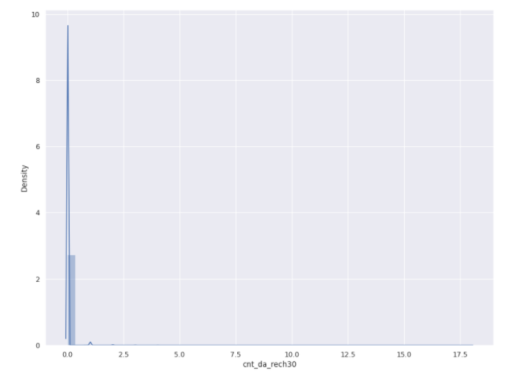

So checking the feature cnt_da_rech30, which informs about the number of times data account got recharged in last 30 days, we see the distribution is concentrated between values 0 and 1 indonesian rupiah . We see almost all the data is spread between 0 and 1k being the number of times data account got recharged in last 30 days 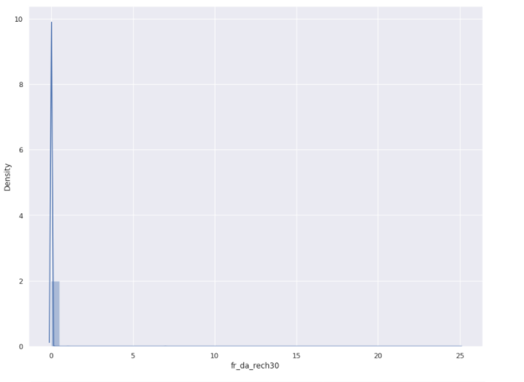

So checking the feature fr_da_rech30, which informs about the frequency of data account recharged in last 30 days, we see the distribution is concentrated between values 0 and 1 indonesian rupiah. We see all the data is spread between 0 and 1 being median of main account balance just before recharge and the segment of amount most frequent in our data for feature fr_da_rech30.

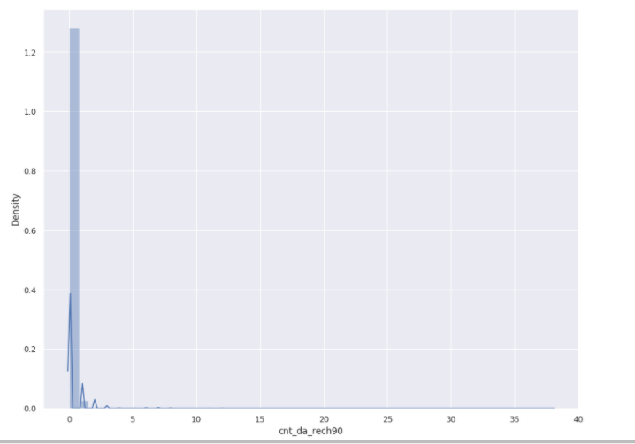

So checking the feature cnt_da_rech90, which informs about the number of times data account got recharged in last 90 days, we see the distribution is concentrated between values 0 and 3 indonesian rupiah. We see all the data is spread between 0 and 3 being number of times data account got recharged in last 90 days and the segment of amount most frequent in our data for feature fr_da_rech30.

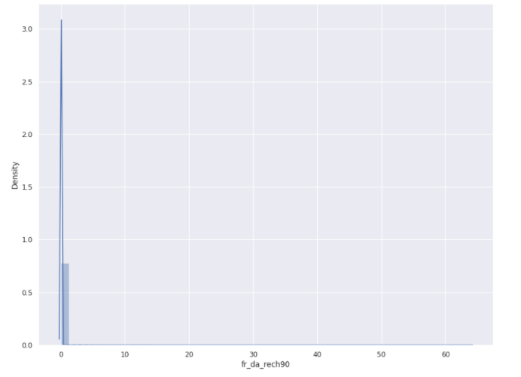

And checking the feature fr_da_rech90, which informs about the frequency of data account recharged in last 30 days, we see the distribution is concentrated between values 0 and 1 indonesian rupiah. We see all the data is spread between 0 and 1 being median of main account balance just before recharge and the segment of amount most frequent in our data for feature fr_da_rech90.

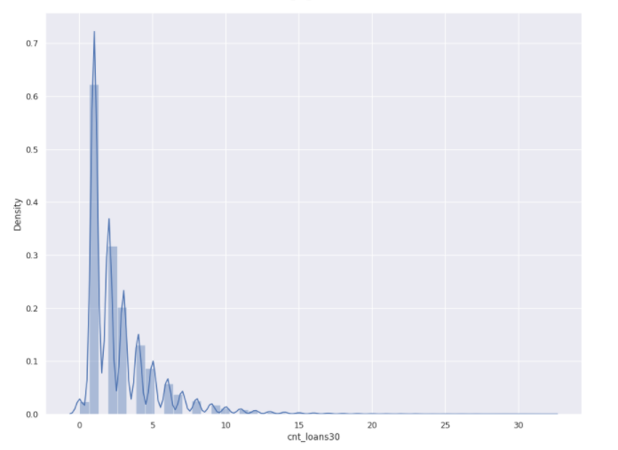

So checking the feature cnt_loans30, which informs about the number of loans taken by user in last 30 days, we see the distribution is concentrated between values 0 and 15. We see all the data is spread between 0 and 10 being the number of loans taken by user and the segment of amount most frequent in our data for feature cnt_loans30.

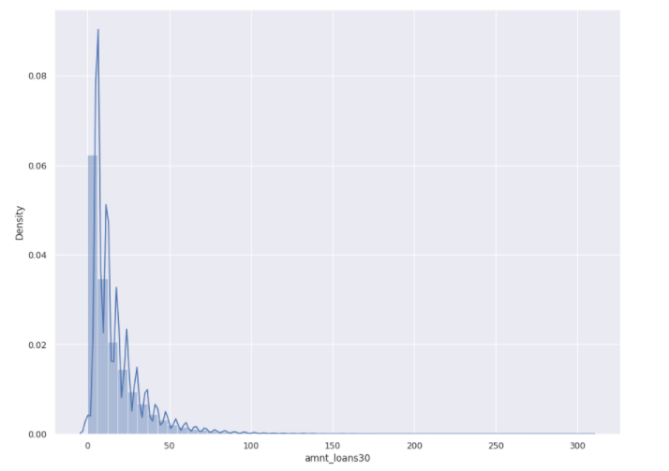

So checking the feature amnt_loans30, which informs about the total amount of loans taken by user in last 30 days, we see the distribution is concentrated between values 0 and 100. We see all the data is spread between 0 and 50 being the number of loans taken by user and the segment of amount most frequent in our data for feature amnt_loans30.

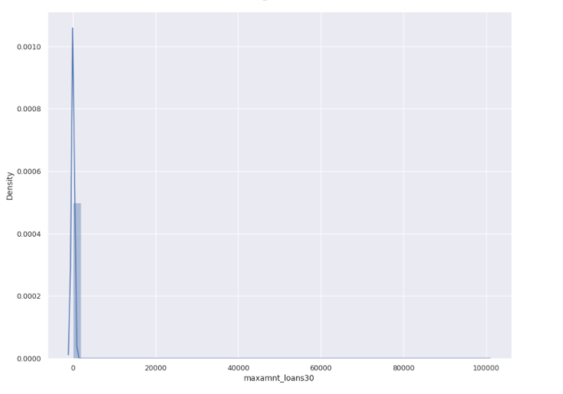

So checking the feature maxamnt_loans30, which informs about the maximum amount of loan taken by the user in last 30 days, we see the distribution is concentrated between values 0 and 1. We see all the data is spread between 0 and 1 being the maximum amount of loan taken by the user in last 30 days and the segment of amount most frequent in our data for feature maxamnt_loans30.

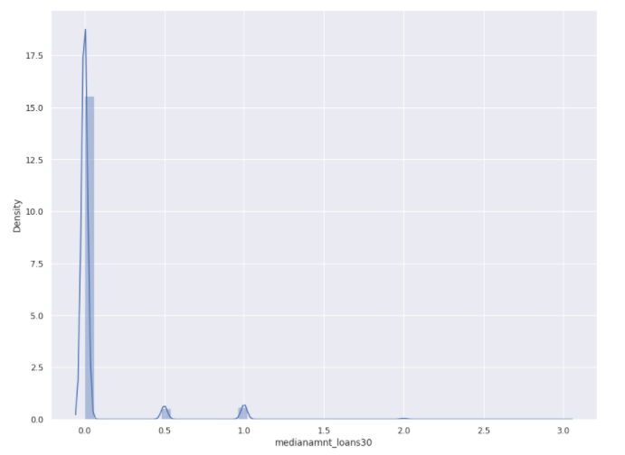

So checking the feature medianamnt_loans30, which informs about the median of amounts of loan taken by the user in last 30 days, we see the distribution is concentrated between values 0, 0.5 and 1. We see all the data is spread between 0 and 1 being the median of amounts of loan taken by the user in last 30 days and the segment of amount most frequent in our data for feature medianamnt_loans30.

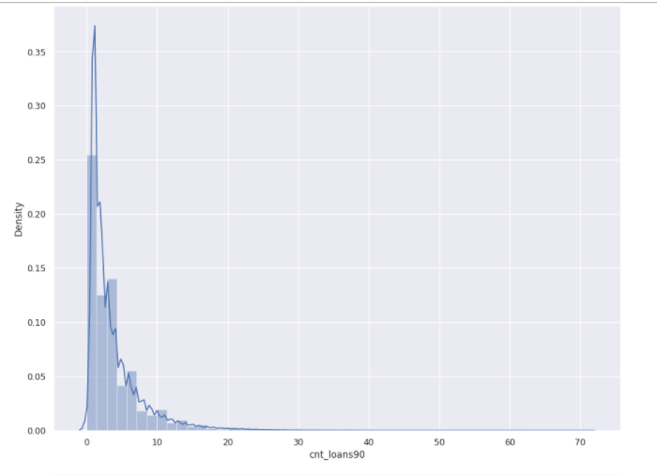

So checking the feature cnt_loans90, which informs about the number of loans taken by user in last 90 days, we see the distribution is concentrated between values 0 and 30. We see all the data is spread between 0 and 10 being the number of loans taken by user in last 90 days and the segment of amount most frequent in our data for feature cnt_loans90.

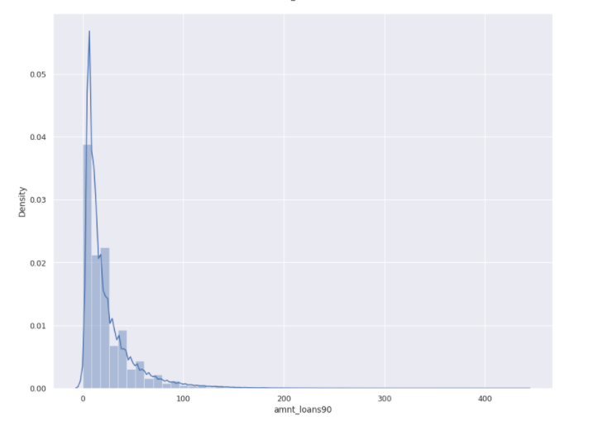

So checking the feature amnt_loans90, which informs about the total amount of loans taken by user in last 90 days, we see the distribution is concentrated between values 0 and 100. We see all the data is spread between 0 and 100 being the number of loans taken by user in last 90 days and the segment of amount most frequent in our data for feature amnt_loans90.

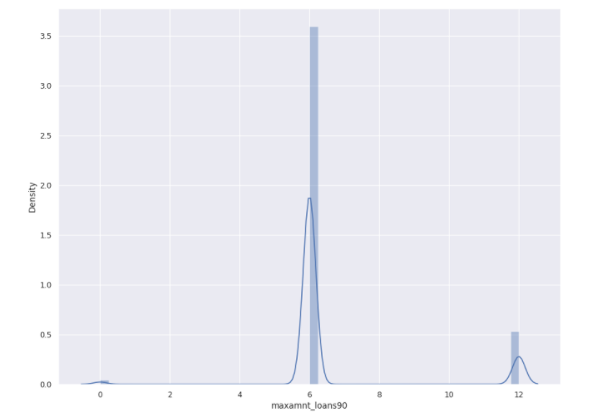

So checking the feature maxamnt_loans90, which informs about the maximum amount of loan taken by the user in last 90 days, we see the distribution is concentrated on values 0, 6 and 12. We see all the data is mostly spread between 0 and 12 being the number of loans taken by user in last 90 days and the segment of amount most frequent in our data for feature amnt_loans90.

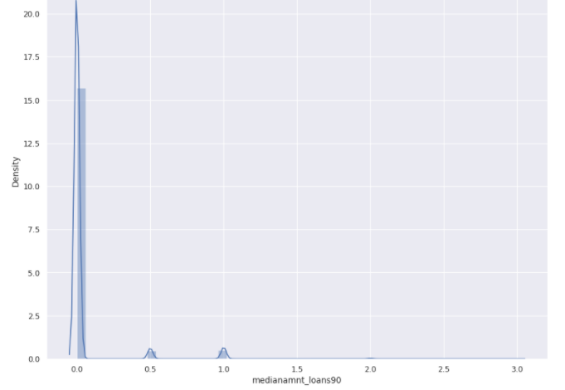

So checking the feature mdianamnt_loans90, which informs about the maximum amount of loan taken by the user in last 90 days, we see the distribution is concentrated on values 0, 0.5 and 1.2. We see all the data is mostly spread on the 0, and informs maximum amount of loan taken by the user in last 90 days in last 90 days and the segment of amount most frequent in our data for feature mdianamnt_loans90

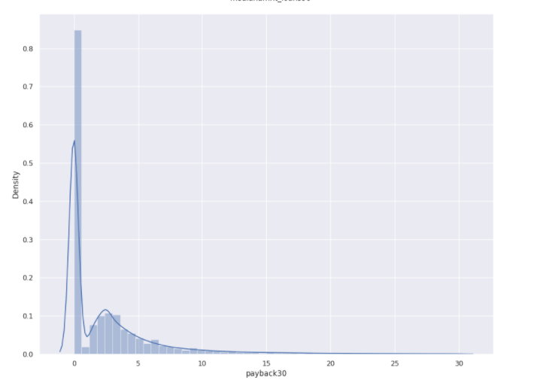

So checking the feature payback30, which informs about the average payback time in days over last 30 days, we see the distribution is concentrated between 0 and 15. We see all the data is mostly spread between the 0 and 15 as average paybak time, and informs Average payback time in days over last 30 days and the segment of amount most frequent in our data for feature payback30

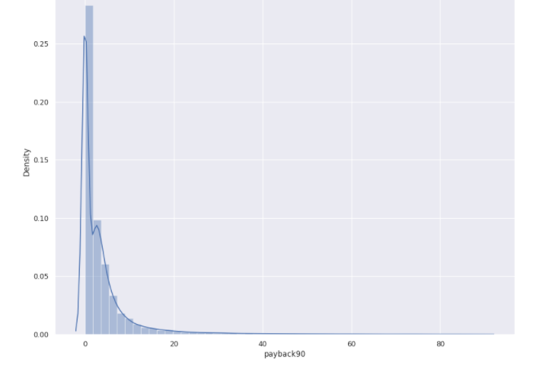

So checking the feature payback90, which informs about the average payback time in days over last 90 days, we see the distribution is concentrated between 0 and 20. We see all the data is mostly spread between the 0 and 20 as average paybak time, and informs Average payback time in days over last 90 days and the segment of amount most frequent in our data for feature payback90

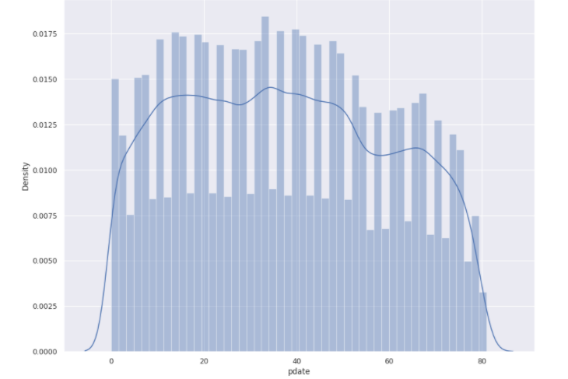

So checking the feature pdate, which informs about the average mirror date, we see the distribution is concentrated between 0 and 80. We see all the data is mostly spread between the 0 and 80 as average pdate, and informs pdate in days and is the segment of amount most frequent in our data for feature pdate.

Now, let’s check the value counts of each feature:

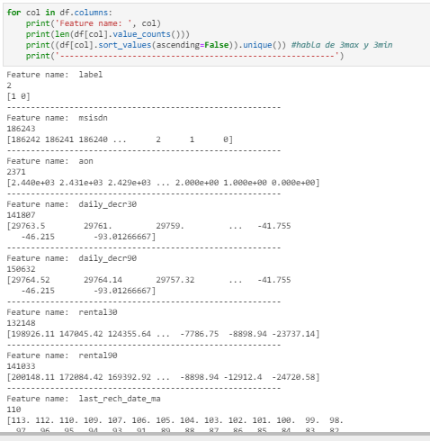

**Here we can see the length of unique values of each column and also showing the values for each column.**

**For example, for label, we have a total of 2 values which is 1 and 0, as already commented.**

**The feature msisdn, which is the mobile number of each user, has 186243 unique values and mostly those mobile number are different for each user.**

**The feature aon, which is age on cellular network in days, has 2371 unique values and the max value is 2440 days which is more or less 6 years and 8 months and the minimum value that we have is 0 days of age on cellular network.**

**For features daily_decr30 and daily_decr90, we see we have a total of 141.807 and 150.632 unique values respectively. Then, checking the values, we see the max of daily_decr30 is 29.763 and the max of daily_decr90 is 29.764 as daily amount spent from the main account averaged over last 30 days and 90 respectively. We also see we have minimums of negative value for both feature: -93. We kept the negative values for these kind of features where we have amounts as there may be the case that the balance got negative when there is not enough money in the account when the spent is executed.**

**When checking the balance of the account, we see features like rental30 and rental90 have a total of 132.148 and 141.033 unique values respectively.**

**When checking the values of the same columns, we see we have 198.926 and 200.148 as the average main account balance over last 30 days and 90 days respectively. Aand from the bottom, we see we have negative values with minimum of -23.737 and -24.720 respectively when checking the balance as it can have negative values since it is counting the balance amount which can be cumalative till date.**

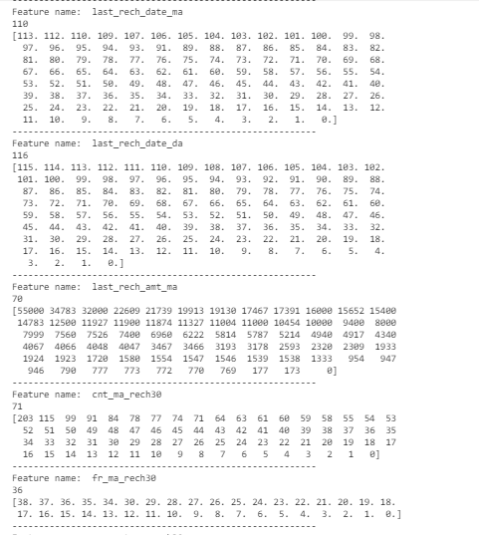

**Now, we can see that the feature last_rech_date_ma and last_rech_date_da have a total of 110 and 116 unique values. These columns have a maximum of 113 and 115 respectively and a minimum of 0 in both cases. The maximum number of days till last recharge of main account is 113 and the maximum number of days till last recharge of data account is 115. And regarding the minimum number of days till last recharge of main account and the minimum number of days till last recharge of data account is both 0.**

Then we have the feature last_rech_amt_ma which has a total unique values of 70. Checking its values, we see we have a maximum of 55k and a minimum of 0 Indonesian Rupiah amount of last recharge of main account.

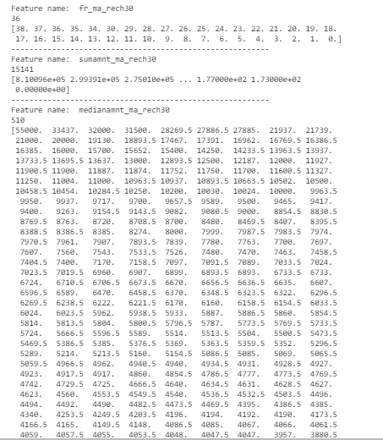

**The feature fr_ma_rech30 has a total of 36 unique values. The minimum and maximum are 0 and 38 respectively as being the frequency of main account recharged in last 30 days.**

**The feature sumamnt_ma_rech30 has a total of 15141 unique values. The minimum and maximum are 0 and 810.096 respectively as being the total amount of recharge in main account over last 30 days (in Indonesian Rupiah).**

**The feature medianamnt_ma_rech30 has a total of 510 unique values. The minimum and maximum are 0 and 55k respectively as being the Median of amount of recharges done in main account over last 30 days at user level (in Indonesian Rupiah).**

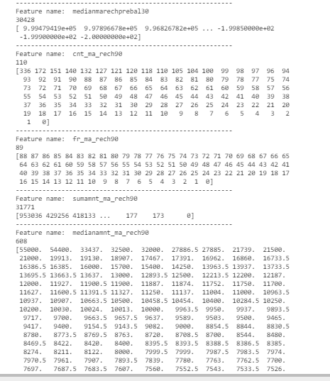

**The feature medianmarechprebal30 has a total of 30.428 unique values. The minimum and maximum are -2 and 999.479 respectively as being the median of main account balance just before recharge in last 30 days at user level (in Indonesian Rupiah).**

**The feature cnt_ma_rech90 has a total of 110 unique values. The minimum and maximum are -2 and 999.479 respectively as being the number of times main account got recharged in last 90 days.**

**The feature fr_ma_rech90 has a total of 89 unique values. The minimum and maximum are 0 and 88 respectively as being the frequency of main account recharged in last 90 days.**

**The feature sumamnt_ma_rech90 has a total of 31.771 unique values. The minimum and maximum are 0 and 953.036 respectively as being the total amount of recharge in main account over last 90 days (in Indonasian Rupiah).**

**The feature medianamnt_ma_rech90 has a total of 608 unique values. The minimum and maximum are 0 and 55k respectively as being the median of amount of recharges done in main account over last 90 days at user level (in Indonasian Rupiah).**

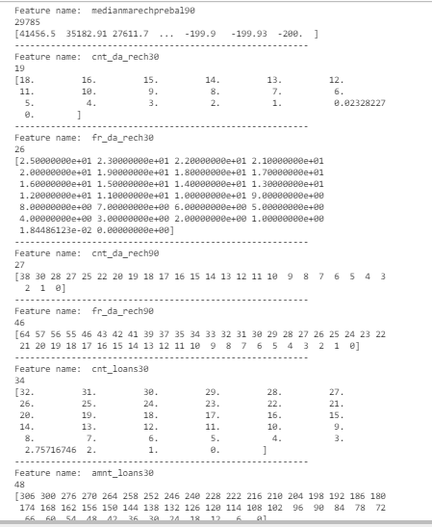

**The feature medianmarechprebal90 has a total of 29.785 unique values. The minimum and maximum are -200 and 41.456 respectively as being the median of main account balance just before recharge in last 90 days at user level (in Indonasian Rupiah)**

**The feature cnt_da_rech30 and cnt_da_rech90 has a total of 19 and 27 unique values. The minimum and maximum of cnt_da_rech30 are 0 and 18 respectively as being the number of times data account got recharged in last 30 days. The minimum and maximum of cnt_da_rech90 are 0 and 38 respectively as being the number of times data account got recharged in last 90 days.**

**The feature fr_da_rech30 and fr_da_rech90 has a total of 26 and 46 unique values. The minimum and maximum of fr_da_rech30 are 0 and 25 respectively as being the frequency of data account recharged in last 30 days. The minimum and maximum of fr_da_rech90 are 0 and 64 respectively as being the frequency of data account recharged in last 90 days.**

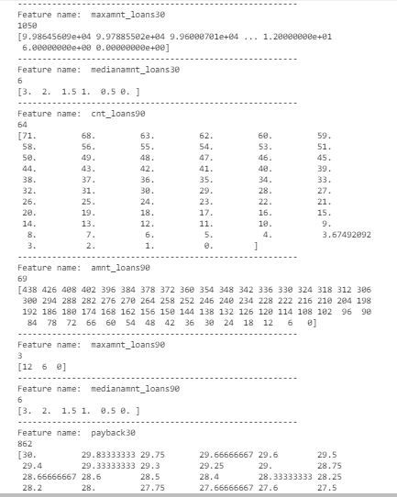

**The feature maxamnt_loans30 has a total of 1050 unique values. The minimum and maximum are 0 and 99.864 respectively as being the maximum amount of loan taken by the user in last 30 days.**

**The feature medianamnt_loans30 has a total of 6 unique values. The minimum and maximum are 0 and 3 respectively as being the median of amounts of loan taken by the user in last 30 days.**

**The feature cnt_loans90 has a total of 64 unique values. The minimum and maximum are 0 and 71 respectively as being the number of loans taken by user in last 90 days.**

**The feature amnt_loans90 has a total of 69 unique values. The minimum and maximum are 0 and 438 respectively as being the total amount of loans taken by user in last 90 days.**

**The feature maxamnt_loans90 has a total of 3 unique values. The values are 0, 6 and 12 respectively as being the maximum amount of loan taken by the user in last 90 days.**

**The feature medianamnt_loans90 has a total of 6 unique values. The minimum and maximum are 0 and 3 respectively as being the median of amounts of loan taken by the user in last 90 days.**

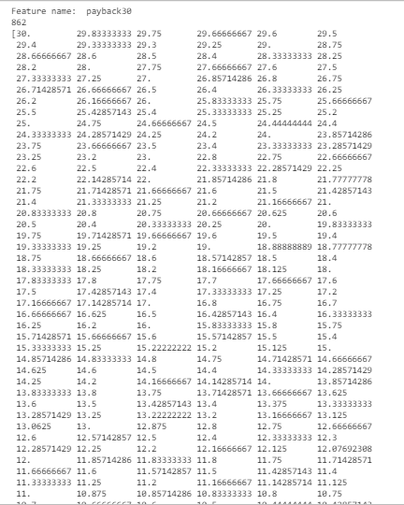

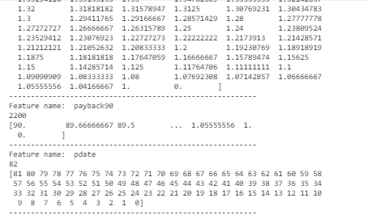

**The feature payback30 has a total of 862 unique values. The minimum and maximum are 0 and 30 respectively as being the average payback time in days over last 30 days.**

**The feature payback90 has a total of 2200 unique values. The minimum and maximum are 0 and 90 respectively as being the average payback time in days over last 90 days.**

**Finally we have a column named pdate which has 82 unique values and starts from minimum of 0 and finish at maximum of 81 payment date.**

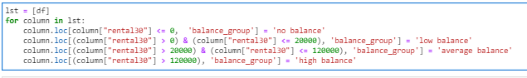

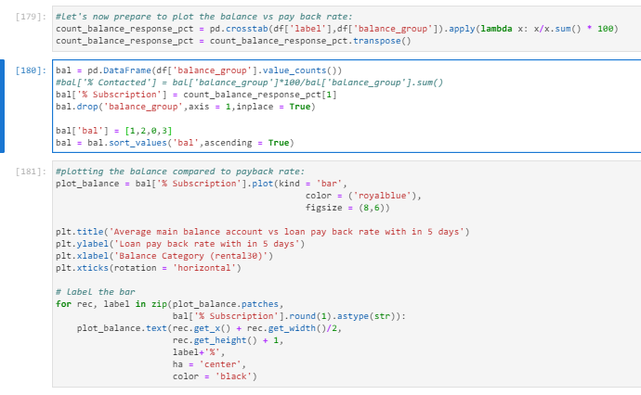

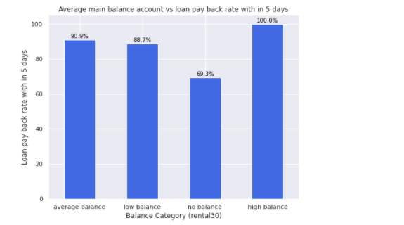

**In the above plot, we can see clearly that we have more accounts with high balance compared to the loan payback rate. Makes complete sense as the accounts with high balance are likely to more chance to pay back the laon within 5 days and accounts with no balance have the lowest probability to payback the loan. It makes perfect sense!**

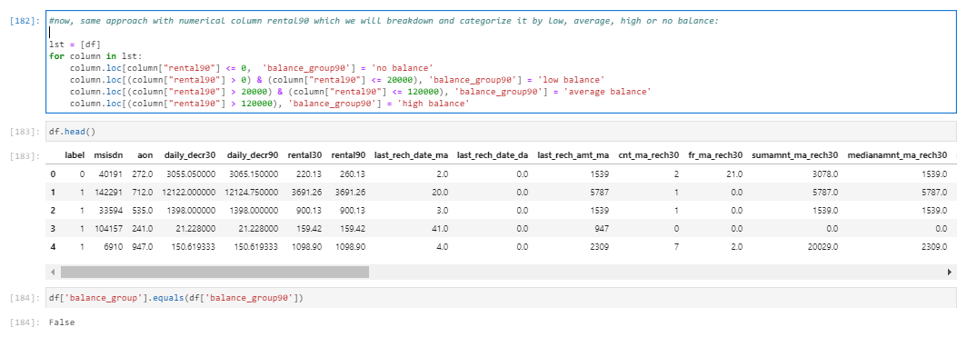

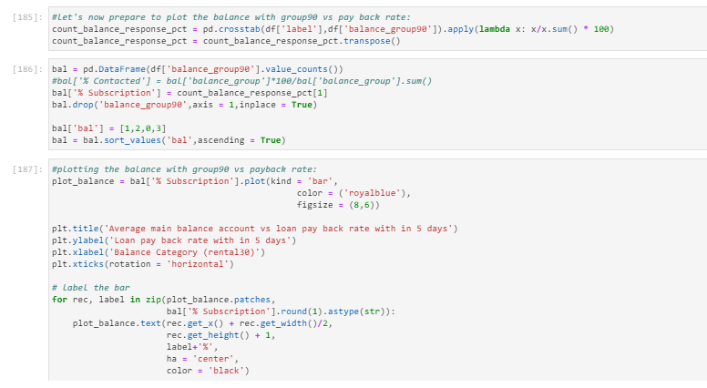

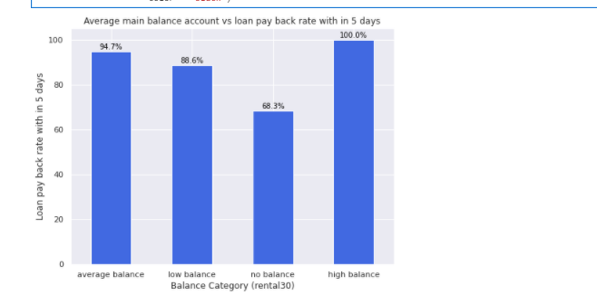

**Looking at the balance for 90 days period, Here seems to be happening the similar case: balance with high amount has more chance to payback the loan compared to the balances with low balance.**

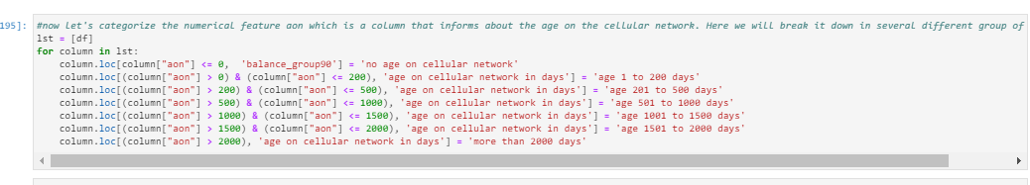

**Daily_decr30 categorized new column:**

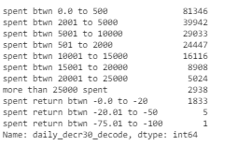

**So, when checking the daily amount spent from main account, averaged over last 30 days (in Indonesian Rupiah), we see that the amount more frequently spend are between 0 and 15k indonesian rupiah. Which means, as expected, less amounts are more frequently spent on daily basis.**

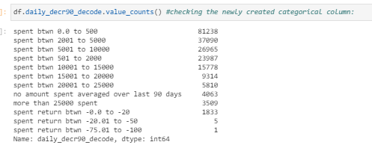

**The same happens with daily_decr90, which states daily amount spent from main account, averaged over last 90 days (in Indonesian Rupiah). So, when checking the daily amount spent from main account, averaged over last 90 days, we see that the amount more frequently spend are between 0 and 15k indonesian rupiah. Which means, as expected, less amounts are more frequently spent on daily basis.**

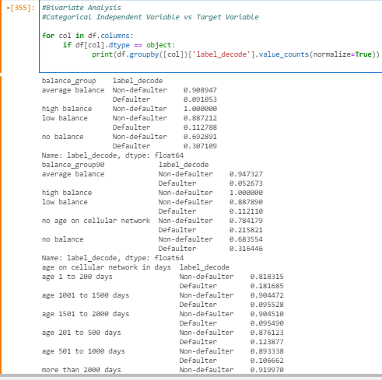

**When checking the relative values of each category by its label_decode, we can mention the following affirmation:**

* **When comparing the balance group, as we can expect, we see that average balance has the lowest defaulter proportion of loan cases and the client with no balance have the highest proportion of loan default cases. And obvious, clients with high balance has no default case at all. We see 100% of the clients with high balance are non-defaulter.**
* **When comparing the balance_group90, we can conclude the same previous.**
* **When checking the age on cellular network in days, we see that having an age of cellular between 1 and 200 days, these clients are more frequent to default compared to others. And on the other hand, clients with cellular aged more than 2000 days are are the clients with lowest default rate. So, we can say that the higher is the age of cellular, less is the probability to be default.**

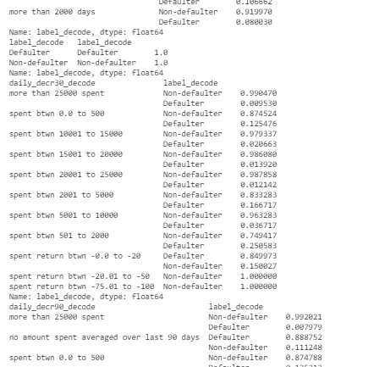

* **When comparing the daily_decr30 with our label, we see the highest defaulters are the clients whose Daily amount spent from main account, averaged over last 30 days is between 501 and 2000 Indonesian Rupiah at default rate of 25%. And the client to be default with lowest rate is the client whose spent is more than 25k per day and the lowest rate is 0.95%.**

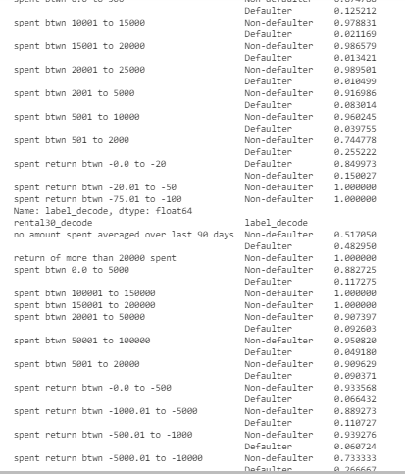

* **The same happens when comparing the daily_decr90 with our label, we see the highest defaulters are the clients whose Daily amount spent from main account, averaged over last 90 days is between 501 and 2000 Indonesian Rupiah and the corresponding rate is 25,52%. And the client to be default with lowest rate is the client whose spent is more than 25k per day and which is around 0.79%**
* **We also see that the rental30, which represents the average main account balance over last 30 days, shows that the client with no amount spent over the last 30 days is 48,29% to likely to be default and 51,70% not likely to be defaulter. And clients with spent between 0 and 5k are more likely to be defaulter compared to others groups with a defaulter rate of 9,2% when comparing clients with positive amounts of spent.**
* **But when also includes the groups of clients with negative spend, we can say that the groups with lowest defaulter rate is the group of clients whose spent is between -500 and -1000 indonesian rupiah.**

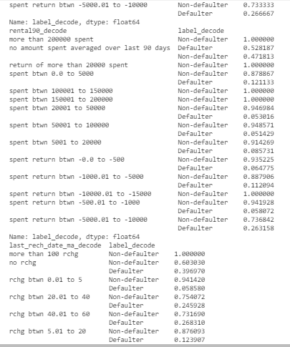

* **When comparing the rental90, which represents the average main account balance over last 90 days, shows that the client with no amount spent over the last 90 days is 52,81% likely to be default and 47,18% not likely to be defaulter. And clients with no spent are more likely to be defaulter compared to others groups with a defaulter rate of 52,81% when comparing the clients with high probability to default.**
* **.When checking the last_rech_date_ma, which means the number of days till last recharge of main account, we see that the clients with oldest recharge, which is recharge over more than 100 days, have no default chance at all. And clients who did not recharge at all their accounts, have a default rate of 39,69%**
* **When comparing the rate of recharges from 0 to 60 days, we see the highest rate of default goes to the group whose recharge happened between days 40 and 60 and the rate is 26,83% as the probability of being default.**

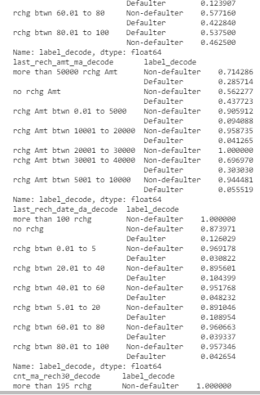

* **.When checking the last_rech_date_ma, and comparing the rate of recharges from 60 to 100 days, we see the highest rate of default goes to the group whose recharge happened between days 80 and 100 and the rate is 53,75% as the probability of being default.**
* **When comparing the last_rech_amt_ma, we can notice the group with highest probability to default is the group composed by clients who do not recharge at all and the lowest probability of default is for the group whose recharge is between 10k and 20k.**
* **Here the non defaulter highlighted group is the people whose recharge amount is between 10k and 30k with a corresponding rate 95,87% and 69,69% respectively.**
* **When comparing the last_rech_date_da, which represents Number of days till last recharge of data account, here we can notice the group with highest probability to default is the group composed by clients who do not recharge at all and the lowest probability of default is for the group whose recharge is between 0 and 5.**
* **Here as the non defaulter, we need to highlight the clients whose data account has more than 100 of recharges and also need to mention the clients with a recharge between 0 and 5 at all and a corresponding rate 100% and 96,91% respectively.**

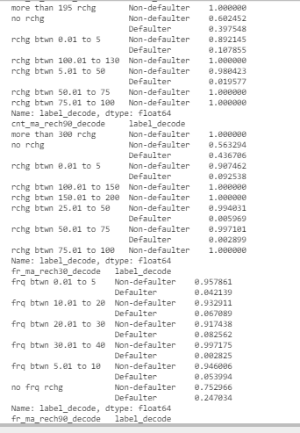

* **When checking the cnt_ma_rech30, we can check that the highest rate of default goes to group of people who has recharged 0 number of times the main account in last 30 days and the minimum rate of default goes to the group of people whose main account got recharged between 5 and 50 number of times in the last 30 days.**
* **The other thing we can highlight here is that we have several group of clients whose has never been default such as people with more than 195 number of times the main account got recharged in the last 30 days and also the group of people whose main account got recharged from 50 to 310 times.**
* **When checking the cnt_ma_rech90, we can check that the highest rate of default goes to group of people who has recharged 0 number of times the main account in last 90 days and the minimum rate of default goes to the group of people whose main account got recharged between 50 and 75 number of times in the last 90 days.**
* **The other thing we can highlight here is that we have several group of clients whose has never been default such as people with more than 300 number of times the main account got recharged in the last 90 days and also the group of people whose main account got recharged from 75 to 200 times.**
* **If we check the relative values of the feature fr_ma_rech30, we can highlight that the highest rate of default goes to the group of client whose had no frequency of main account recharged in last 30 days with a probability rate of 24,70% and the lowest default rate goes to the group of clients whose frequency was between 30 and 40 of main account being recharged in the last 30 days.**
* **And if we check the non defaulter side, we can say that the highest position goes to clients whose frecuency was between 30 and 40 of main account being recharged in the last 30 days ,**

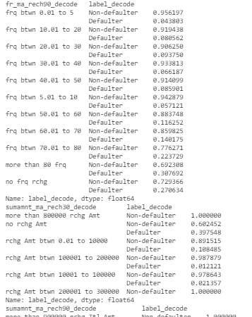

* **When comparing the fr_ma_rech90, we can say that the highest rate of default goes to clients who has been more than 80 times frequent in getting their main account recharged in last 90 days and this rate is 30,7% and also the clients who has been 0 frequent in getting their main account recharged in last 90 days. And regarding the lowest rate of default, we can say that it goes to clients who has been frequent between 0 to 5 in getting their main account recharged in last 30 days and this rate is 4,3%.**
* **And we can also notice that the client with highest rate of non-defaulter are the clients who has been 0 to 5 times frequent in getting their main account recharged in last 90 days and with a rate of 95,61%. Then, when checking the lowest rate for non-defaulter, we see that it goes to the clients with more than 80 frequencies in getting their main account recharged in last 90 days.**
* **If we check the feature sumamnt_ma_rech30, we can check the highest rate of being default goes to the users who has no total amount of recharge in main account over last 30 days (in Indonesian Rupiah) and the lowest rate of being default goes to the users whose total amount recharge of main account was between 10k and 100k Indonesian rupiah over the last 30 days.**
* **Then, we also need to mention that users with total amount of recharge in main account between 200k and 300k and recharge of more than 800k over the last 30 days are the two groups where the non default rate is 100%**

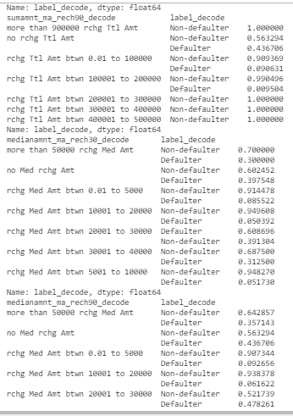

* **If we check the feature sumamnt_ma_rech90, we can check the highest rate of being default goes to the users who has no total amount of recharge in main account over last 90 days (in Indonesian Rupiah) and the lowest rate of being default goes to the users whose total amount recharge of main account was between 100k and 200k Indonesian rupiah over the last 90 days.**
* **Then, we also need to mention that users with total amount of recharge in main account between 200k and 500k and recharge of more than 900k over the last 90 days are the two groups where the non-default rate is 100%**
* **When checking the feature medianamnt_ma_rech30, we see the highest rate of being default goes to users who has a median of amount of recharges done in main account over last 30 days at user level of recharge between 20k and 30k in Indonesian Rupiah and the lowest rate of default goes to user whose median of amount of recharges done in main account over last 30 days at user level is between 10k and 20k.**
* **And we need to mention that as non-defaulter when checking the feature medianamnt_ma_rech30, we see the highest rate of being non default goes to users who has a median of amount of recharges done in main account over last 30 days at user level of recharge between 10k and 20k in Indonesian Rupiah and the lowest rate of non default goes to user whose median of amount of recharges done in main account over last 30 days at user level is between 20k and 30k.**

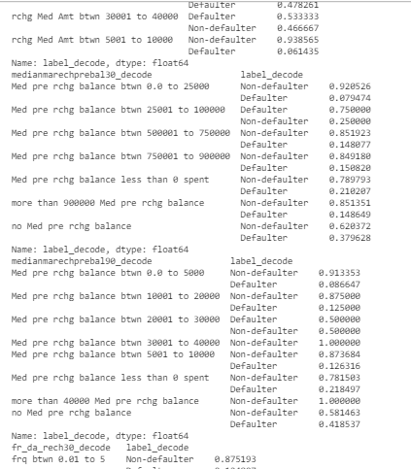

* **So when checking the feature medianamnt_ma_rech90, we see the highest default rate is for users who has a median of amount of recharges done in main account over last 90 days at user level of recharge between 30k and 40k in Indonesian Rupiah and we see the lowest default rate is for users who has a median of amount of recharges done in main account over last 90 days at user level of recharge between 5k and 10k in Indonesian Rupiah.**
* **We can also highlight that users who has a median of amount of recharges done in main account over last 90 days at user level of recharge between 30k and 40k has the lowest non defaulter rate and the users who has a median of amount of recharges done in main account over last 90 days at user level of recharge between 5k and 10k has the highest non defaulter rate.**
* **When checking the medianmarechprebal30, we see the highest rate of default rate goes to the users whose median of main account balance just before recharge in last 30 days at user level is between 25k and 100k in Indonesian Rupiah. And we also see the lowest rate of default rate goes to the users whose median of main account balance just before recharge in last 30 days at user level is between 0k and 25k in Indonesian Rupiah.**
* **We also need to mention that the users whose median of main account balance just before recharge in last 30 days at user level is between 25k and 100k has the lowest non defaulter rate and the users whose median of main account balance just before recharge in last 30 days at user level is between 0k and 25k has the highest non defaulter rate.**
* **When checking the medianmarechprebal90, we see the highest rate of default rate goes to the users whose median of main account balance just before recharge in last 90 days at user level is between 20k and 30k in Indonesian Rupiah. And we also see the lowest rate of default rate goes to the users whose median of main account balance just before recharge in last 90 days at user level is between 0k and 5k in Indonesian Rupiah.**
* **We also need to mention that the users whose median of main account balance just before recharge in last 90 days at user level is more than 30k has the highest non defaulter rate.**

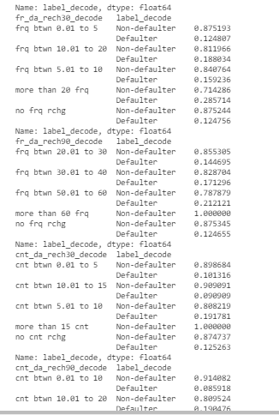

* **When checking the fr_da_rech30, we see the highest rate of default rate goes to the users whose frequency of data account recharged in last 30 days is more than 20. And we also see the lowest rate of default rate goes to the users who has 0 frequency of data account recharged in last 30 days .**
* **We also need to mention that the users whose frequency of data account recharged in last 30 days is more than 20 frecuencies has the lowest non defaulter rate and users whose frequency of data account recharged in last 30 days is 0 frequencies has the highest non defaulter rate.**
* **Checking the feature cnt_da_rech30, we can say that the highest rate of default rate goes to the users whose Number of times data account got recharged in last 30 days is between 5 and 10. And we also see the lowest rate of default rate goes to the users whose Number of times data account got recharged in last 30 days is between 10 to 15.**
* **We also need to mention that the users whose Number of times data account got recharged in last 30 days is more than 15 has the highest non defaulter rate.**

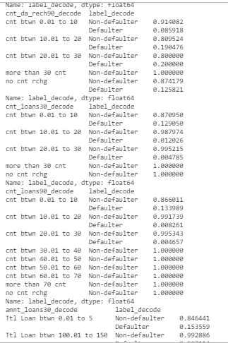

* **Checking the feature cnt_da_rech90, we can say that the highest rate of default rate goes to the users whose Number of times data account got recharged in last 90 days is between 20 and 30. And we also see the lowest rate of default rate goes to the users whose Number of times data account got recharged in last 90 days is between 1 to 10.**
* **We also need to mention that the users whose Number of times data account got recharged in last 90 days is more than 30 has the highest non defaulter rate which is 100%.**
* **For feature cnt_loans90, we can highlight that Number of loans higher than 30 taken by user in last 90 days have a non-default rate of 100%. (this is not ok, bt ok)**

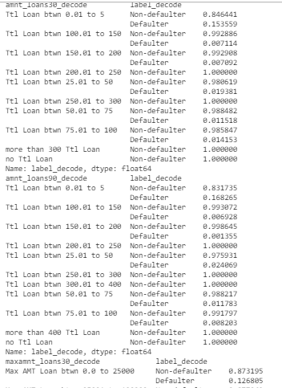

* **When checking the loan data by feature amnt_loans30, Here we should say that the highest default rate goes to the users who have asked for loan between 0 and 5. But if we compare its default rate to its non default rate we can see the non default rate is higher, hence the loan should be paid without issue. (84%>15%)**
* **And again, when checking the loan data by feature amnt_loans30, Here we should say that the lowest default rate goes to the users who have asked for loan between 150 and 200. But if we compare its default rate to its non default rate we can see the non default rate is higher, hence the loan should be paid without issue. (99%>0.7%)**
* **And then, we also have cases where the non default occurs 100% which are the cases where we have no amount asked for loan.**
* **Feature amnt_loans90 works similar way as amnt_loans30.**

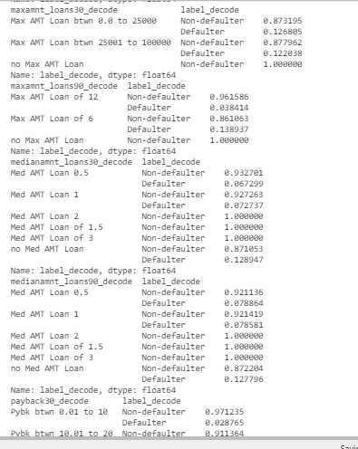

* **For medianamnt_loans30 and medianamnt_loans90, we have similar pattern in both, we can see the highest defaulter goes to users who haven’t asked for Median of amounts of loan taken by the user in last 30 days (weird***). But what is true is that in both features, the cusers with median of amount of loan taken between 1.5 and 3 have normally 100% of non defaulter.**
* **The previous weird*** say can be resolved and understood in the following way: the no medium amount have more probability to be non defaulter than being defaulter. Now it should make sense.**

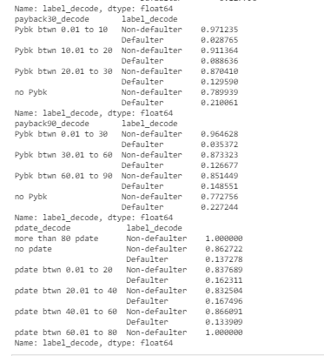

* **So, when checking the features payback30 and payback90, we can notice the highest default rate goes to NO PAYBACK time category which is correct and makes FULL sense because there is no payback time.**
* **Then, we can also highlight that the lowest default rate in both features is when the payback time is between 0 and 10 which is the shortest payback time when some kind of payback time, which is interesting having the lowest default rate compared to other higher average payback time.**
* **Then, we also need to add that regarding the non-defaulter rate for both features payback30 and payback90, we can say that the highest non defaulter rate goes to the users whose payback average time is between 0 and 10 and 0 and 30 respectively.**
* **Finally, regarding the pdate, we can say that the highest default rate goes to pdate between 20 and 40 and the lowest goes to pdate between 40 and 60 days. We need to add that regarding the non default rate, the categories which wins the highest rate are the pdates 60 onwards.**

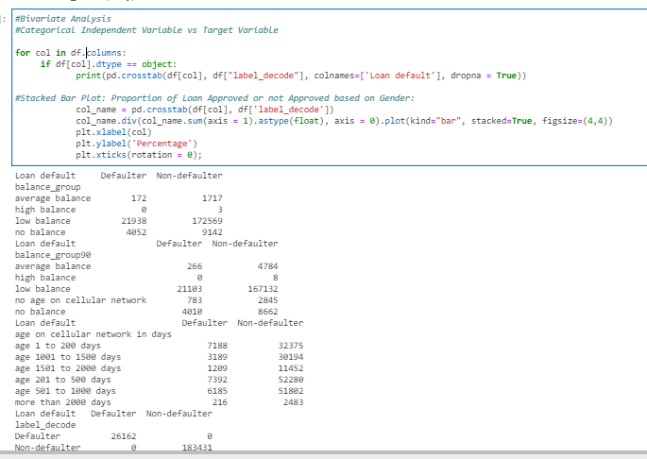

**First thing first, as always we have more cases of non defaulter than defaulter cases.**

**So, from the above screenshot we can see that when checking the balance_group, the low balance have the most of the cases, a total of 21938 out of total defaulter cases (172+21938+4052) which is around 83,85% of the total defaulter cases in the balance group30. Happens the same with non defaulter, around 99% of the non defaulter cases is for low balance clients.**

**And if we check the balance group90, we have the same pattern which is that the low balance have the most of the defaulter and also non defaulter cases.**

**When checking the cellular age, we can see from the total defaulter cases, 57,44% of thedefaulter cases are for cell phone ages from 1 to 500 days. Regarding the non defaulter cases, we can say that 57,63% of the cases are for cell phone ages between 200 and 1000 days.**

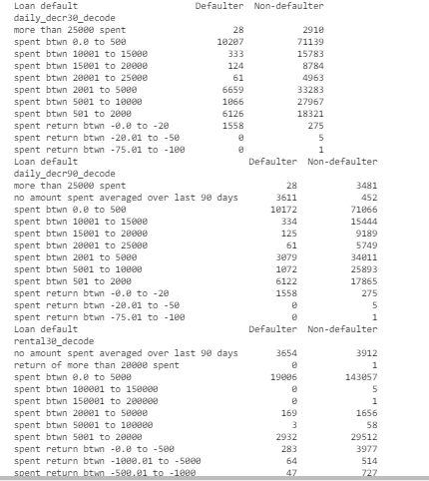

**When checking the daily_decr30 and daily_decr90, we see that the group with highest daily amount spent from main account, averaged over last 30 days or 90days in both defaulter and non defaulter cases is when the daily amount spent from main account, averaged over last 30 days or 90 days is between 0 and 500 which make sense as it is more common to have less daily amount spent compared to others higher daily spent which may happen occasionally.**

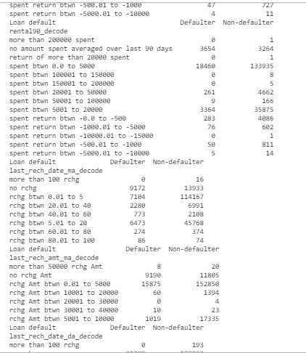

**Same happens with features rental 30 and rental 90, that the highest number of default and non defaulter cases is when the average main account balance over last 30 days or over 90 days is between 0 and 5k Indonesian rupiah.**

**And when checking the last_rech_date_ma feature, we can see that highest defaulter case is when the number of days till last recharge of main account is 0. And regarding the non defaulter cases, we can say that the highest number of non defaulter cases is when the number of days till last recharge of main account is between 0 and 5 days.**

**And when checking the last_rech_amt_ma, we can see that the highest number of defaulter and non-defaulter cases is when the amount of last recharge of main account is between 0 to 5k in Indonesian Rupiah.**



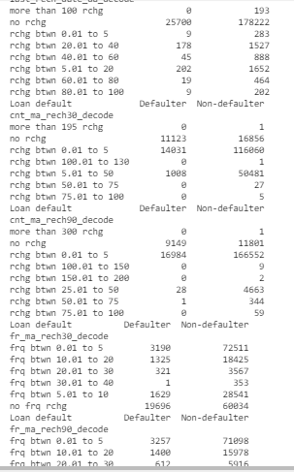

**When checking the feature last_rech_date_da, we can say that the highest number of cases of defaulter and non-defaulter is when there is 0 number of days till last recharge of data account.**

**When checking the feature cnt_ma_rech30, we can say that the highest number of cases of defaulter and non-defaulter is when Number of times main account got recharged in last 30 days is between 0 and 5.**

**When checking the feature cnt_ma_rech90, we can say that the highest number of cases of defaulter and non-defaulter is when Number of times main account got recharged in last 90 days is between 0 and 5.**

**When checking the feature fr_ma_rech30, we can say that the highest number of cases of defaulter is when Frequency of main account recharged in last 30 days is 0 and the highest number of cases of a non defaulter is when Frequency of main account recharged in last 30 days is from 0 and 5 frequencies.**

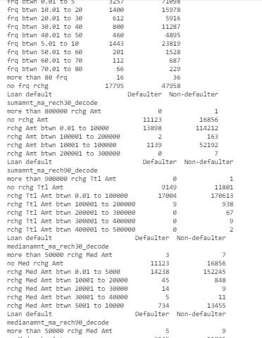

**When checking the feature fr_ma_rech90, we can say that the highest number of cases of defaulter is when Frequency of main account recharged in last 90 days is 0 and the highest number of cases of a non defaulter is when Frequency of main account recharged in last 90 days is from 0 and 5 frequencies.**

**When checking the feature sumamnt_ma_rech30, we can say that the highest number defaulter and non defaulter cases is when Total amount of recharge in main account over last 30 days is between 0 and 10k Indonesian rupiah.**

**When checking the feature sumamnt_ma_rech90, we can say that the highest number defaulter and non defaulter cases is when Total amount of recharge in main account over last 90 days is between 0 and 100k Indonesian rupiah.**

**When checking the feature medianamnt_ma_rech30, we can say that the highest number defaulter and non defaulter cases is when Median of amount of recharges done in main account over last 30 days at user level is between 0 and 5k Indonesian rupiah.**

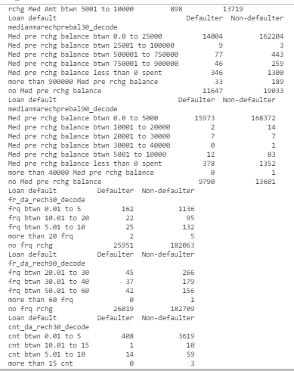

**When checking the features medianmarechprebal30 , we can say that the highest number defaulter and non defaulter cases is when Median of main account balance just before recharge in last 30 days at user level is between 0 and 25k Indonesian rupiah.**

**When checking the features medianmarechprebal90, we can say that the highest number defaulter and non defaulter cases is when Median of main account balance just before recharge in last 90 days at user level is between 0 and 5k Indonesian rupiah.**

**When checking the features fr_da_rech30 and fr_da_rech90, we can say that the highest number defaulter and non defaulter cases is when Frequency of data account recharged in last 30 days or 90 days is 0.**

**When checking the features cnt_da_rech30, we can say that the highest number defaulter and non defaulter cases is when Number of times data account got recharged in last 30 days is 0.**

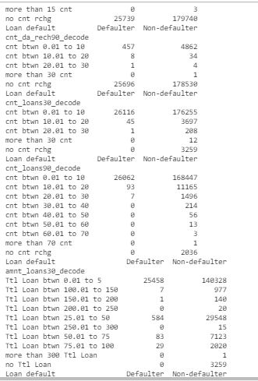

**When checking the features cnt_da_rech90, we can say that the highest number defaulter and non defaulter cases is when Number of times data account got recharged in last 90 days is 0.**

**When checking the features cnt_loans30 and cnt_loans90, we can say that the highest number of defaulter and non defaulter cases is when Number of loans taken by user in last 30 days or 90 days is between 0 and 10.**

**When checking the features amnt_loans30 and amnt_loans90, we can say that the highest number of defaulter and non defaulter cases is when Total amount of loans taken by user in last 30 days or 90 days is between 0 and 5.**

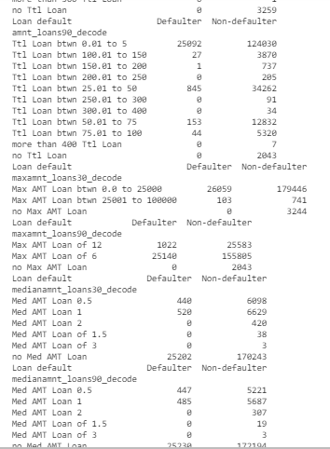

**When checking the features maxamnt_loans30 and maxamnt_loans90, we can say that the highest number of defaulter and non defaulter cases is when maximum amount of loan taken by the user in last 30 days is between 0 and 25k in case of maxamnt_loans30. And when maximum amount of loan taken by the user in last 90 days is max loan amount of 6 in case of maxamnt_loans90.**

**When checking the features mediaamnt_loans30, we can say that the highest number of defaulter and non defaulter cases is when Median of amounts of loan taken by the user in last 30 days is 0.**

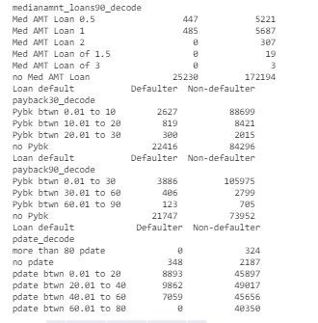

**When checking the features mediaamnt_loans90, we can say that the highest number of defaulter and non defaulter cases is when Median of amounts of loan taken by the user in last 90 days is 0.**

**The above conslusions can be easily seen throughout the following bar plots:**

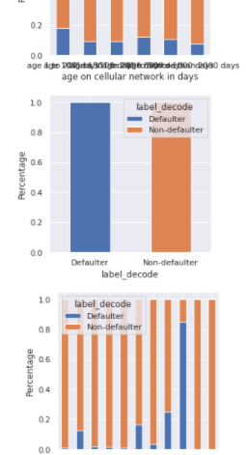

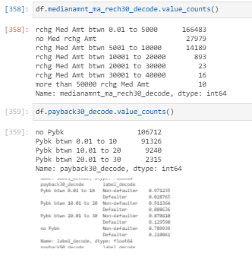

**When checking the medianamnt_ma_rech30, we can see that the highest number of counts of Median of amount of recharges done in main account over last 30 days at user level (in Indonesian Rupiah) is for amount between 0 and 5k.**

**When checking the payback30, we can see that the highest number of counts of average payback time in days over last 30 days level (in Indonesian Rupiah) is for no payback30.**

Let’s plot and check the relation between each feature:

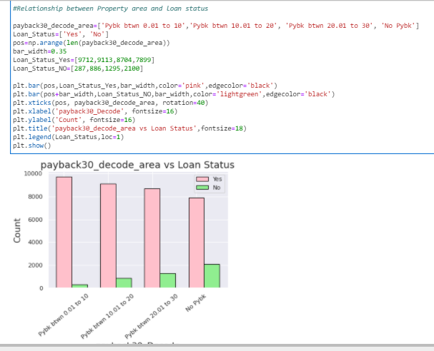

**We can easily see in the above plot that we have way more cases of non defaulter than defaulter. But checking the non defaulter counts, we can notice the no payback has more cases. And when we have some kind of period for payback, we see the defaulter cases increases as large as the payback period is.**

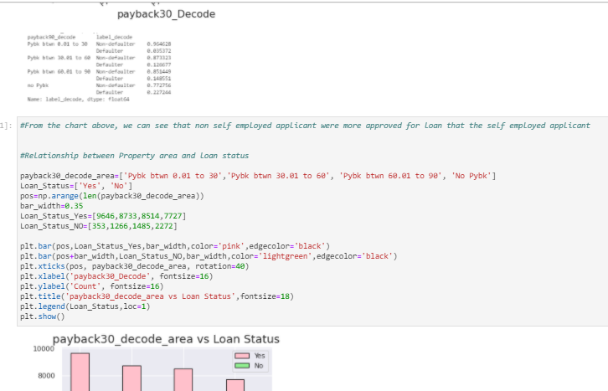

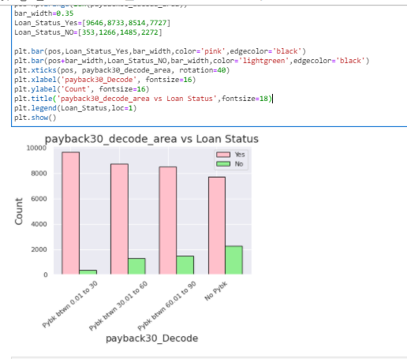

**We can easily see in the above plot that we have way more cases of non defaulter than defaulter. But checking the non defaulter counts, we can notice the no payback has more cases. And when we have some kind of period for payback, we see the defaulter cases increases as large as the payback period is.**

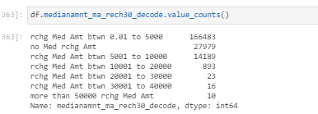

**When checking the medianamnt_ma_rech30, we can see that the highest number of counts of Median of amount of recharges done in main account over last 30 days at user level (in Indonesian Rupiah) is for amount between 0 and 5k.**

**When checking the payback30, we can see that the highest number of counts of average payback time in days over last 30 days level (in Indonesian Rupiah) is for no payback30.**

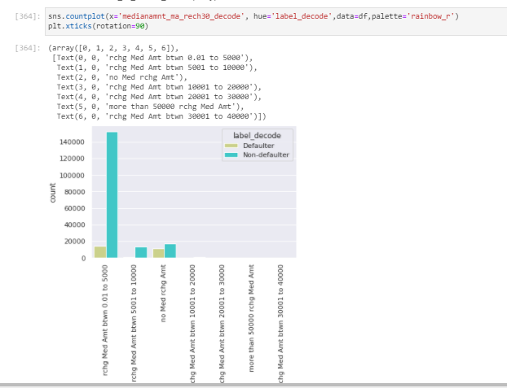

**In the above plot we can see the non defaulter with highest number of cases is for when Median of amount of recharges done in main account over last 30 days at user level is between 0 to 5k in Indonesian Rupiah)**

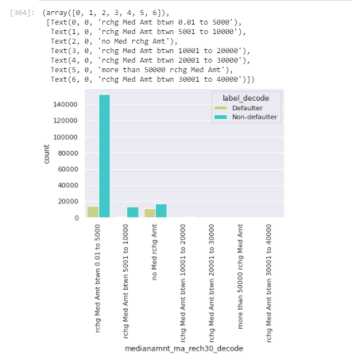

**In the above barplot we can clearly see the highest non defaulter cases are for when Median of amount of recharges done in main account over last 30 days at user level is between 0 to 5k in Indonesian Rupiah)**

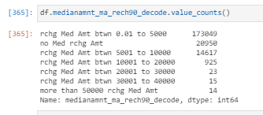

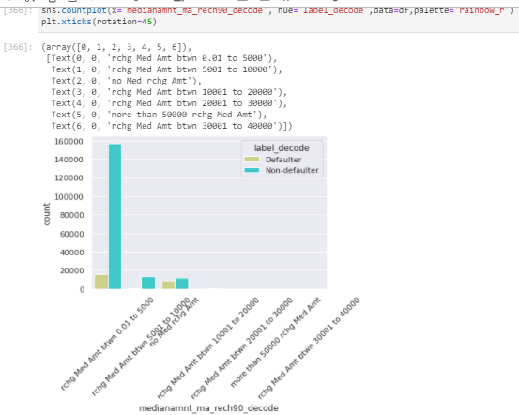

**In the above barplot we can clearly see the highest non defaulter cases are for when Median of amount of recharges done in main account over last 90 days at user level is between 0 to 5k in Indonesian Rupiah)**

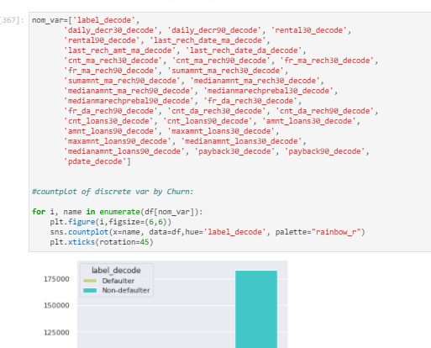

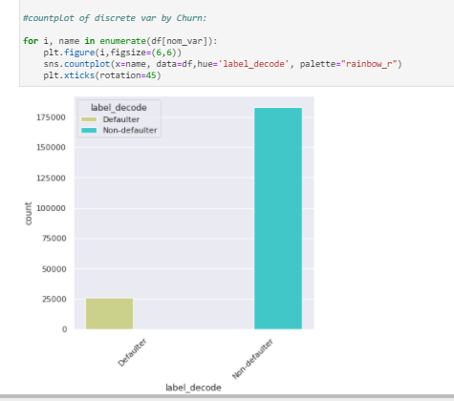

**Here we clearly see the non defaulter cases are way higher than the defaulter cases.**

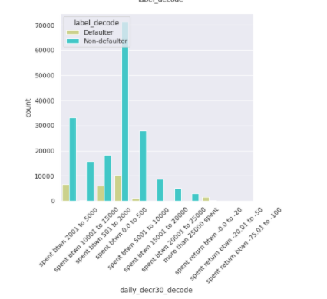

**In the above daily_decr30 plot, we can easily see that Daily amount spent from main account, averaged over last 30 days between 0 and 500 Indonesian Rupiah have the highest counts of defaulter and non-defaulter cases.**

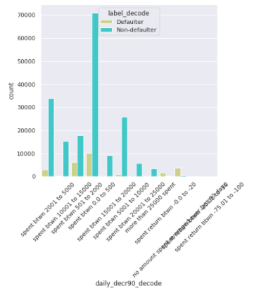

**In the above daily_decr90 plot, we can easily see that Daily amount spent from main account, averaged over last 90 days between 0 and 500 Indonesian Rupiah have the highest counts of defaulter and non-defaulter cases.**

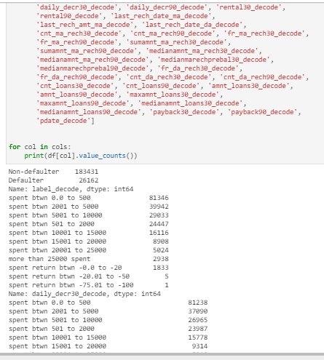

**OK, above we can see the highest cases goes to non-defaulter when comparing it to defaulter cases.**

**In case of daily_decr30 and daily_decr90 , we see the highest cases goes to when Daily amount spent from main account, averaged over last 30 days or 90 days is between 0 and 500 Indonesian Rupiah.**

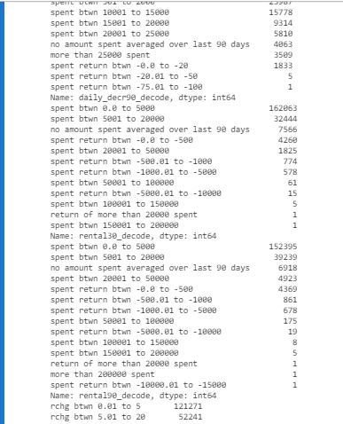

**In case of daily_decr90, we see the lowest cases goes to when Daily amount spent from main account, averaged over last 90 days is below 0 Indonesian Rupiah.**

**In case of renatal30 and rental90, we see the highest cases goes to when Average main account balance over last 30 days is between 0 and 5000 Indonesian Rupiah.**

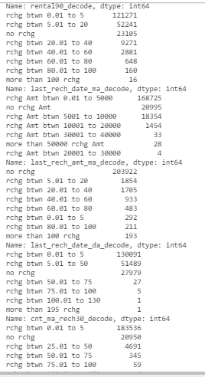

**In case of last_rech_date_ma and last_rech_amt_ma, we see the highest cases goes to when Number of days till last recharge of main account is between 0 and 5 days and also when Amount of last recharge of main account is between 0 and 5000 in Indonesian Rupiah. And if we refer to the lowest counts, it goes to when Number of days till last recharge of main account is more than 100 days and also when the Amount of last recharge of main account is more than 20k Indonesian Rupiah.**

**When talking about last_rech_date_da , we can say that the highest cases ggoes to when there is no Number of days till last recharge of data account and the lowest count goes to when there are more than 100 days till last recharge of data account.**

**When talking about cnt_ma_rech30 and cnt_ma_rech90 , we can say that the highest cases goes to when we have between 0 and 5 the number of times main account got recharged in last 30 days or 90 days and the lowest count goes to when there are more than 75 the number of times main account got recharged in last 30 days or more than 100 times when main account got recharged in last 90 days.**

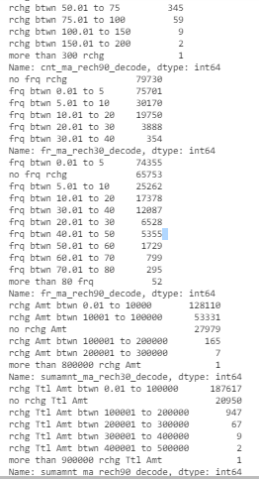

**When talking about fr_ma_rech30 and fr_ma_rech90 , we can say that the highest cases goes to when there is no Frequency of main account recharged in last 30 days or the frequency is between 0 and 5 as for frequency of main account recharged in last 90 days and the lowest count goes to when there are more than 80 Frequency of main account recharged in last 90 days or frequencies between 30 and 40 as for frequency of main account recharged in last 30 days.**

**When talking about sumamnt_ma_rech30, we can say that the highest cases goes to when there is Total amount of recharge between 0 and 10k Indonesian Rupiah in main account over last 30 days and the lowest count goes to when there are more than 800k Indonesian Rupiah in main account over last 30 days.**

**When talking about sumamnt_ma_rech90, we can say that the highest cases goes to when there is Total amount of recharge between 0 and 100k Indonesian Rupiah in main account over last 90 days and the lowest count goes to when there are more than 300k Indonesian Rupiah in main account over last 90 days.**

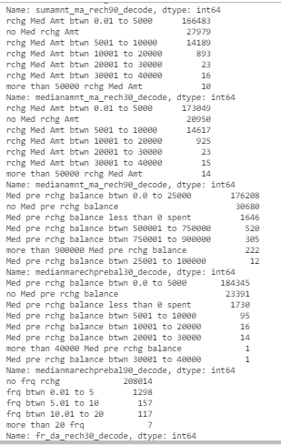

**When talking about medianamnt_ma_rech30 and medianamnt_ma_rech90 , we can say that the highest cases goes to when there is Median of amount of recharges done in main account over last 30 or 90 days at user level is between 0 and 5k Indonesian Rupiah and the lowest count goes to when there are more than 20k Indonesian Rupiah as Median of amount of recharges done in main account over last 30 or 90 days at user level.**

**When talking about medianmarechprebal30, we can say that the highest cases goes to when there is Median of main account balance is between 0 and 25k just before recharge in last 30 days at user level and the lowest count goes to when there is Median of main account balance is between 25k and 100k just before recharge in last 30 days at user level.**

**When talking about medianmarechprebal90, we can say that the highest cases goes to when there is Median of main account balance is between 0 and 5k just before recharge in last 90 days at user level and the lowest count goes to when there is Median of main account balance is more than 30k just before recharge in last 90 days at user level.**

**When talking about fr_da_rech30, we can say that the highest cases goes to when there is NO Frequency of data account recharged in last 30 days and the lowest count goes to when there is more than 20 frequencies of data account recharged in last 30 days.**

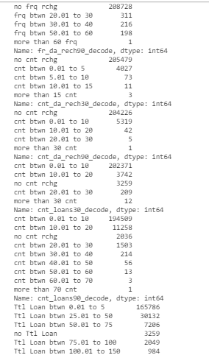

**When talking about fr_da_rech90, we can say that the highest cases goes to when there is NO Frequency of data account recharged in last 90 days and the lowest count goes to when there is more than 60 frequencies of data account recharged in last 90 days.**

**When talking about cnt_da_rech30 and cnt_da_rech90, we can say that the highest cases goes to when there is NO Number of times data account got recharged in last 30 days or 90 days and the lowest count goes to when there is more than 15 number of times data account got recharged in last 30 or 90 days.**

**When talking about cnt_loans30 and cnt_loans90, we can say that the highest cases goes to when the number of loans taken by user in last 30 days is between 0 and 10 and the lowest count goes to when there is more than 30 the number of loans taken by user in last 30 days or more than 70 loans taken by user in last 90 days.**

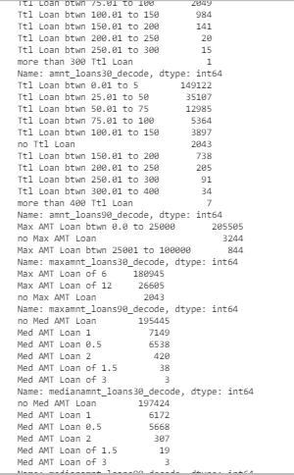

**When talking about amnt_loans30 and amnt_loans90, we can say that the highest cases goes to when the Total amount of loans taken by user in last 30 days is between 0 and 5 and the lowest count goes to when there is more than 300 the Total amount of loans taken by user in last 30 days or more than 400 loans taken by user in last 90 days.**

**When talking about maxamnt_loans30 and maxamnt_loans90, we can say that the highest cases goes to when the maximum amount of loan taken by the user in last 30 days is between 0 and 25k Indonesian rupiah or when the maximum amount of loan taken by the user in last 90 days is 6 and the lowest count goes to when there is more than 25k the maximum amount of loan taken by the user in last 30 days or when there is no maximum amount of loan taken by the user in last 90 days.**

**When talking about medianamnt_loans30 and medianamnt_loans90, we can say that the highest cases goes to when there is no Median of amounts of loan taken by the user in last 30 days or 90 days and the lowest count goes to when there is 3 the Median of amounts of loan taken by the user in last 30 days or 90 days.**

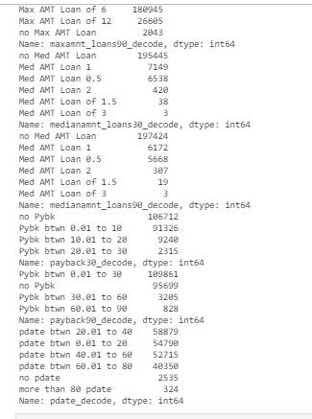

**When talking about medianamnt_loans30 and medianamnt_loans90, we can say that the highest cases goes to when there is no Median of amounts of loan taken by the user in last 30 days or 90 days and the lowest count goes to when there is 3 the Median of amounts of loan taken by the user in last 30 days or 90 days.**

**When talking about payback30 or payback90, we can say that the highest cases goes to when there is NO Average payback time in days over last 30 days or 90 days and the lowest count goes to when there is payback time between 20 and 30 days as Average payback time in days over last 30 days or when there is payback time between 60 and 90 days as Average payback time in days over last 90 days.**

**When talking about pdate, we can say that the highest cases goes to when there is pdate between 20 and 40 days and and the lowest counts goes to pdate with more than 80 pdate.**

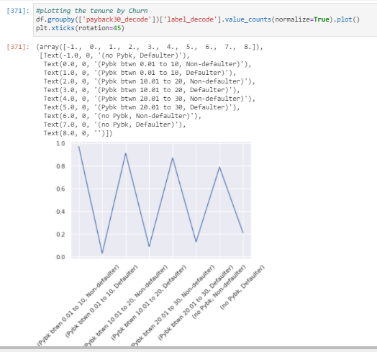

**In above plot we can see that the variation of the proportion of being defaulter and non defaulter is getting reduced when we have larger payback time.**

**We also see the highest proportion of being defaulter or non defaulter is when the payback30 is between 0 and 10. And the proportion gets reduced till it gets no Average payback time in days over last 30 days.**

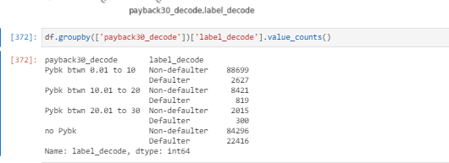

**Here we see the same but in absolute numbers:**

**In above plot we can see that the variation of the proportion of being defaulter and non defaulter is getting reduced when we have larger payback time.**

**We also see the highest proportion of being defaulter or non defaulter is when the payback30 is between 0 and 10. And the proportion gets reduced till it gets no Average payback time in days over last 30 days.**

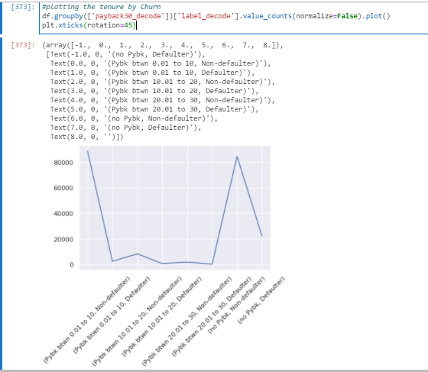

**Here by label, we see clearly that the conclusion make sense:**

**If we check the numbers of defaulters vs non defaulters for each single group of payback30, we can see in the above plot that the highest numbers of cases goes to when the Average payback time in days over last 30 days is between 0 and 10 being non defaulter. And in second place when the Average payback time in days over last 30 days is None in case of non defaulted.**

**We see the other groups have less number of cases, lower then the first 2 peak point.**

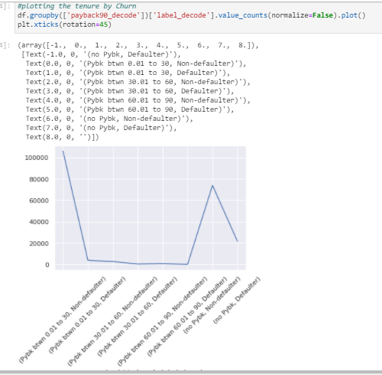

**Here happens something similar to the pattern of payback30:**

**In above plot we can see that the variation of the proportion of being defaulter and non defaulter is getting reduced when we have larger payback time.**

**We also see the highest proportion of being defaulter or non defaulter is when the payback90 is between 0 and 30. And the proportion gets reduced till it gets NO Average payback time in days over last 90 days.**

**Here by label in our plot, we see clearly that the conclusion make sense:**

**If we check the numbers of defaulters vs non defaulters for each single group of payback90, we can see in the above plot that the highest numbers of cases goes to when the Average payback time in days over last 00 days is between 0 and 30 being non defaulter. And in second place when the Average payback time in days over last 90 days is None in case of non defaulted.**

**We see the other groups have less number of cases, lower then the first 2 peak point.**

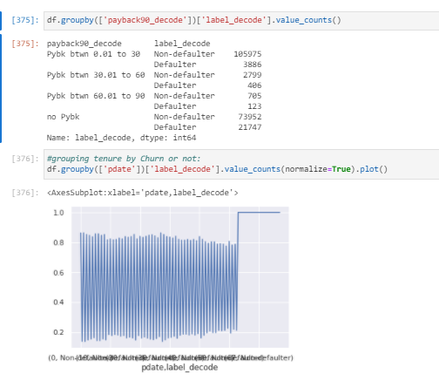

**Here happens something similar to the pattern of payback30:**

**In above plot we can see that the variation of the proportion of being defaulter and non defaulter is getting reduced when we have larger payback time.**

**We also see the highest proportion of being defaulter or non defaulter is when the payback90 is between 0 and 30. And the proportion gets reduced till it gets NO Average payback time in days over last 90 days.**

**Here by label in our plot, we see clearly that the conclusion make sense:**

**If we check the numbers of defaulters vs non defaulters for each single group of payback90, we can see in the above plot that the highest numbers of cases goes to when the Average payback time in days over last 00 days is between 0 and 30 being non defaulter. And in second place when the Average payback time in days over last 90 days is None in case of non defaulted.**

**We see the other groups have less number of cases, lower then the first 2 peak point.**

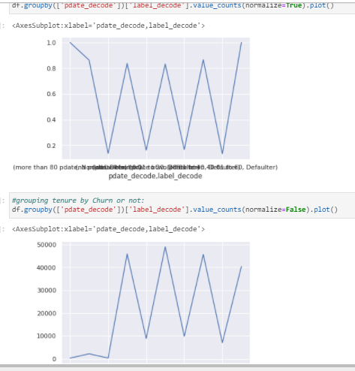

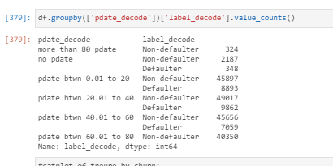

**Okay, so checking the pdate data, we have that:**

**In above plot and absolute numbers, we can see the highest proportion of being defaulter or non defaulter is when the pdate is between 20 and 40 and the lowest proportion of being defaulter or non defaulter is when either the pdate is 0 or more than 80 days.**

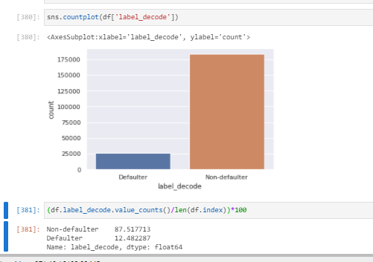

**As we mentioned several times, the non defaulter has way more cases then defaulter as it is normal that most of the clients pay back the loan.**

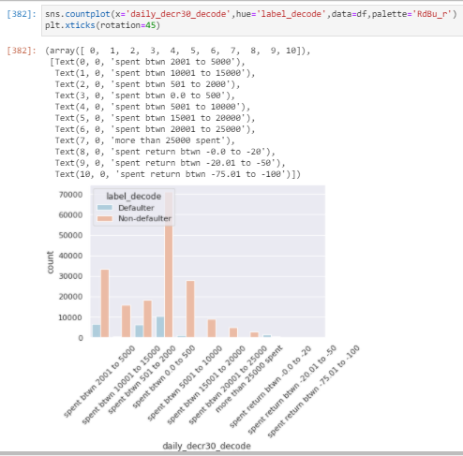

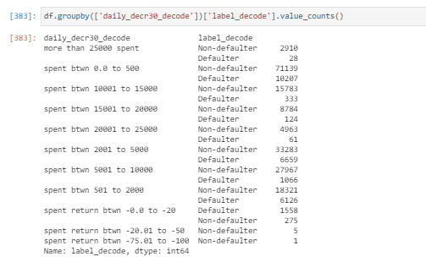

**Okay, so checking the daily_decr30 data and comparing it with our label, we have that:**

**In above plot and absolute numbers, we can see the highest proportion of being defaulter or non defaulter is when the daily_decr30 is between 0 and 500 and the lowest proportion of being defaulter or non defaulter is when either the daily_decr30 is lower than 0 or more than 25000 as the daily amount spent from main account, averaged over last 30 days (in Indonesian Rupiah).**

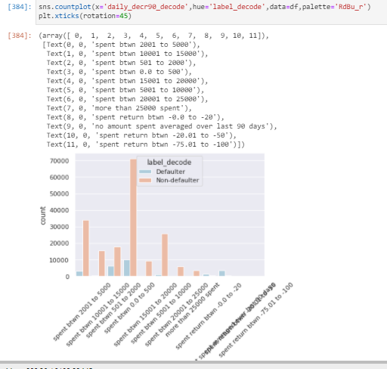

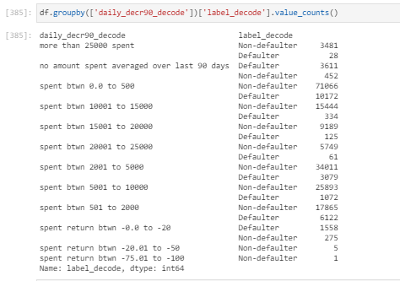

**Here happens something similar to the pattern of daily_decr30.**

**Okay, so checking the daily_decr90 data and comparing it with our label, we have that:**

**In above plot and absolute numbers, we can see the highest proportion of being defaulter or non defaulter is when the daily_decr90 is between 0 and 500 and the lowest proportion of being defaulter or non defaulter is when either the daily_decr90 is lower than 0 or more than 25000 as the daily amount spent from main account, averaged over last 90 days (in Indonesian Rupiah).**

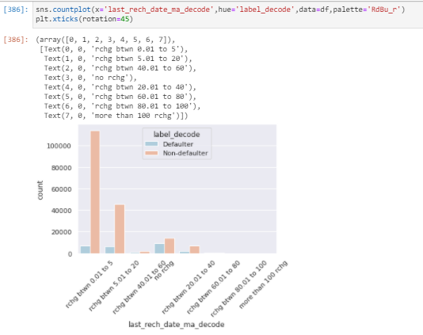

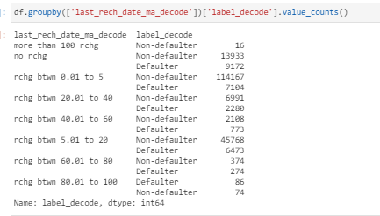

**Okay, so checking the last_rech_date_ma data and comparing it with our label, we have that:**

**In above plot and absolute numbers, we can see the highest proportion of being defaulter or non defaulter is when the last_rech_date_ma is between 0 and 5 and the lowest proportion of being defaulter or non defaulter is when the last_rech_date_ma is more than 100 as the Number of days till last recharge of main account.**

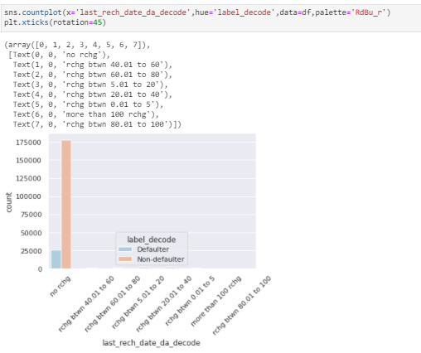

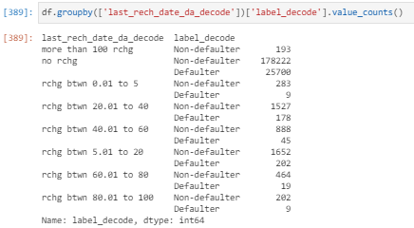

**Okay, so checking the last_rech_date_da data and comparing it with our label, we have that:**

**In above plot and absolute numbers, we can see the highest proportion of being defaulter or non defaulter is when there is NO last_rech_date_da, means the Number of days till last recharge of data account is equal to 0 and the lowest proportion of being defaulter or non defaulter is when the last_rech_date_da is more than 100 as the Number of days till last recharge of data account.**

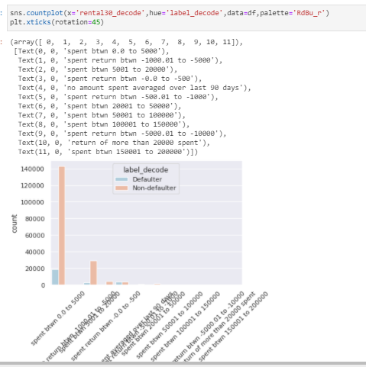

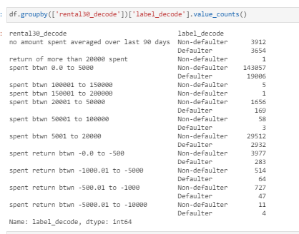

**Okay, so checking the rental30 data and comparing it with our label, we have that:**

**In above plot and absolute numbers, we can see the highest proportion of being defaulter or non defaulter is when the rental30 is between 0 and 5k, means the Average main account balance over last 30 days is between 0 and 5k balance and the lowest proportion of being defaulter or non defaulter is when the rental30 is either more than 20k or rental being below 0, which means that the Average main account balance over last 30 days is less than 0.**

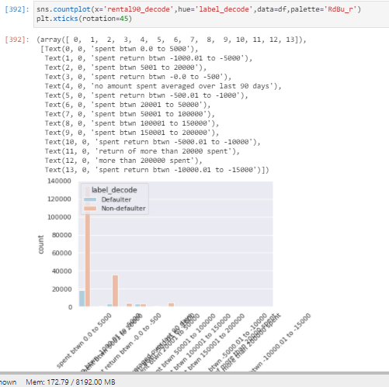

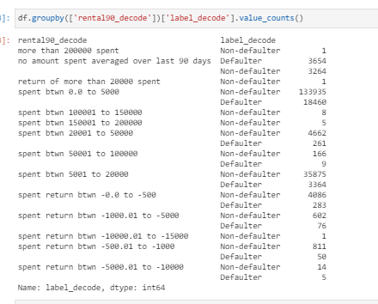

**Here happens something similar to the pattern of rental30:**

**Okay, so checking the rental90 data and comparing it with our label, we have that:**

**In above plot and absolute numbers, we can see the highest proportion of being defaulter or non defaulter is when the rental90 is between 0 and 5k, means the Average main account balance over last 90 days is between 0 and 5k balance and the lowest proportion of being defaulter or non defaulter is when the rental90 is either more than 20k or rental90 being below 0, which means that the Average main account balance over last 30 days is less than 0.**

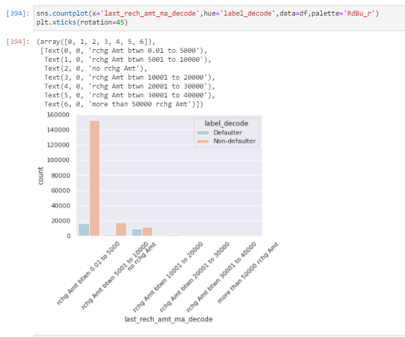

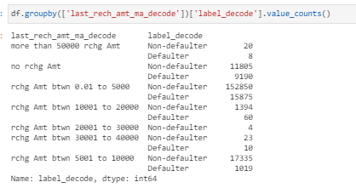

**Okay, so checking the last_rech_amt_ma data and comparing it with our label, we have that:**

**In above plot and absolute numbers, we can see the highest proportion of being defaulter or non defaulter is when the last_rech_amt_ma is between 0 and 5k, means the Amount of last recharge of main account (in Indonesian Rupiah) is between 0 and 5k recharge and the lowest proportion of being non defaulter is when the last_rech_amt_ma is more than 50k as the Amount of last recharge of main account (in Indonesian Rupiah)**

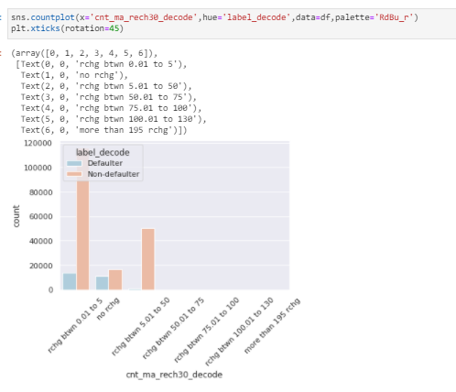

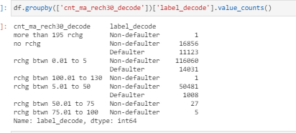

**Okay, so checking the cnt_ma_rech30 data and comparing it with our label, we have that:**

**In above plot and absolute numbers, we can see the highest proportion of being defaulter or non defaulter is when the cnt_ma_rech30 is between 0 and 5k, means the Number of times main account got recharged in last 30 days is between 0 and 5k times and the lowest proportion of being defaulter or non defaulter is when the cnt_ma_rech30 is either more than 195 or cnt_ma_rech30 being between 50 and 100.**

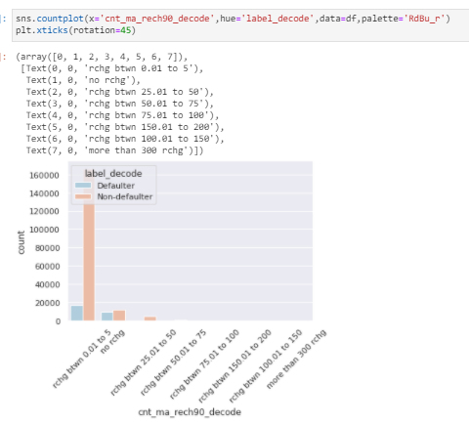

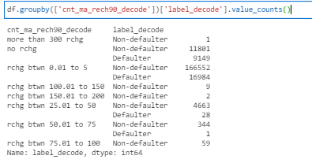

**Here happens something similar to the pattern of cnt_ma_rech30:**

**In above plot and absolute numbers, we can see the highest proportion of being defaulter or non defaulter is when the cnt_ma_rech90 is between 0 and 5k, means the Number of times main account got recharged in last 90 days is between 0 and 5k times and the lowest proportion of being defaulter or non defaulter is when the cnt_ma_rech90 is either more than 300 or cnt_ma_rech90 being between 50 and 100.**

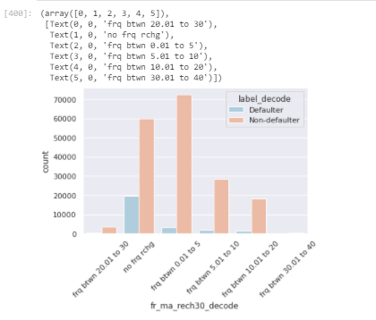

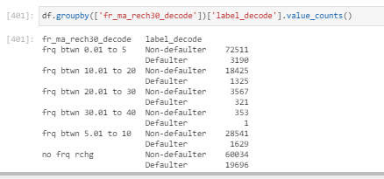

**Okay, so checking the fr_ma_rech30 data and comparing it with our label, we have that:**

**In above plot and absolute numbers, we can see the highest proportion of being defaulter or non defaulter is when the fr_ma_rech30 is either between 0 and 5k or no frequency of main account recharged in last 30 days. And the lowest proportion of being defaulter or non defaulter when the fr_ma_rech30 is between 30 and 40, which means that the Frequency of main account recharged in last 30 days is more than 30 frequencies and less than 40 frequencies.**

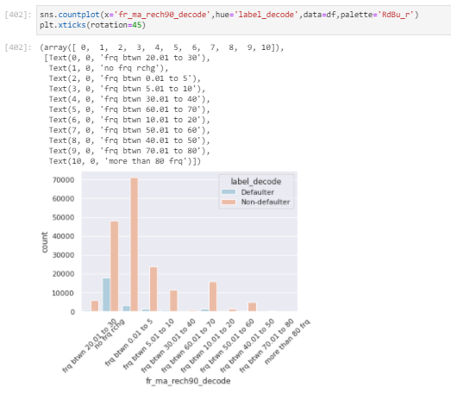

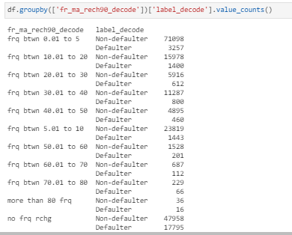

**Here happens something similar to the pattern of fr_ma_rech30:**

**Okay, so checking the fr_ma_rech90 data and comparing it with our label, we have that:**

**In above plot and absolute numbers, we can see the highest proportion of being defaulter or non defaulter is when the fr_ma_rech90 is either between 0 and 5k or no frequency of main account recharged in last 90 days. And the lowest proportion of being defaulter or non defaulter when the fr_ma_rech90 is more than 80 frequencies, which means that the Frequency of main account recharged in last 90 days is more than 80 frequencies.**

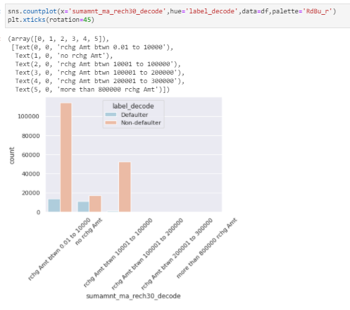

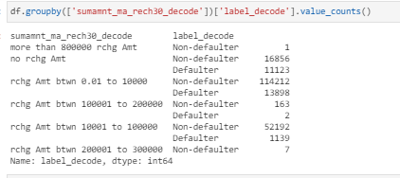

**Okay, so checking the sumamnt_ma_rech30 data and comparing it with our label, we have that:**

**In above plot and absolute numbers, we can see the highest proportion of being defaulter or non defaulter is when the sumamnt_ma_rech30 is between 0 and 10k, means the Total amount of recharge in main account over last 30 days is between 0 and 10k Indonesian rupiah and the lowest proportion of non defaulter is when the sumamnt_ma_rech30 is more than 800k.**

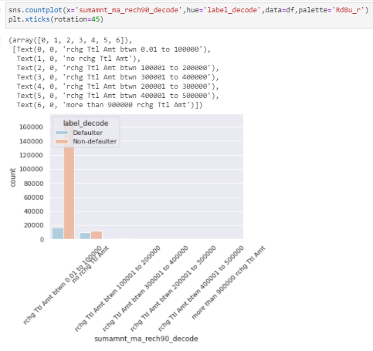

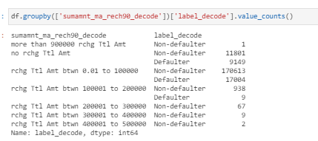

**Here happens something similar to the pattern of sumamnt_ma_rech30:**

**Okay, so checking the sumamnt_ma_rech90 data and comparing it with our label, we have that:**

**In above plot and absolute numbers, we can see the highest proportion of being defaulter or non defaulter is when the sumamnt_ma_rech90 is between 0 and 100k, means the Total amount of recharge in main account over last 90 days is between 0 and 100k Indonesian rupiah and the lowest proportion of non defaulter is when the sumamnt_ma_rech90 is more than 900k.**

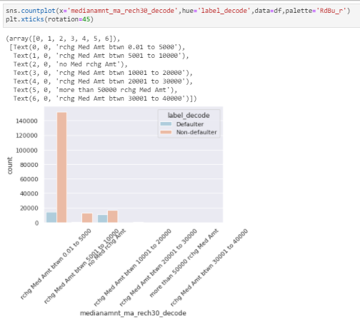

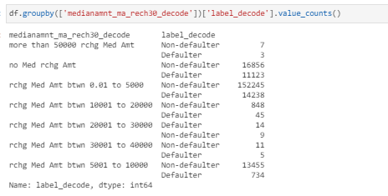

**Okay, so checking the medianamnt_ma_rech30 data and comparing it with our label, we have that:**

**In above plot and absolute numbers, we can see the highest proportion of being defaulter or non defaulter is when the medianamnt_ma_rech30 is between 0 and 5k, means the Median of amount of recharges done in main account over last 30 days at user is between 0 and 5k Indonesian rupiah and the lowest proportion of defaulter and non defaulter is when the medianamnt_ma_rech30 is more than 50k, which means Median of amount of recharges done in main account over last 30 days at user is more than 50k Indonesian rupiah.**

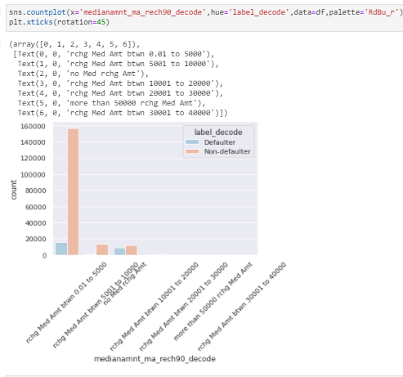

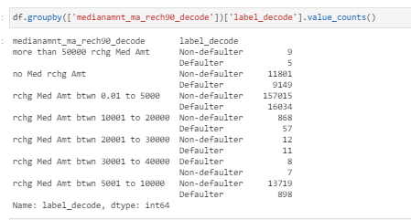

**Here happens something similar to the pattern of medianamnt_ma_rech30:**

**Okay, so checking the medianamnt_ma_rech90 data and comparing it with our label, we have that:**

**In above plot and absolute numbers, we can see the highest proportion of being defaulter or non defaulter is when the medianamnt_ma_rech90 is between 0 and 5k, means the Median of amount of recharges done in main account over last 90 days at user is between 0 and 5k Indonesian rupiah and the lowest proportion of defaulter and non defaulter is when either the medianamnt_ma_rech90 is more than 50k or the medianamnt_ma_rech90 is between 30k and 40k.**

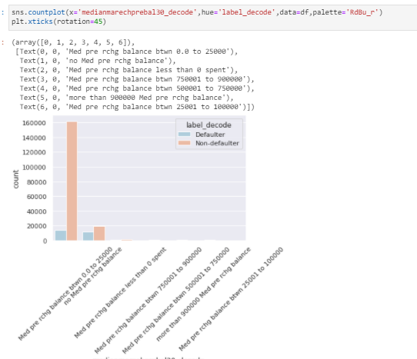

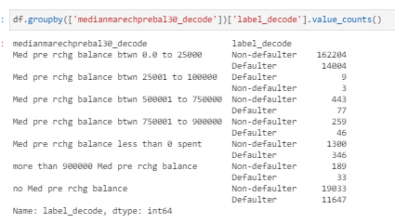

**Okay, so checking the medianmarechprebal30 data and comparing it with our label, we have that:**

**In above plot and absolute numbers, we can see the highest proportion of being defaulter or non defaulter is when the medianmarechprebal30 is between 0 and 25k, means the Median of main account balance just before recharge in last 30 days at user level is between 0 and 25k Indonesian rupiah and the lowest proportion of defaulter and non defaulter is when the medianmarechprebal30 is between 25k and 100k, which means Median of main account balance just before recharge in last 30 days at user level is between 25k and 100k Indonesian rupiah.**

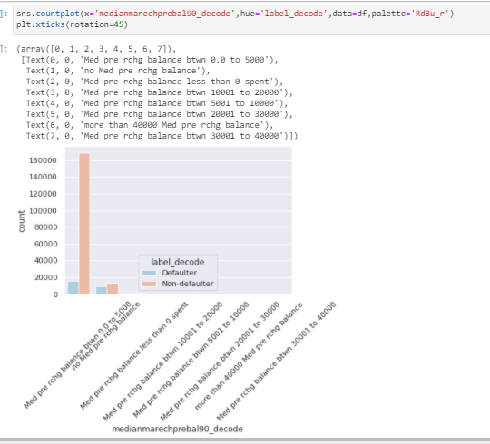

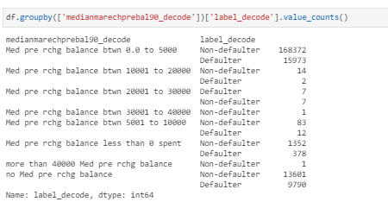

**Here happens something similar to the pattern of medianmarechprebal30:**

**Okay, so checking the medianmarechprebal90 data and comparing it with our label, we have that:**

**In above plot and absolute numbers, we can see the highest proportion of being defaulter or non defaulter is when the medianmarechprebal90 is between 0 and 25k, means the Median of main account balance just before recharge in last 90 days at user level is between 0 and 25k Indonesian rupiah and the lowest proportion of defaulter and non defaulter is when either the medianmarechprebal90 is between 10k and 40k or medianmarechprebal90 is more than 40k, which means the lowest data occurs when Median of main account balance just before recharge in last 90 days at user level is more than 10k.**

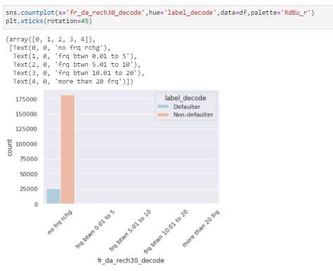

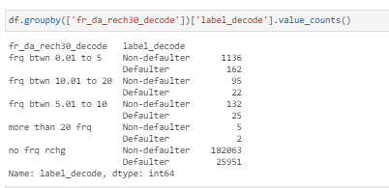

**Okay, so checking the fr_da_rech30 data and comparing it with our label, we have that:**

**In above plot and absolute numbers, we can see the highest proportion of being defaulter or non defaulter is when the fr_da_rech30 is 0, means the Frequency of data account recharged in last 30 days is None and the lowest proportion of defaulter and non defaulter is when the fr_da_rech30 is more than 20 frequencies, which means when we have more than 20 frequencies of data account recharged in last 30 days.**

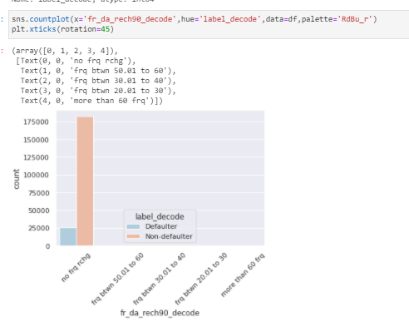

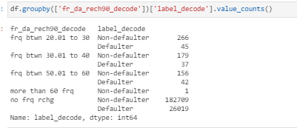

**Here happens something similar to the pattern of fr_da_rech30:**

**Okay, so checking the fr_da_rech90 data and comparing it with our label, we have that:**

**In above plot and absolute numbers, we can see the highest proportion of being defaulter or non defaulter is when the fr_da_rech90 is 0, means the Frequency of data account recharged in last 90 days is None and the lowest proportion of defaulter and non defaulter is when the fr_da_rech90 is more than 60 frequencies, which means when we have more than 60 frequencies of data account recharged in last 90 days.**

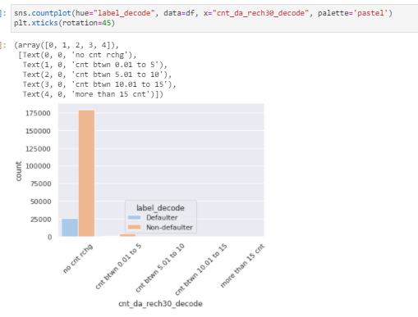

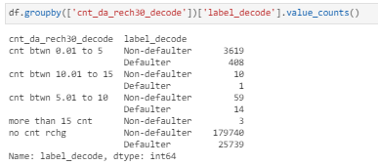

**Okay, so checking the cnt_da_rech30 data and comparing it with our label, we have that:**

**In above plot and absolute numbers, we can see the highest proportion of being defaulter or non defaulter is when the cnt_da_rech30 is 0, means the Number of times data account got recharged in last 30 days is None and the lowest proportion of defaulter and non defaulter is when the cnt_da_rech30 is more than 10, which means when we have more than 10 times the data account got recharged in last 30 days.**

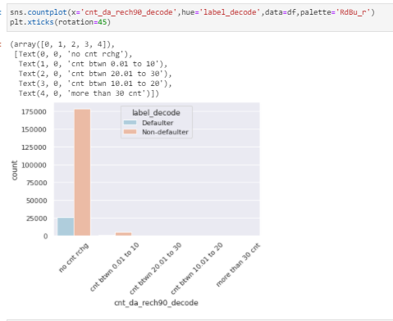

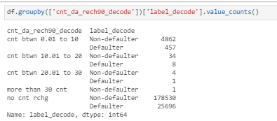

**Here happens something similar to the pattern of cnt_da_rech30:**

**Okay, so checking the cnt_da_rech90 data and comparing it with our label, we have that:**

**In above plot and absolute numbers, we can see the highest proportion of being defaulter or non defaulter is when the cnt_da_rech90 is 0, means the Number of times data account got recharged in last 90 days is None and the lowest proportion of defaulter and non defaulter is when the cnt_da_rech90 is more than 10, which means when we have more than 10 times the data account got recharged in last 90 days.**

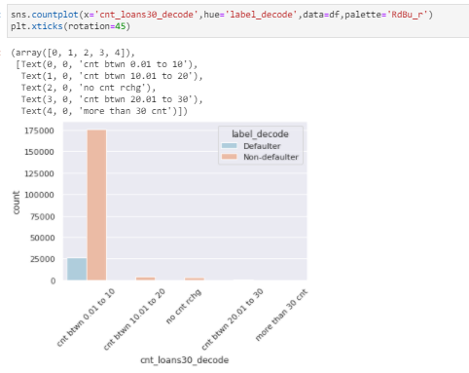

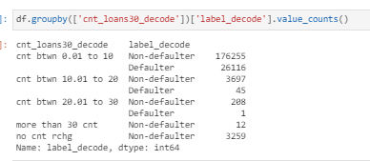

**Okay, so checking the cnt_loans30 data and comparing it with our label, we have that:**

**In above plot and absolute numbers, we can see the highest proportion of being defaulter or non defaulter is when the cnt_ loans30 is between 0 and 10 and the lowest proportion of defaulter and non defaulter is when the cnt_ loans30 is more than 30, which means when we have more than 30 number of loans taken by user in last 30 days.**

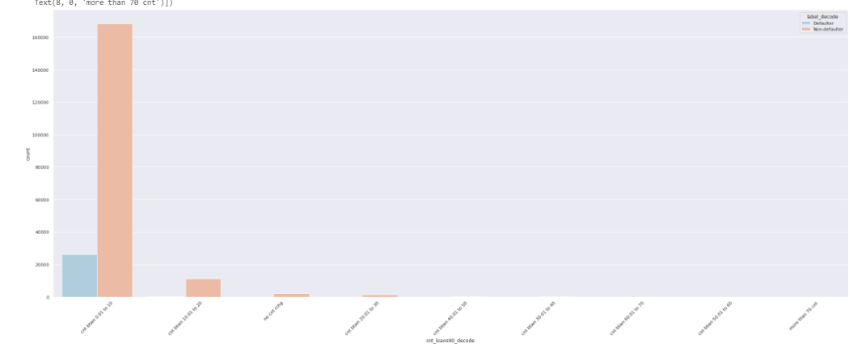

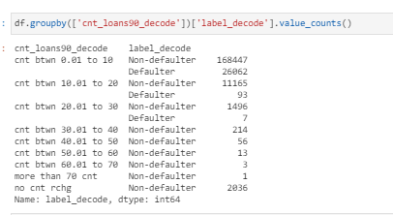

**Here happens something similar to the pattern of cnt_loans30:**

**Okay, so checking the cnt_loans90 data and comparing it with our label, we have that:**

**In above plot and absolute numbers, we can see the highest proportion of being defaulter or non defaulter is when the cnt_ loans90 is between 0 and 10 and the lowest proportion of defaulter and non defaulter is when the cnt_ loans90 is more than 30, which means when we have more than 30 number of loans taken by user in last 90 days.**

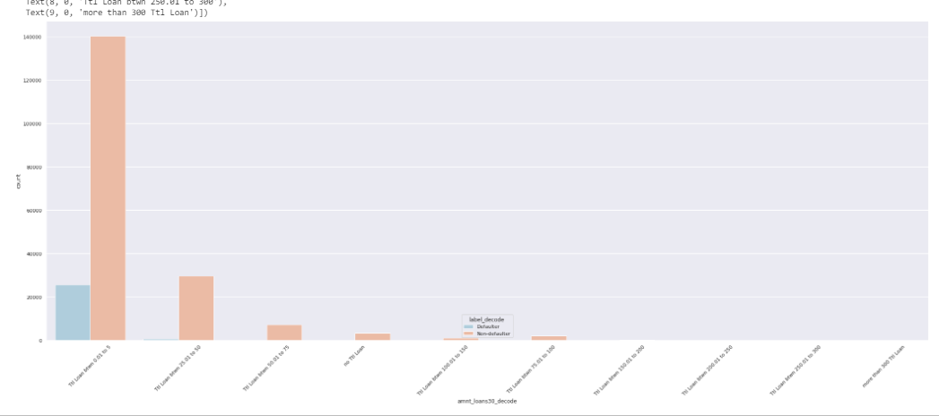

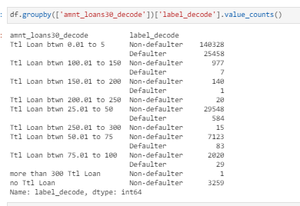

**Okay, so checking the amnt_loans30 data and comparing it with our label, we have that:**

**In above plot and absolute numbers, we can see the highest proportion of being defaulter or non defaulter is when the amnt_loans30 is between 0 and 5, means the Total amount of loans taken by user in last 30 days is between 0 and 5 loans and the lowest proportion of defaulter and non defaulter is when the amnt_loans30 is more than 300, which means when we have more than 300 the Total amount of loans taken by user in last 30 days.**

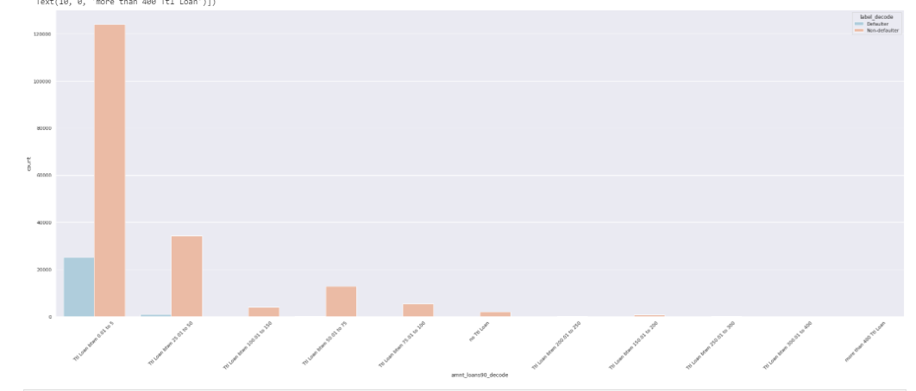

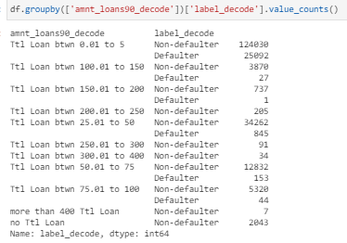

**Here happens something similar to the pattern of amnt_loans30:**

**Okay, so checking the amnt_loans90 data and comparing it with our label, we have that:**

**In above plot and absolute numbers, we can see the highest proportion of being defaulter or non defaulter is when the amnt_loans90 is between 0 and 5, means the Total amount of loans taken by user in last 90 days is between 0 and 5 loans and the lowest proportion of defaulter and non defaulter is when the amnt_loans90 is more than 150, which means when we have more than 150 the Total amount of loans taken by user in last 90 days.**

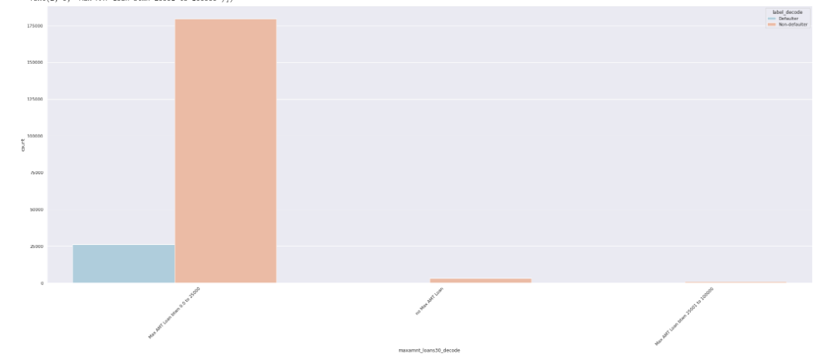

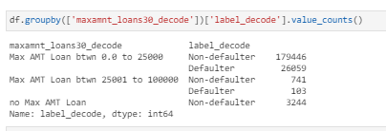

**Okay, so checking the maxamnt_loans30 data and comparing it with our label, we have that:**

**In above plot and absolute numbers, we can see the highest proportion of being defaulter or non defaulter is when the maxamnt_loans30 is between 0 and 25k, means the maximum amount of loan taken by the user in last 30 days is between 0 and 25k. And the lowest proportion of defaulter and non defaulter is when the maxamnt_loans30 is between 25k and 100k, which means the maximum amount of loan taken by the user is between 25k and 100k in last 30 days.**

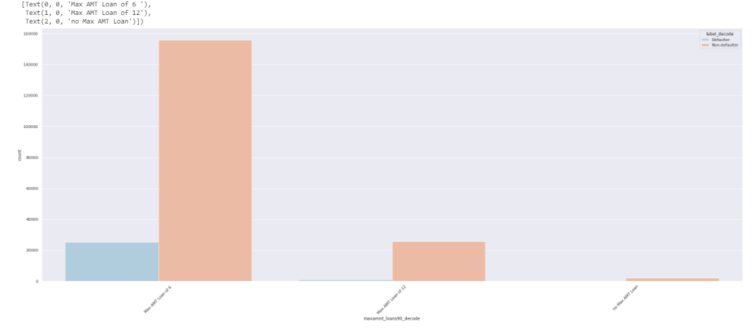

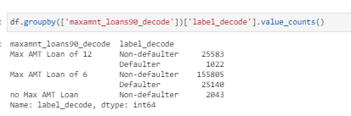

**Here happens something similar to the pattern of maxamnt_loans30:**

**Okay, so checking the maxamnt_loans90 data and comparing it with our label, we have that:**

**In above plot and absolute numbers, we can see the highest proportion of being defaulter or non defaulter is when the maxamnt_loans90 is 6, means the maximum amount of loan taken by the user in last 90 days is 6. And the lowest proportion of defaulter and non defaulter is when the maxamnt_loans90 is None, which means the maximum amount of loan taken by the user is 0 in last 90 days.**

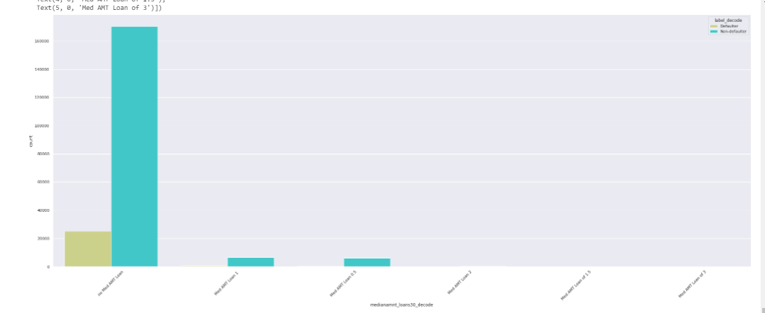

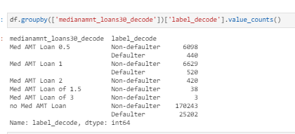

**Okay, so checking the medianamnt_loans30 data and comparing it with our label, we have that:**

**In above plot and absolute numbers, we can see the highest proportion of being defaulter or non defaulter is when the medianamnt_loans30 is None, means the Median of amounts of loan taken by the user in last 30 days is 0. And the lowest proportion of defaulter and non defaulter is when the medianamnt_loans30 is 3, which means the Median of amounts of loan taken by the user in last 30 days is 3.**

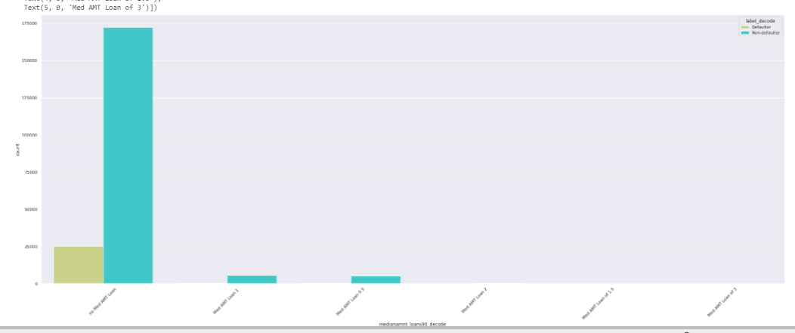

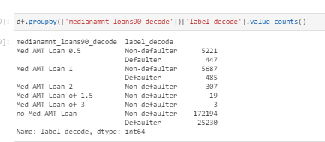

**Here happens something similar to the pattern of medianamnt_loans30:**

**Okay, so checking the medianamnt_loans90 data and comparing it with our label, we have that:**

**In above plot and absolute numbers, we can see the highest proportion of being defaulter or non defaulter is when the medianamnt_loans90 is None, means the Median of amounts of loan taken by the user in last 90 days is 0. And the lowest proportion of defaulter and non defaulter is when the medianamnt_loans90 is 3, which means the Median of amounts of loan taken by the user in last 90 days is 3.**

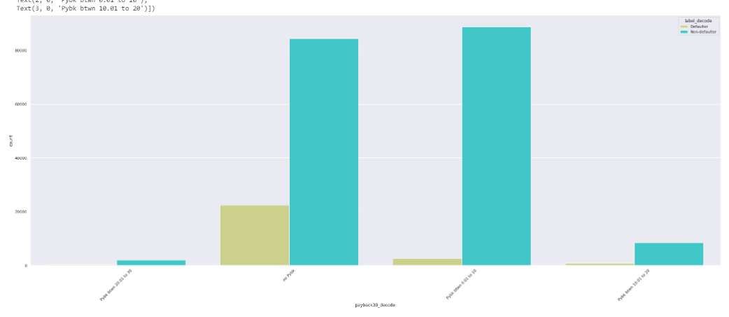

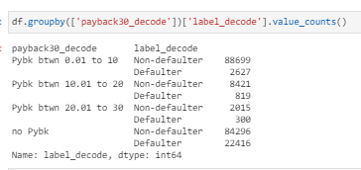

**Okay, so checking the payback30 data and comparing it with our label, we have that:**

**In above plot and absolute numbers, we can see the highest proportion of being defaulter or non defaulter is when either the payback30 is None or payback30 is between 0 and 10 days , means the Average payback time over last 30 days is either 0 days or between 0 and 10 days. And the lowest proportion of defaulter and non defaulter is when the payback30 is between 20 and 30, which means the Average payback time is between 20 and 30 days over last 30 days .**

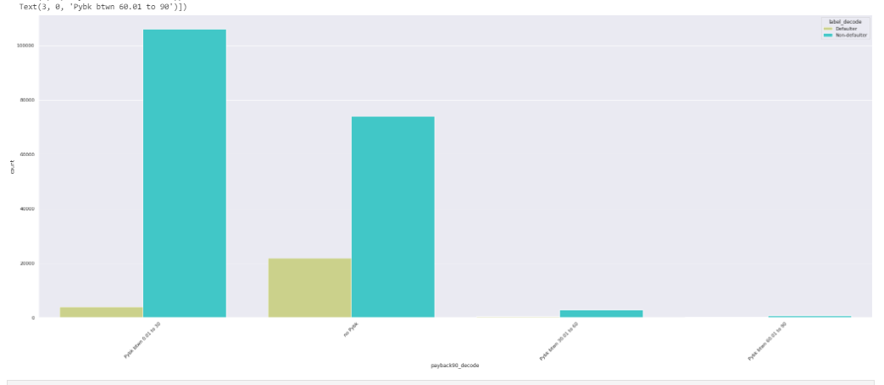

**Here happens something similar to the pattern of payback30:**

**Okay, so checking the payback90 data and comparing it with our label, we have that:**

**In above plot and absolute numbers, we can see the highest proportion of being defaulter or non defaulter is when either the payback90 is None or payback90 is between 0 and 10 days , means the Average payback time over last 90 days is either 0 days or between 0 and 10 days. And the lowest proportion of defaulter and non defaulter is when the payback90 is between 20 and 30, which means the Average payback time is between 20 and 30 days over last 90 days .**

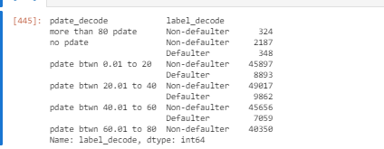

**And finally, regarding pdate, we can highlight that the highest proportion of being defaulter or non defaulter is between 20 and 40 days and the lowest proportion of being defaulter or non defaulter is when we have more than 80 days of pdate.**

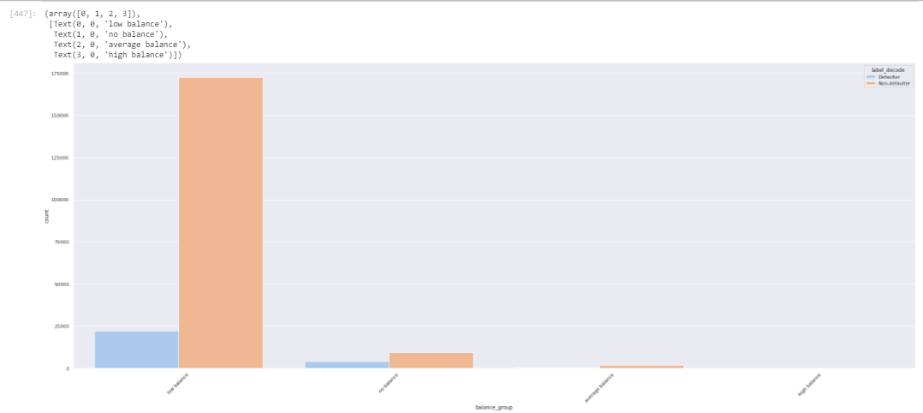

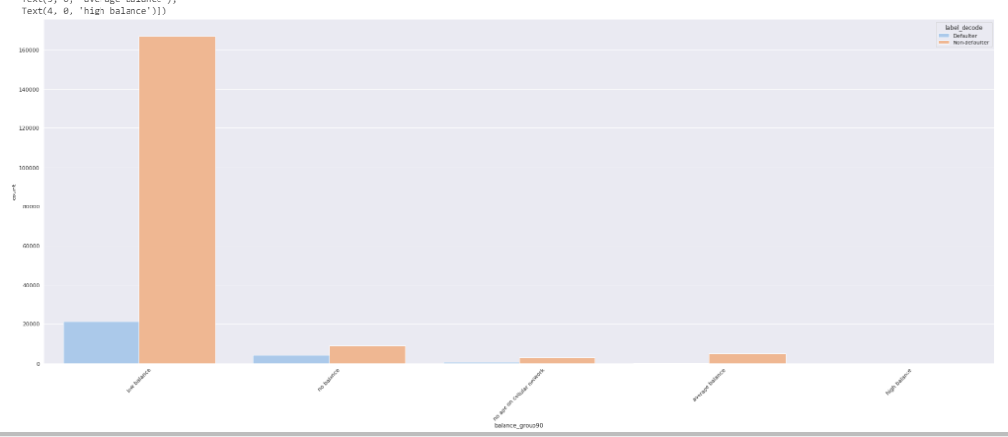

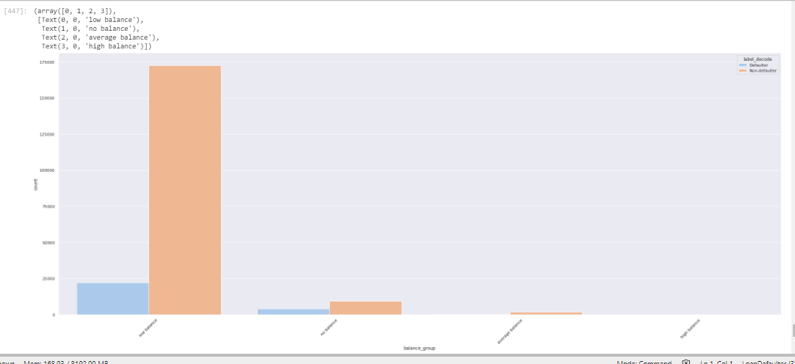

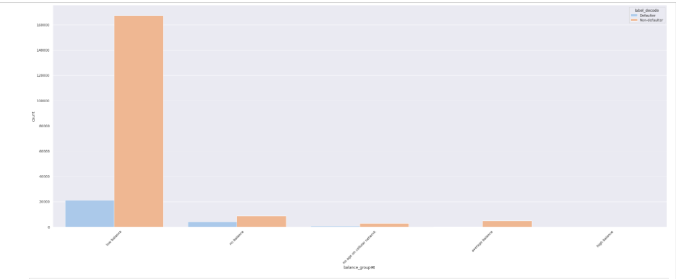

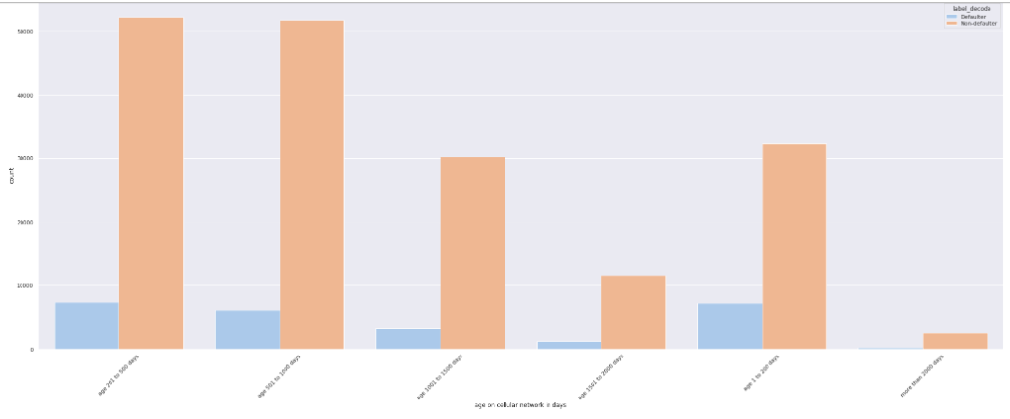

**In above 5 barplots you will see the conclusions we already shared in previous plots.**

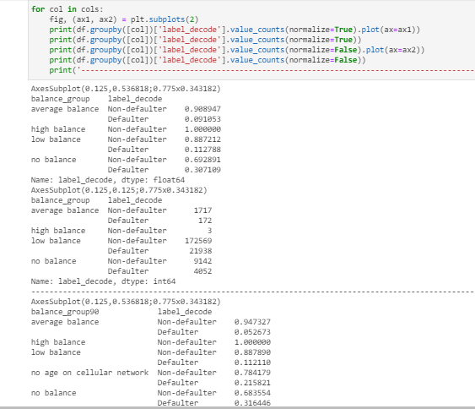

**We already discussed these values counts before, but we will highlight the main findings:**

* **Clients with high balance are more likely to be Non-defaulter.**
* **Clients with low balance are more likely to be Non-defaulter (69,28%) than Defaulter (30,71%)**
* **Clients with low balance has the highest number of defaulter and non defaulter cases. And comparing this group itself, we have 8 times more the non defaulter cases compared to defaulter cases due to our imbalanced data.**

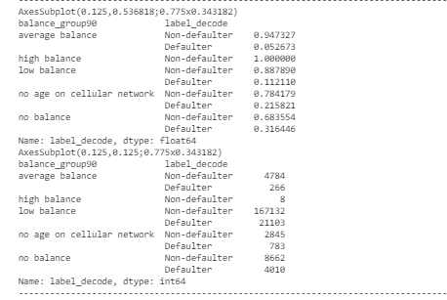

**We already discussed these values counts before, but we will highlight the main findings:**

* **Clients with high balance have the highest rate of non-defaulter which is 100%**
* **The users without balance have the lowest rate of non-default percentage and the highest rate of default percentage.**
* **Clients with low balance has the highest number of defaulter and non defaulter cases. And comparing this group itself, we have almost 8 times more the non defaulter cases compared to defaulter cases due to our imbalanced data.**

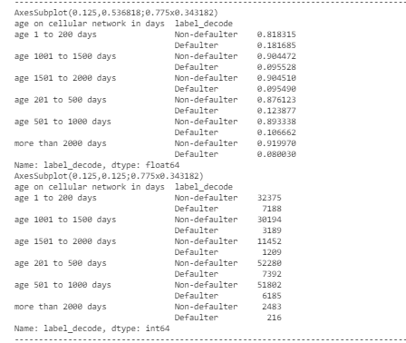

**We already discussed these values counts before, but we will highlight the main findings:**

* **Clients with cellular age more than 2000 days have the highest rate of non-defaulter which is 91,99% and the lowest rate of defaulter which is 8%**
* **Clients with cellular between 1 and 200 days have the highest rate of defaulter which is 18,16% and the lowest rate of non-defaulter which is 81,83%**
* **Clients with cellular age between 200 and 500 has the highest number of defaulter and non defaulter cases. And comparing this group itself, we have almost 7 times more the non defaulter cases compared to defaulter cases due to our imbalanced data.**

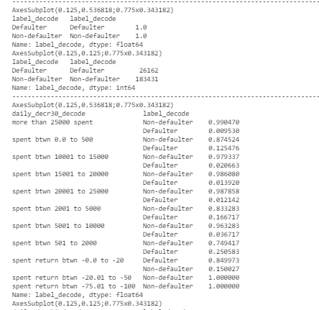

**We already discussed these values counts before, but we will highlight the main findings:**

* **Clients with daily_decr30 more than 25k have the lowest rate of defaulter which is 0.9%**
* **Clients with daily_decr30 between 1 and -20 have the highest rate of defaulter which is 84,99% and the lowest non-defaulter rate which is 15%**
* **Clients with daily_decr30 spent between less then -20 have the highest non defaulter rate.**

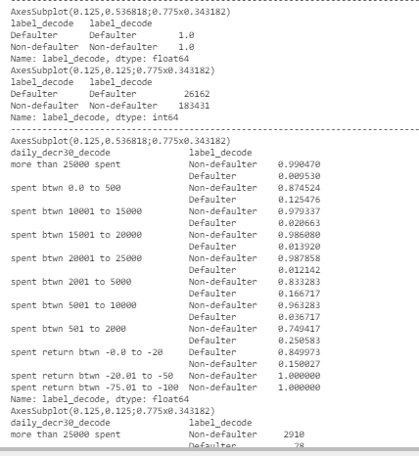

**We already discussed these values counts before, but we will highlight the main findings:**

* **Clients with daily_decr30 more than 25k have the lowest rate of defaulter which is 0.9%**
* **Clients with daily_decr30 between 1 and -20 have the highest rate of defaulter which is 84,99% and the lowest non-defaulter rate which is 15%**
* **Clients with daily_decr30 spent between less then -20 have the highest non defaulter rate.**

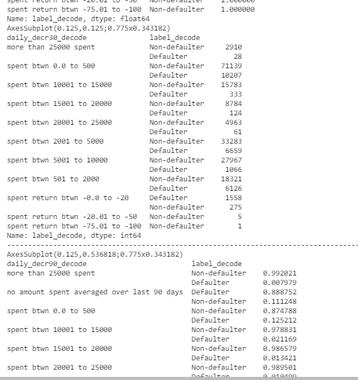

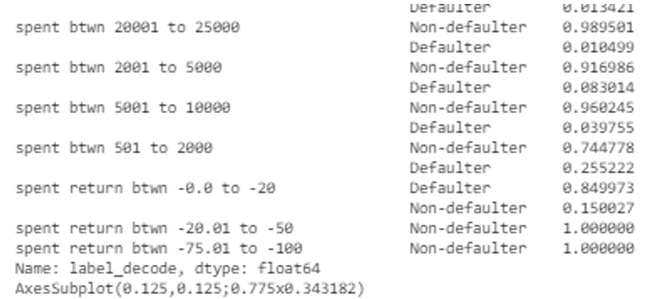

**We already discussed these values counts before, but we will highlight the main findings:**

* **Clients with daily_decr90 more than 25k have the lowest rate of defaulter which is 0.7%**
* **Clients with daily_decr90 between 1 and -20 the lowest non-defaulter rate which is 15%**
* **Clients with daily_decr90 between -20 and -100 the highest non-defaulter rate which is 100%**
* **Clients with daily_decr90 without spent have the highest defaulter rate.**

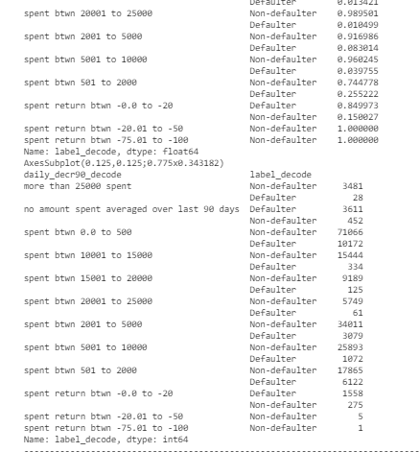

**We already discussed these values counts before, but we will highlight the main findings:**

* **Clients with daily_decr90 more than 25k have the lowest number of defaulter which is 28 cases.**
* **Clients with daily_decr90 between -1 and -20 the lowest non-defaulter number which is 275.**
* **Clients with daily_decr90 between -20 and -100 the lowest non-defaulter number which in total is 6 and which represents 100% of it.**
* **Clients with daily_decr90 between 0 and 500 spnt have the highest number of defautler and non defaulter cases.**

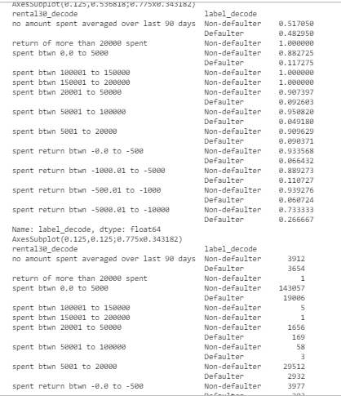

**We already discussed these values counts before, but we will highlight the main findings:**

* **Clients with rental30 more than 10k have the highest non defaulter rate which 100%.**
* **Clients without any rental30, means without any amount spent averaged over 30 days, have the highest defaulter rate which is 48,29% and have the lowest non defaulted rate which is 51,7%.**
* **Clients with rental30 between 50k and 100k has the lowest defaulter rate which is 4,9%**

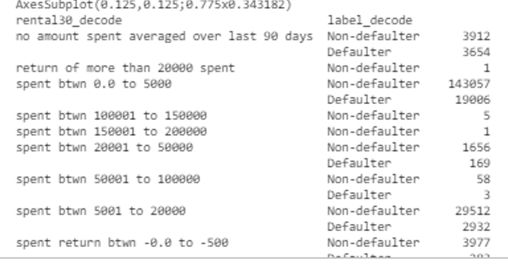

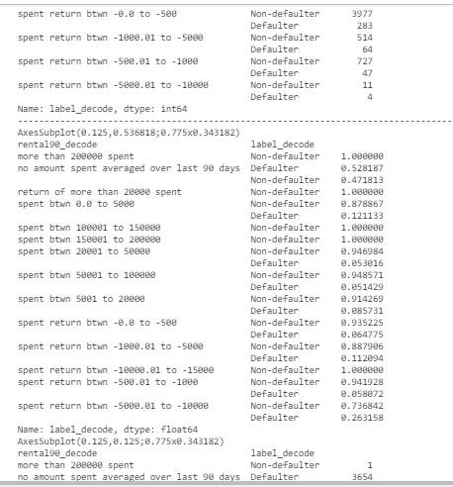

**We already discussed these values counts before, but we will highlight the main findings:**

* **Here we can highlight that clients with rental30 between 0 and 5k are users that have the highest number of nondefaulter and defaulter cases.**
* **And users with either rental30 between 100k and 200k or rental30 between -5k and -10k have the lowest number of nondefaulter and defaulter cases.**
* **Most of our data have 100% of non defaulter cases, in this case it happens with when we have rental90 between 20k and 50k or rental90 over than 100k or return is between -10k and -15k.**

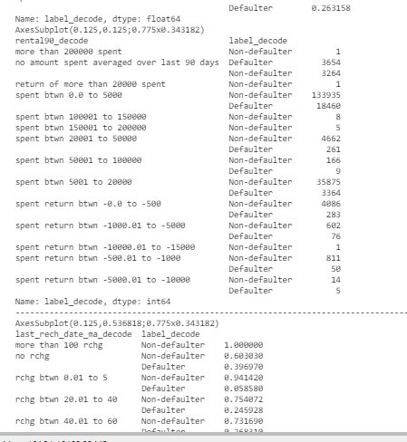

**We already discussed these values counts before, but we will highlight the main findings:**

* **Clients with rental90 more between 0 and 5k have the highest number of defaulter and non defaulter cases.**
* **Clients with negative rental90 values have the lowest number of defaulter and non defaulter cases.**

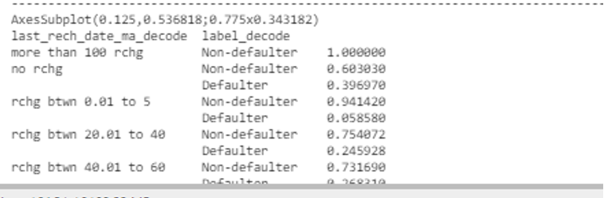

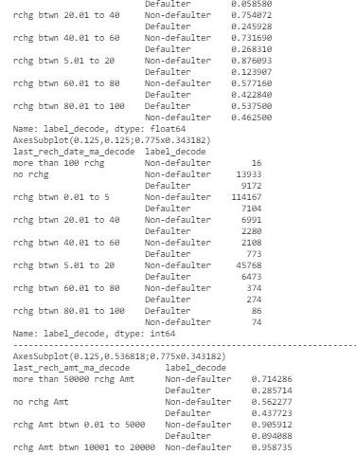

**We already discussed these values counts before, but we will highlight the main findings:**

* **Here we can highlight that clients with last_rech_date_ma more than 100 are users that have the highest rate of nondefaulter which is 100%.**
* **We can also highlight that clients with last_rech_date_ma between 0 and 5 are users that have the lowest rate of defaulter which is 5,85%.**
* **We can also highlight that clients with last_rech_date_ma between 80 and 100 are users that have the highest rate of defaulter which is 53,75% and lowest rate of non defaulter which is 46,25%**
* **Here we will also highlight that the highest number of non defaulter goes to users whose last_rech_date_ma is between 0 and 5 and the highest number of defaulter goes to users whose last_rech_date_ma is None, means not recharge at all.**

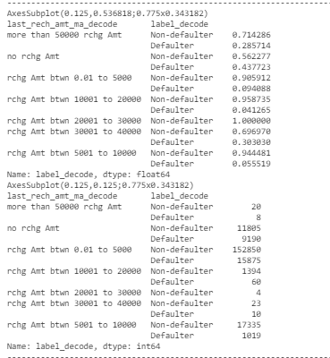

**We already discussed these values counts before, but we will highlight the main findings:**

* **Here we can highlight that the highest rate of non defaulter goes to users whose last_rech_amt_ma is between 20k and 30k**
* **We can also highlight that the lowest rate of non defaulter goes to users whose last_rech_amt_ma is None**
* **Here we can highlight that the highest rate of defaulter goes to users whose last_rech_amt_ma is None**
* **We can also highlight that the lowest rate of defaulter goes to users whose last_rech_amt_ma is between 10k and 20k**
* **Needless to say, that the last_rech_amt_ma with highest number of cases is amount between 0 and 5k and the last_rech_amt_ma with lowest number of cases is amount higher than 50k**

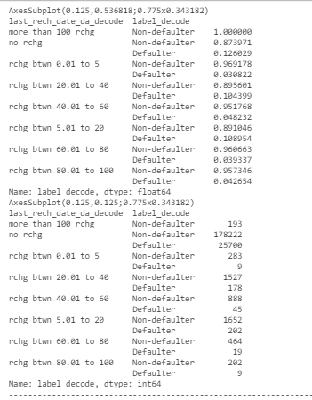

**We already discussed these values counts before, but we will highlight the main findings:**

* **Here we can highlight that the highest rate of non defaulter goes to users whose last_rech_date_da is more than 100.**
* **We can also highlight that the lowest rate of non defaulter goes to users whose last_rech_date_da is None**
* **Here we can highlight that the highest rate of defaulter goes to users whose last_rech_date_da is None**
* **We can also highlight that the lowest rate of defaulter goes to users whose last_rech_date_da is between 1 and 5**
* **Needless to say, that the last_rech_date_da with highest number of cases is when number of days is None and the last_rech_date_da with lowest number of cases is when number of days is higher than 100**

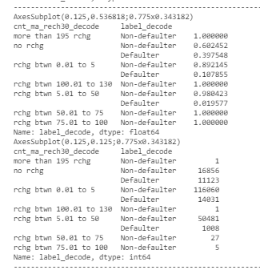

**We already discussed these values counts before, but we will highlight the main findings:**

* **Here we can highlight that the highest rate of non defaulter goes to users whose cnt_ma_rech is more than 195 or between 100 and 130 or between 50 to 100.**
* **We can also highlight that the lowest rate of non defaulter goes to users whose cnt_ma_rech is None**
* **Here we can highlight that the highest rate of defaulter goes to users whose cnt_ma_rech is None**
* **We can also highlight that the lowest rate of defaulter goes to users whose cnt_ma_rech is between 5 and 50.**
* **Needless to say, that the cnt_ma_rech with highest number of cases is when number of times is between 0 and 5 and the cnt_ma_rech with lowest number of cases is when number of times is higher than 195.**

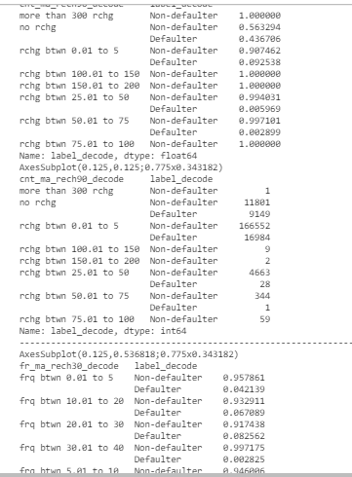

**We already discussed these values counts before, but we will highlight the main findings:**

* **Here we can highlight that the highest rate of non defaulter goes to users whose cnt_ma_rech90 is more than 300 or between 75 and 200.**
* **We can also highlight that the lowest rate of non defaulter goes to users whose cnt_ma_rech90 is None**
* **Here we can highlight that the highest rate of defaulter goes to users whose cnt_ma_rech90 is None**
* **We can also highlight that the lowest rate of defaulter goes to users whose cnt_ma_rech90 is between 50 and 75.**
* **Needless to say, that the cnt_ma_rech90 with highest number of cases is when number of times is between 0 and 5 and the cnt_ma_rech90 with lowest number of cases is when number of times is higher than 300.**

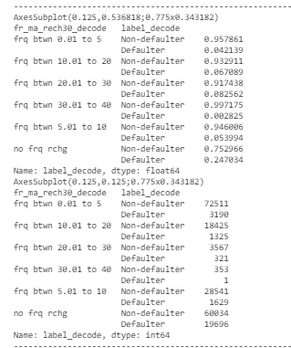

**We already discussed these values counts before, but we will highlight the main findings:**

* **Here we can highlight that the users with fr_ma_rech30 between 30 and 40 has the highest rate of non defaulter cases and lowest rate of defaulter cases.**
* **Here we can highlight that the users with fr_ma_rech30 None has the highest rate of defaulter cases and lowest rate of non-defaulter cases.**
* **Needless to say, that the fr_ma_rech30 with highest number of cases is when number of frequencies is either between 0 and 5 or none frecuencies and the fr_ma_rech30 with lowest number of cases is when number of frequencies is between 30 and 40.**

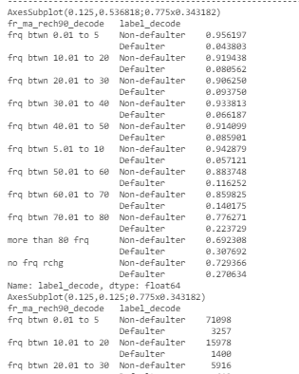

**We already discussed these values counts before, but we will highlight the main findings:**

* **Here we can highlight that the users with fr_ma_rech90 between 1 and 5 has the highest rate of non defaulter cases and lowest rate of defaulter cases.**
* **Here we can highlight that the users with fr_ma_rech30 more than 80 frecuencies has the highest rate of defaulter cases and lowest rate of non-defaulter cases.**

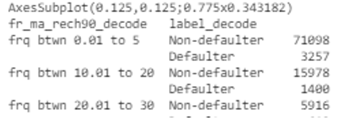

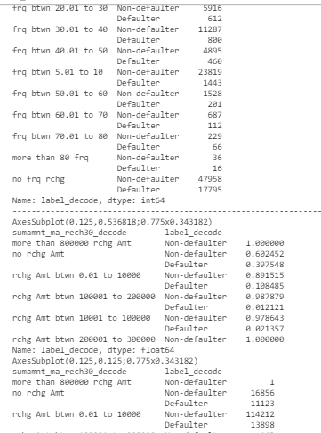

**We already discussed these values counts before, but we will highlight the main findings:**

* **Here we can highlight that the users with sumamnt_ma_rech30 between 10k and 100k has the lowest rate of defaulter cases.**
* **Here we can highlight that the users with sumamnt_ma_rech30 None has the highest rate of defaulter cases.**
* **Here we can highlight that the users with sumamnt_ma_rech30 more than 800k amount and amount between 200k and 300k has the highest rate of non defaulter cases.**

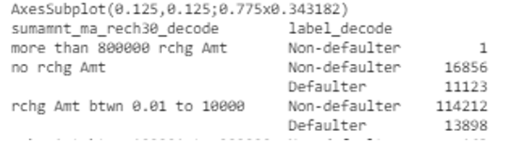

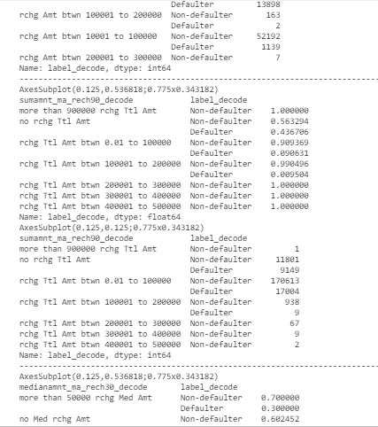

**We already discussed these values counts before, but we will highlight the main findings:**

* **Here we can highlight that the users with sumamnt_ma_rech90 more than 200k has the highest rate of non defaulter cases which is 100%**
* **Here we can highlight that the users with sumamnt_ma_rech90 None has the highest rate of defaulter cases.**
* **Here we can highlight that the users with sumamnt_ma_rech90 more than 900k amount has the highest rate of non defaulter cases.**
* **Needless to say, that the sumamnt_ma_rech90 with highest number of non defaulter and defaulter cases goes to when the features sumamnt_ma_rech90 is between 1 and 100k.**
* **And the lowest number of non defaulter goes to when the features sumamnt_ma_rech90 is between 200k and 500k.**

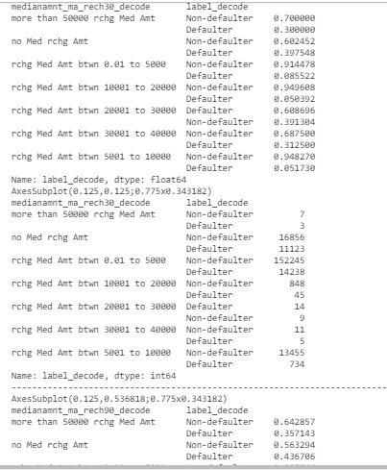

**We already discussed these values counts before, but we will highlight the main findings:**

* **Here we can highlight that the users with medianamnt_ma_rech30 more between 10k and 20k has the highest rate of non defaulter cases which is 94,96%**
* **Here we can highlight that the users with medianamnt_ma_rech30 between 20k and 30k has the highest rate of defaulter cases.**
* **The medianamnt_ma_rech30 with lowest number of non defaulter and highest defaulter cases goes to when the features medianamnt_ma_rech30 is between 20 and 30k.**
* **And the lowest number of defaulter goes to when the features medianamnt_ma_rech30 is between 10k and 20k.**
* **Needless to say, the highest number of non-defaulter and defaulter cases goes to when the features medianamnt_ma_rech30 is between 1 and 5k.**
* **And the lowest number of non-defaulter and defaulter cases goes to when the features medianamnt_ma_rech30 is more than 50k.**

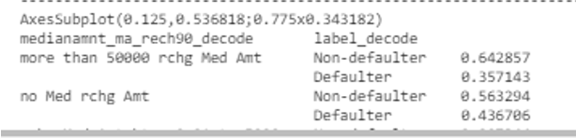

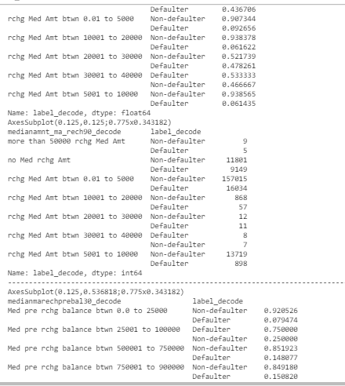

**We already discussed these values counts before, but we will highlight the main findings:**

* **Here we can highlight that the users with medianamnt_ma_rech90 more between 5k and 10k has the highest rate of non defaulter cases which is 93,85%**
* **Here we can highlight that the users with medianamnt_ma_rech90 between 30k and 40k has the highest rate of defaulter cases.**
* **The medianamnt_ma_rech90 with lowest number of non defaulter and highest defaulter cases goes to when the features medianamnt_ma_rech90 is between 30 and 40k.**
* **And the lowest number of defaulter goes to when the features medianamnt_ma_rech90 is between 5k and 1k.**
* **Needless to say, the highest number of non-defaulter and defaulter cases goes to when the features medianamnt_ma_rech90 is between 1 and 5k.**
* **And the lowest number of non-defaulter and defaulter cases goes to when the features medianamnt_ma_rech30 is more than 50k.**

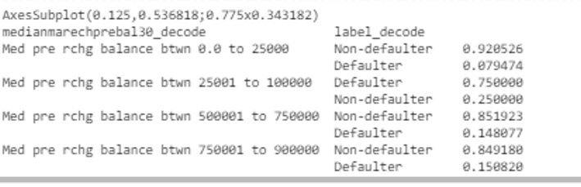

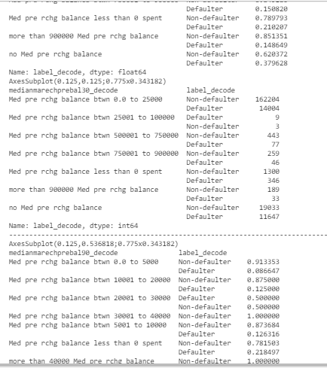

**We already discussed these values counts before, but we will highlight the main findings:**

* **Here we can highlight that the users with medianmarechprebal30 between 0 and 25k has the highest rate of non defaulter cases which is 92,05% and has the lowest rate of defaulter cases with a rate of 7,9%**
* **Here we can highlight that the users with medianmarechprebal30 between 25k and 100k has the lowest rate of non defaulter cases which is 25% and has the highest rate of defaulter cases with a rate of 75%**
* **Needless to say, the highest number of non-defaulter and defaulter cases goes to when the features medianmarechprebal30 is between 0 and 25k.**
* **And the lowest number of non-defaulter and defaulter cases goes to when the features medianmarechprebal30 is between 25k and 100k.**

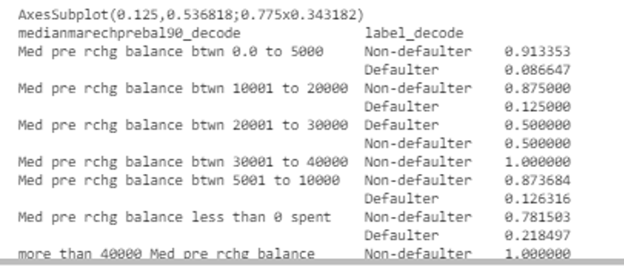

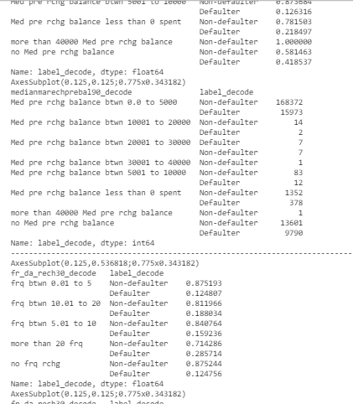

**We already discussed these values counts before, but we will highlight the main findings:**

* **Here we can highlight that the users with medianmarechprebal90 more than 30k has the highest rate of non defaulter cases which is 100%.**
* **Here we can highlight that the users with medianmarechprebal90 between 20k and 30k has the lowest rate of non defaulter cases which is 50% and has the highest rate of defaulter cases with a rate of 50%**
* **Here we can highlight that the users with medianmarechprebal90 between 0 and 5k has the lowest rate of defaulter cases with a rate of 8,66%**
* **Needless to say, the highest number of non-defaulter and defaulter cases goes to when the features medianmarechprebal90 is between 0 and 5k.**
* **And the lowest number of non-defaulter and defaulter cases goes to when the features medianmarechprebal90 is more than 30k.**

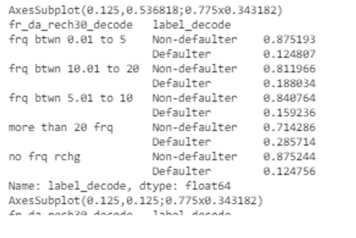

* **Here we can highlight that the users with fr_da_rech30 more than 20 frequencies has the lowest rate of non defaulter cases which is 71% and has the highest rate of defaulter cases with a rate of 28%**
* **Here we can highlight that the users with fr_da_rech30 NOne has the highest rate of non defaulter cases which is 87,52% and has the lowest rate of defaulter cases with a rate of 12,47%**

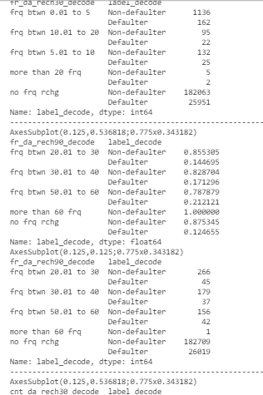

* **Needless to say, the highest number of non-defaulter and defaulter cases goes to when the features fr_da_rech30 is None.**
* **And the lowest number of non-defaulter and defaulter cases goes to when the features fr_da_rech30 is more than 20 frequencies.**
* **Here we can highlight that the users with fr_da_rech90 with None has the lowest rate of defaulter cases which is 12,46%.**
* **Here we can highlight that the users with fr_da_rech90 with frequency between 50 to 60 has the highest rate of defaulter cases which is 21,21% and has the lowest rate of nondefaulter cases with a rate of 78,78%**
* **And the users with fr_da_rech90 more than 60 frecuencies has the highest non defaulter rate which is 100%.**
* **Needless to say, the highest number of non-defaulter and defaulter cases goes to when the features fr_da_rech90 is None.**
* **And the lowest number of non-defaulter and defaulter cases goes to when the features fr_da_rech90 is more than 60 frequencies.**

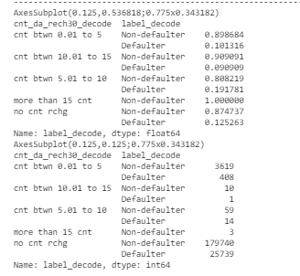

* **Here we can highlight that the users with cnt_da_rech30 between 10 and 15 has the lowest rate of defaulter cases which is 9,09%.**
* **Here we can highlight that the users with cnt_da_rech30 with frequency between 5 to 10 has the highest rate of defaulter cases which is 19,17% and has the lowest rate of non defaulter cases with a rate of 80,82%**
* **And the users with cnt_da_rech30 more than 15 has the highest non defaulter rate which is 100%.**
* **Needless to say, the highest number of non-defaulter and defaulter cases goes to when the features cnt_da_rech30 is None.**
* **And the lowest number of non-defaulter and defaulter cases goes to when the features cnt_da_rech30 is more than 15.**

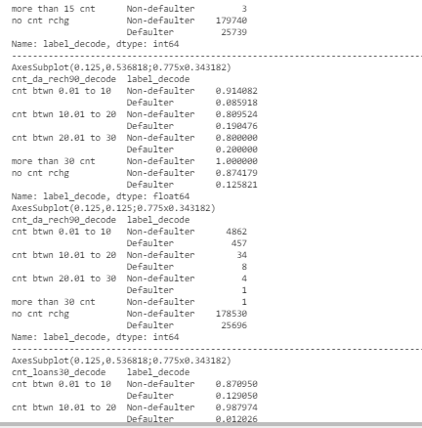

* **Here we can highlight that the users with cnt_da_rech90 between 0 and 10 has the lowest rate of defaulter cases which is 8,59%.**
* **Here we can highlight that the users with cnt_da_rech90 between 20 to 30 has the highest rate of defaulter cases which is 20% and has the lowest rate of non defaulter cases with a rate of 80%**
* **And the users with cnt_da_rech90 more than 30 has the highest non defaulter rate which is 100%.**
* **Needless to say, the highest number of non-defaulter and defaulter cases goes to when the features cnt_da_rech90 is None.**
* **And the lowest number of non-defaulter and defaulter cases goes to when the features cnt_da_rech90 is more than 30.**

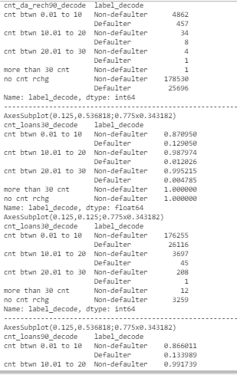

* **Here we can highlight that the users with cnt_loans30 between 20 and 30 has the lowest rate of defaulter cases which is 0,4785%.**
* **Here we can highlight that the users with cnt_loans30 between 0 to 10 has the highest rate of defaulter cases which is 12,9% and has the lowest rate of non defaulter cases with a rate of 87,09%**
* **And the users with cnt_loans30 more than 30 has the highest non defaulter rate which is 100%.**
* **Needless to say, the highest number of non-defaulter and defaulter cases goes to when the features cnt_loans30 is between 0 and 10.**
* **And the lowest number of non-defaulter cases goes to when the features cnt_loans30 is more than 30.**

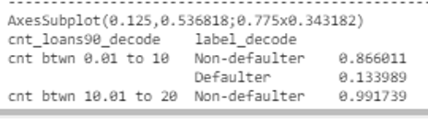

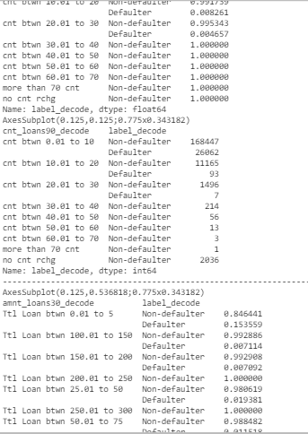

* **Here we can highlight that the users with cnt_loans90 between 20 and 30 has the lowest rate of defaulter cases which is 0,46%.**
* **Here we can highlight that the users with cnt_loans90 between 0 to 10 has the highest rate of defaulter cases which is 13,39%**
* **And the users with cnt_loans90 more than 30 has the highest non defaulter rate which is 100%.**
* **Needless to say, the highest number of non-defaulter and defaulter cases goes to when the features cnt_loans90 is between 0 and 10.**
* **And the lowest number of non-defaulter cases goes to when the features cnt_loans90 is more than 30.**

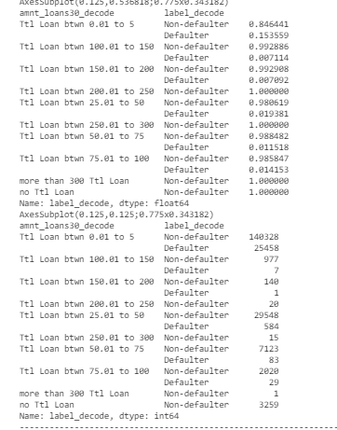

* **Here we can highlight that the users with amnt_loans30 between 0 and 5 has the lowest rate of nondefaulter cases which is 84,64% and has the highest rate of defaulter cases which is 15,35%**
* **Here we can highlight that the users with amnt_loans30 between 150 to 200 has the lowest rate of defaulter cases which is 0.70%**
* **And the users with amnt_loans30 more than 200 has the highest non defaulter rate which is 100% and same happens when we have no amnt_loan.**
* **Needless to say, the highest number of non-defaulter and defaulter cases goes to when the features amnt_loans30 is between 0 and 5.**
* **And the lowest number of non-defaulter cases goes to when the features amnt_loans30 is more than 300.**

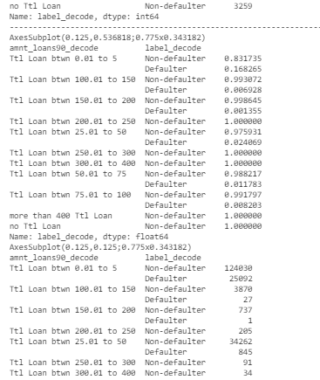

* **Here we can highlight that the users with amnt_loans90 between 0 and 5 has the lowest rate of nondefaulter cases which is 83,17% and has the highest rate of defaulter cases which is 16,82%**
* **Here we can highlight that the users with amnt_loans90 between 150 to 200 has the lowest rate of defaulter cases which is 0.13%**
* **And the users with amnt_loans90 more than 200 has the highest non defaulter rate which is 100% and same happens when we have no amnt_loan.**
* **Needless to say, the highest number of non-defaulter and defaulter cases goes to when the features amnt_loans90 is between 0 and 5.**
* **And the lowest number of non-defaulter cases goes to when the features amnt_loans90 is more than 300.**

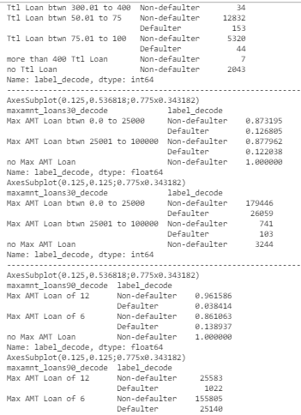

* **Here we can highlight that the users with maxamnt_loans30 between 25k and 100k has the highest rate of nondefaulter cases which is 100%.**
* **Needless to say, the highest number of non-defaulter and defaulter cases goes to when the features maxamnt_loans30 is between 0 and 25k.**
* **Here we can highlight that the users with maxamnt_loans90 of 12 has the highest rate of defaulter cases which is 13,89%.**
* **Here we can highlight that the users with maxamnt_loans90 of None has the highest rate of none defaulter cases which is 100%.**
* **Needless to say, the highest number of non-defaulter and defaulter cases goes to when the features maxamnt_loans90 is 6.**

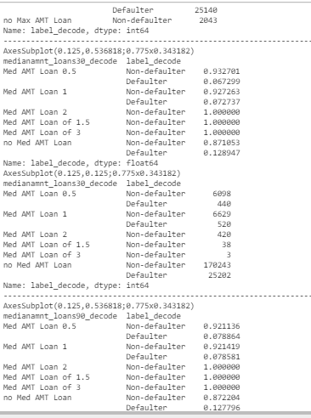

* **Here we can highlight that the users with mediaamnt_loans30 between 1.5 and 3 has the highest rate of nondefaulter cases which is 100%.**
* **When mediaamnt_loans30 is None, this is when we have the highest rate of defaulter and lowest rate of non-defaulter.**
* **Needless to say, the highest number of non-defaulter and defaulter cases goes to when the features mediaamnt_loans30 is None.**

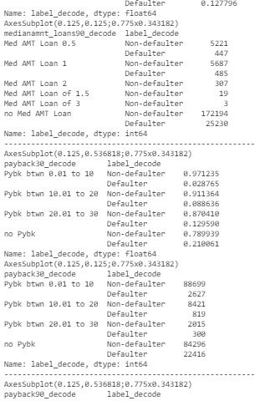

* **Here we can highlight that the users with payback30 between 0 and 10 has the highest rate of nondefaulter cases which is 97,12% and has the lowest defaulter rate which is 2,87%**
* **Here we can highlight that the users with None payback30 has the lowest rate of nondefaulter cases which is 78,99% and has the highest defaulter rate which is 21%**
* **Needless to say, the highest number of non-defaulter and defaulter cases goes to when the features payback30 is either between 0 and 10 or None.**

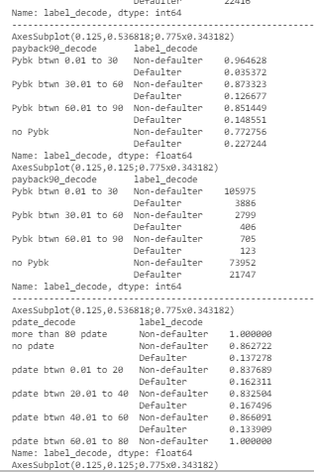

**Here happens similar case as payback30:**

* **Here we can highlight that the users with payback90 between 0 and 30 has the highest rate of nondefaulter cases which is 96,46% and has the lowest defaulter rate which is 3,53%**
* **Here we can highlight that the users with None payback90 has the lowest rate of nondefaulter cases which is 77,27% and has the highest defaulter rate which is 22,72%**
* **Needless to say, the highest number of non-defaulter and defaulter cases goes to when the features payback90 is either between 0 and 30 or None.**

And here you can see the above findings like maximums and minimums in a linear way:

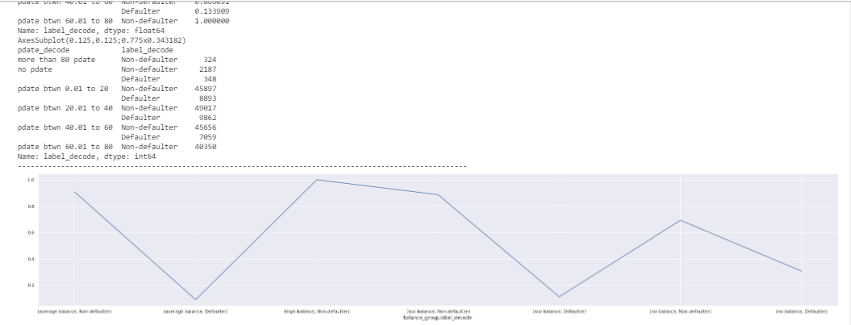

As we said, the high balance has the highest non defaulter rate when checking feature balance_group and its lowest is defaulter rate having average balance.

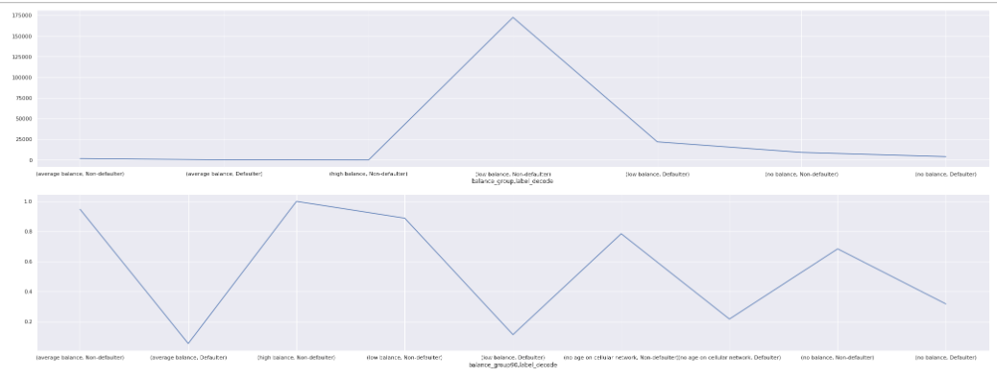

First plot, the low balance has the highest peak.

In the second plot, As we said, the high balance has the highest non defaulter rate when checking feature balance_group and its lowest is defaulter rate having average balance.

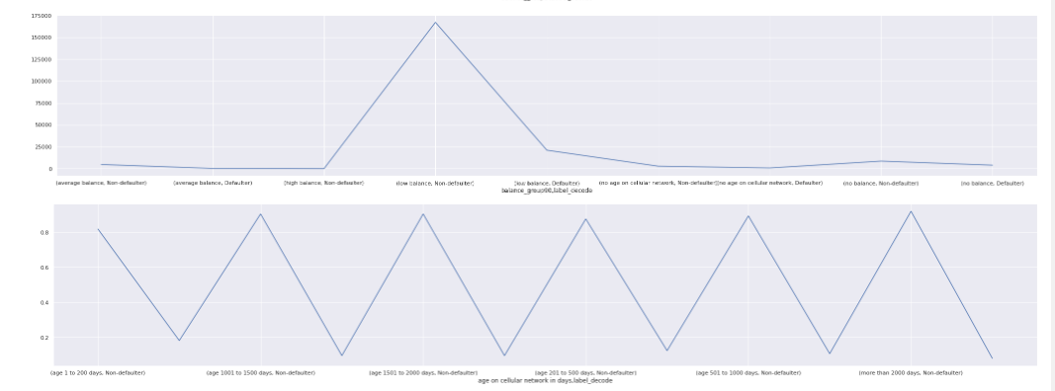

First plot, the low balance has the highest peak.

In the second plot, here we can see the percentaje is very stable along the categories.

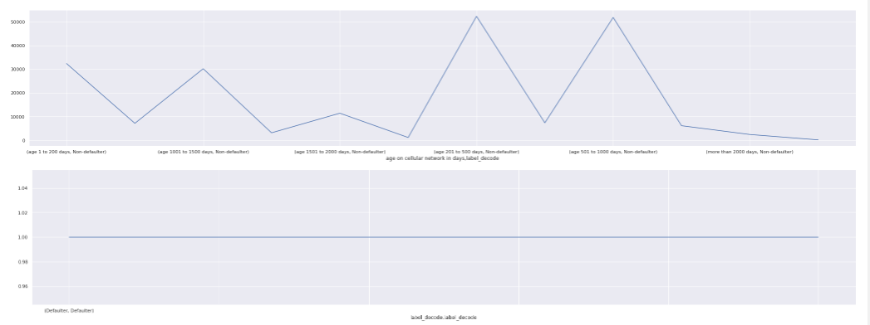

First plot, the cellular age between 200 and 1000 days has the highest peak.

In the second plot, here we can see the percentaje is very stable along the categories as they are the same as the target.

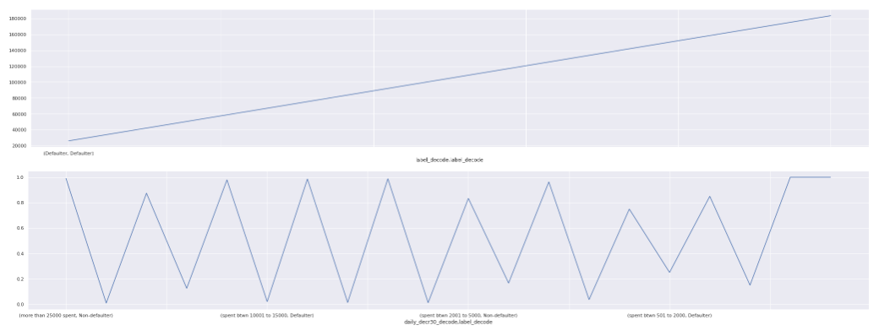

First plot, we have a positive relation of our target label.

In the second plot, here we can see the percentaje is very close and stable, no big variation along the categories as they are the same as the target.

As we said, the high balance has the highest non defaulter rate when checking feature balance_group and its lowest is defaulter rate having average balance.

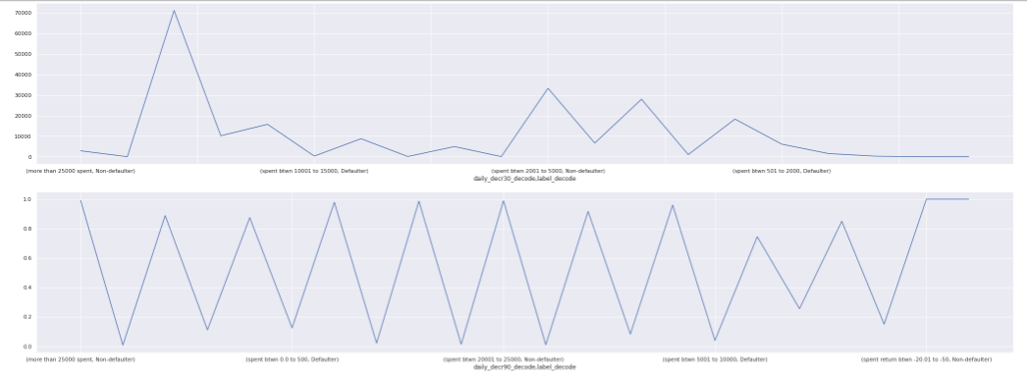

First plot, As we said, the spent between 0 and 500 has the highest non defaulter and defaulter cases when checking feature daily_decr90.

In the second plot, here we can see the percentaje is very stable, no big diference in the percentage along the categories.

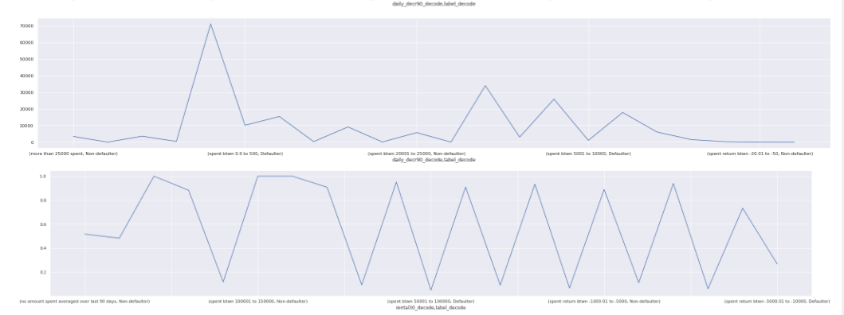

First plot, As we said, the spent between 0 and 500 has the highest non defaulter and defaulter cases when checking feature rental30.

In the second plot, here we can see the percentaje is very stable, no big diference in the percentage along the categories.

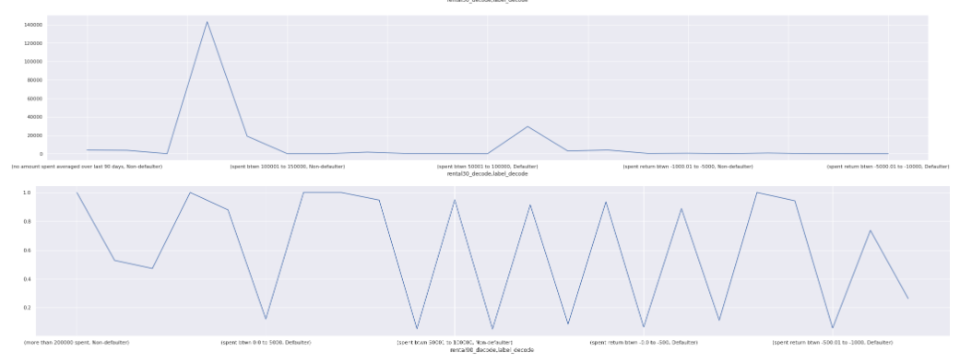

First plot, As we said, the spent between 0 and 500 has the highest non defaulter and defaulter cases when checking feature rental90.

In the second plot, here we can see the percentaje is very stable, no big diference in the percentage along the categories.

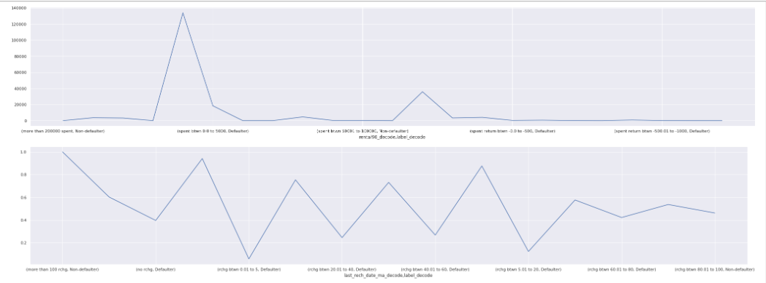

First plot, As we said, the spent between 100 and 200 has the highest non defaulter and defaulter cases when checking feature rental90.

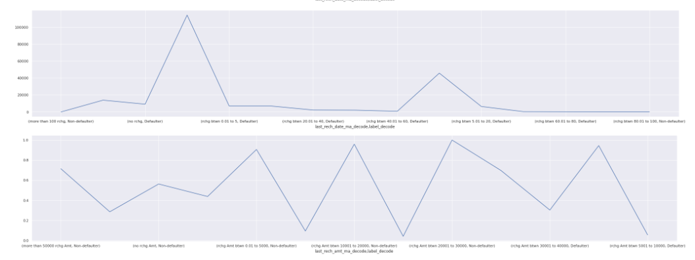

First plot, As we said, the recharge more than 100 has the highest non defaulter when checking feature last_rech_amt_ma

In the second plot, here we can see the percentaje is very stable, no big diference in the percentage along the categories. The highest and lowest rate are close to each other.

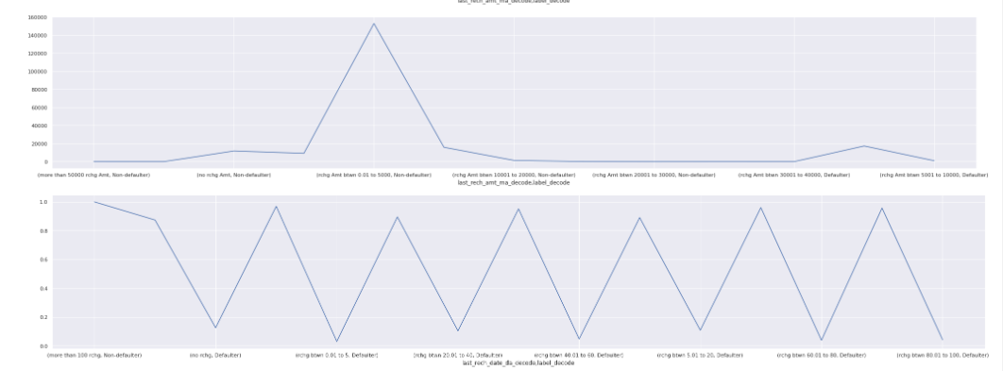

First plot, As we said, the amount between 0 and 5k has the highest non defaulter when checking feature last_rech_amt_ma

In the second plot, here we can see the percentaje is very stable, no big diference in the percentage along the categories. The highest and lowest rate are close to each other.

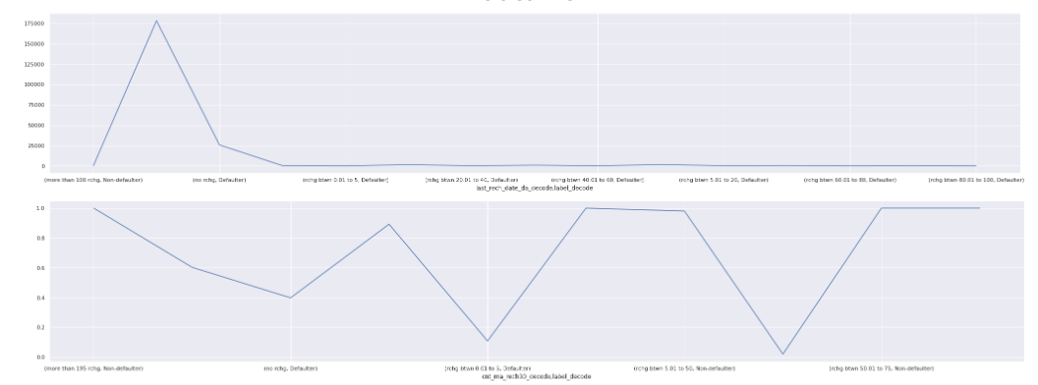

First plot, As we said, the recharge is None that is when it has the highest non defaulter when checking feature last_rech_date_da

In the second plot, here we can see the percentaje is very stable, no big diference in the percentage along the categories. The highest and lowest rate are close to each other.

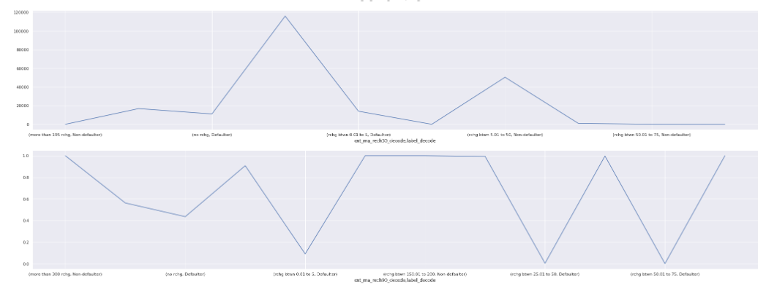

First plot, As we said, the recharge is None that is when it has the highest non defaulter when checking feature cnt_ma_rech30

In the second plot, here we can see the percentaje is very stable, no big diference in the percentage along the categories. The highest and lowest rate are close to each other.

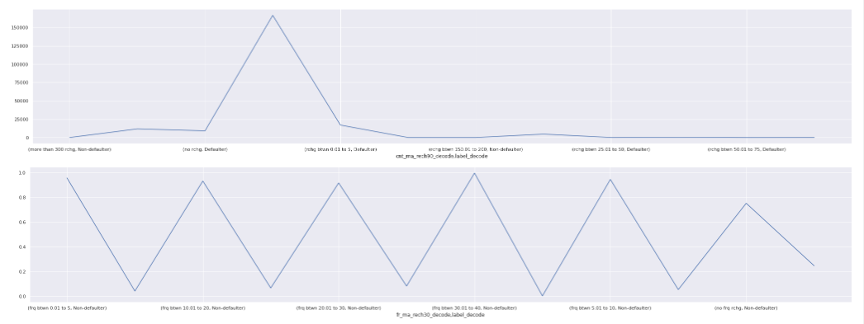

First plot, As we said, the count is None that is when it has the highest defaulter when checking feature cnt_ma_rech30

In the second plot, here we can see the percentaje is very stable, no big diference in the percentage along the categories. The highest and lowest rate are close to each other.

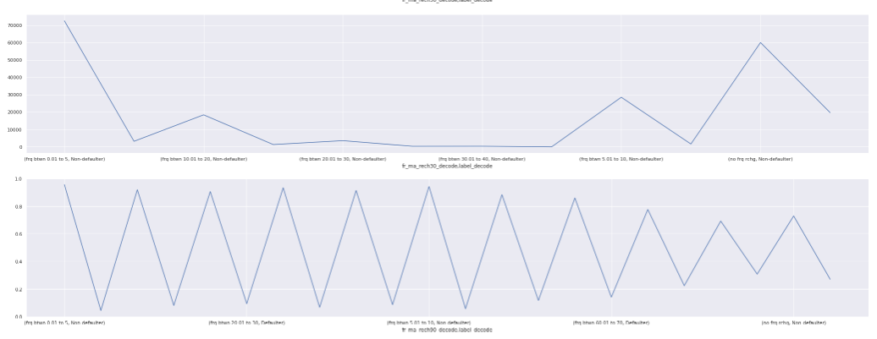

First plot, As we said, the frequency is between 0 and 5 that is when it has the highest non defaulter when checking feature fr_ma_rech30

In the second plot, here we can see the percentaje is very stable, no big diference in the percentage along the categories. The highest and lowest rate are close to each other.

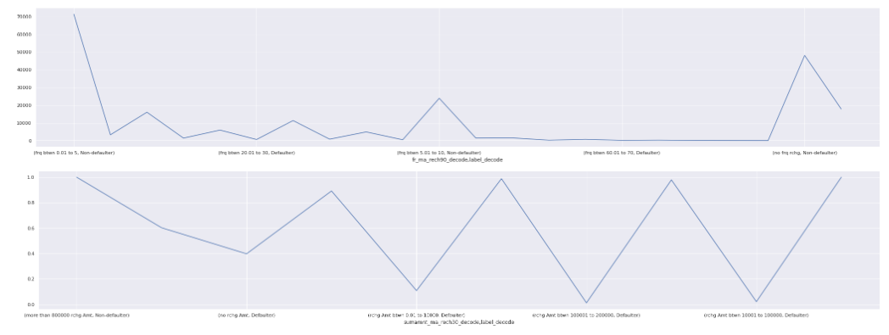

First plot, As we said, the frequency is between 0 and 5 that is when it has the highest non defaulter when checking feature fr_ma_rech90

In the second plot, here we can see the percentaje is very stable, no big diference in the percentage along the categories. The highest and lowest rate are close to each other.

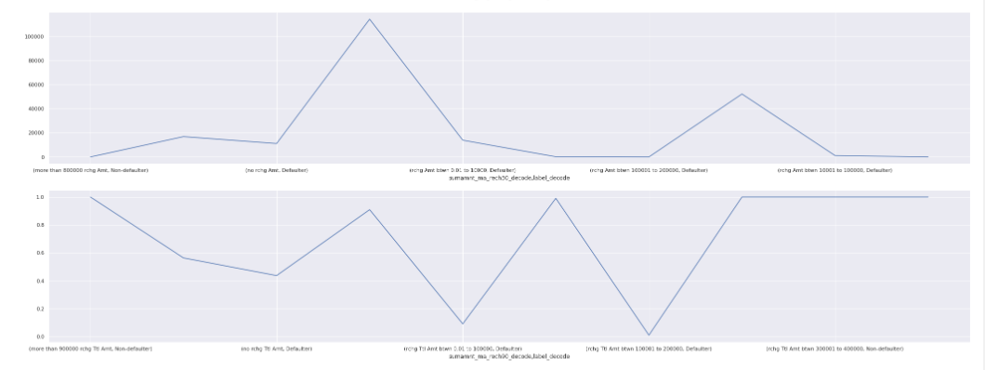

First plot, As we said, the frequency is None that is when it has the highest defaulter when checking feature sumamnt_ma_rech30

In the second plot, here we can see the percentaje is very stable, no big diference in the percentage along the categories. The highest and lowest rate are close to each other.

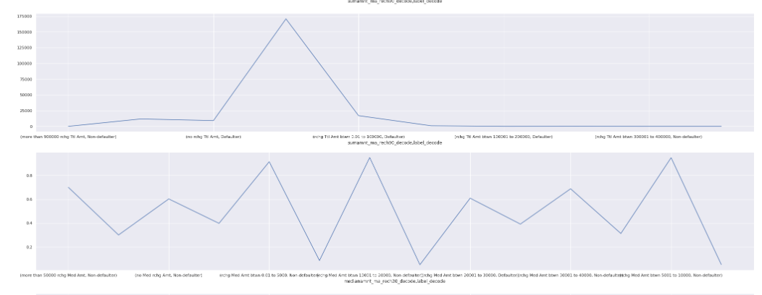

First plot, As we said, the amount sum is between 0 and 100k that is when it has the highest non defaulter when checking feature sumamnt_ma_rec90

In the second plot, here we can see the percentaje is stable in the percentage along the categories. The highest and lowest rate are close to each other eventhough we have cases like mediabetween 5k and 10k where non defaulter has a highest rate.

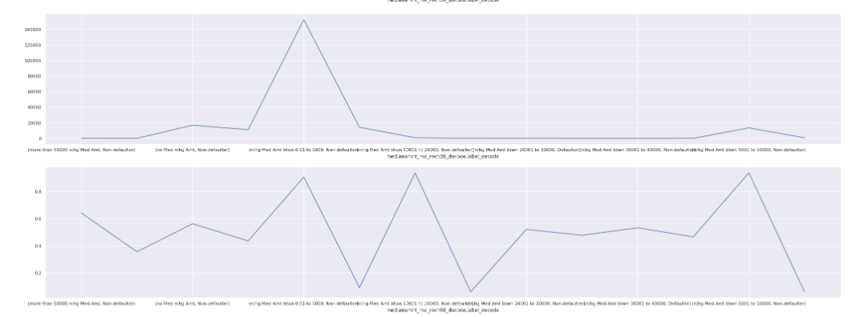

First plot, As we said, the amount sum is between 0 and 100k that is when it has the highest non defaulter when checking feature sumamnt_ma_rec90

In the second plot, here we can see the percentaje is stable in the percentage along the categories. The highest and lowest rate are close to each other eventhough we have cases like mediabetween 5k and 10k where non defaulter has a highest rate.

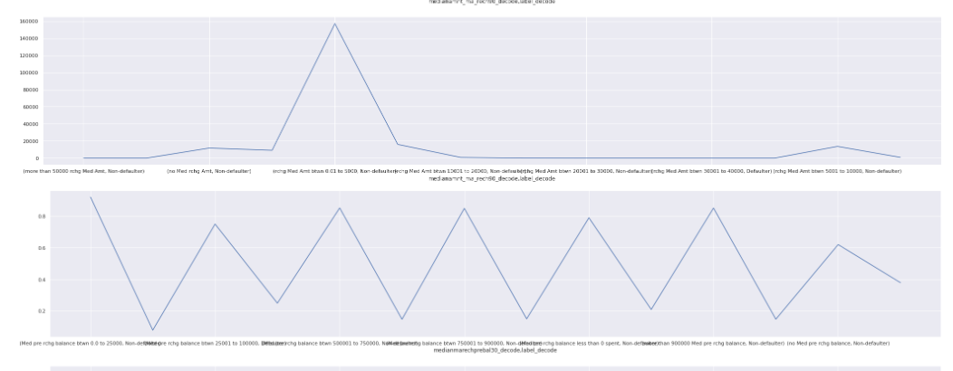

First plot, As we said, the amount sum is between 0 and 100k that is when it has the highest non defaulter when checking feature medianamnt_ma_rec30

In the second plot, here we can see the percentaje is stable in the percentage along the categories. The highest and lowest rate are close to each other eventhough we have cases like mediabetween 0 and 25k where non defaulter has a highest rate.

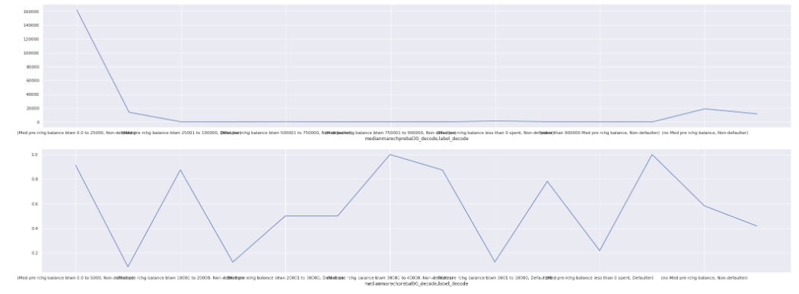

First plot, As we said, the median amount is between 0 and 25k that is when it has the highest non defaulter when checking feature medianmarechprebal30.

In the second plot, here we can see the percentaje is stable in the percentage along the categories. The highest and lowest rate are close to each other eventhough we have cases like medianone medianmarechprebal30 where non defaulter has a highest rate.

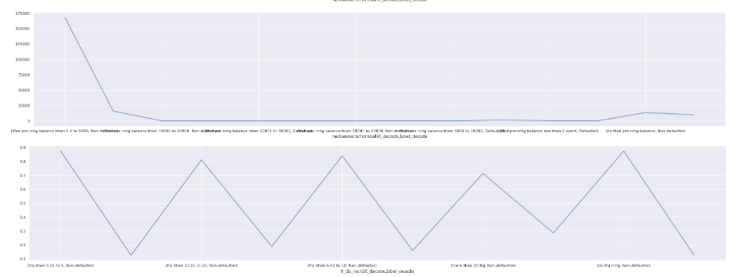

First plot, As we said, the median amount is between 0 and 5k that is when it has the highest non defaulter when checking feature medianmarechprebal90.

In the second plot, here we can see the percentaje is stable in the percentage along the categories. The highest and lowest rate are close to each other eventhough we have cases like medianone medianmarechprebal90 or medianmarechprebal90 between 0 and 5 where non defaulter has a highest rate.

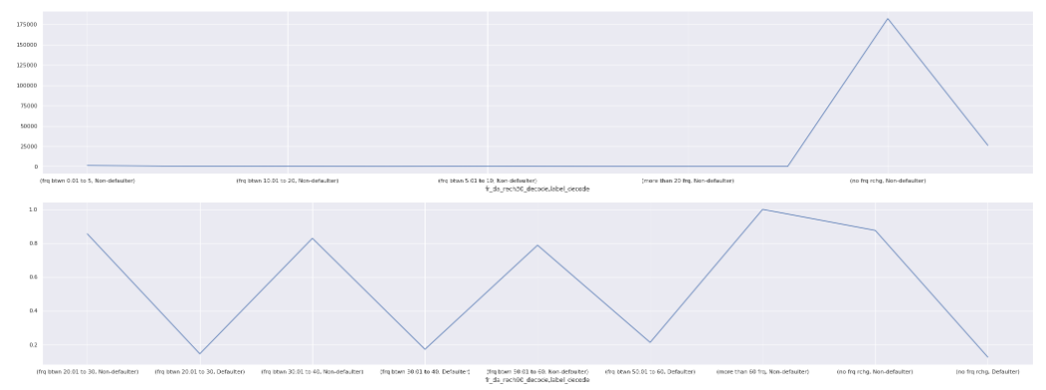

First plot, As we said, the frequency is None that is when it has the highest non defaulter when checking feature fr_da_rech30.

In the second plot, here we can see the percentaje is stable in the percentage along the categories. The highest and lowest rate are close to each other eventhough we have cases like medianone fr_da_rech30 or fr_da_rech30 more than 60 frequencies where non defaulter or defaulter has a highest rate.

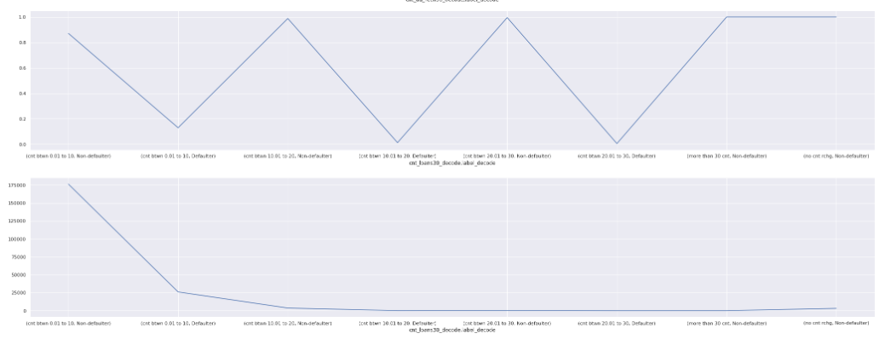

In the first plot, here we can see the percentaje is stable in the percentage along the categories. The highest and lowest rate are close to each other.

In the second plot, As we said, the times between 0 and 10 has the highest non defaulter when checking feature cnt_rech30.

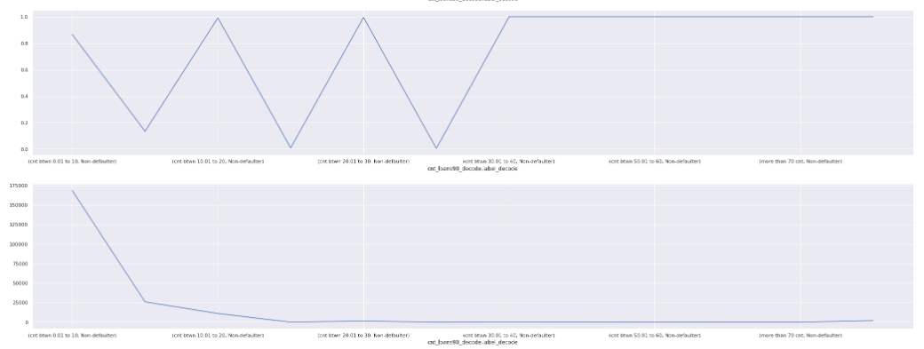

In the first plot, here we can see the percentaje is stable in the percentage along the categories. The highest and lowest rate are close to each other.

In the second plot, As we said, the times between 0 and 10 has the highest non defaulter when checking feature cnt_rech90.

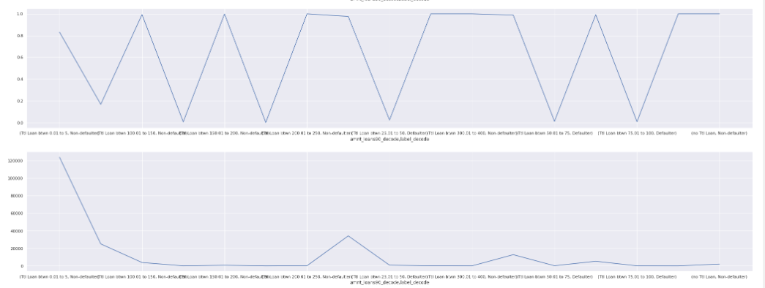

In the first plot, here we can see the percentaje is stable in the percentage along the categories. The highest and lowest rate are close to each other.

In the second plot, As we said, the amount between 0 and 5 has the highest non defaulter when checking feature amnt_loans90.

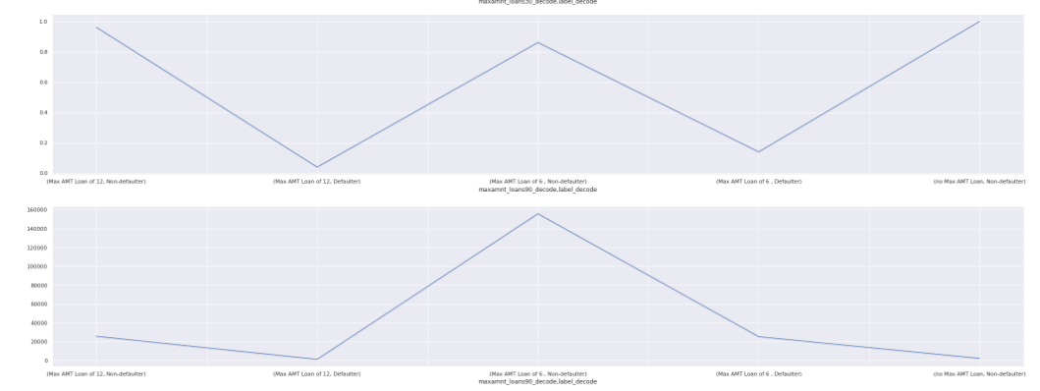

In this plot, As we said, the maximum amount of 6 has the highest non defaulter when checking feature maxamnt_loans90.

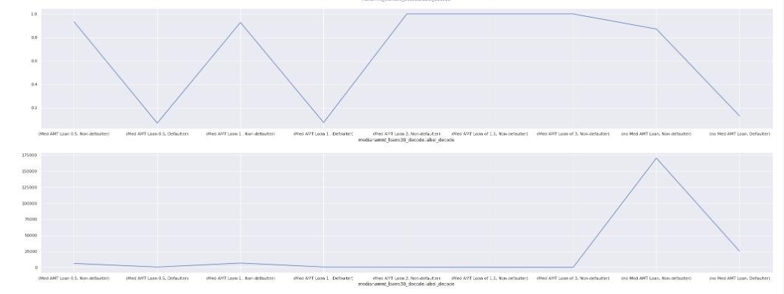

In the first plot, here we can see the percentaje is stable in the percentage along the categories. The highest and lowest rate are close to each other.

In the second plot, As we said, the None median has the highest non defaulter when checking feature medianamnt_loans30.

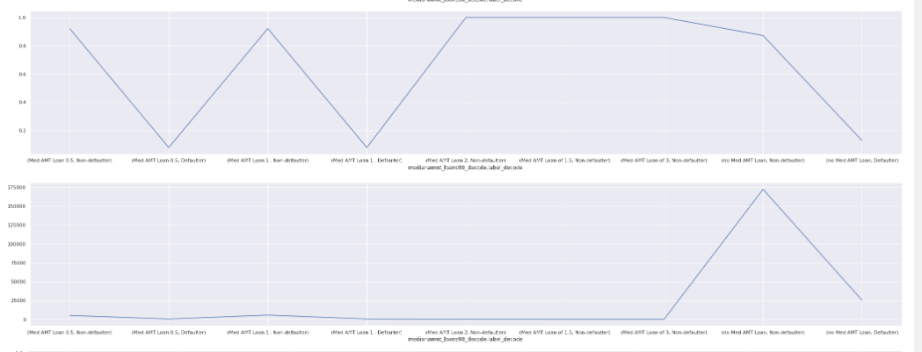

In the first plot, here we can see the percentaje is stable in the percentage along the categories. The highest and lowest rate are close to each other.

In the second plot, As we said, the None median has the highest non defaulter when checking feature medianamnt_loans90.

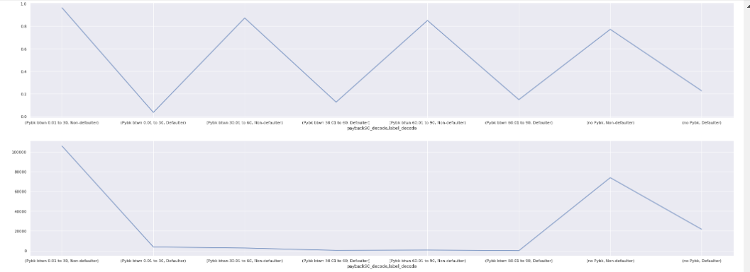

In the first plot, here we can see the percentaje is stable in the percentage along the categories. The highest and lowest rate are close to each other.

In the second plot, As we said, the None Payback has the highest non defaulter when checking feature payback30.

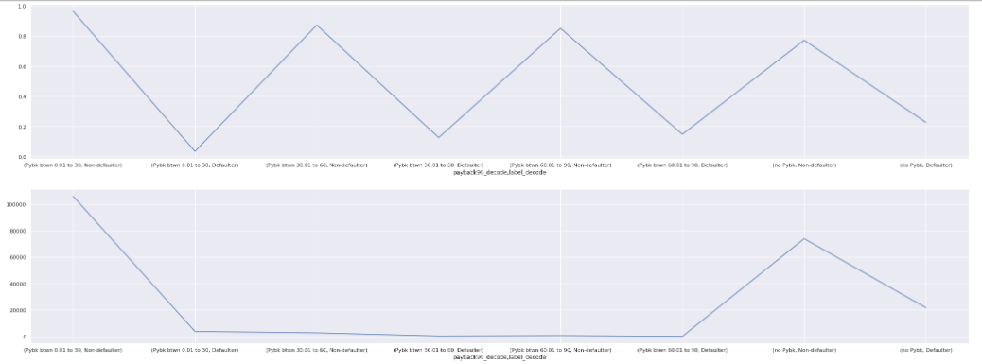

In the first plot, here we can see the percentaje is stable in the percentage along the categories. The highest and lowest rate are close to each other.

In the second plot, As we said, the payback between 0 and 30 has the highest non defaulter when checking feature payback90_loans30.

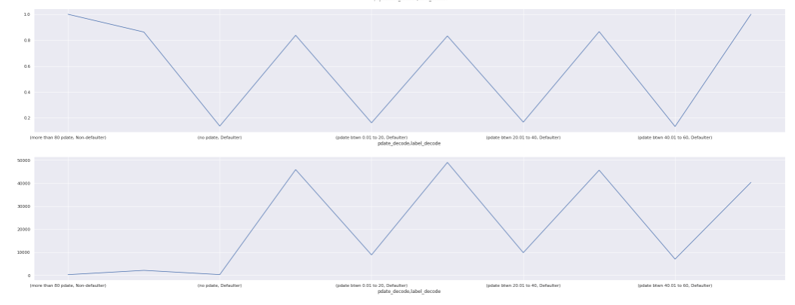

In the first plot, here we can see the percentaje is stable in the percentage along the categories. The highest and lowest rate are close to each other.

In the second plot, As we said, all categories has a stable non defaulter and defaulter number of cases when checking feature pdate.

Boxplots:

We also plotted box plots for all our features including the target in order to check outliers in all the features:

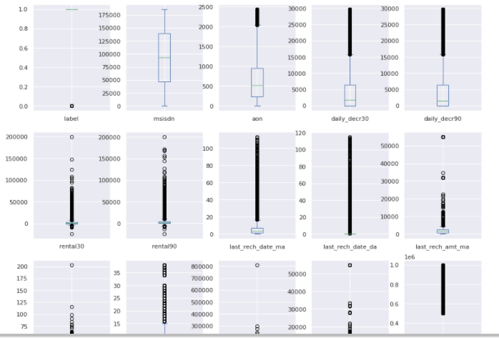

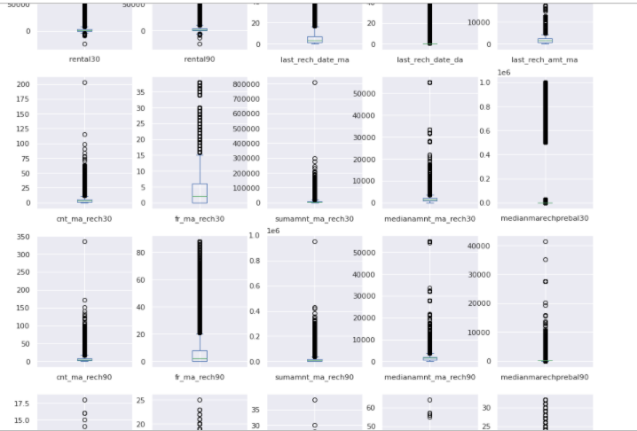

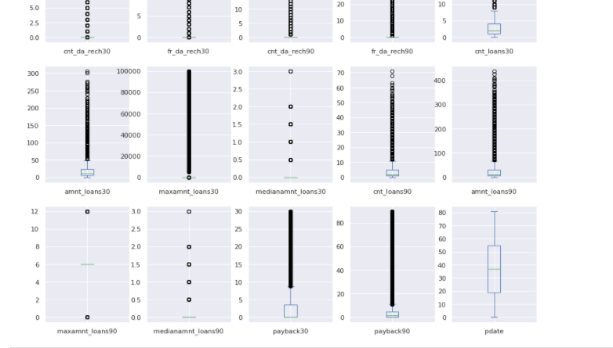

The circles are the outliers for each feature. Almost all the features have outliers including our target variable which is one of the variables that has high number of outliers.

Short conclusion of outliers, all the features except msisdn and pdate have outliers. Some have small interquartile and other larger.

In the above and below boxplots, we can clearly see that almost all the features, except pdate and msisdn, has outliers in its distribution.

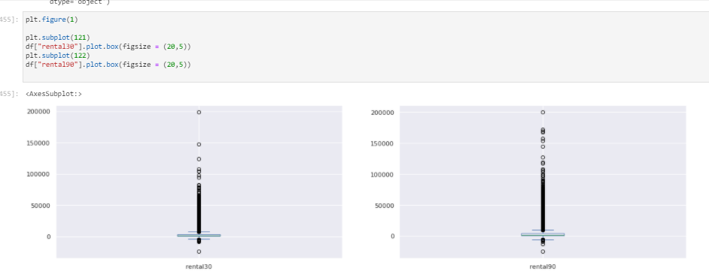

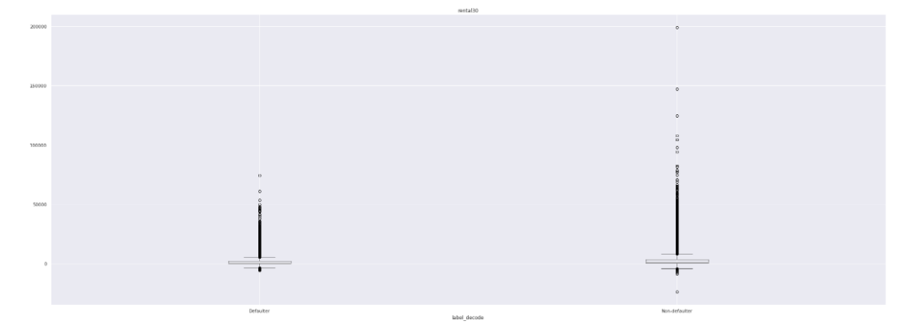

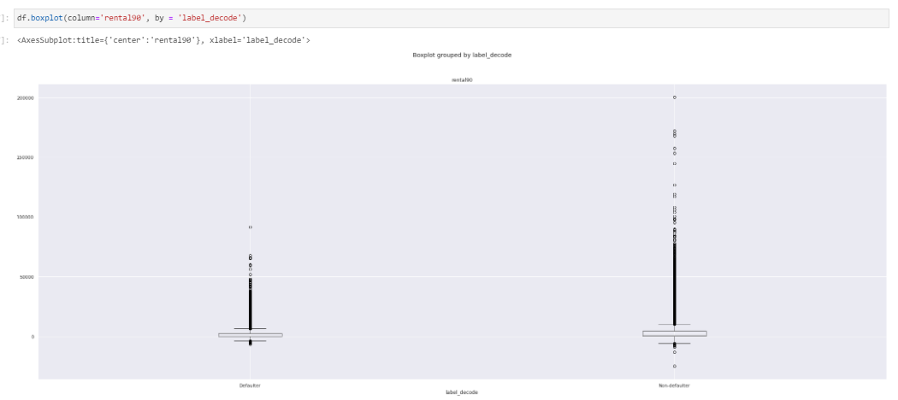

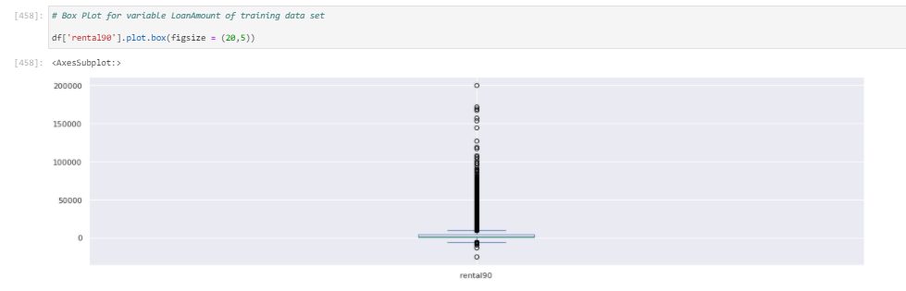

**As we said, all features including the above features have outliers except the features pdate and msisdn, which is mobile number of user.**

**As we already explained the main findings in the above plots, so here we will highlight the main point of each plot:**

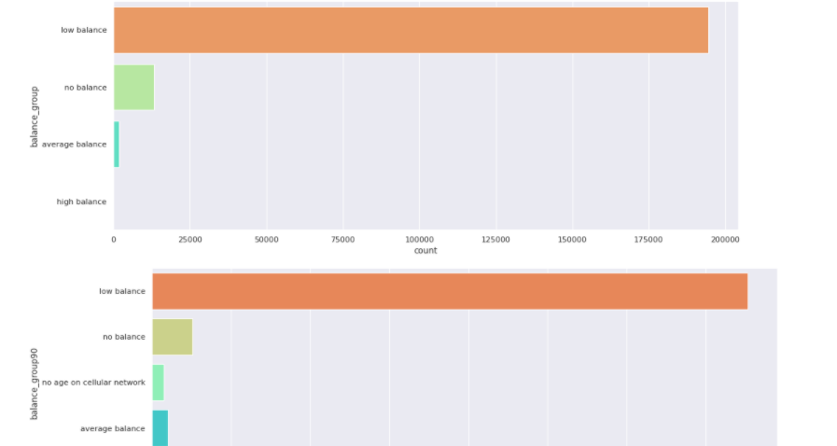

**For balance30_group and balance90_group, we can see the low balance has the highest number of instances.**

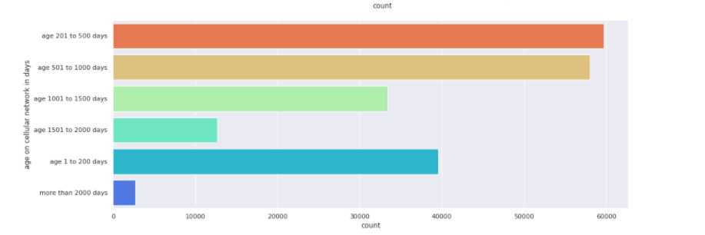

**For age on cellular network, we can see the age between 200 and 1000 has the highest number of instances compared to other groups.**

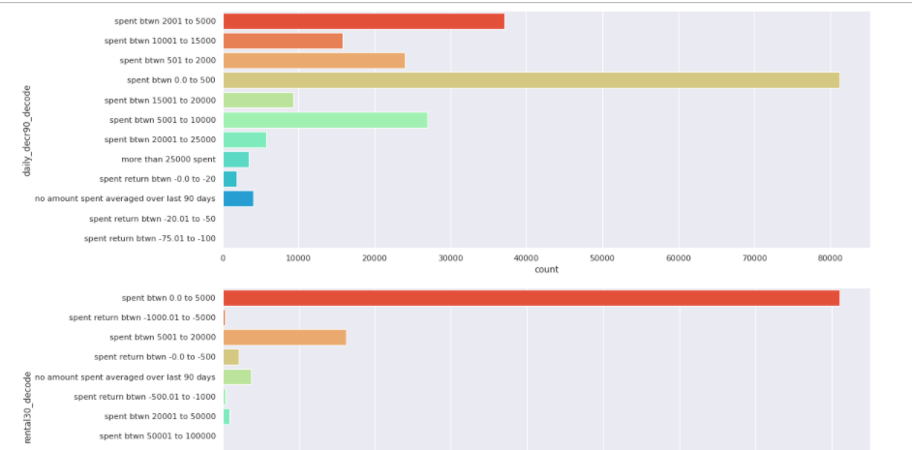

**For daily_decr90, we can see the spent between 0 and 500 has the highest number of instances. And the second place is for spent between 2k and 5k.**

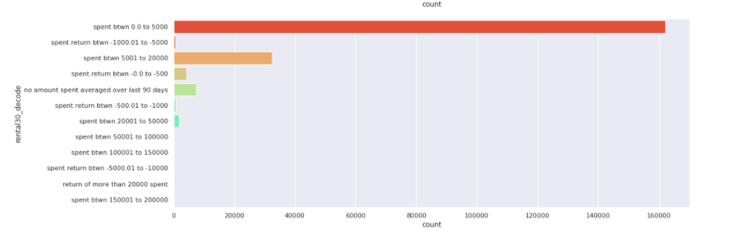

**For rental30, we can see the spent between 0 and 5k has the highest number of instances compared to other groups.**

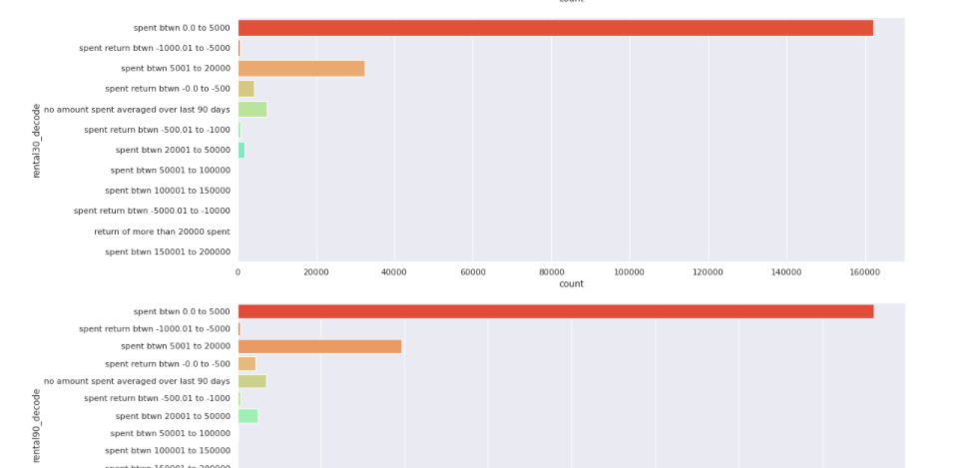

**For rental90, we can see the spent between 0 and 5k has the highest number of instances compared to other groups.**

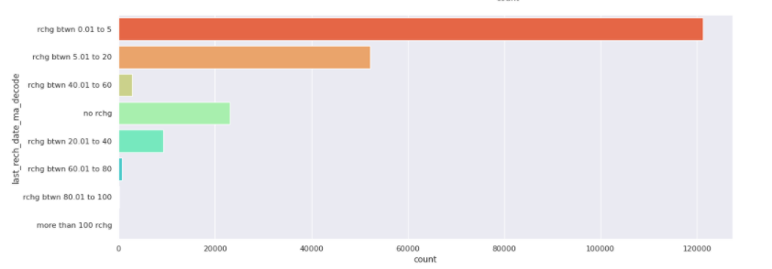

**For rech_date_ma, we can see the recharge between 0 and 20 has the highest number of instances compared to other groups.**

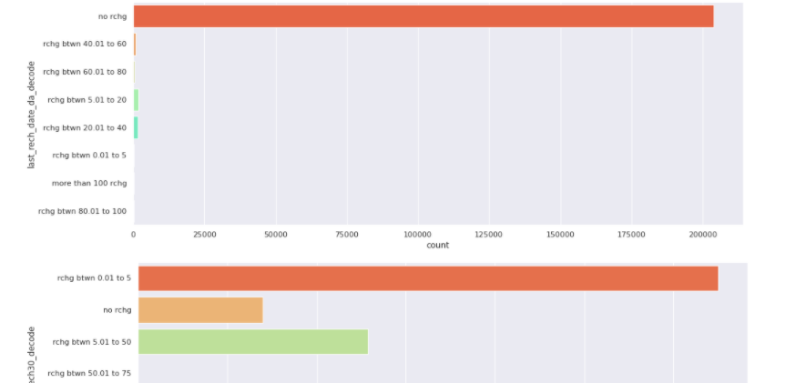

**For rech_date_da, we can see the recharge between 0 and 20 has the highest number of instances compared to other groups.**

**For cn_ma_rech30, we can see the recharge between 0 and 5 has the highest number of instances compared to other groups.**

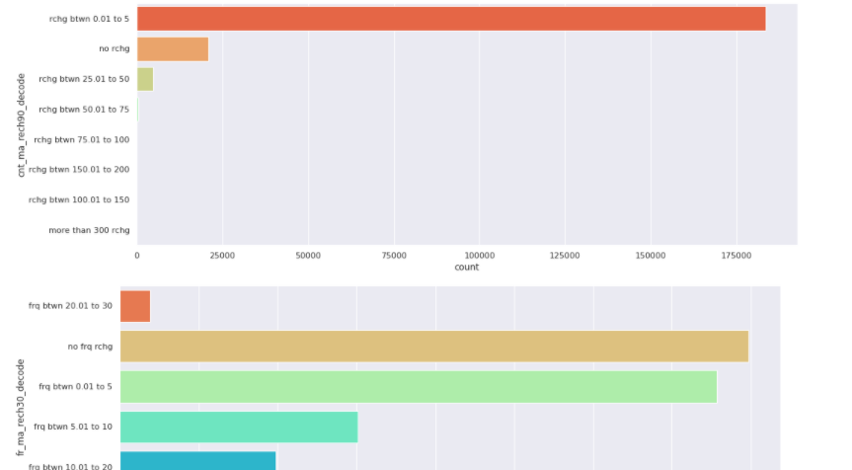

**For cnt_ma_rech90, we can see the recharge between 0 and 5 has the highest number of instances compared to other groups.**

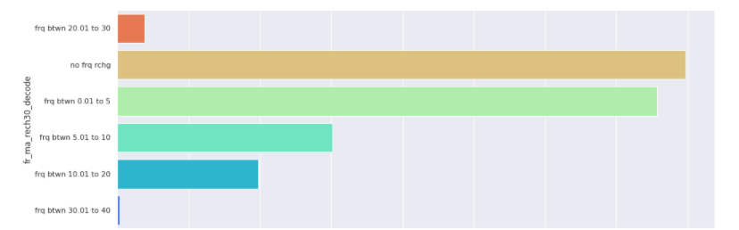

**For fr_ma_rech30, we can see either the recharge between 0 and 5 or no frequency of recharge has the highest number of instances compared to other groups.**

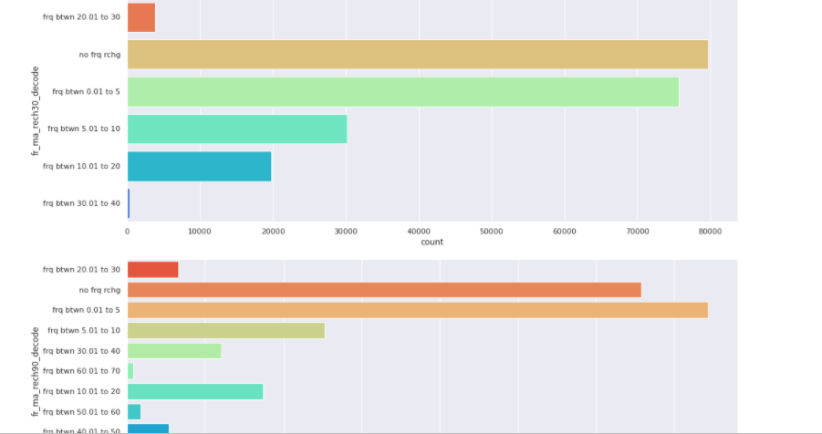

**For fr_ma_rech90, we can see either the recharge between 0 and 5 or no frequency of recharge has the highest number of instances compared to other groups.**

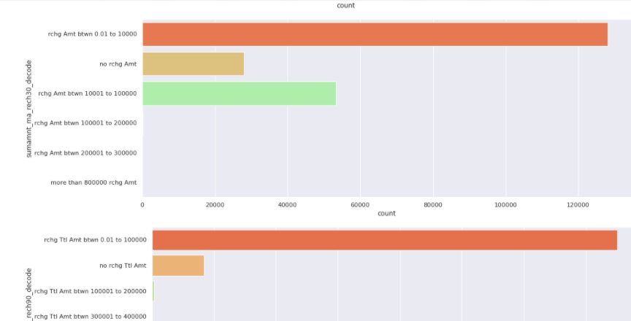

**For sumamnt_ma_rech30 and sumamnt_ma_rech90, we can see the recharge total amount between 0 and 100k has the highest number of instances compared to other groups.**

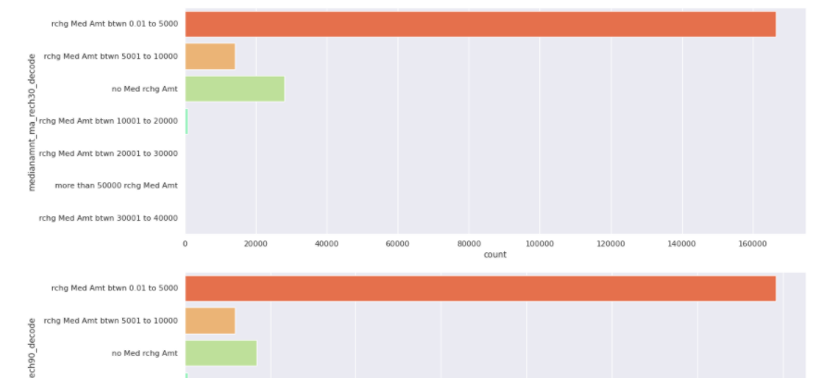

**For medianamnt_ma_rech30 and medianamnt_ma_rech90, we can see the recharge median amount between 0 and 5k has the highest number of instances compared to other groups.**

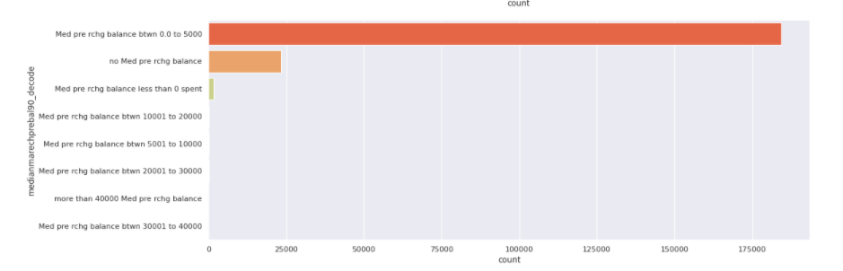

**For medianmarechprebal90, we can see the median pre recharge balance between 0 and 5k has the highest number of instances compared to other groups.**

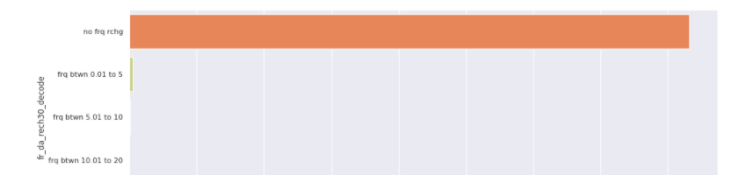

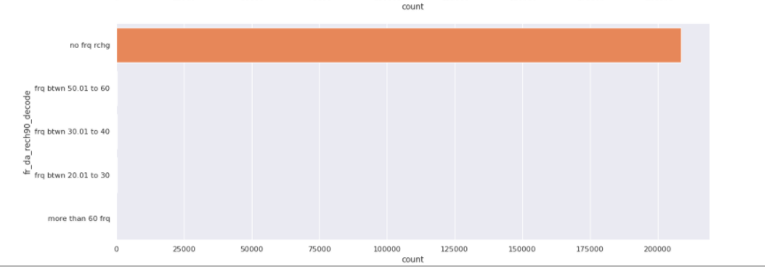

**For fr_da_rech30 and fr_da_rech90, we can see the frequency None has the highest number of instances compared to other groups.**

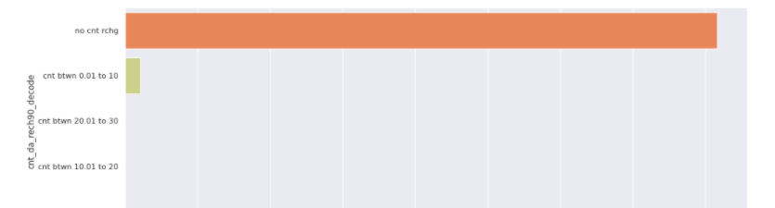

**For cnt_da_rech90, we can see the 0 number of times has the highest number of instances compared to other groups.**

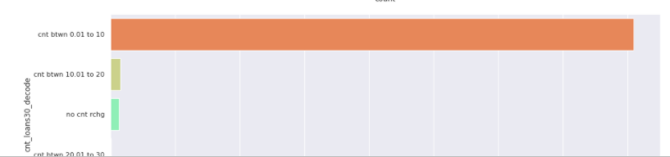

**For cnt_loans30, we can see the number of times between 0 and 10 has the highest number of instances compared to other groups.**

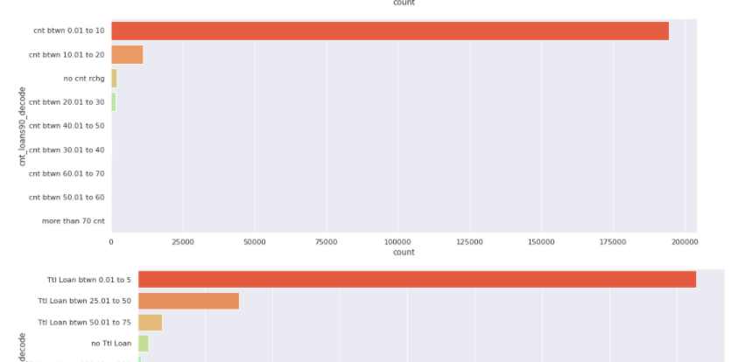

**For cnt_loans90, we can see the 0 number of times has the highest number of instances compared to other groups.**

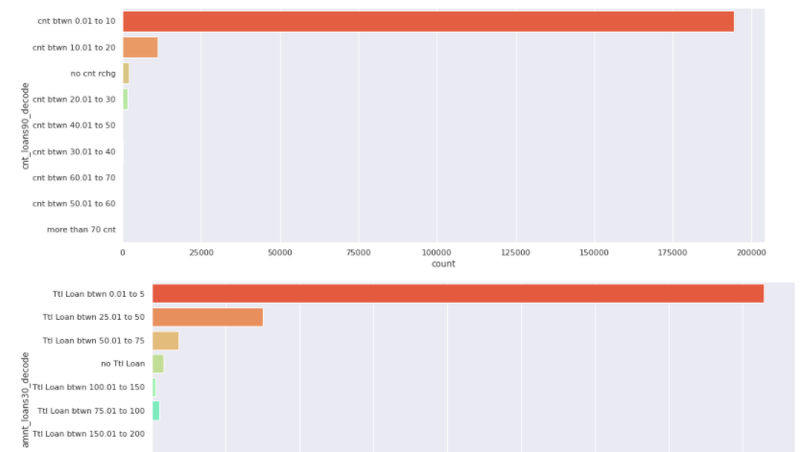

**For cnt_da_rech90, we can see the 0 number of times has the highest number of instances compared to other groups.**

**For amnt_loans30, we can see the total loan between 0 and 5 has the highest number of instances compared to other groups.**

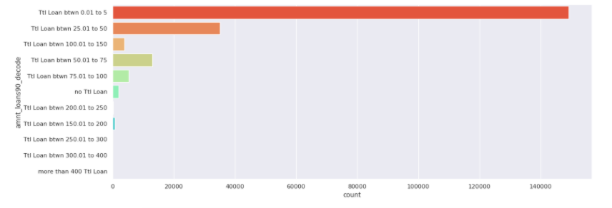

**For amnt_loans90, we can see the total loan between 0 and 5 has the highest number of instances compared to other groups.**

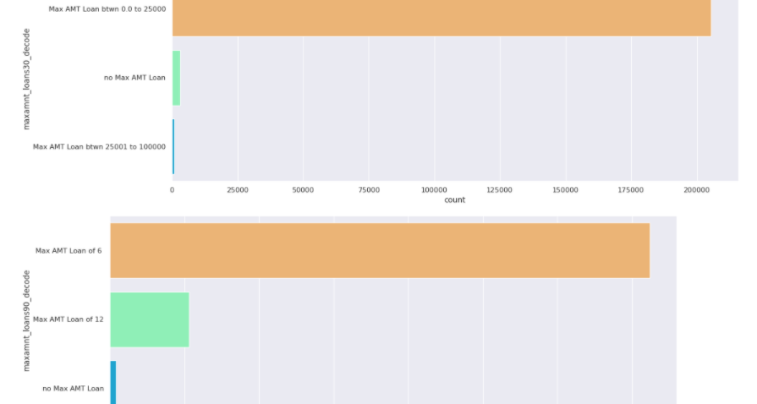

**For maxamnt_loans30, we can see the maximum amount between 0 and 25k has the highest number of instances compared to other groups.**

**For maxamnt_loans90, we can see the maximum amount 6 has the highest number of instances compared to other groups.**

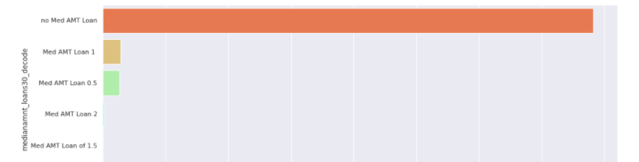

**For medianamnt_loans30, we can see the Median amount of loan with None median amount has the highest number of instances compared to other groups.**

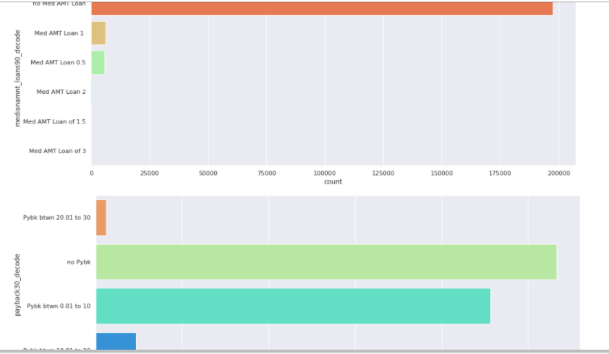

**For medianamnt_loans90, we can see the Median amount of loan with None median amount has the highest number of instances compared to other groups.**

**For payback30, we can see either payback None or payback between 0 and 10 have the highest number of instances compared to other groups.**

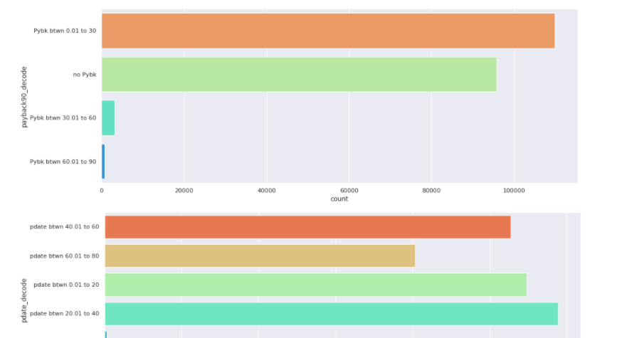

**For payback90, we can see either payback None or payback between 0 and 30 have the highest number of instances compared to other groups.**

**For pdate, we can see pdate has no big difference between different categories. Pdate between 20 and 40 has the highest number of cases.**

**Now we will plot the barplots but in this case we will plot all the categorical features broken down by the target value:**

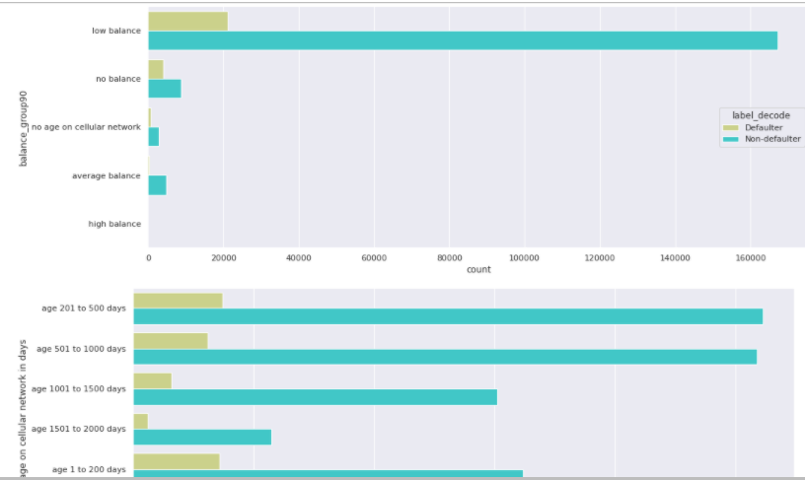

**When checking the balance_group90, we can see the lowbalance has the highest number of defaulter and non defaulter cases.**

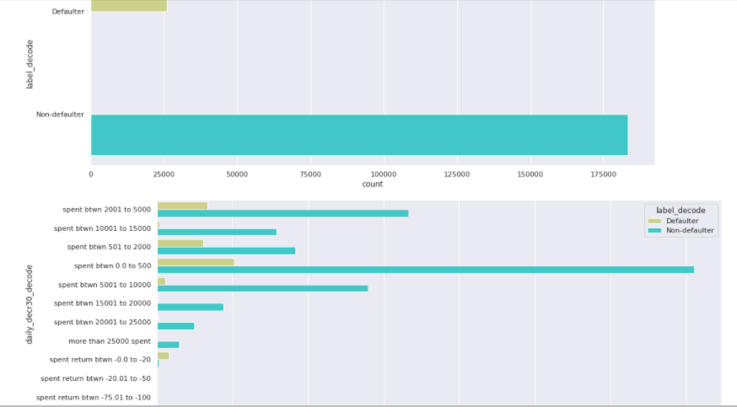

**When checking the daily_decr30, we can see the spent between 0 and 500 has the highest number of defaulter and non defaulter cases. As in all cases, the non defaulter are likely to happen to occur than defaulter cases.**

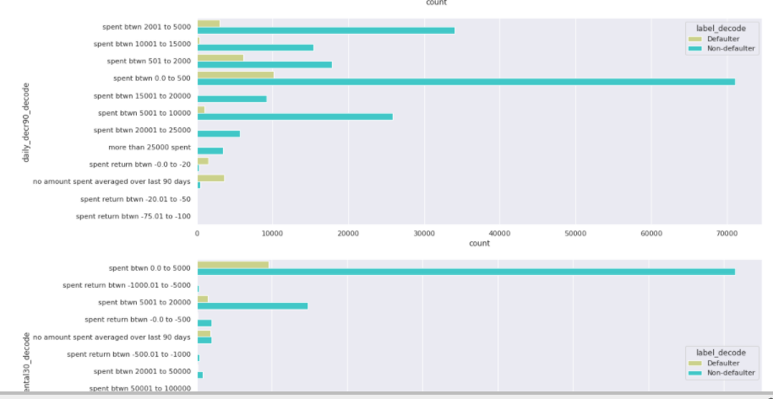

**When checking the daily_decr90, we can see the spent between 0 and 500 has the highest number of defaulter and non defaulter cases. As in all cases, the non defaulter are likely to happen to occur than defaulter cases.**

**When checking the rental30, we can see the spent between 0 and 5k has the highest number of defaulter and non defaulter cases. As in all cases, the non defaulter are likely to happen to occur than defaulter cases.**

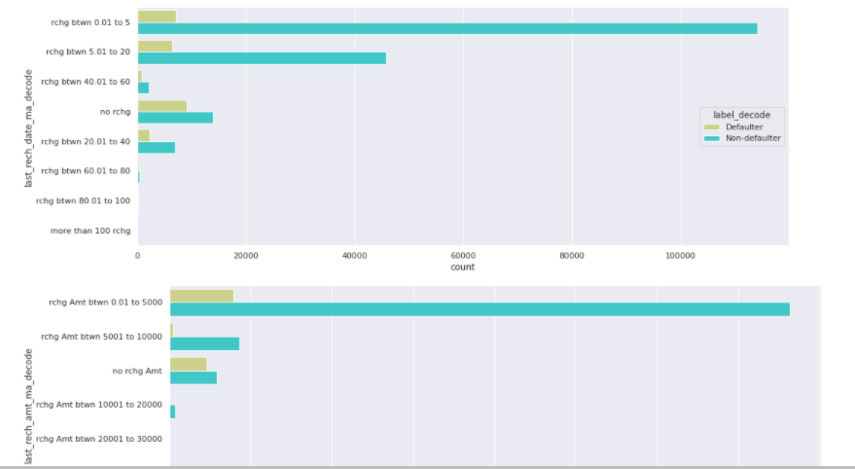

**When checking the last_rech_date_ma, we can see the recharge between 0 and 5 has the highest number of non defaulter cases and none recharge has the highest number defaulter cases. As in all cases, the non defaulter are likely to happen to occur than defaulter cases.**

**When checking the last_rech_amt_ma, we can see the recharge between 0 and 5k has the highest number of non defaulter and defaulter cases. As in all cases, the non defaulter are likely to happen to occur than defaulter cases.**

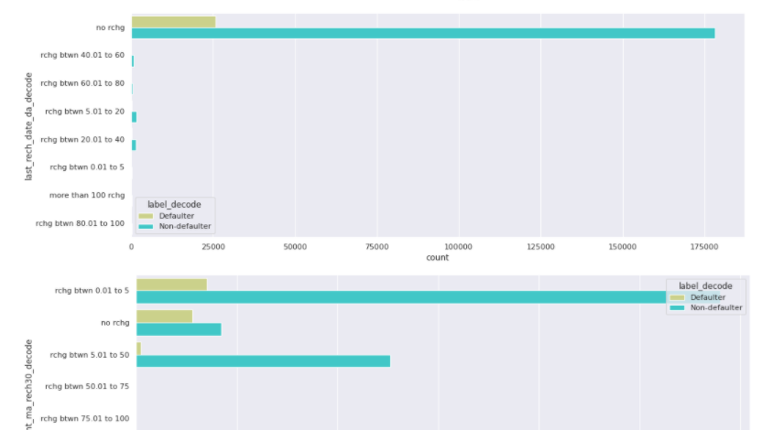

**When checking the last_rech_date_da, we can see the None recharge has the highest number of non defaulter and defaulter cases. As in all cases, the non defaulter are likely to happen to occur than defaulter cases.**

**When checking the cnt_ma_rech30, we can see the times between 0 and 5 has the highest number of non defaulter and defaulter cases. As in all cases, the non defaulter are likely to happen to occur than defaulter cases.**

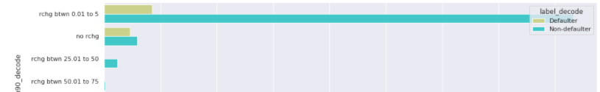

**When checking the cnt_ma_rech90, we can see the times between 0 and 5 has the highest number of non defaulter and defaulter cases. As in all cases, the non defaulter are likely to happen to occur than defaulter cases.**

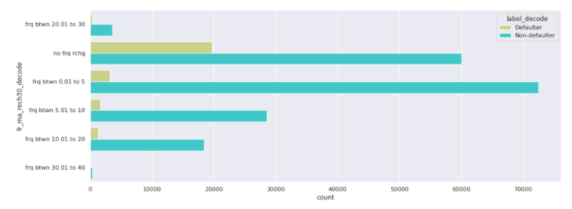

**When checking the fr_ma_rech30, we can see the frequency between 0 and 5 has the highest number of non defaulter and the frequency None has the highest number of defaulter cases. As in all cases, the non defaulter are likely to happen to occur than defaulter cases.**

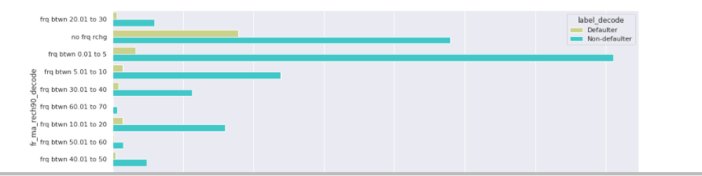

**When checking the fr_ma_rech90, we can see the frequency between 0 and 5 has the highest number of non defaulter and the frequency None has the highest number of defaulter cases. As in all cases, the non defaulter are likely to happen to occur than defaulter cases.**

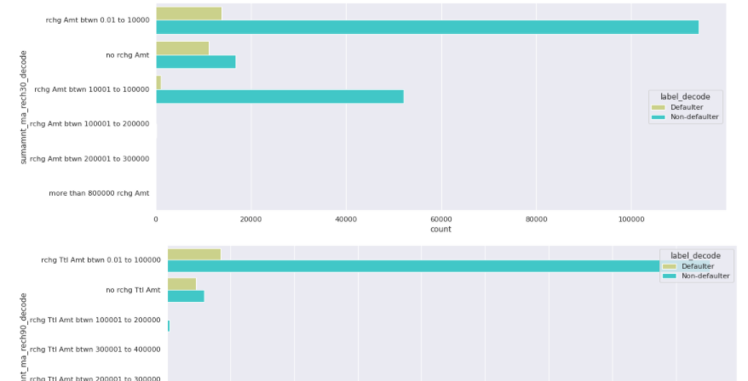

**When checking the sumamnt_ma_rech30, we can see the frequency between 0 and 10k has the highest number of non defaulter and defaulter cases. As in all cases, the non defaulter are likely to happen to occur than defaulter cases.**

**When checking the sumamnt_ma_rech90, we can see the frequency between 0 and 10k has the highest number of non defaulter and defaulter cases. As in all cases, the non defaulter are likely to happen to occur than defaulter cases.**

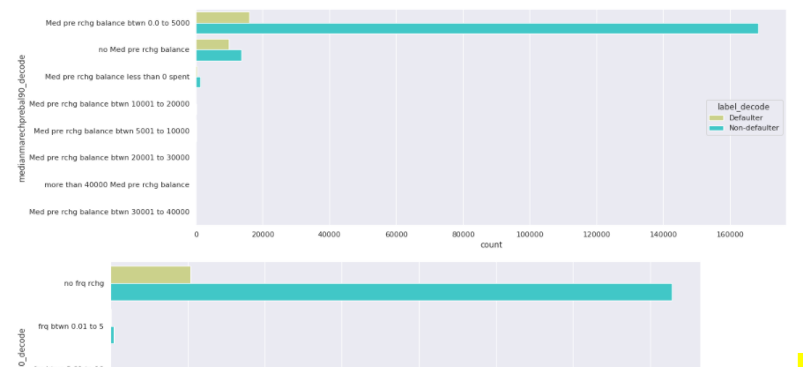

**When checking the medianmarechprebal90, we can see the median pre recharge balance between 0 and 5k has the highest number of non defaulter and defaulter cases. As in all cases, the non defaulter are likely to happen to occur than defaulter cases.**

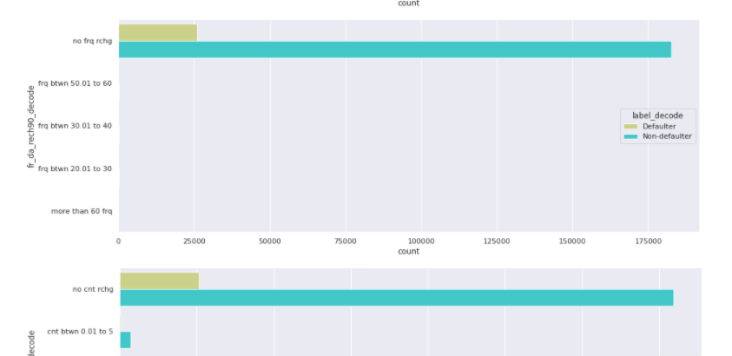

**When checking the fr_da_rech90, we can see the frequency None has the highest number of non defaulter and defaulter cases. As in all cases, the non defaulter are likely to happen to occur than defaulter cases.**

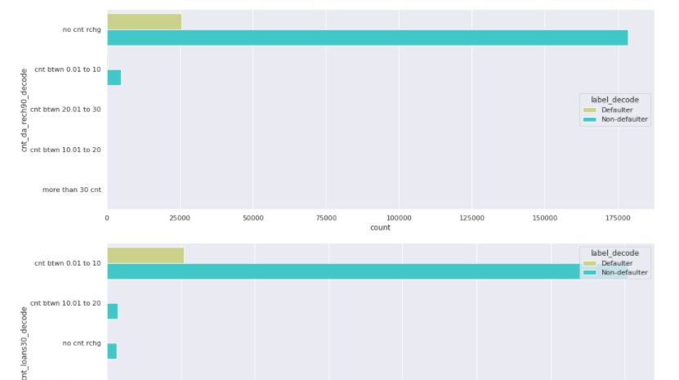

**When checking the cnt_da_rech90, we can see the times of recharge None has the highest number of non defaulter and defaulter cases. As in all cases, the non defaulter are likely to happen to occur than defaulter cases.**

**When checking the cnt_loans30, we can see the times of recharge between 0 and 10 has the highest number of non defaulter and defaulter cases. As in all cases, the non defaulter are likely to happen to occur than defaulter cases.**

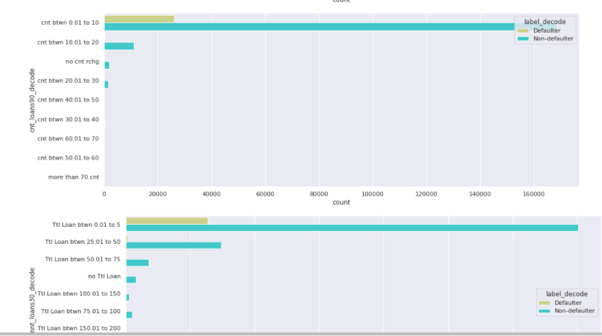

**When checking the cnt_loans90, we can see the times of recharge between 0 and 10 has the highest number of non defaulter and defaulter cases. As in all cases, the non defaulter are likely to happen to occur than defaulter cases.**

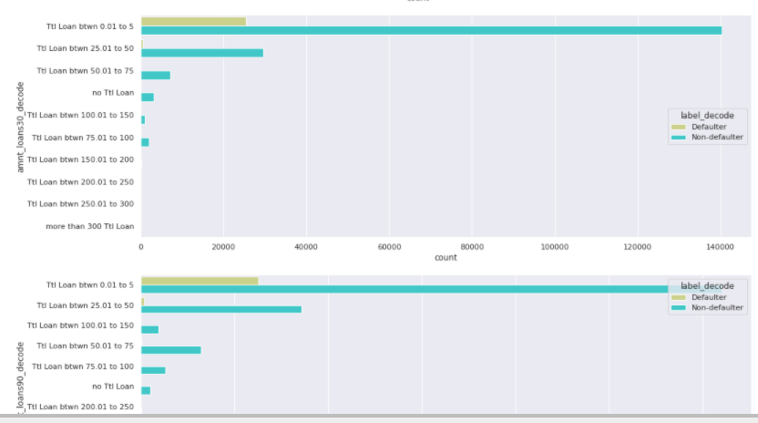

**When checking the amnt_loans30, we can see the total loan between 0 and 5 has the highest number of non defaulter and defaulter cases. As in all cases, the non defaulter are likely to happen to occur than defaulter cases.**

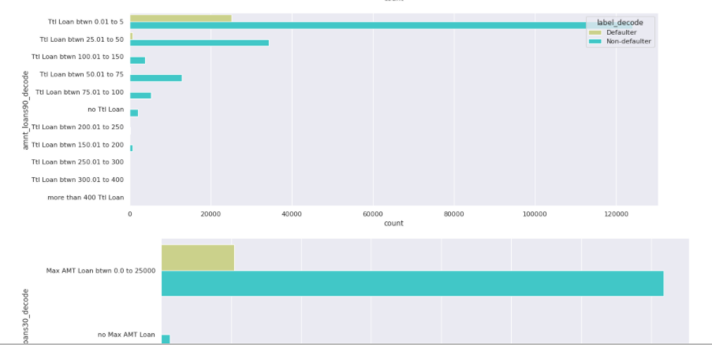

**When checking the amnt_loans90, we can see the total loan between 0 and 5 has the highest number of non defaulter and defaulter cases. As in all cases, the non defaulter are likely to happen to occur than defaulter cases.**

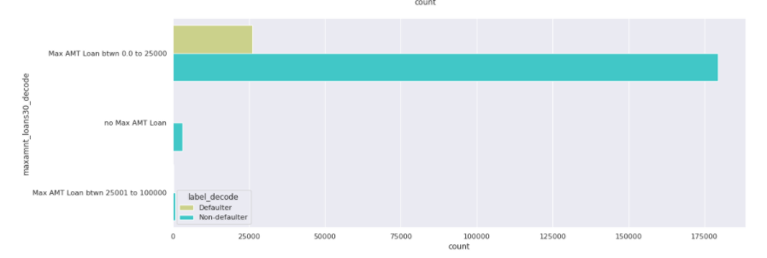

**When checking the maxamnt_loans30, we can see the maximum amount of loan between 0 and 25k has the highest number of non defaulter and defaulter cases. As in all cases, the non defaulter are likely to happen to occur than defaulter cases.**

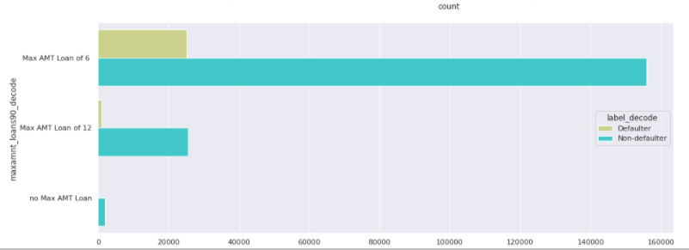

**`**

**When checking the maxamnt_loans90, we can see the maximum amount of loan of 6 has the highest number of non defaulter and defaulter cases. As in all cases, the non defaulter are likely to happen to occur than defaulter cases.**

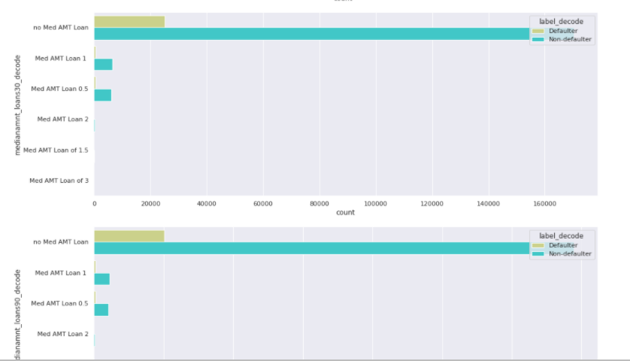

**When checking the medianamnt_loans30 and medianamnt_loans90, we can see the median amount of loan of None has the highest number of non defaulter and defaulter cases. As in all cases, the non defaulter are likely to happen to occur than defaulter cases.**

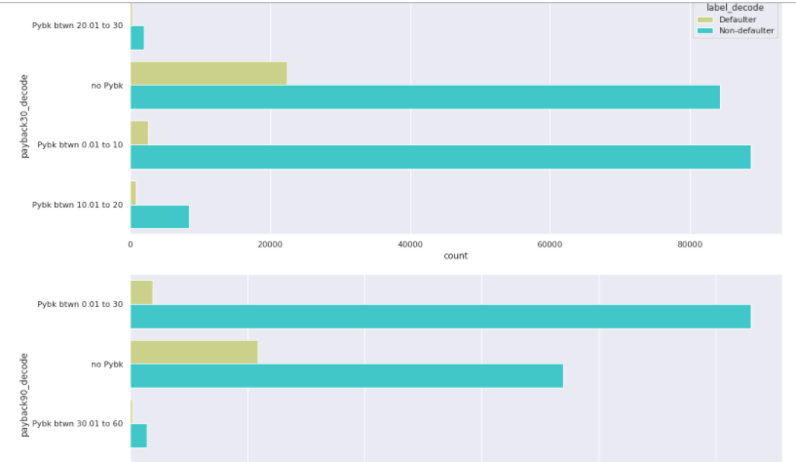

**When checking the payback30 and payback90, we can see the payback loan of None has the highest number of defaulter cases. We can notice the payback30 between 0 and 10 has the highest number of non-defaulter cases and payback90 between 0 and 30 has the highest number of non-defaulter cases. As in all cases, the non defaulter are likely to happen to occur than defaulter cases.**

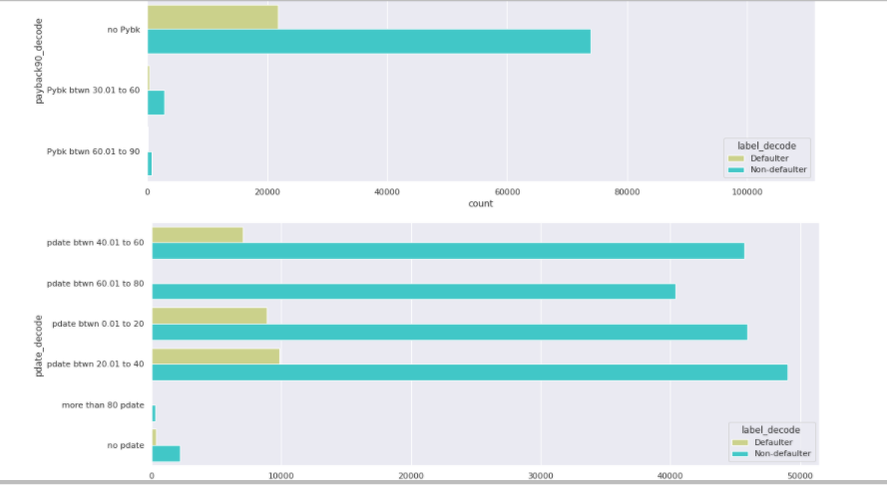

**When checking the pdate, we can see the pdate between 20 and 40 has the highest number of non defaulter and defaulter cases. As in all cases, the non defaulter are likely to happen to occur than defaulter cases.**

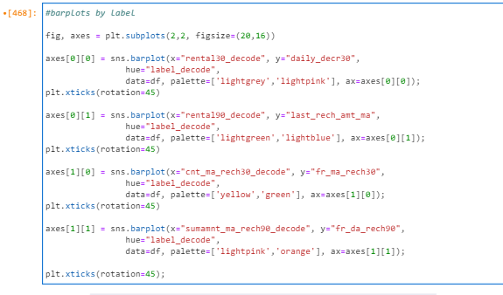

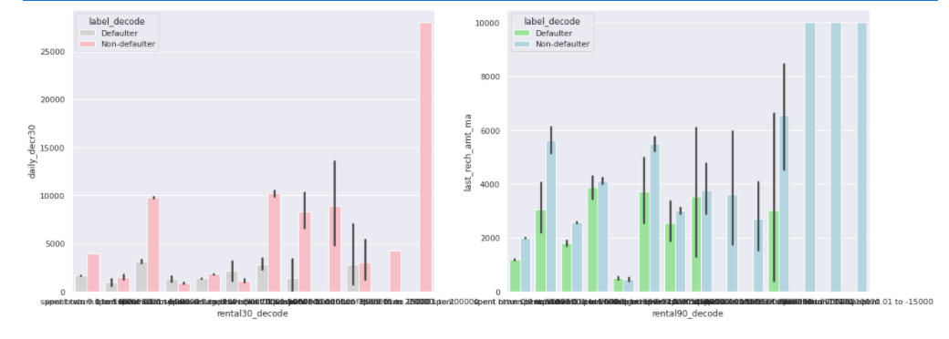

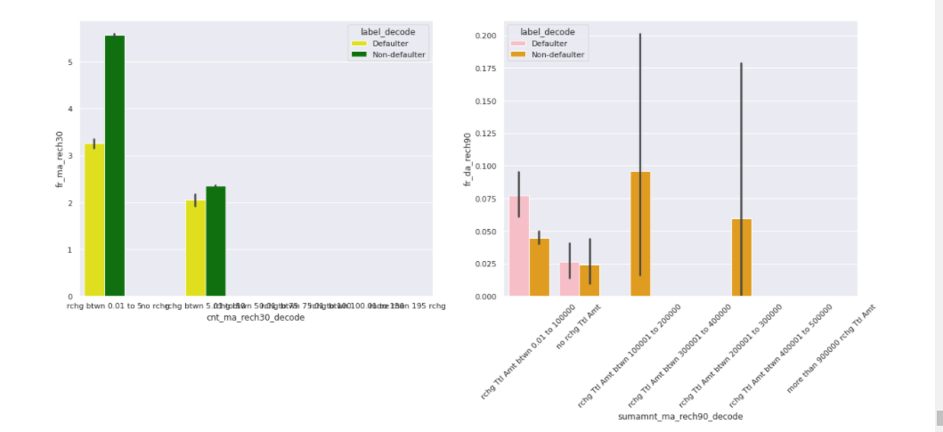

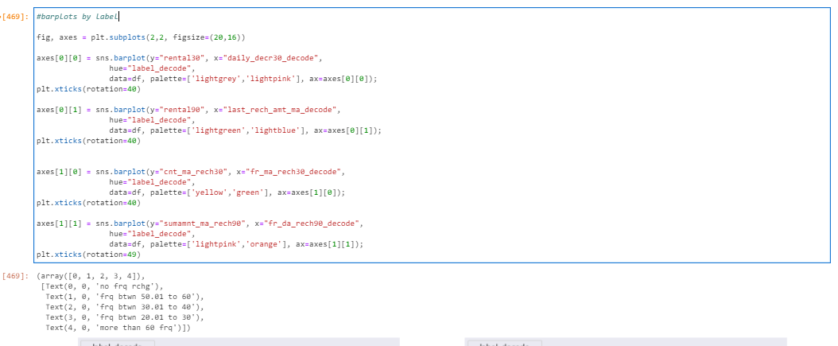

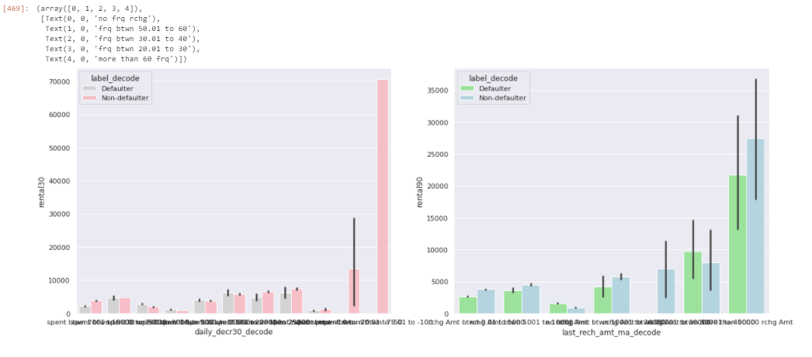

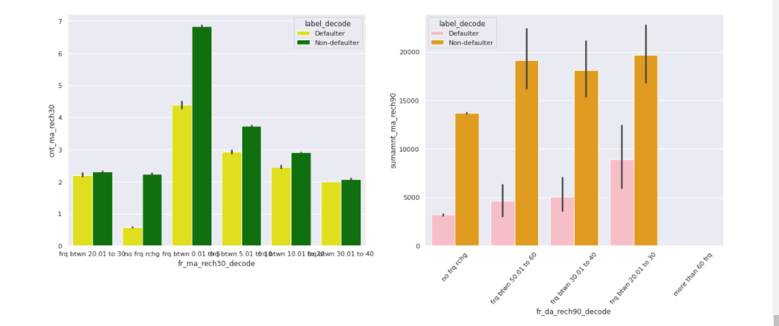

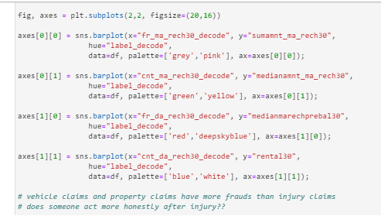

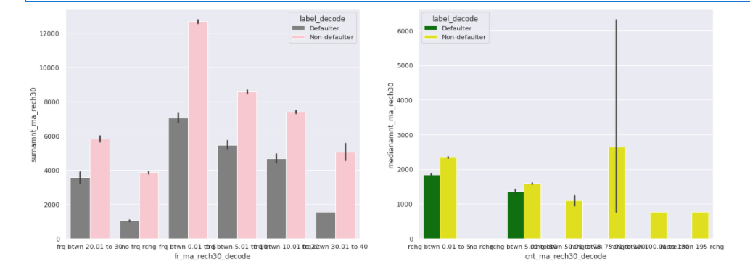

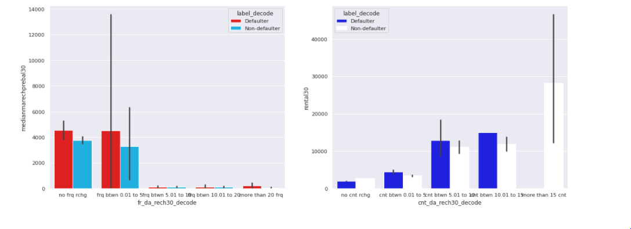

The conclusions for the above bar plots are the same as shared previously.

We also have descriptive details of our data:

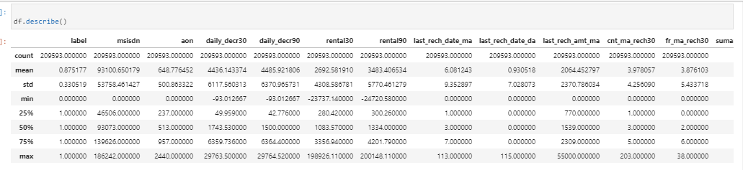

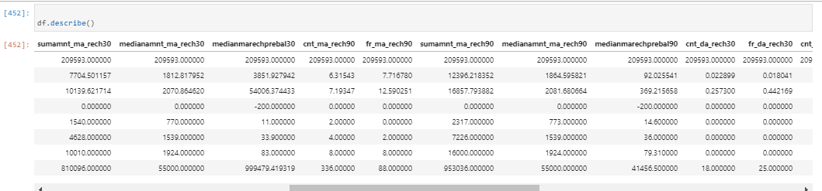

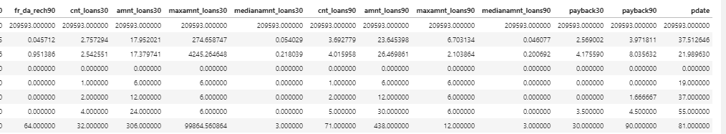

Let’s do a quick check on the describe table:

In the first row of the descriptive analisis, we see we have the total number of cases in every single feature, which means there is no missing value in our data. Checking the total number of instances, we could check and confirm that we do not have any missing values.

From the above plot we could check at first sight if we had any skewness or outliers.

All Features except Label has right side skewness and these features







Are the features where the mean is above the median, which means we have a right skewness (positive skewness).

For outlier check at first sight, we We also see comparing the 75% percentile with the maximum of the same column, and we can notice all the features except the target variable one have many outliers as we have larger values for the maximum compared to 75% percentile values.

. With the above plot we also can check if we have same or different scaling of the features. If so, apply any kind of normalization technique such as standard scaler or tmin-tmax scaler.

For skewness , we also checked it through:

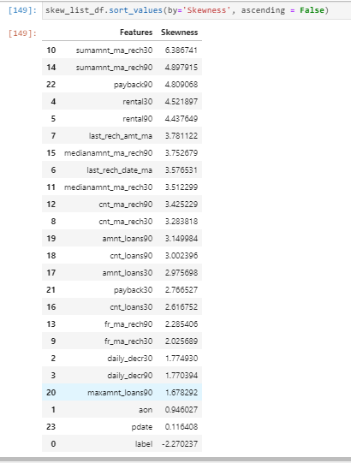

Then, also checked the outliers and:

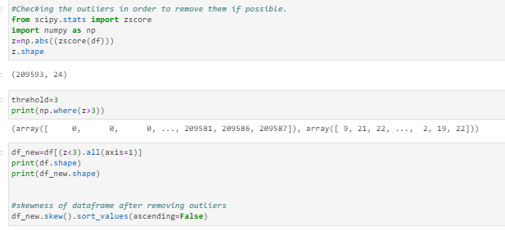

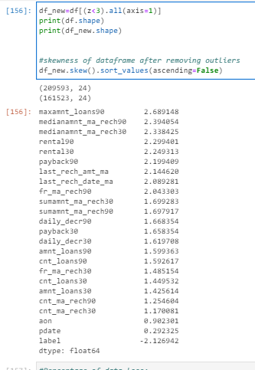

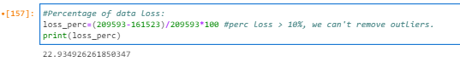

The percentage of lose is higher than 10% so we cant remove all the ouliers.

Let’s check with z>4 in order to remove outliers less than 10% of our data:

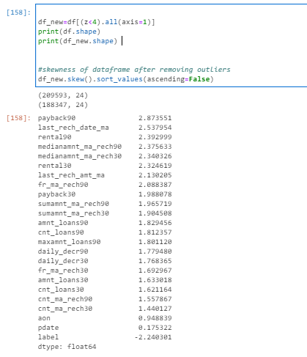

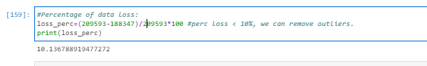

Now, the loss of data is more or less 10%, so we can proceed with removing the outliers.

After removing the outliers, we have that our skewness is:

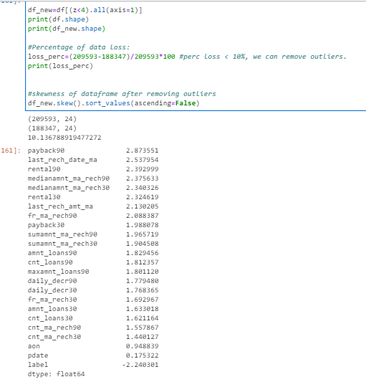

This is the maximum we can do with removing outliers. Now, let’s proceed further because soon we will use transformation technique to reduce the skewness.

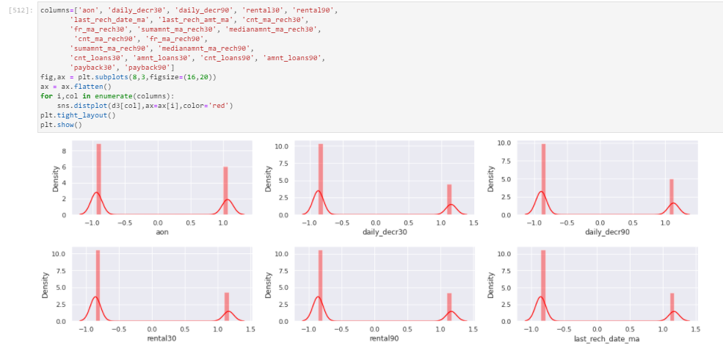

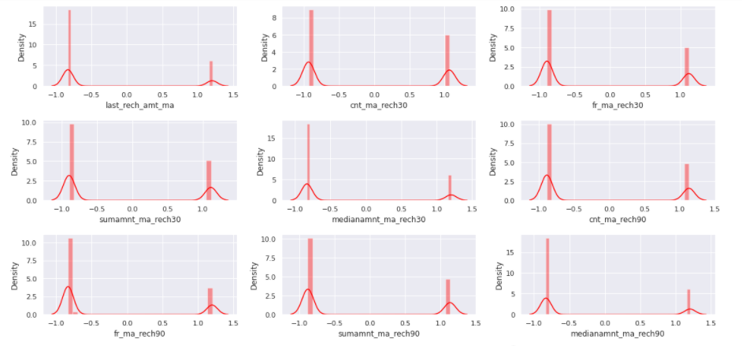

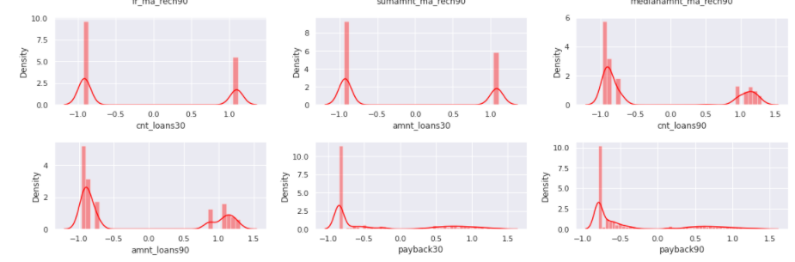

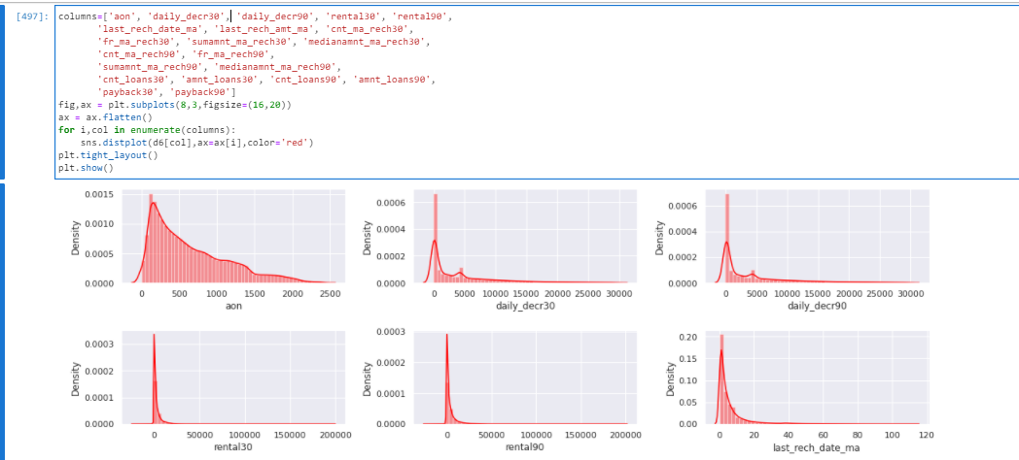

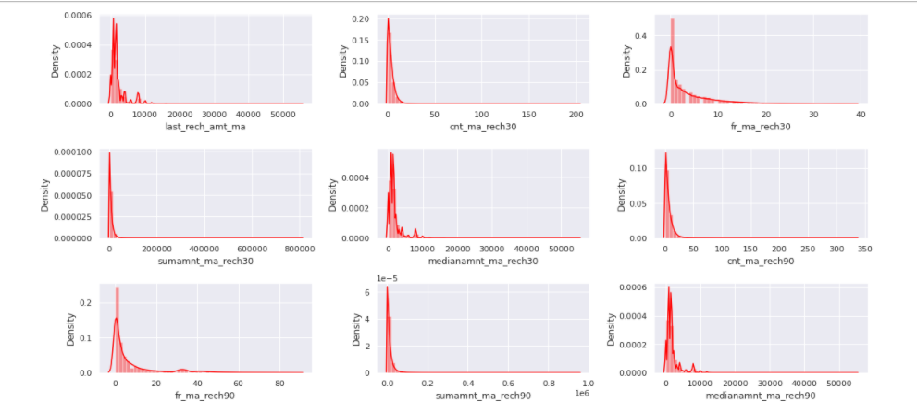

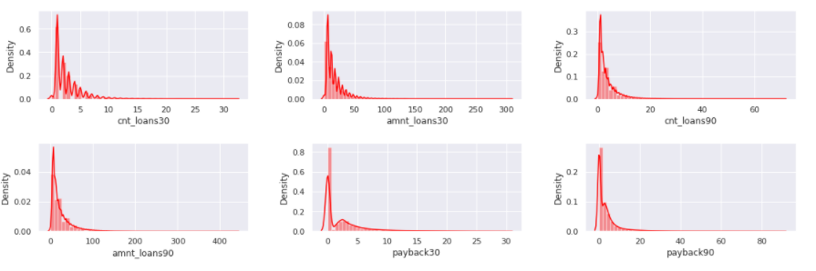

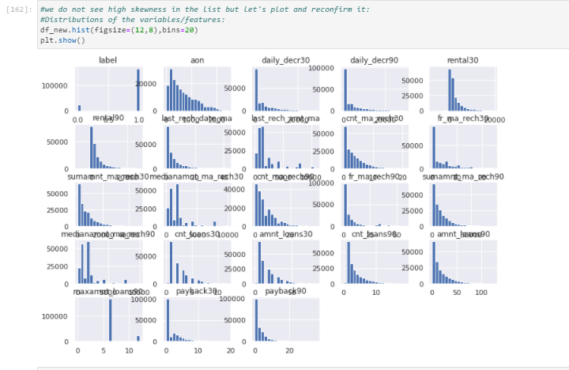

Checking and seeing the above plots we can see a bit of skewed data on the right side.

Trying to reduce the skewness:

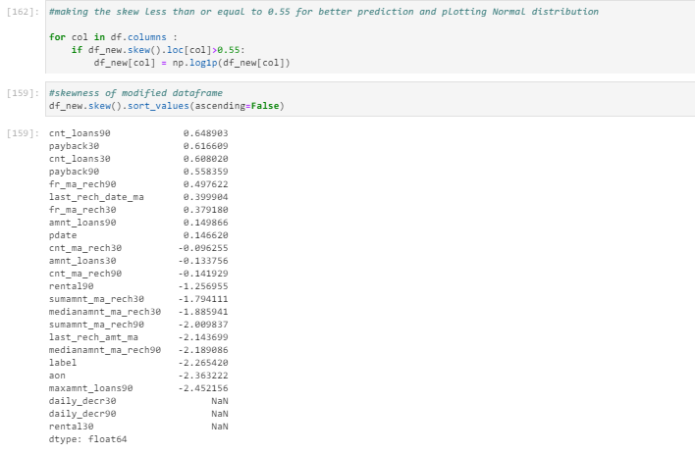

We tried to reduce the skewness but since there is no such imorovement, now that the skewness of more columns are more near to zero, but we do not see such a grand difference. Making the skewness value near to zero will help to get better score. So, the features that still has high skewness, we will use a transformation technique called power transform yeo-johnson.

But before doing any transformation. Let's check and calculate VIF and check multicolinearity.

Before calculating the multicollinearity, we need to get rid of nan and infinitive data and replace it by mean:

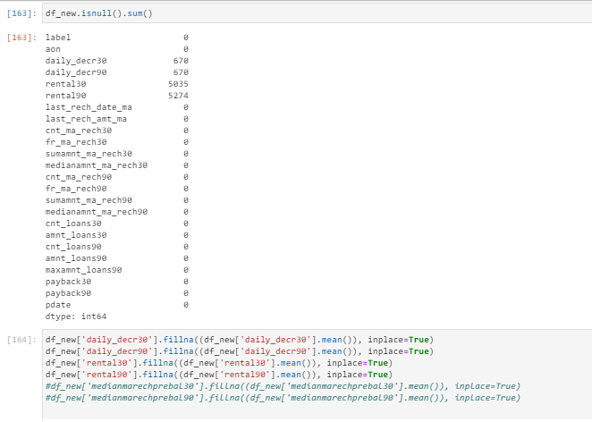

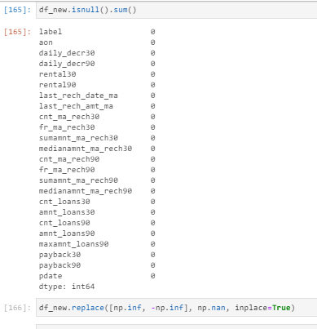

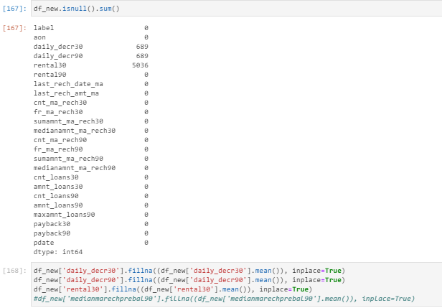

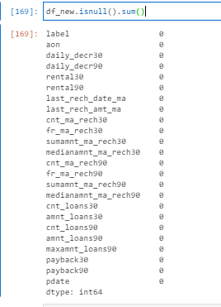

Once we could rid of the nan and infinitive values, we can now calculate the VIF values and check the multicollinearity between our features:

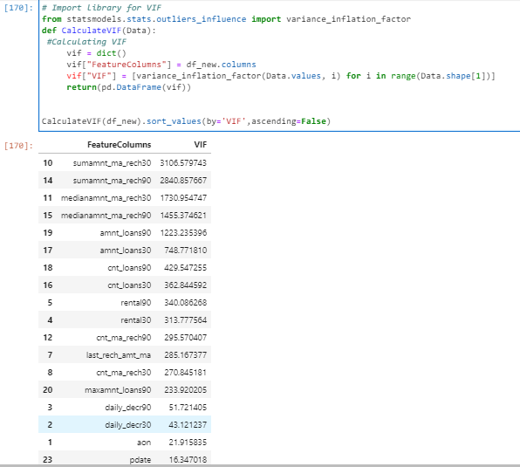

And remove the feature with highest VIF value:

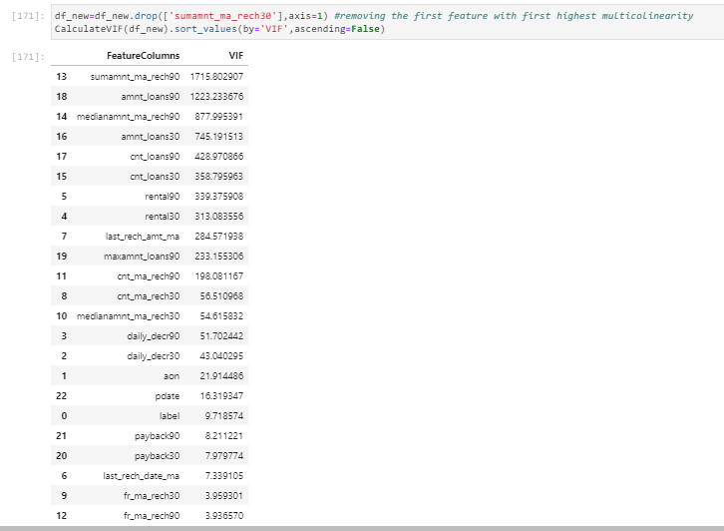

Dropping the feature with highest VIF :

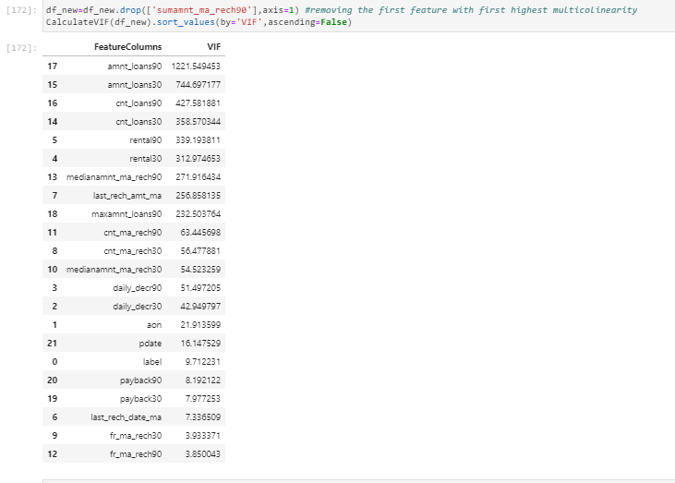

Dropping again the first feature with highest VIF value:

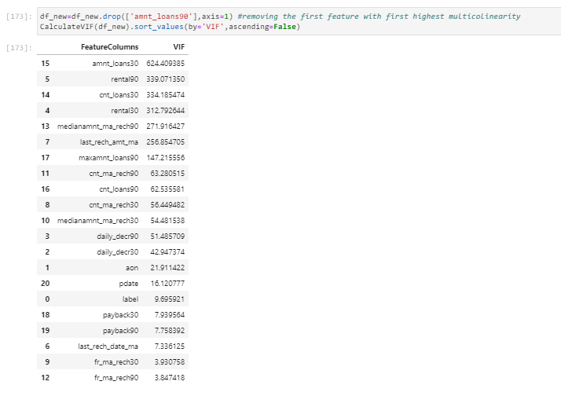

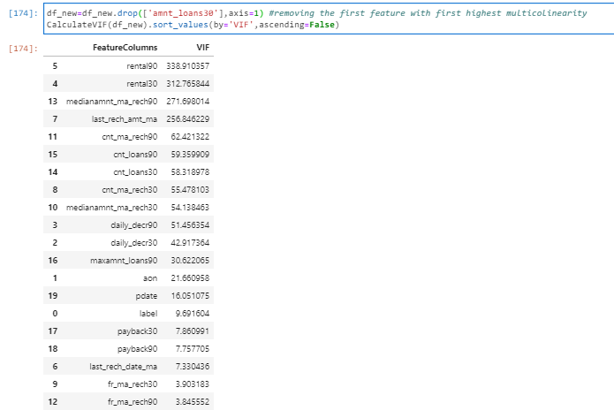

#stop deleting more variables as it decreases the ML score.

#since i was informed i should delete max 4 column in this case as we have less number of features and continue with model building, i am continuing with model building.

Then, we also plotted the correlation between features through a heatmap in order to see easily the best correlations between all our features including our target “Label”:

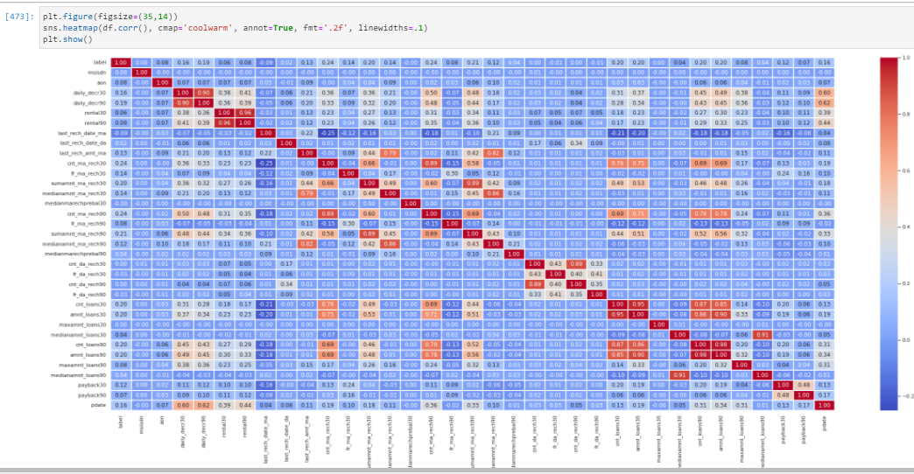

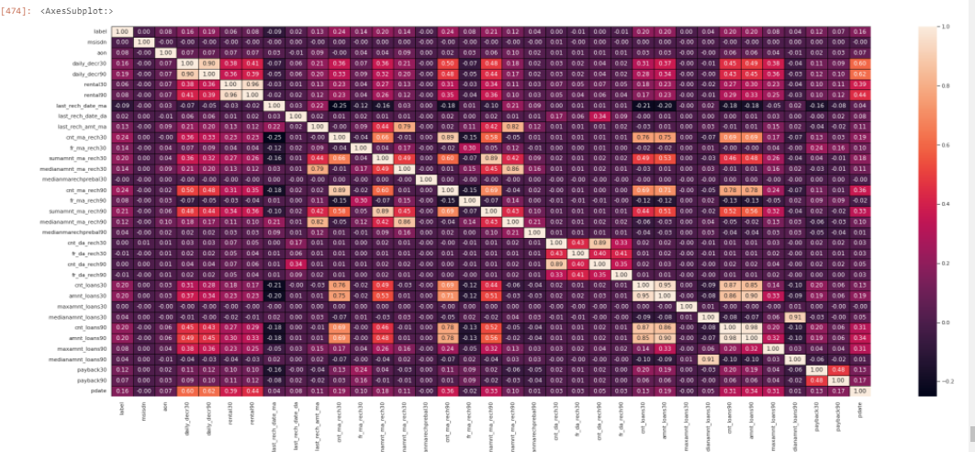

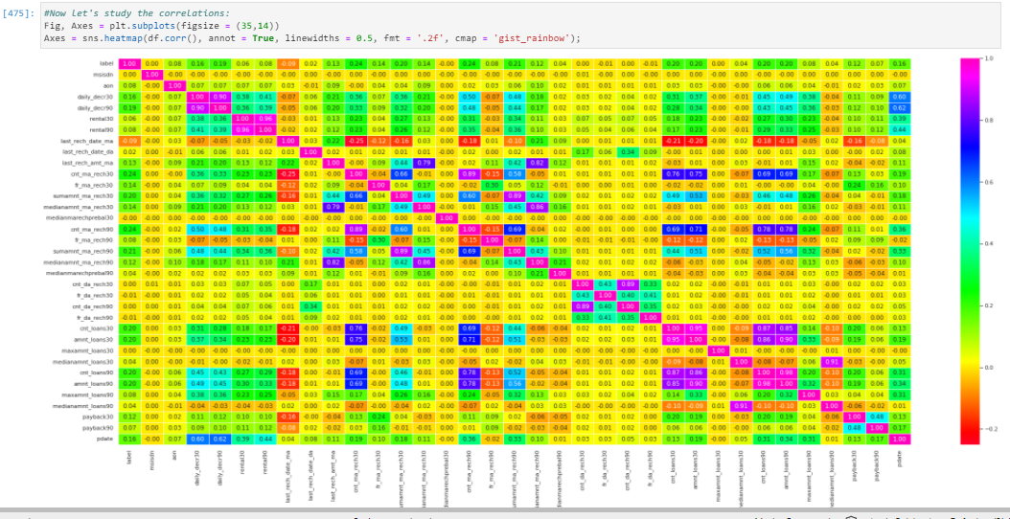

**In the correlation heatmap we see that cnt_loans90 is 98% correlated with amnt_loans90.**

**And then, the cnt_loans30 is 95% correlated with amnt_loans30.**

**Both previous correlations make sense as Total amounts of a loans taken by a user is very much correlated on the number of loans taken by user for the same period of time.**

**Then, the medianamnt_loans90 is 91% correlated with the medianamnt_loans30 which make sense as the median of amounts of loan taken by the user in last 90 days is correlated with the respective median of amounts of loan taken by the user in last 30 days as both are medians of each period. Both have correlations as medians are the values in middle when sorting the values in a ordered way from smallest to highest. So, medians of 30 days and 90 days should be very close to the 30 days since the amounts of loan for period of 90 days would have similar distribution of loans during the period of 30 days.**

**As expected, The cnt_da_rech30, The cnt_loans30 and amnt_loans30 are highly correlated with cnt_da_rech90, cnt_loans90 and amnt_loans90 for the same reason as previous. Independently of the duration of the period, following the statistics like Number of times data account got recharged in last 30 days will have similar distribution as Number of times data account got recharged in last 90 days. Same happens with cnt_loans30 as the Number of loans taken by user in last 30 days would have similar distribution as Number of loans taken by user in last 90 days. And same with amnt_loans30 where the Total amount of loans taken by user in last 30 days would have similar distribution as Total amount of loans taken by user in last 90 days. In summary, the same variable with different period would have similar distribution even if the period of time is different when following the normal distribution.**

**Then, we also have the rental30 and rental90 have similar distribution for the same reason as previous correlation cases. Means that the average main account balance over last 90 days would have similar distribution as average main account balance over last 30 days.**

**The same happens with daily_decr30 and daily_decr90 whose correlation is 90% and the reason is the same as the previous one: independently of the period, both have similar distribution.**

**Then, we also have variables like cnt_ma_rech90 and fr_ma_rech30 which have a correlation of 89%. Okay, these two are fine to have correlation as one is the frequency of main account recharged in last 30 days and the other one is the number of times main account got recharged in last 90 days. So, as we said previously, independently of the different period, the frequency and the number of times are counting the same fact which is that the account got recharged. Hence, make sense to have high correlation.**

**Now, we also have high correlation of 89% between the variables sumamnt_ma_rech90 and medianamnt_ma_rech30. It is understandable as the median of amount of recharges done in main account over last 30 days at user level depends and is correlated with total amount of recharge in main account over last 90 days. In the final, independently of the period, the median of amount of recharges depends and is correlated with the total amount of recharge.**

**And we also see we have high correlation with medianamnt_ma_rech90 and cnt_ma_rech30. The reason is the same as the previous one: Median of amount of recharges done in main account over last 90 days at user level is correlated with number of times main account got recharged in last 30 days. OK, here the reason we can explain is that the number of times main account got recharged depends when and how many times the user decide to recharge the account and also depend on the amount of recharges done in the main account.**

**As expected, medianamnt_ma_rech30 and medianamnt_ma_rech90 are highly correlated having correlation of 86%.**

**If we concentrate on the target and check the best correlations against it, then we will see that the following features are considered the best correlated features within our dataset:**

**When checking the relationships between the features and the target, we see some feature like dailydecr30, dailydecr90, last_rech_amnt_ma, cnt_ma_rech30, fr_ma_rech30, sumamnt_ma_rech30, medianamnt_ma_rech30, cnt_ma_rech90, sumamnt_ma_rech90, medianamnt_ma_rech90, cnt_loans30, amnt_loans30, amnt_loans30, payback30 and pdate that are more correlated and have more possibility to impact more on our target variable label. These variables have higher impact on the target then the others when comparing the percentage of correlation. So, the higher correlation, more probability to have higher impact on the Loan default classification.**

Once we deleted outliers and now we only have some skewness, which we will handle it through method yeo johnson power transformation:

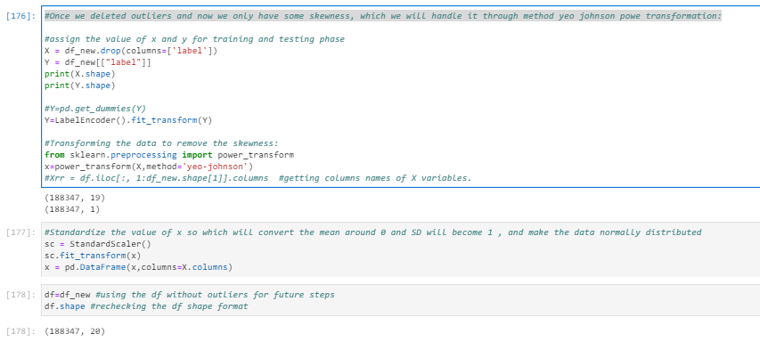

After having power transformed and stardarized the scale of our data, we start with ML algorithm training which we mentioned before.

**Interpretation of the Results:**

First of all, we did not need with the missing values but yes the weird extreme values by imputing them either with mode or mean of the same feature.

Then, we had skewness, multicollinearity and outliers that we had in all the columns. We looked and managed these 3 statistical measures through some power transformation yeo-johnson method, dropping irrelevant columns through VIF calculation and calculating ZScore for the 3 statistical measures respectively.

Then, after analysing several different visualizations, pre-processing and modelling, we got the following results:

In machine learning, it is a general practice to rely on a correlation matrix to decide what features to be incorporated into our models. We noticed we had several features such as dailydecr30, dailydecr90, last_rech_amnt_ma, cnt_ma_rech30, fr_ma_rech30, sumamnt_ma_rech30, medianamnt_ma_rech30, cnt_ma_rech90, sumamnt_ma_rech90, medianamnt_ma_rech90, cnt_loans30, amnt_loans30, amnt_loans30, payback30 among the features which are the features that have higher impact comparing all the available features.

Let’s check the important features by gini-importance:

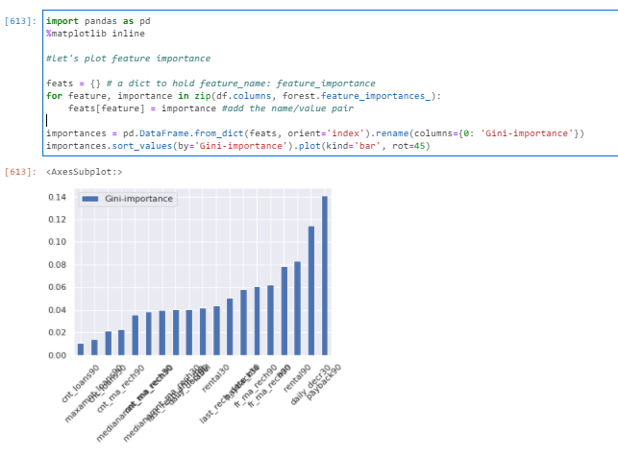

And then, we had some features selected by our model that impact the most on the classification and that are the following ones selected by the model:

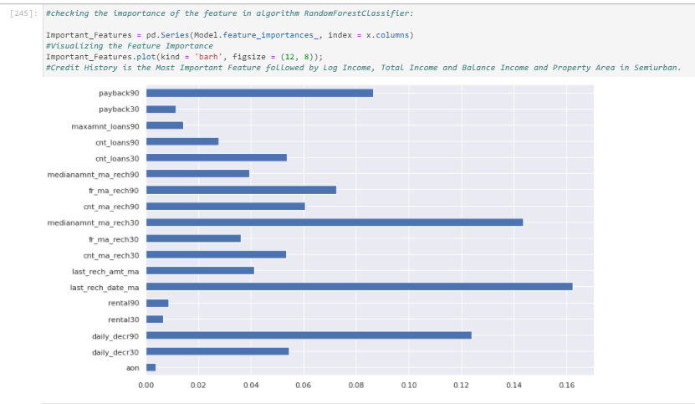

These variables have higher impact on the target then the others when comparing the impact through the model. So, the higher correlation, more probability to have higher impact.

And in the modelling section, we studied and saw that RF and GBR where the best models when training or data set.

Then, we checked and compared the obtained results with algorithm Random Forest Regressor which got us CV mean of 94,61%

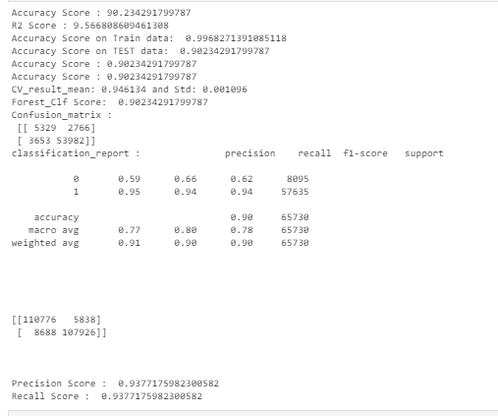

Before deciding the best algorithm, we have gone through the several different steps such as: split data, train data through diferents algorithms and their corresponding different parameters.

The list of each algorithm used is as following:

* + LogisticRegression
  + DecisionTreeClassifier
  + KNeighborsClassifier
  + RFC
  + AdaBoostClassifier
  + GradientBoostingClassifier

From which we selected RFC which gave me the best results in comparison with the other algorithms after applying GridSearchCV.

Following this is the estimation of Random Forest Classifier. Employing n_estimators = 10, criterion = 'entropy', random_state = 38, the results are then evaluated by the accuracy, r2score, CV mean, RF Score, Precision, Recall, F1Score, Confusion Matrix and classification report. These evalution metrics are estimated to be:

Accuracy Score : 90.234291799787

R2 Score : 9.566808609461308

Accuracy Score on Train data: 0.9968271391085118

Accuracy Score on TEST data: 0.90234291799787

Accuracy Score : 0.90234291799787

Accuracy Score : 0.90234291799787

CV_result_mean: 0.946134 and Std: 0.001096

Forest_Clf Score: 0.90234291799787

Confusion_matrix :

[[ 5329 2766]

[ 3653 53982]]

classification_report : precision recall f1-score support

0 0.59 0.66 0.62 8095

1 0.95 0.94 0.94 57635

accuracy 0.90 65730

macro avg 0.77 0.80 0.78 65730

weighted avg 0.91 0.90 0.90 65730

[[110776 5838]

[ 8688 107926]]

Precision Score : 0.9377175982300582

Recall Score : 0.9377175982300582

demonstrating that RFC is implying a very good fit. In an iterative algorithm, the ‘optimal’ weight for each feature is indeed obtained by fine tuning an arbitrary value on a function, and going down its slope step by step until it reaches the lowest point of the function. Hence, our focus should concentrate on the explanatory power CVmean and the error minimisation of the model.

In random forest, the estimation of SGD is not feasible because some of the hyperparameters are not continuous, such as the number of estimators. Rather, we can employ the randomizedSearchCV to minimise the model errors by tuning the hyperparameters.

For hyperparameter tuning, we perform many iterations of the entire fivefold cross-validation process, each of which sets different model settings, such as the number of estimators, min samples split, min sample leaf, max features, and max depth. Then, we compare all these models, pick up the best one, train it on the training set, and then evaluate on the test set as follows:

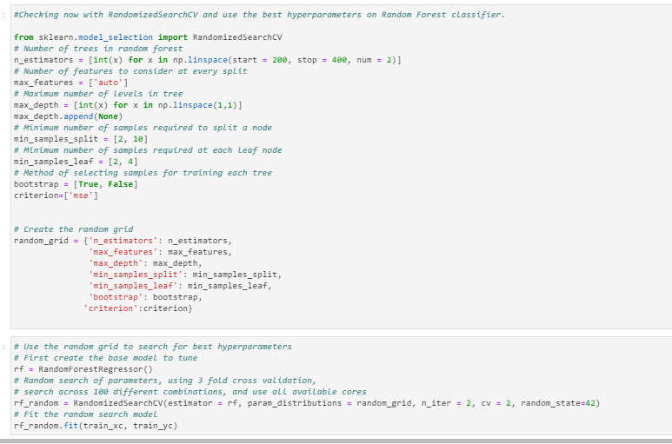

Hence, we take the result based on grid search as the best result associated with random forest.

Lastly, we discuss the results based on the RF. In the base model, provides a R2R2 of -85,6 the test set while the Accuracy, precision, cv mean, recall, confusion matrix and classification report are estimated to be:

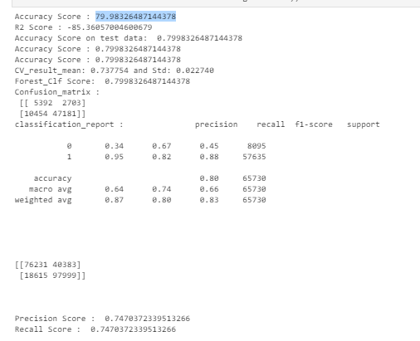

It is very obvious that RF fits our data reasonably well. In order to obtain even better results, we then employ the grid search with CV to minimise the model errors by tuning the hyperparameters, including subsample, learning rates, the number of estimators, min samples split, min sample leaf, max features, and max depth:

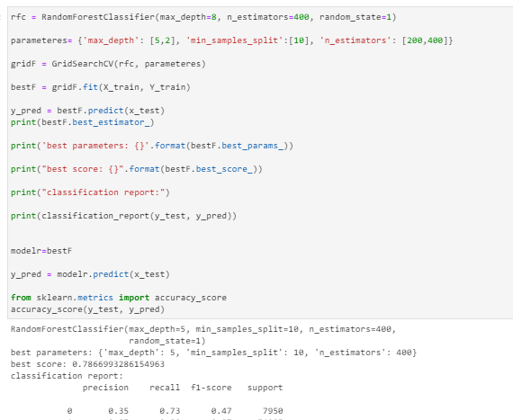

We then obtain a score of 78,66% for the test set .

For most of the time, RF also fits the data very well for example in this case. However, the model does not perform well with high bias for some extreme values that are lying far away from the cluster. Again, the model has achieved very good model fitting since most of the predicted values are lying close to the predicted values and its performance is slightly better than compared to other algorithms.

Finally, we compare the results of these estimation techniques. In terms of explanatory power, this study shows that RF and GBM have equally good performances. In terms of error minimisation, RF is slightly better than GBM with respect to the performance error metrics and R2 score while it outperforms AdaBoost. Hence, we demonstrate that RF has very powerful tools for making accurate classification of the credit loan default classification, since the performances of this algorithm is higher to the other ones.

**CONCLUSION**

**Key Findings and Conclusions of the Study:**

If we concentrate on the main 3 questions, then the results answer the research questions as follows:

* Question 1 –Which variables are important to predict the price of variable?

If we first concentrate on the target and check the best and important features against it, then we will see that the following features are considered the best features within our dataset:



In machine learning, it is a general practice to rely on a correlation matrix to decide what features to be incorporated into our models. We noticed we had several features such as among the features which are the features that have higher impact comparing all the available features.

Answer: We see several features such as dailydecr30, dailydecr90, last_rech_amnt_ma, cnt_ma_rech30, fr_ma_rech30, sumamnt_ma_rech30, medianamnt_ma_rech30, cnt_ma_rech90, sumamnt_ma_rech90, medianamnt_ma_rech90, cnt_loans30, amnt_loans30, amnt_loans30, payback90 among the features shown in the above screenshot are the features that have higher impact comparing all the available features.

In general, the selection of a ML trained and tested model for a case like loan default classification is very much influenced by the quality and availability of data. When we have wide range of data, the model can be trained easily and will be effective as sufficiently long time series of credit default and relevant fundamental variables allow error-correction or vector error-correction models to be estimated.

So basically, here the study shows a comparison the classification algorithms work when classifying the outcome. The results were promising for the data due to it being rich with features and instances and having strong correlation.

However, RF gave the improved the results score compared to the results previously obtained, and got the best accuracy and cv mean score and results overall. The final results of this study showed that RF makes better classification compared to other used algorithms.

Summarizing, the results answer the research questions as follows:

- Question 1 – Which machine learning algorithm performs better and has the most accurate result in loan default prediction? And why? RF made the best performance overall when both all the metrics and scores are taking into consideration.

- Question 2 –Which variables are important to predict the default classification? We see several features such as dailydecr30, dailydecr90, last_rech_amnt_ma, cnt_ma_rech30, fr_ma_rech30, sumamnt_ma_rech30, medianamnt_ma_rech30, cnt_ma_rech90, sumamnt_ma_rech90, medianamnt_ma_rech90, cnt_loans30, amnt_loans30, amnt_loans30, payback90 among the features shown in the above screenshot are the features that have higher impact comparing all the available features.

- Question 3 - How do these variables describe the user is defaulter or not?

These variables have higher impact on the target then the others when comparing the percentage of correlation. So, the higher correlation, more probability to have higher impact on the Loan default target.

**Learning Outcomes of the Study in respect of Data Science:**

As we may know improvement in computer technology has made it possible data that cannot previously be captured, processed and analysed such as loan default prediction. This study is an attempt to use machine learning algorithms in classifying the loan default binary category, and then compare their results.

In this study, our models are trained with credit loan data using random forest (RF) and gradient boosting machine (GBM) among others. We have demonstrated that advanced machine learning algorithms can achieve very accurate prediction of loan payback classification, as evaluated by the performance metrics. Given our dataset used for this study, our main conclusion is that RF and GBM are able to generate comparably accurate price estimations with lower prediction errors, compared with the other algorithm results.

The existing literature has demonstrated mixed results about which algorithm is superior in making predictions. Previous studies suggest that RF has a better performance than GBR but other studies demonstrate that both models have comparable predictive power and almost equally applicable in making predictions (Ahmad et al., [2017](https://www.tandfonline.com/doi/full/10.1080/09599916.2020.1832558)). In another study about the forecast of daily lake water levels, RF is found to exhibit the best results when compared to linear regression, SVM and ANN with respect to R2R2 and RMSE (Li et al., [2016](https://www.tandfonline.com/doi/full/10.1080/09599916.2020.1832558)). Utilising RF, stochastic gradient boosting and SVM to predict genomic breeding values, Ogutu et al. ([2011](https://www.tandfonline.com/doi/full/10.1080/09599916.2020.1832558)) conclude that boosting has had the best performance, followed by SVM and RF. In this study, SVM performs better than RF (see also Caruana & Niculescu-Mizil, [2006](https://www.tandfonline.com/doi/full/10.1080/09599916.2020.1832558)).

I think we should suggest that the choice of algorithm depends on several factors including, the size of data set, computing power, time constraint and researcher’s knowledge about machine learning. If the accuracy of prediction is the priority, we recommend utilising RF or GBM, although their computations often take much longer times than SVM. Needless to say, it is a good practice to use more than one algorithm to compare the predictions.

**Limitations of this work and Scope for Future Work:**

To conclude, the application of machine learning in loan default prediction is still at an early stage. We hope this study can provide some methodological improvements and contributions to credit loan classification and presenting an alternative to the valuation of loan allowance. Future direction of research may consider incorporating additional credit loan transaction data including more features.

Even though, we are very happy with our final model’s performance, but here we can improve the results by working more intensively on the model and performance results. The inclusion of RFC for categorical variables improved our model’s performance. That being said, there are still additional features, methods and algorithms we would like to try that we think could further improve the model’s performance, as we already mentioned.

Future work on this study could be divided into main areas to improve the result even further. Which can be done by:

- The used pre-processing methods do help in the classification accuracy. So, experimenting with different combinations of pre-processing methods to achieve better prediction accuracy.

- Make use of the available features and if they could be combined as binning features that can improve the data and hence the performance of the model and their results.

- Training the datasets with different classification methods that combines both norms. In order to expand the comparison and check the performance.

- Some of the factors that have been studied and analised in this study has a weak correlation with the target. Hence, by adding more factors to the dataset that affect the credit loan prediction, average income, expenses, average daily transaction or even money saved in order to increase the number of factors that have an impact on loan default classification. This could also lead to a better finding for question 1 and 2, hence also 3.

. - The results of this study have shown that FR is prone to overfitting. However, RF still a strong algorithm that has a lot of options that could, with the right methods, provide a better prediction accuracy.

For future work, we recommend that working on large dataset would yield a better and real picture about the model training and testing results. We have undertaken only few Machine Learning algorithms that are classifiers, but we need to train many other ones and understand their predicting behaviour for categorical values. By improving the error values this work can be useful for development of applications for various respective loan credit prediction.

**Ok done, por fine! This took me around 2 weeks or more, wow! Will not do this much detailed work in the following projects!**

**Sir, please give me feedback for this project, at least the improvement I can do in it: the way of working, more EDA tht I can do, or more analytical methods I can use and analyze, etc. Any other statistical and/or inference that I should have included or worked on this project…anything you think I should include in my following projects.**

**And suggest me also the steps or info that should not have worked in that much detail…anything that I can improve as learning and training.**

**At least, tell me more methods or ways of working these projects and steps or statistical methods I can use and include in my projects.**

**I will be waiting for your best advises! Dn!**